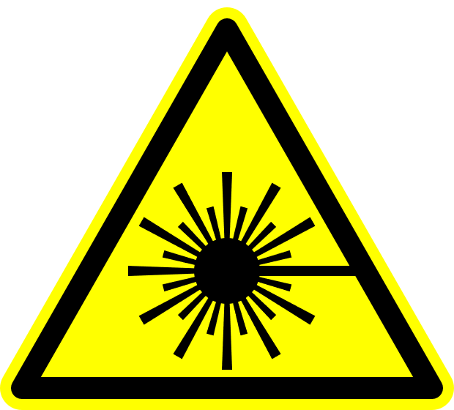

**Class 3B Laser Controlled Area**

**AUTHORIZED PERSONNEL ONLY**

**Avoid eye or skin exposure to direct laser radiation.**

**Laser eye protection required:**

**OD>7 @1053nm**

**OD>2.6 @980-1075nm**

**Laser Safety Officer:** Jim F. Herrold **Phone:** 766-2638

**Laser Supervisor: Phone:**

**!**

**WARNING**