MANAGER SELF SERVICE > TIME MANAGEMENT > REPORT TIME > TIMESHEET

**Note – you are no longer allowed to enter time for yourself – but you can still view the time once it has been entered (payable time pages), see comp time balance, view exceptions, etc.

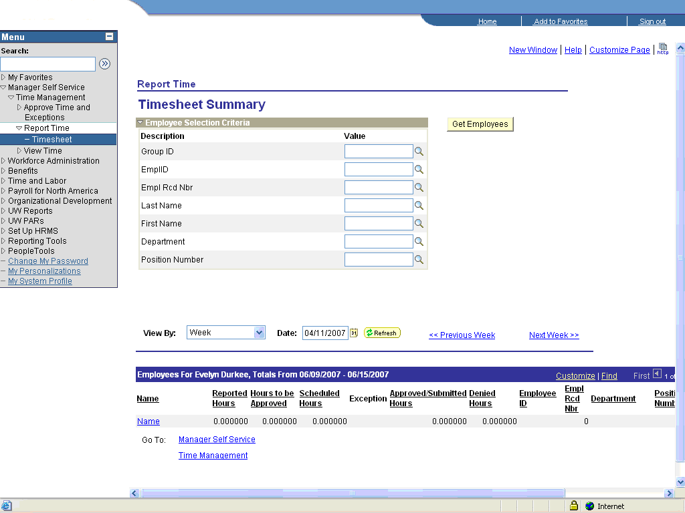

Enter the EmplID, then click on ‘Get Employees’

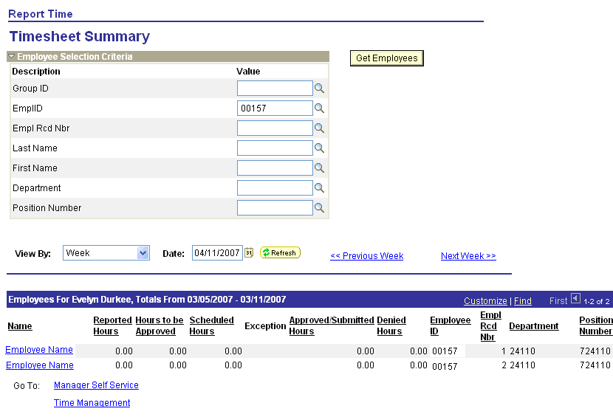

If the employee has more than one Empl Rcd, the system will display all that you can see for this date.

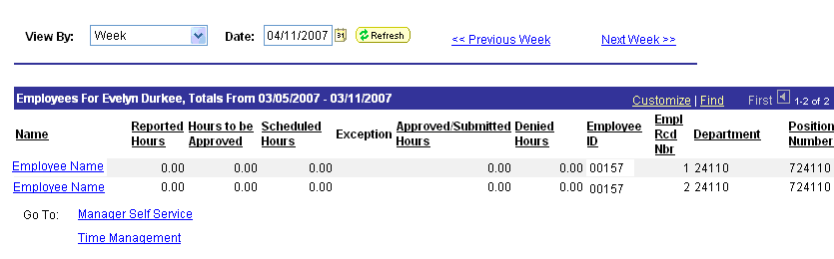

View By: will default to ‘Week’ – do not change.

Date: will default to today’s date –change this to be the first date for the time that you are reporting for this employee.

Click the Refresh button.
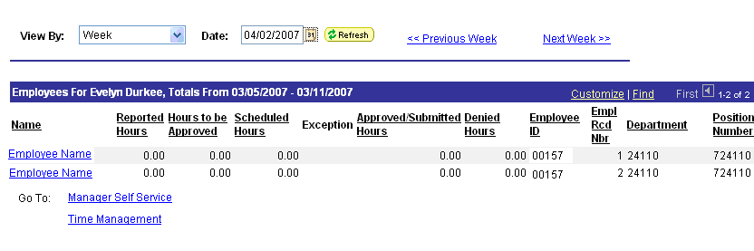

Click on the Name corresponding to the employee record you want.

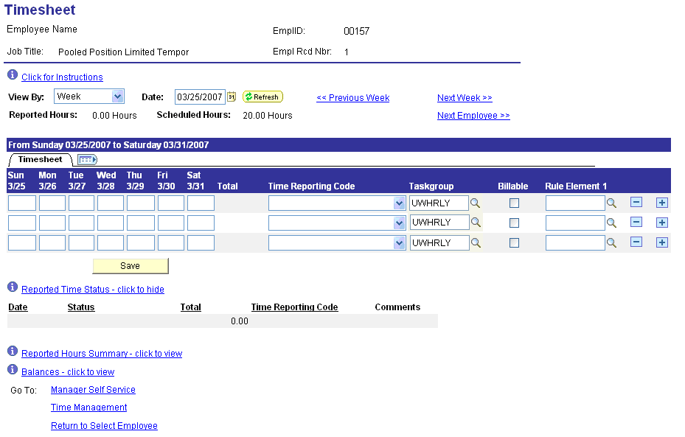

The page will display seven days at a time and will start with the Sunday corresponding to the date that you entered on the previous search page.

If the fields for the individual days do not allow data entry, then the date entered on the search page was either more than 90 days prior to today, greater than 30 days from today, or outside the employees employment dates.
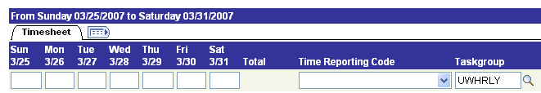

Allows data entry

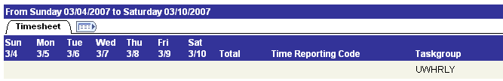

Does not allow data entry

Enter the hours that the employee worked each day, then click on the Time Reporting Code drop down arrow and select the appropriate code for their actual work hours.

**Note - you can only enter time out two decimals**

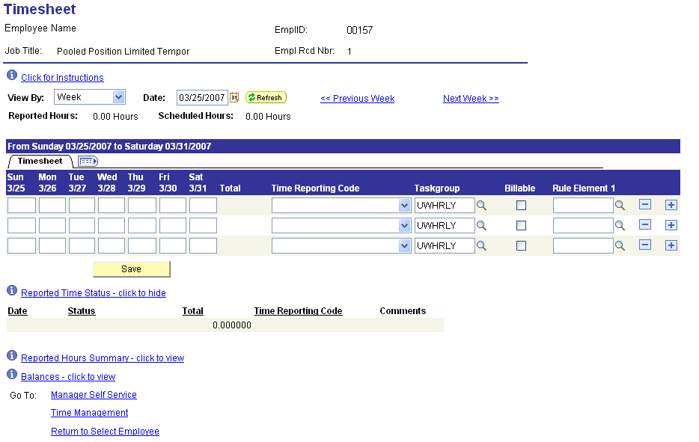

Hours must be reported on a separate line for each time reporting code. If you need more than three earning codes, click on the plus sign (+) to add a row – repeat as needed.

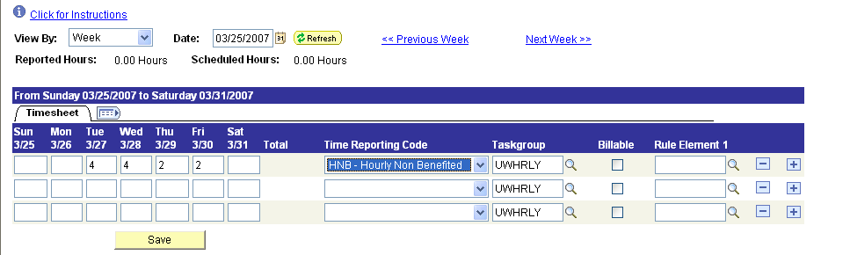

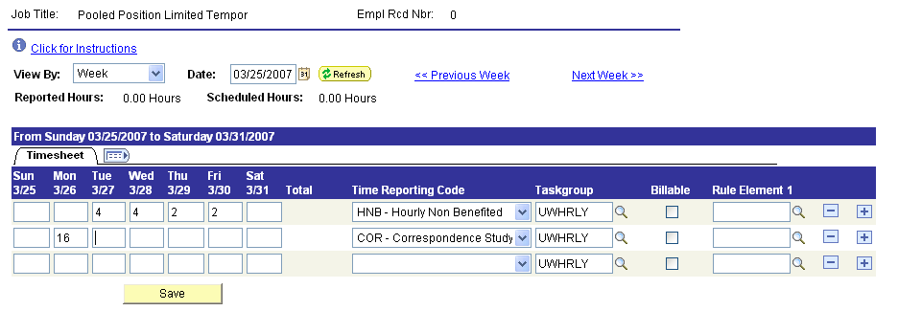

When you have completed the week Save the data.

You should get this page when you Save:
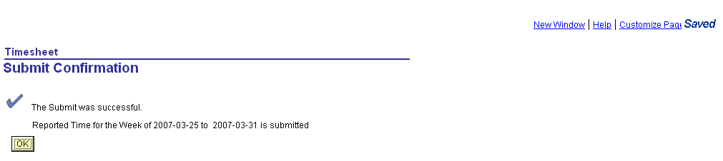

Click OK.

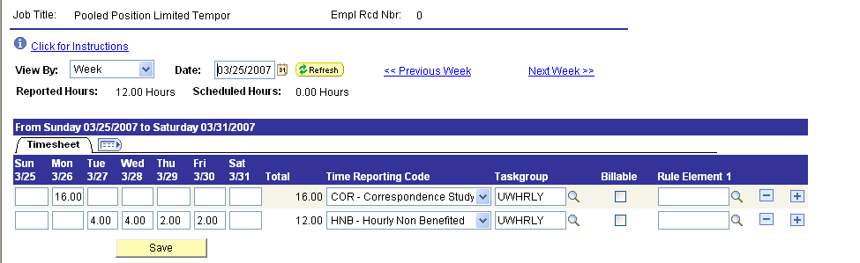
Be sure to Save the record
after each week is entered.

Click on the Next Week button and repeat the process for each week.

Once the time has been saved, you can enter a comment for that time if needed:

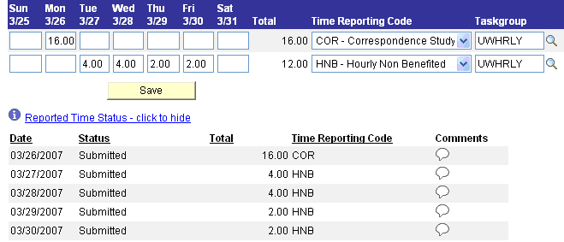

Click on the comments icon for the day and time reporting code that you want.

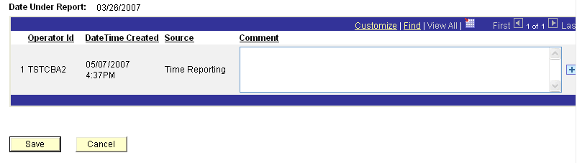

After entering the comment, click Save.

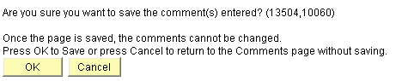

Click OK

If the employee is benefited, you will see the total hours they are “scheduled” for the week – this is based on their FTE and their calendar.

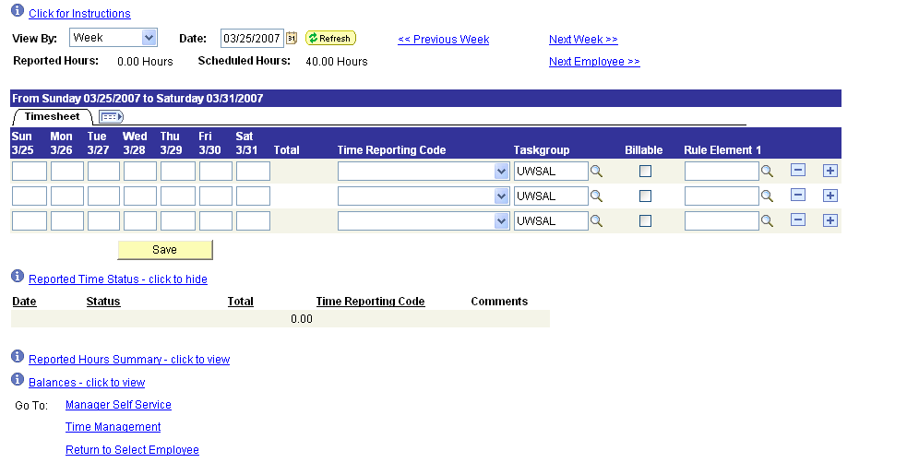

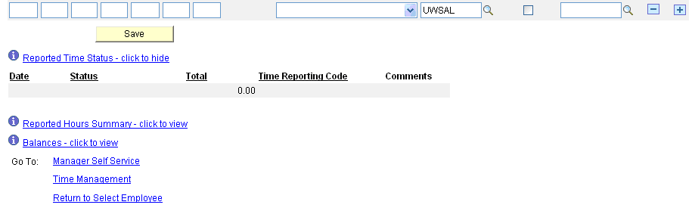

Additionally, for benefited employees, you can see the current leave hours available for this employee by clicking on the ‘Balances – click to view’ link.

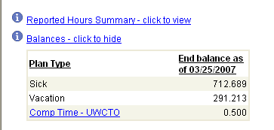

This shows the leave hours available as of today, which may not be accurate for the date the leave is being posted. For example, if you are reporting time from 2 months ago, the balance shown may be enough to cover the time, but what was available 2 months ago may not be enough for the leave.

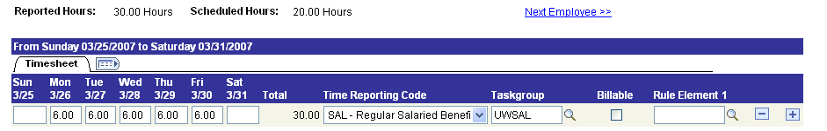

If the total time that is entered for the week exceeds the scheduled hours for the employee, the system will create additional compensation for that week. If the total time is 40 hours or less, the hours over the scheduled amount up to 40, will automatically be paid to the employee as STR (straight time). For employees whose FTE is less than 100%, you can have the STR hours added to their compensatory bank instead of automatically being paid to the employee by changing the Rule Element 1 to ‘F’ (Flex time) for that week. Any time over 40 hours will default to compensatory time and automatically be added to the employee’s comp bank. If you need to actually pay the employee for hours over 40, change Rule Element 1 to ‘P’ (Paid time). We cannot accommodate splitting the time between paid and comp within the same week, so it all either has to be all paid time or all comp time. You can vary this for an individual from week to week, but within a week it must be paid or comp.

These are the valid values for Rule Element 1 and how they process:

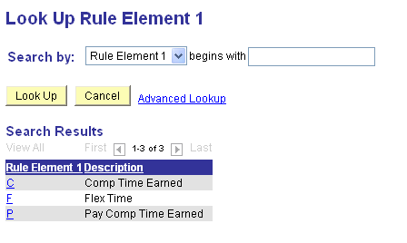
‘C’ – Comp Time Earned code is the default, so if nothing is entered the system will make it this.

FTE = 100%:
C – Hours > 40 in the comp bank
F – Hours > 40 in the comp bank
P – Hours > 40 paid to employee

FTE < 100%:
C – Hours > scheduled and less than 40 paid to employee (STR); Hours > 40 in the comp bank
F – Hours > scheduled and less than 40 in the comp bank; Hours > 40 in the comp bank
P – Hours > scheduled and less than 40 paid to employee (STR); Hours > 40 paid to the employee

Time reporting codes available for benefited, non-exempt employees:

BREAV Bereavement
CTP Comp Time Balance Paid
CTTKN Comp Time Taken
DSG Donated Sick Leave Given
HOL Holiday Pay - Salaried
HTOFF Holiday Falls on Regular Day Off
LEGAL Legal Duty
LWOP Leave Without Pay
MILIT Military Duty
ONC On Call Pay
SAL Regular Work Hours
SALWB Winter Break Hours Worked
SICK Sick Leave Taken
SNOW Snow Day Hours Worked
VAC Vacation Taken
WB Winter Break Off

There are other time reporting codes that will display on the drop down arrow (such as DSR – Donated Sick Leave Received), but these codes are only used by the system and you will get an error if you try to save time on one of them.

Time reporting codes available for benefited, exempt employees:

BREAV Bereavement
CTP Comp Time Balance Paid
CTTKN Comp Time Taken
DSG Donated Sick Leave Given
LEGAL Legal Duty
LWOP Leave Without Pay
MILIT Military Duty
SAL Regular Work Hours
SICK Sick Leave Taken
VAC Vacation Taken

There are other time reporting codes that will display on the drop down arrow (such as DSR – Donated Sick Leave Received), but these codes are only used by the system and you will get an error if you try to save time on one of them.

Time reporting codes available for non-benefited, non-exempt employees:

COR Correspondence Study
HNB Hourly Non Benefited
HNI Hourly Non Benefited – Intl St

There are other time reporting codes that will display on the drop down arrow (such as OTHNN – Overtime 1.5), but these codes are only used by the system and you will get an error if you try to save time on one of them.

Time reporting codes available for non-benefited additional jobs for salaried employees:

ADD Additional Pay Benefited Empl
ADI Additional Job Salaried – Intl
COR Correspondence Study
ONC On Call Pay
SPECL Addition Hours – auto 1.5

There are other time reporting codes that will display on the drop down arrow (such as OTADD – Overtime 1.5), but these codes are only used by the system and you will get an error if you try to save time on one of them.

The time that has been entered will always display either on the Timesheet page or the Payable Time Detail page – even after it has been processed by payroll. If you need to make any corrections to time previously processed, you make the change here *Note* - the system will only allow departments to make changes for time reported on a date 90 days prior to today or 30 days greater than today. If the date is before 90 days from today, contact Payroll to make the correction.

Current time:

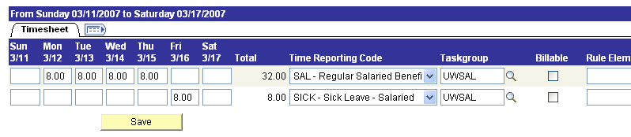

After changes:

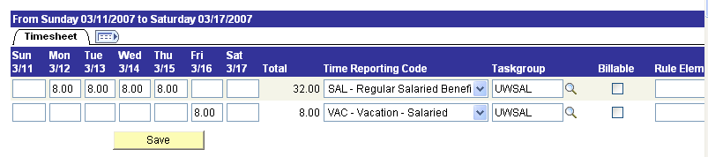

The hours, any leave balances, and any pay will be adjusted as needed on the next payroll that runs that has this employee record.

There is a Time Administration program that usually runs nightly which processes the data (applies rules, checks dates, checks leave balances, etc.) that has been entered on the timesheet page. Any data that has errors will be displayed on the Exception page; the time that passes the Time Administration process without errors will be displayed on the Payable Time Summary Page.

You can view what has been entered on the timesheet page (see a history of the time) at:

TIME AND LABOR > VIEW TIME > REPORTED TIME AUDIT

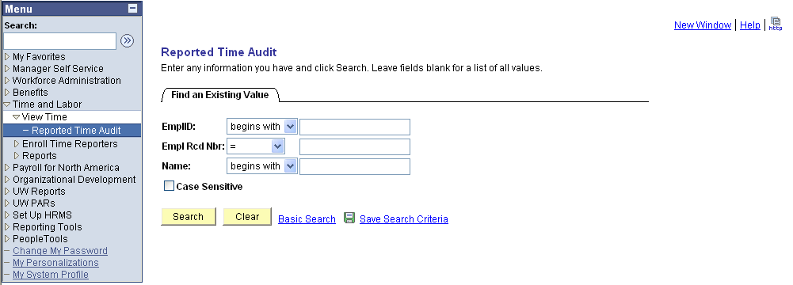

Enter the Emplid and click ‘Search’

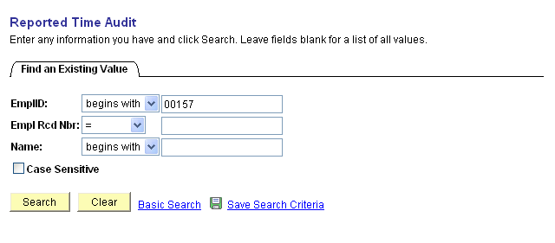

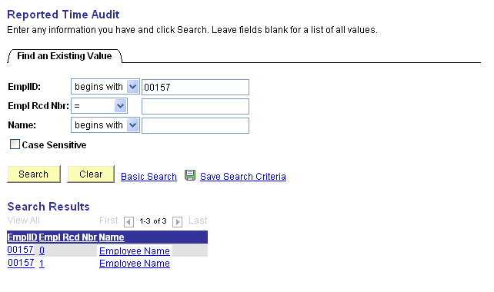
If the employee has more than one Empl Rcd, the system will display all that you can see for this employee.

Click on the Name corresponding to the employee record you want.

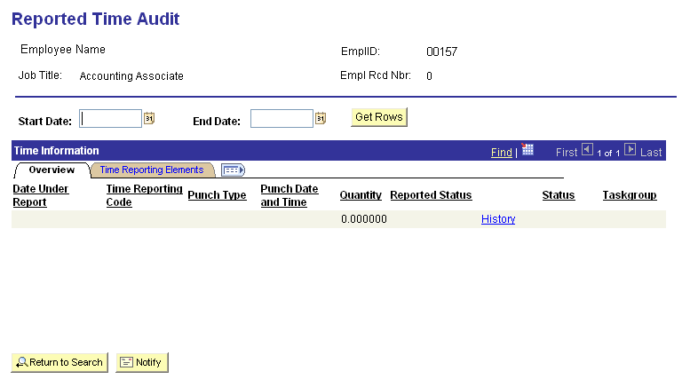

Enter the Start Date and End date of the time you want to see and then click ‘Get Rows’

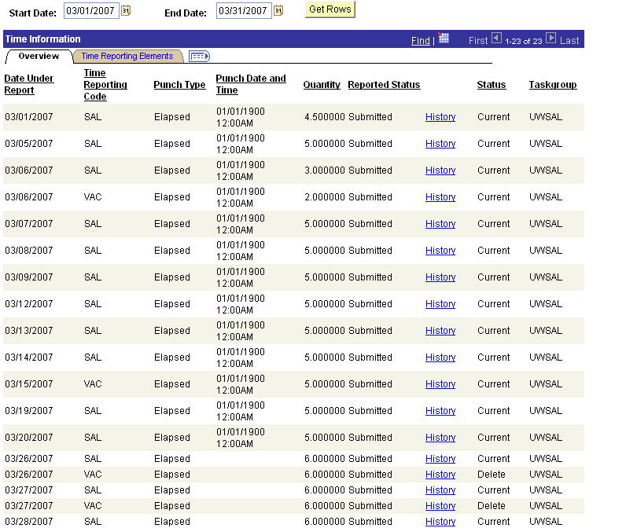

There are three pages that will show what will be processed or has been processed:

MANAGER SELF SERVICE > TIME MANAGEMENT > VIEW TIME > PAYABLE TIME SUMMARY
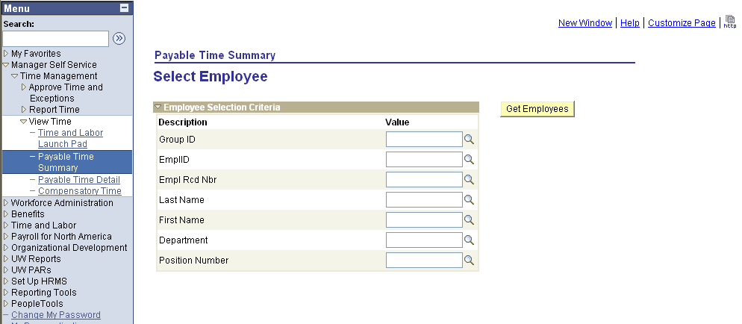

Enter the EmplID, then click on ‘Get Employees’

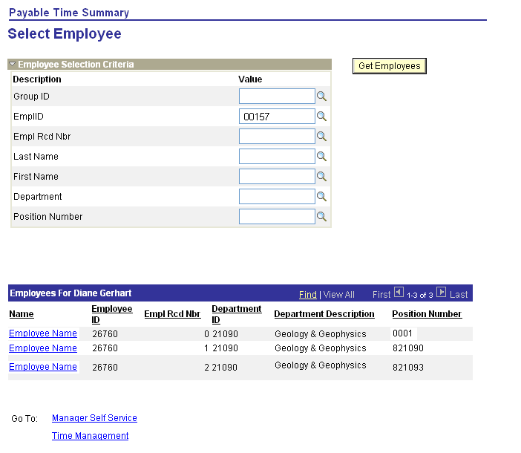

Click on the Employee Name for the Empl Rcd that you want
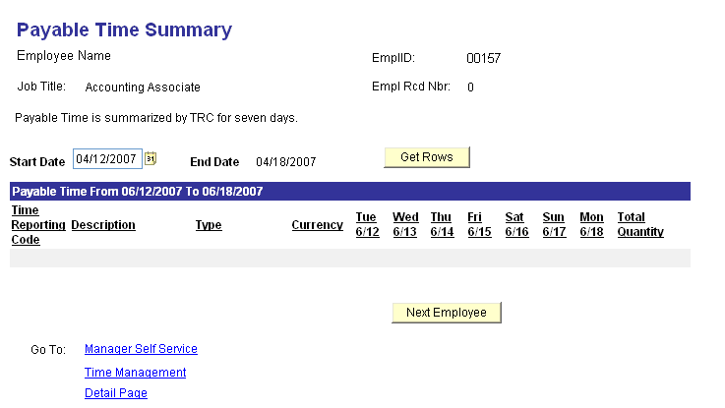

Start Date will default to today’s date - enter the first date of the time you want to see – the page will display seven days at a time starting with the date entered.

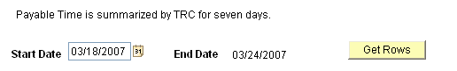

Click ‘Get Rows’

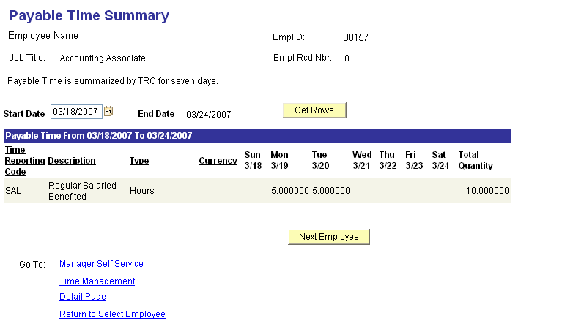

Or you can use the Payable Time Detail which will show you the transactions as they were processed by the payroll, so if you have made an adjustment to time you can see its history:

MANAGER SELF SERVICE > TIME MANAGEMENT > VIEW TIME > PAYABLE TIME DETAIL

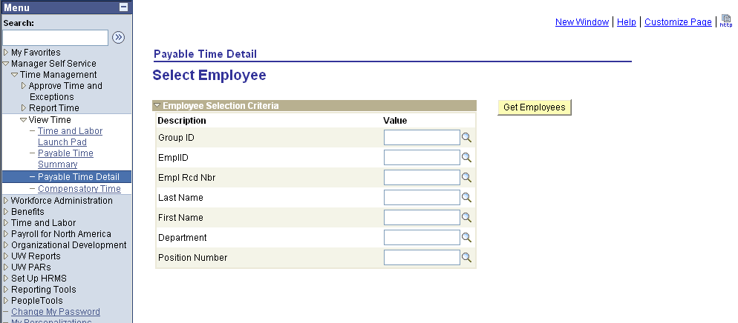

Enter the EmplID, then click on ‘Get Employees’
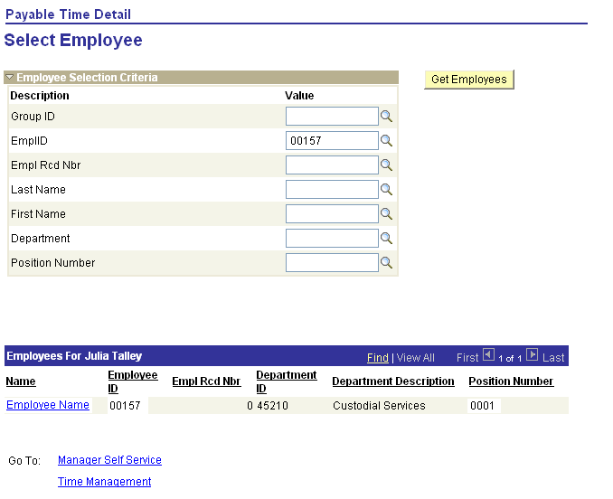

Click on the Employee Name for the Empl Rcd that you want

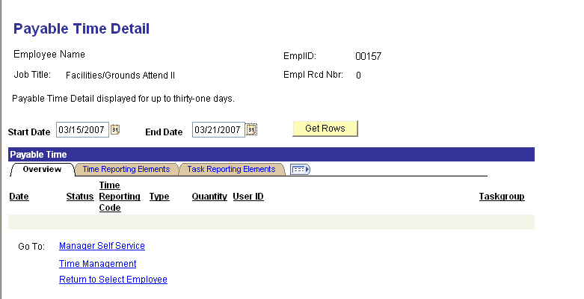

The Start Date will default to today’s date and the End Date will default to 6 days from now – change the Start Date to the first date of the time you want to see and then change to End Date to the last date of the time – noting that you cannot go over 30 days between the dates (31 days total).

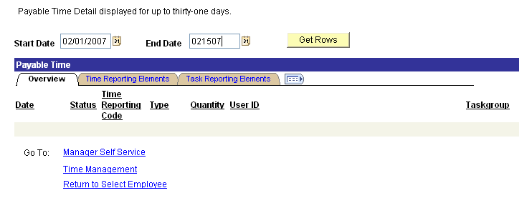

Click on ‘Get Rows’

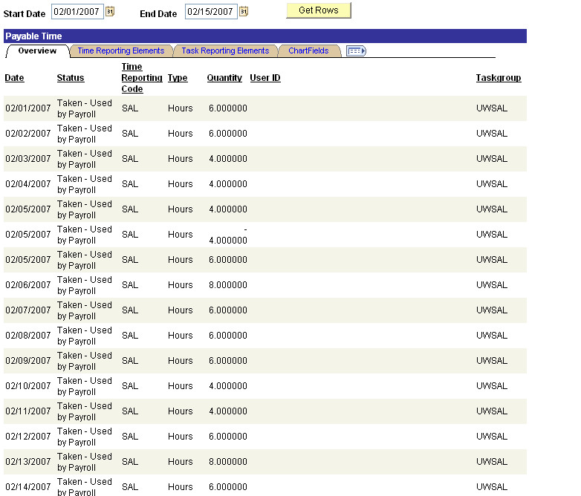

The page shows all transactions by date and time reporting code

For a transaction that has been changed you will see the first (original) transaction that was processed:

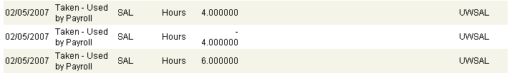

The next row will be a reversing transaction (the negative sign is above the hours):

The next row will be the replacing transaction:

Or you can use the Time and Labor Launch Pad:

MANAGER SELF SERVICE > TIME MANAGEMENT > VIEW TIME > TIME AND LABOR LAUNCH PAD

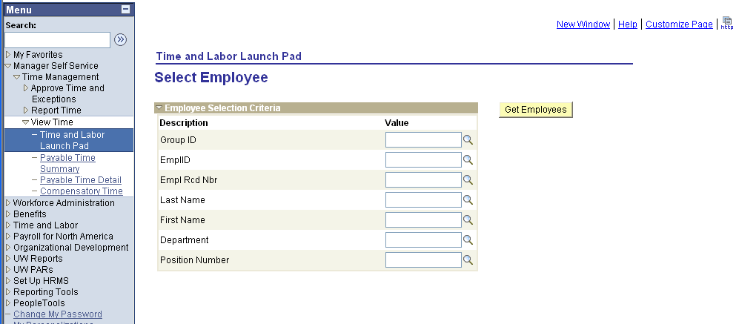

Enter the EmplID, then click on ‘Get Employees’

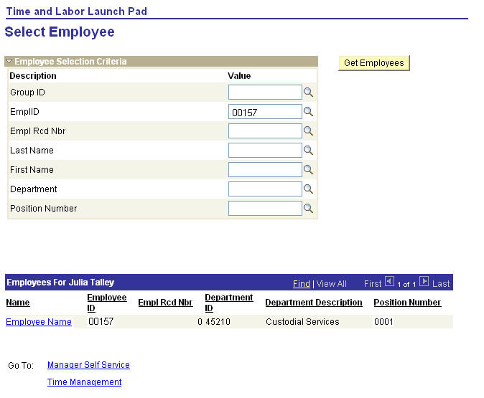
Click on the Employee Name for the Empl Rcd that you want.
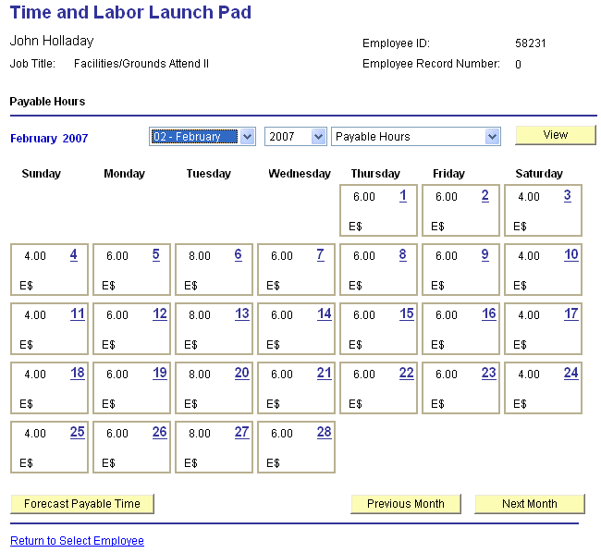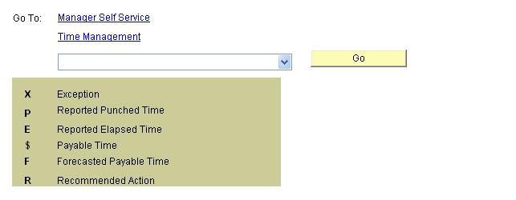
To change the month and/or year click on the appropriate down arrow. The view will default to Payable Hours, to change click on the down arrow and choose a different view.

The legend at the bottom of the page describes the status of the hours displayed.

To see the detail for a day click on the date for that day:



