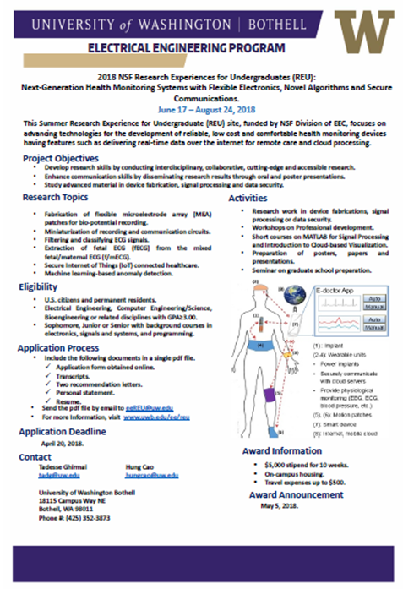
University of Washington Bothell
Electrical Engineering Program

2018 REU Application Form

Please complete all the information requested below.

- Personal Information:

- Last Name:_________________ First Name:____________ Middle Name:_________
- Date of Birth:_______________ Gender:__________________________
- Citizenship Status (US or Permanent resident): ____________________
- Address: _____________________________________________________
- Email: _______________________________________________________
- Phone Number (cell number preferred): __________________________

- Education Information:

- Name of Institution:___________________________________________________
- Major: ______________________________________________________________
- Class Standing (Sophomore, Junior or Senior) : ____________________________
- GPA: Overall:________________________ Major:_____________________

- Project Interest: Please indicate your area of choice for your REU project in the preferred order (Area of projects are: Device and System Fabrication; Bio-signal Processing; and Secure Data Communication and Computing).

- First Choice:_________________________________________________
- Second Choice:_______________________________________________
- Third Choice: ________________________________________________

- Biographical Information: Please indicate all racial background that applies to you.

______ American Indian or Alaska Native
______ Asian
______ Black or African American:
______ Hispanic or Latino
______ Native Hawaiian or Other Pacific Islander
______ White
______ Other
______ I do not want to indicate

Signature: ____________________________________ Date: _______________________
Instruction: Please attach this application form with your transcript, personal statement, resume and two letter of recommendation as one pdf document and email it to eeREU@uw.edu by the due date of April 10, 2018.

Note: Women and underrepresented students are highly encouraged to apply.

