ENGLISH 2025-02

Gateway to the English Major (COM 2)

This course is a Gateway to English. It is designed for up-and-coming majors.

Course Description:

We live in language! In this course, learn how to participate fully in public culture through literary and language arts. You will gain the primary skills and techniques that make you a functioning citizen and an outstanding English major;
This course provides an introduction to English Studies, covering the history of English as an academic field, the options available within it, and possible career paths. Students will also be taught the skills they need to succeed as English majors, including critical reading and writing, and literary and rhetorical analysis.
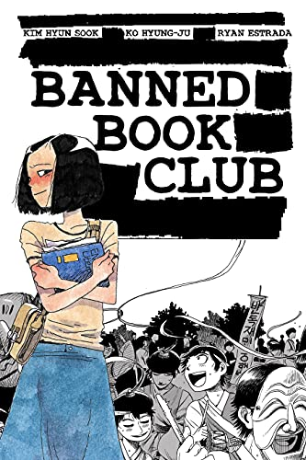
Your studies will include reading in a number of genres, and you will be expected to attend or view UW events and other theatre productions. Assignments will cultivate a variety of skills appropriate to the many responsibilities and paths of an English major, including digital and public humanities.

Prerequisite: COM1; English major status.

For our theme, we will engage the core question for an English major:

WHO GETS TO DECIDE WHAT WE READ?

Book list:

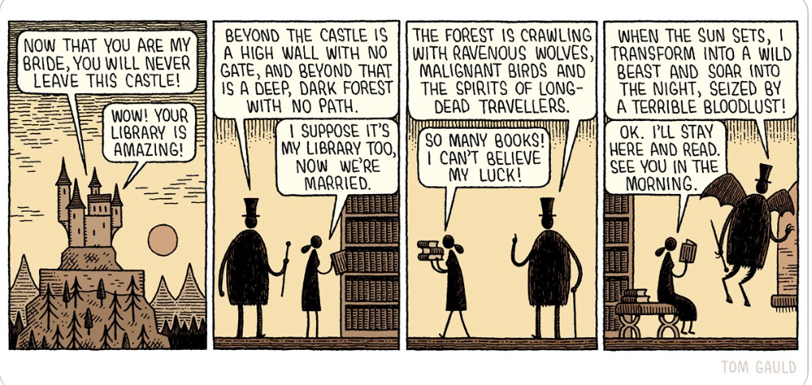

Purchase:

Kim, Hyun Sook; Ko, Hyung-Ju, Estrada, Ryan, Banned Book Club 2nd ed. Iron Circus 9781945820427
Capote, Truman, Breakfast at Tiffany’s Knopf Doubleday: 9780679745655
Kendall, Tim, ed., Poetry of the First World War Oxford Classics: 978-0198703204
Bechdel, Alison, Fun Home Mariner 9780618871711
Takei, George, They Called us Enemy Top Shelf: 9781603094504

**& one additional text, selected by the class

You will also be asked to view the following ahead of class:

Breakfast at Tiffany’s, 1961, dir. Blake Edwards (Amazon Prime)
A Face in the Crowd, 1957, dir. Elia Kazan (Amazon Prime)
Jesus Christ Superstar, 1973, dir. Norman Jewison (Amazon Prime)
The Life of Brian, 1979, dir. Terry Jones (Amazon Prime)

And a number of short pieces in your course modules in pdf

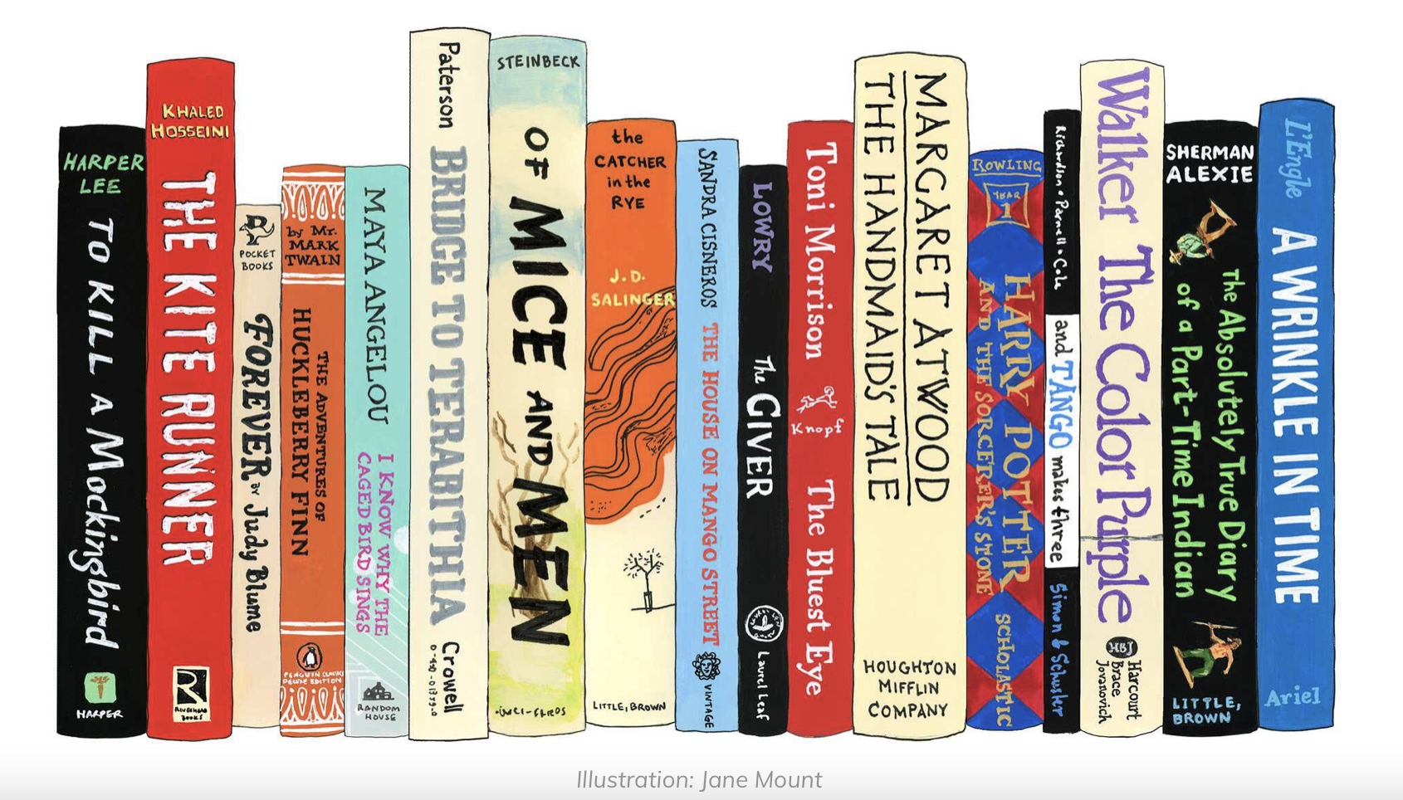
NPR American Experience

Learning Outcomes

Catalog Description: 2025. Introduction to English Studies. 3. [(none)|}COM2]. This course provides an introduction to English Studies, covering the history of English as an academic field, the options available within it, and possible career paths. Students will also be taught the skills they need to succeed as English majors, including critical reading and writing, and literary and rhetorical analysis. Prerequisite: COM1; English major status.

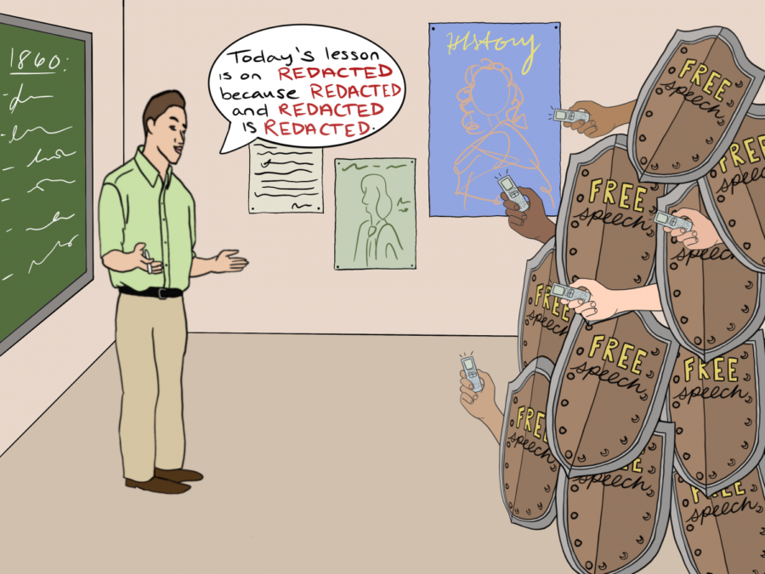
Objectives: Specifically, you will learn to:
- Use a variety of techniques to understand literature’s structures and operations
- Recognize literary theories and their concepts
- Accurately Close Read a variety of genres and in a range of periods
- Recognize and address a variety of audiences and occasions
- Effectively address audiences in multiple modes and media
- Identify and use resources for study
- Map your path toward career and personal goals

Requirements & Grading Scheme:

Your grade will be based upon:

1) IN CLASS: The Breakfast at Tiffany’s semiotic hat collection due September 15 20
—including: visuals & oral presentation in class & at AHC event
written explanation
2) Close Reading Exercises due September 29 20
in class

3) Close Reading Paper due October 13 20
online

4) Poster presentation: Banned Book Gallery Walk due December 8 20
—including: poster (high production values) in person
Sources bibliography
Presentation of poster

5) Participation —including: attendance assessed Dec 1 10
Participation in TWO after-hours 2025 events
(Oct 12, 25, Nov 10)
Attending ONE UW T&D performance
(Coop, Sept 23 & 24; Sissy, Oct 1; Antigone, Oct 19-23)
group work (e.g. Carbon Sink Nov 15)

6) Final paper: 3-page reflection on your item from the Gallery Walk due December 15 10
—in the form of a newspaper column 1:15 p.m.
—explaining why it is censored; why it needs to be read
—making a cultural and aesthetic argument

Evaluation Procedures

All work will be evaluated for its ideas and expression according to the following criteria:
Grades will be apportioned as follows:
A = demonstrates unusual thought and skill
B = demonstrates thought and skill
C = suggests thought and skill
D = suggests lack of thought and skill
F = demonstrates lack of thought and skill (Table derived from William Irmscher)
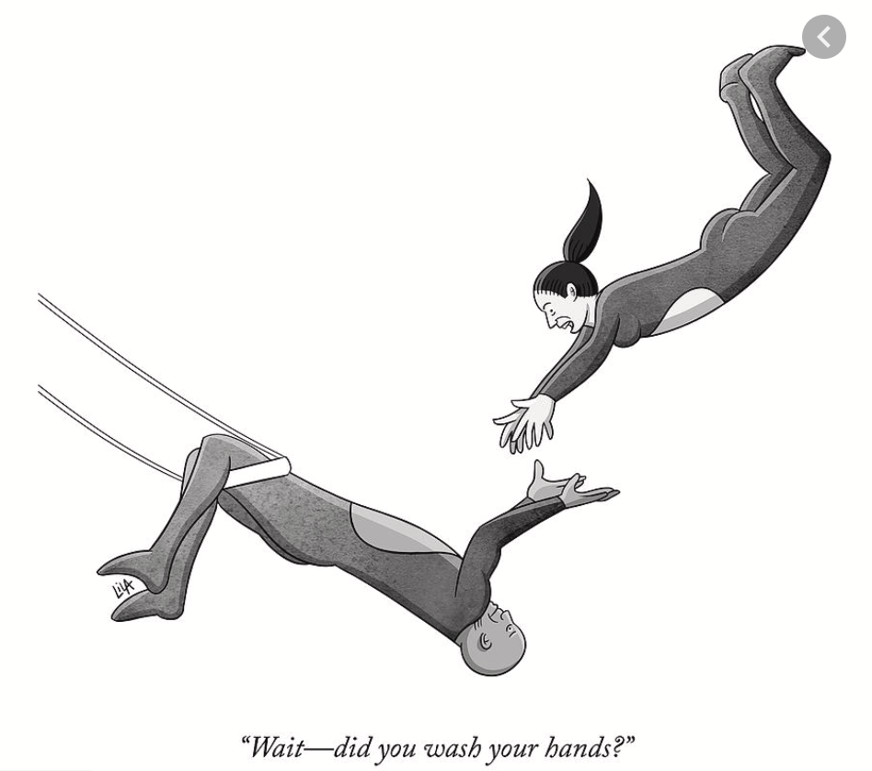
Class Policies

NOTES: Please do not come to class if
you are sick.

I will assume you have read and are fully informed about the following, and about UW statements on education and safety. Please be alert to all incoming messages about campus climate and public health best and required practices.

Syllabi sometimes have to change in the course of a semester. Please watch your UW email, and the online announcements in case of any change.

1) Modes of Interaction: We are aiming to start in person. Should conditions require, you may be asked to participate in COVID mitigation measures to ensure the class can continue in person. Some of your work will require engaging with recorded or online materials, and responding on zoom or online. Each mode requires your preparation, timely attention to materials and tasks, and your participation.
2) Conferences: where these are required, you must participate. Schedule appointments by email (cmf@uwyo.edu) or text (307 760-0376). By prior arrangement, you can conference in person (masked & at a distance), by phone, by skype (doctorcmf) or zoom.
3) Work completed on time and to task accrues benefits; late submissions accrue penalties. Group work requires you to play a full part in the group.
4) A passing grade indicates not just your ability, but the extent of your knowledge, so attendance matters. Make sure you are marked present for each class you attend (zoom or in person). If you miss 4 classes (2 weeks), or fail to use the course site as required, penalties will apply; full attendance and participation will benefit your grade. Save possible absences for emergencies. For excused absences, see UW Regulation 2-108 (Student Attendance Policy).
5) You all have ideas of your own. Nonetheless, you will need to research other critics and theorists to ground or refine your own ideas. When you use others’ work, you should not simply quote it; you should build on it or argue against it. You must give these sources full credit according to the rules set out in the newest MLA Stylebook. You will find MLA rubrics at http://owl.english.purdue.edu/owl/resource/747/01/. Use the menu on the left of that page to find specific advice. If you fail to acknowledge your borrowings in writing, in endnotes, and in bibliography or works cited, you will become subject to university regulations on plagiarism: UW Reg 2-114: Student Academic Dishonesty. Avoid this!
6) Assignments in this course are NOT collaborative unless explicitly stated to be so.
7) Assignments will be submitted in a variety of forms. Some assignments will be submitted online.
Keep a copy & a backup of every paper you submit; if something goes astray, you can produce it.
8) The materials we study require your full attention. You may use a laptop to read class texts, but during discussion your laptop should be CLOSED. (It is an important and effective intellectual exercise to develop discussion notes AFTER discussion.) Phones should be silenced and in your bag; No independent video or audio recording during class is allowed (unless by direction from DSS). This protects the privacy of your fellow students.
9) The University of Wyoming values an educational environment that is diverse, equitable, and inclusive. The diversity that students and faculty bring to class, including age, country of origin, culture, disability, economic class, ethnicity, gender identity, immigration status, linguistic, political affiliation, race, religion, sexual orientation, veteran status, worldview, and other social and cultural diversity is valued, respected, and considered a resource for learning.
10) Equitable access to learning. If you have a disability, including but not limited to physical, learning, sensory or psychological disabilities, and want to request accommodations, please register with and provide documentation of your disability to Disability Support Services (DSS) at 128 Knight Hall, (307) 766-3073, or udss@uwyo.edu. You are advised to request accommodations within the first week of classes, since these are not retroactive. Visit www.uwyo.edu/udss for more information.
11) Classroom climate: This is a professional circumstance, from which you all wish to advance your lives and careers. Exercise professional standards and judgement in all aspects of class. Spirited debate and disagreement are part of university learning. All views will be heard, and to facilitate these opportunities, the class requires an atmosphere of civility and respect among participants. Personal attacks, offensive language, name-calling, and dismissive gestures do not meet the standards of professional debate. Such behaviors can lead to dismissal from community discussions in any course venue.
12) Student support: We will work together to help you succeed in this class. If you are dealing with issues outside of class, UW may be able to help. Please be aware, in this context, that I have some reporting requirements that are part of my role as a professor at UW.
Professor’s Duty to Report: I will keep anything you tell me as private as possible. That said, some matters must be reported on:
—If you are experiencing sexual harassment, sexual assault or discrimination, please do report it. But do know that when you report it to me, I am required to bring these specific matters to the attention of UW’s Title IX Coordinator. To talk to those offices directly, you can contact Equal Opportunity Report and Response (Bureau of Mines Room 319, 766-5200, report-it@uwyo.edu, www.uwyo.edu/reportit). You can also report incidents or complaints to the UW Police Department. You can get support at the STOP Violence program (stopviolence@uwyo.edu, www.uwyo.edu/stop, 766-3296) (or SAFE Project (www.safeproject.org, campus@safeproject.org, 766-3434, 24-Hour hotline: 745-3556).
—If you are struggling with an issue that may be traumatic, or unusual stress. I will likely inform the Dean of Students Office or Counseling Center, so that they may offer you support. If you would like to reach out to them for assistance, you can contact them through www.uwyo.edu/dos/uwyocares.
—If our interaction involves a disruptive behavior or potential violation of policy, I will inform the Dean of Students, even when you and I may have reached an informal resolution to the incident. The purpose of this is to keep the Dean apprised of any behaviors and what was done to resolve them.

**If you discover that war, famine, flood, or pestilence is about to make you contravene a class policy, or has made you do so already, CALL PROF. I can help with problems I know about, not with ones I don’t. So even after the fact, if something goes wrong or you are missing class, CALL ME.
**Unforeseen circumstances may force changes in parts of this syllabus and schedule. Should changes become necessary, you will be notified via email and, where possible, in class. Make sure WyoWeb has your current email, address, and phone number.
**If you are in doubt about any of this, see me.
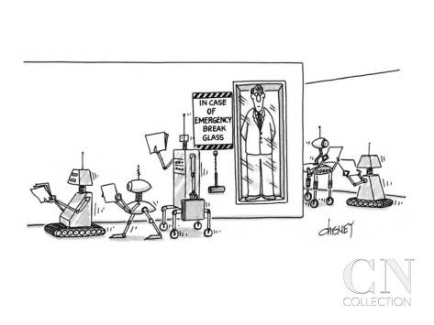
CAMPUS RESOURCES
DISABILITY SUPPORT SERVICES: udss@uwyo.edu, 766-3073, 128 Knight Hall, www.uwyo.edu/udss
COUNSELING CENTER: uccstaff@uwyo.edu,
766-2187, 766-8989 (After hours),
341 Knight Hall, www.uwyo.edu/ucc
ACADEMIC AFFAIRS: 766-4286,
312 Old Main, www.uwyo.edu/acadaffairs
DEAN OF STUDENTS OFFICE: dos@uwyo.edu,
766-3296, 128 Knight Hall, www.uwyo.edu/dos
UW POLICE DEPARTMENT: uwpd@uwyo.edu,
766-5179, 1426 E Flint St, www.uwyo.edu/uwpd
STUDENT CODE OF CONDUCT WEBSITE: www.uwyo.edu/dos/conduct

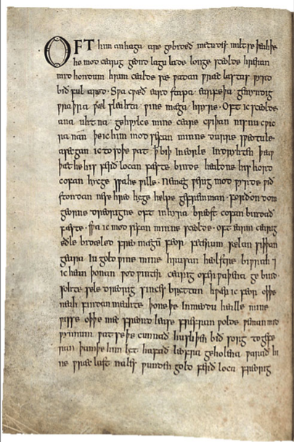
SCHEDULE

ENGLISH 2025-01: Gateway to the English Major (COM 2)

WEEK 1:1 23 August
Introduction to the Course: þu mælaest englisc?

In Class: Excerpts from “The Battle of Maldon”

Follow up: https://www.youtube.com/watch?v=s4zJIy0JaHM

Tools: http://www.oldenglishaerobics.net/maldon.php
https://www.oldenglishtranslator.co.uk
https://hord.ca/projects/eow/
http://people.uleth.ca/~daniel.odonnell/Tutorials/oldenglish-metre-a-brief-guide

Discussion of texts, contexts, and who gets to communicate and when

Week 1:2 25 August
Reading Thematically: Who Chooses What to Read, & Why?

Read: “What Makes Censors Tick?”—pdf

Bring your laptop: we will research Unexpected Englishes …
https://guides.lib.de.us/banned
https://poets.org/text/poetrys-place-history-banned-books
http://cbldf.org/banned-challenged-comics/
https://portlandlibrary.bibliocommons.com/list/share/170042001/517478261

Discussion of Confirmation Bias
Discussion of books we SHOULD read
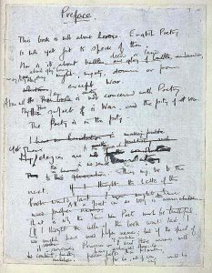
Week 2:1 30 August
Reading Closely: What is on the Page?

Read: Banned Book Club —UW bookstore

Week 2:2 1 September
On writing a bannable book

Read: WW1 poems: Early & Late Owen
Technique: Close Reading I: Imagery
Theory I: Close Reading as Theory

Follow up: Close Reading Toolkit 1: Imagery
British Library, WWI Digital Archive: Wilfred Owen,
Week 3:1 6 September

Read: WW1 poems: Sassoon & Rosenberg
Technique: Close Reading II: Simile & Metaphor
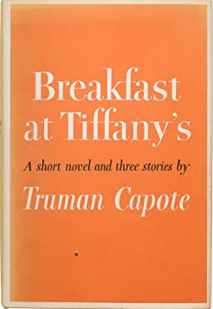
Theory II: Power (Foucault)

Follow up: Close Reading Toolkit 2: Simile & Metaphor
Week 3:2 8 September

Read: Breakfast at Tiffany’s (UW bookstore)
Technique: Close Reading III: Reading Critically, & Culturally
Theory III: Signs & Semiotics

<ASSIGNMENT SET:
The Breakfast at Tiffany’s semiotic hat collection: creativity & audience>

Week 4:1 13 September
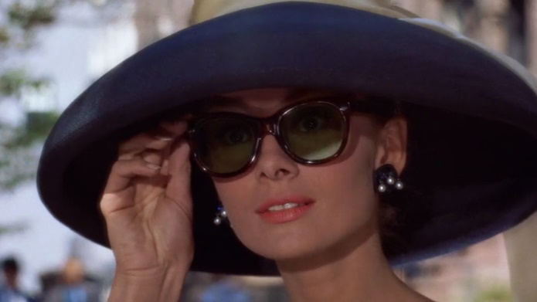
View: Breakfast at Tiffany’s
Technique: Close Reading IV: Diction & Register

Follow up: Close Reading Toolkit 4: Diction & Register

In-class work on Semiotic Hat Collection
on creative responses: haiku

<IN CLASS ASSIGNMENT SET: CLOSE READING EXERCISES:
academic perspectives>
<ASSIGNMENT SET: CLOSE READING PAPER:
academic perspectives>
Week 4:2 15 September

<IN CLASS ASSIGNMENT: THE SEMIOTIC HAT COLLECTION
Hats & Haikus
with one page written explanation of your creative response

EVENT 1: Ebsen Papers Launch (TBD)
Wear your “Semiotic Hat”!
Week 5:1 20 Sept

Read: Carole Ann Duffy, “Warming her Pearls” & “Little Red Cap” —pdf
Technique: Close Reading V: Style & Tone

Follow up: Close Reading Toolkit 5: Style & Tone
Week 5:2 22 Sept NO CLASS: practice close reading exercises

PERFORMANCE I: Coop, Sept 23 & 24 (attend 1 of 3)

Week 6:1 27 Sept It’s all theory (& making the world)

View: Trailers for: All Quiet on the Western Front (Eric Maria Remarque, 1929 novel)
1930: https://www.youtube.com/watch?v=grapXipP3fM
(Full movie at:
https://www.vudu.com/content/movies/details/All-Quiet-on-the-Western-Front/4902 )
1979: https://www.youtube.com/watch?v=DX1PW2n8POg
(Full movie at: https://www.youtube.com/watch?v=MhC4ESwuPPI)
2022: https://screenrant.com/all-quiet-western-front-images-netflix-wwi-movie/

Technique: Close Reading Toolkit VI: Grammar & Syntax

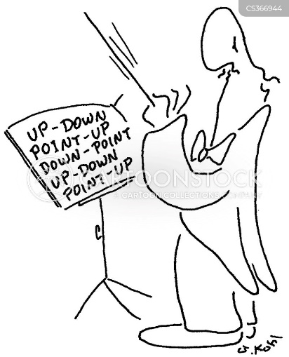
Follow up: Close Reading Toolkit 6: Grammar & Syntax

Week 6:2 29 Sept

Read: Gwendolen Brooks, “Me Real Cool”
Langston Hughes, “A Raisin in the Sun”

Technique: Close Reading Toolkit VII: Prosody

< ASSIGNMENT IN CLASS: CLOSE READING EXERCISES>

Follow up: Close Reading Toolkit 6: Prosody

PERFORMANCE: II: UW T&D recommended: Sissy, Oct 1
(attend 1 of 3)
Week 7:1 4 Oct

Read: J.K. Rowling Any Harry Potter text GUESTS: Susan Simpson?
Online discussions re JKR Kaijsa Calkins (UW Libs)
Theory IV: Systems & Ecologies Paul Flesher (AHC)
Ann Mason (Relative Theatrics)
Week 7:2 6 Oct

Read: Reviews & Controversies re:
Sherman Alexei, The Absolutely True Diary of a Part-Time Indian
Angie Thomas, The Hate U Give, check out book & film
The Manchurian Candidate, 1962, dir. John Frankenheimer.

We will discuss these controversies, and select ONE of these texts for the class to read or view for a later class meeting.
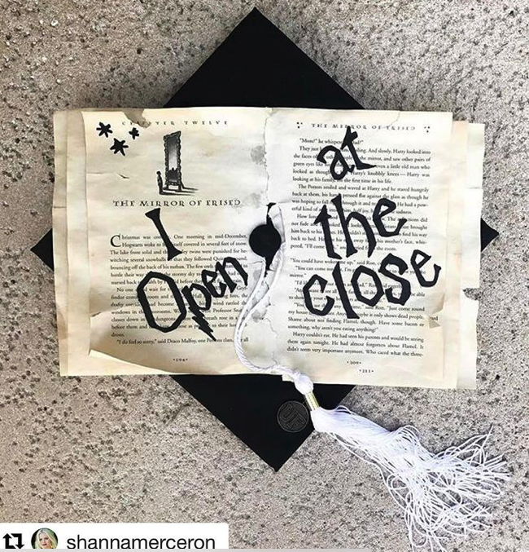
Week 8:1 11 Oct

VOTES DUE FOR CLASS-SELECTED TEXT

CLASS IS RESCHEDULED TO:
- WEDNESDAY 12 OCT, COE 123, 5-7 p.m.:
Tracks in English
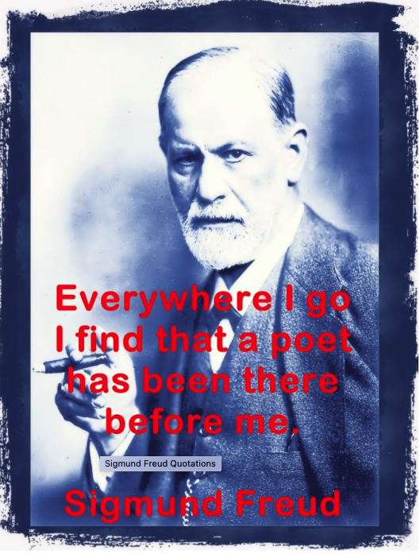
Week 8:2 13 Oct NO CLASS

<ASSIGNMENT DUE ONLINE: CLOSE READING PAPER>

Week 9:1 18 Oct

Read: Alison Bechdel, Fun Home —UW Bookstore
Theory V: Psychoanalytic Criticism

Week 9:2 20 Oct

Read: George Takei, They Called Us Enemy—UW Bookstore
Theory VI: New Historicism & Thick Descriptions

Week 10:1 25 Oct (Registration Week)

CLASS IS RESCHEDULED TO:
- TODAY, 3-5 p.m., Coe Library 123
Theory VII: Public Humanities Objects & Collections Road Show

Week 10:2 27 Oct NO CLASS

PERFORMANCE III: Antigone, Oct 19-23 (attend 1 of 3)

Week 11:1 1 Nov

THE BOOK WE CHOSE
Can we read without context?
How to handle context
What kinds of intervention can a critic accomplish?

<ASSIGNMENT SET: PUBLIC EVENT:
A CELEBRATION OF BANNED BOOKS>
Week 11:2 3 Nov Public engagement & Cultural Leadership

View: A Face in the Crowd
Research: Contexts for Kazan & Schulberg & the HUAC
Theory VIII: Actor Networks
Week 12:1 8 Nov

Read: Elizabeth Barrett Browning, “Curse for a Nation”—pdf in module
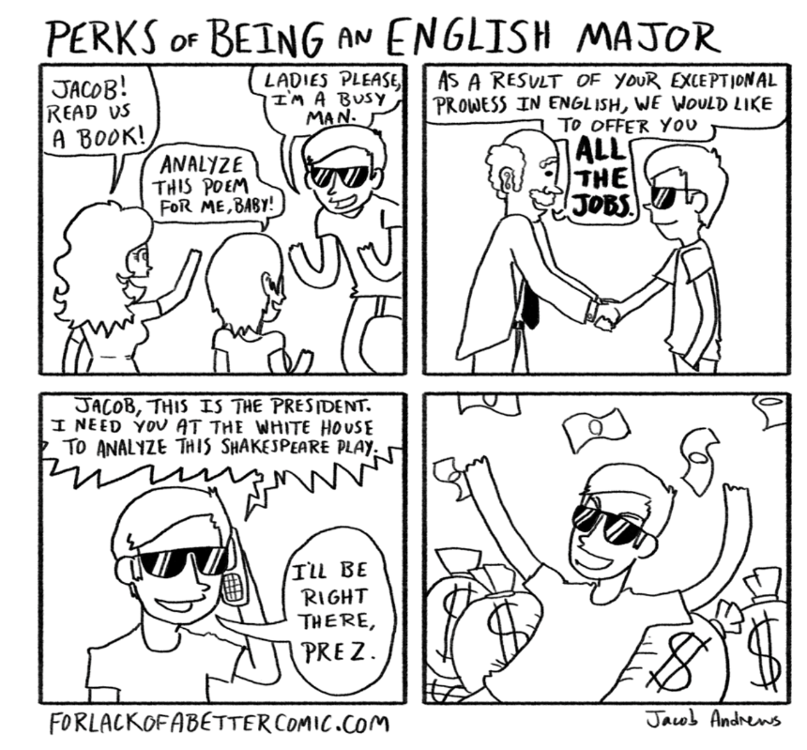
Theory IX: Deconstruction

Week 12:2 10 Nov :

CLASS IS RESCHEDULED TO:
TODAY, 5-7 p.m., COE 123
Careers: Academic & Alternate

Week 13:1 15 Nov:
Modern Media, & the Modes of Censorship

Read: “Covehithe,” China Miéville—pdf
Elisa Gabbert, “Poems from the Storm”
https://www.nybooks.com/articles/2020/05/28/chris-nealon-carolyn-forche-climate-poetry/ (available after sign-up for free account)
Theory X: Posthumanities

Group Research: “Carbon Sink” at the University of Wyoming
What do we need to research?

Week 13:2 17 Nov

<Group study presentation: Carbon Sink-ing at UW
The challenges of …>

Presentation Day for those who have not completed 3 events

In class: Winnie Soon: “Unerasable Characters”: https://eliterature.org/elo2021/posthuman/

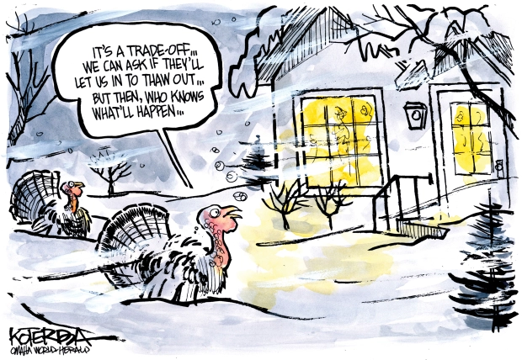

Week 22 Nov THANKSGIVING WEEK

22 Nov

Week 14:1 29 Nov

View: Jesus Christ Superstar
The Life of Brian

<ASSIGNMENT SET: FINAL PAPER: Newspaper Column
Cultural Communication & Leadership>

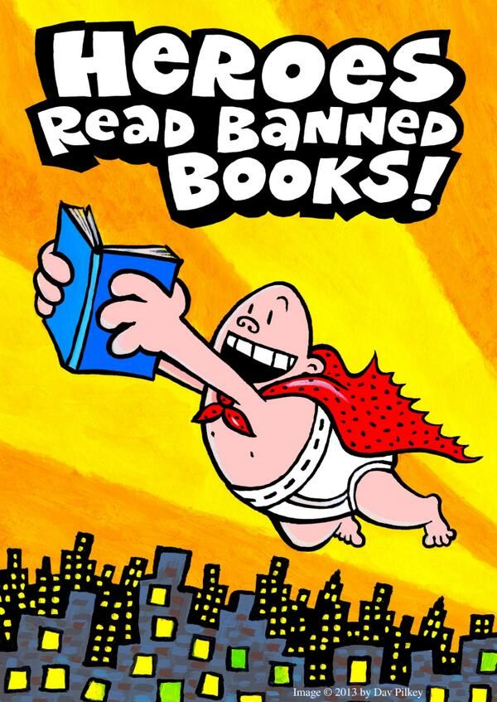

Week 14:2 1 Dec NO CLASS:

Individual Student conferences on final projects

Week 15:1 6 Dec NO CLASS:

Individual Student conferences on final projects

Week 15:2 8 Dec

<GALLERY WALK: A CELEBRATION OF BANNED BOOKS>

DEC 15, 1:15 p.m. < FINAL REFLECTION PAPER DUE ONLINE >

