APPOINTING AUTHORITY APPROVAL GUIDE

Description:
This script will walk you through the process of approving a position request, a job opening, and a job offer, or salary authorization as needed, as an Appointing Authority. This process will be triggered by receiving an email requesting your approval.

Personal Notes

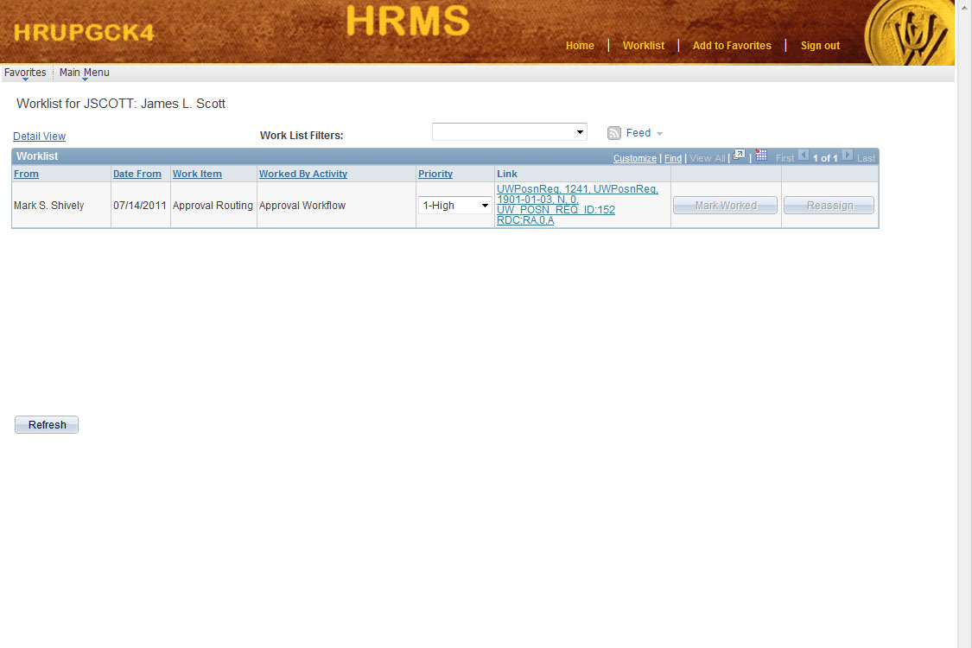

Step |  |  | Notes
1 | Begin by clicking on the Worklist link at the top right of the page. Your worklist should now be displayed.
2 | Look in the Work Item column to determine which items need your attention. You will want to concentrate on the Approval Routing items. Then click on the link in the Link column.
If your Work Item is a Position Request Approval,
Continue with page 3.

If your Work Item is a Job Opening Approval,
Continue with page 4.
If your Work Item is a Job Offer Approval,
Continue with page 5.

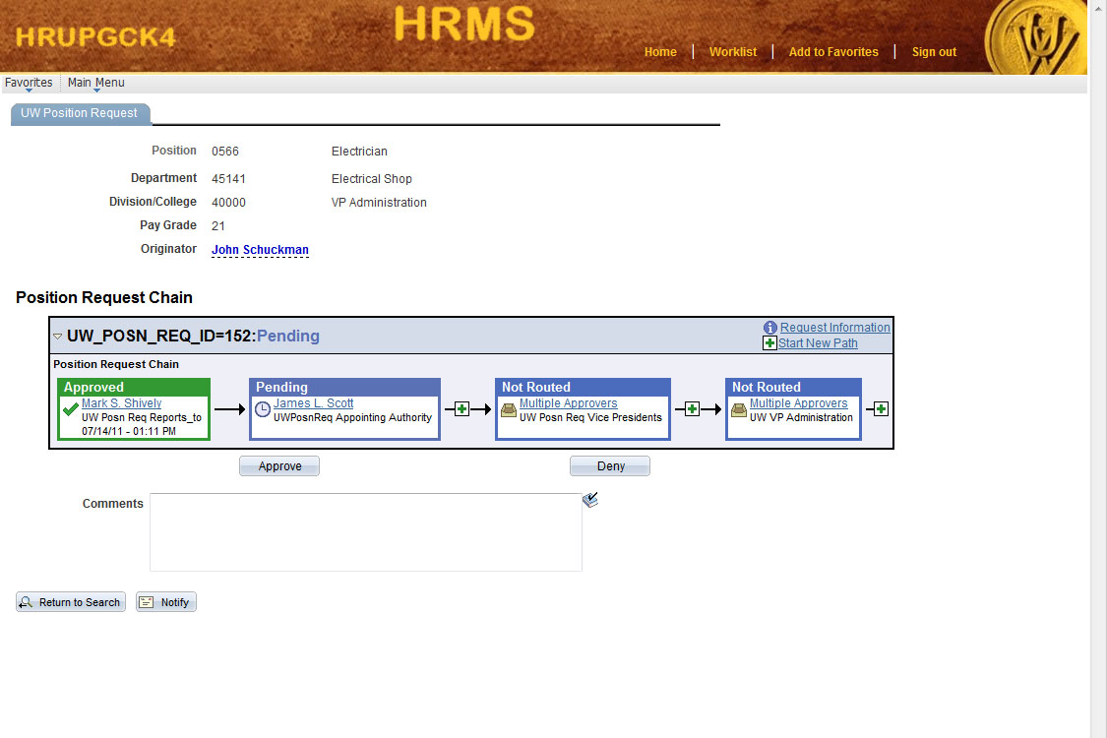

Step |  |  | Notes
1 | The Position Request Approval page should now be displayed.
2 | Review the information on the page.
3 | If you approve of the information contained within, enter any appropriate commentary in the Comments box.
4 | Click on the Approve button.

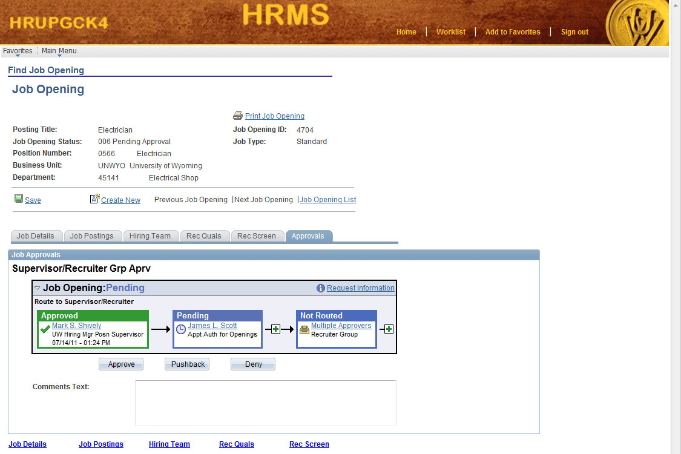

Step |  |  | Notes
1 | The Job Opening Details page should now be displayed.
2 | Review the information on the Job Details page. Click on the Job Postings tab. Click on the Job Title link and review the Job Opening Posting Information.
3 | Click on the Approvals tab.
4 | If you approve of the information contained within, enter any appropriate commentary in the Comments box.
5 | Click on the Approve button.

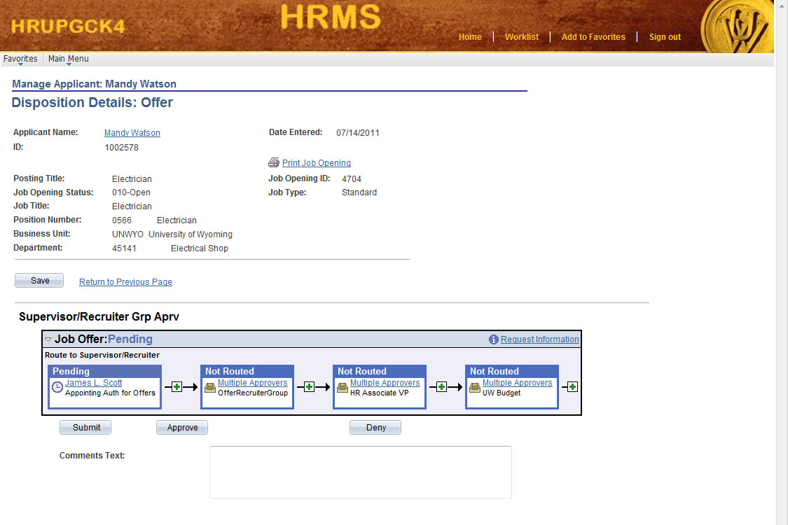

Step |  |  | Notes
1 | The Job Offer Details page should now be displayed.
2 | Review the information on the page.
3 | If you approve of the information contained within, enter any appropriate commentary in the Comments box.
4 | Click on the Approve button.

