08

**Fall**

# 

# — New Pre-Hire 360® Reports - with Norming

**A Guide for Hiring Managers**

**February 2016**

Contents

What is SkillSurvey Pre-Hire 360®? 4

How Do References Rate Candidates? 5

What is Norming? 6

How are Candidates Compared to the Norm Group? 6

What Do the Percentiles Indicate? 7

University of Wyoming Instructions – How to use this report 8

Executive Summary 9

Predictive Analytics 10

Competency Cluster Summary 11

Average Rating by Reference 11

Reference Comments 12

Competency Clusters 13

Additional Reference Feedback 14

Reference Contact Information 14

What Does a Red IP Address Mean? 15

# —

# What is SkillSurvey Pre-Hire 360®?

Pre-Hire 360® provides insight into a candidate’s future job performance by offering organizations access to input about a candidate’s past performance from their former managers, coworkers, and direct reports.

Founded on 25 years’ experience in job competency modeling, the web-based system automates the process of receiving feedback from references via job-specific surveys on at least 26 critical behaviors and skills that when scientifically studied, have shown to correlate with work outcomes.

The process is approved by candidates, confirmed when they sign a consent form that releases their references from legal liability. The release and the system then provide a confidential forum for references to offer the candid feedback you need to make a better informed hiring decision.

The SkillSurvey Pre-Hire 360 Report features the following:

* Averaged Reference Ratings based on Responses to Behavioral Competency Questions
* Open-Ended Comments provided by References
* Confidentiality of Responses

Leverage proven I/O psychologist best practices and predictive talent analytics

SkillSurvey’s online reference process through its patented Pre-Hire 360® workflow uses best practices in job competency modeling, rigorous statistical validation and customer research to identify the skills required for a given position. SkillSurvey pioneered online reference checking (check out our patents), and we continuously validate our process to ensure it is delivering results.

Predictive Validity

Results from SkillSurvey’s scientific studies statistically predict supervisor evaluations, hiring manager satisfaction, new hire job satisfaction and involuntary turnover. Our studies of over 49,000 new hires have validated that candidates hired through the Pre-Hire 360 workflow in SkillSurvey Reference helped organizations reduce first-year turnover for cause by 35.5%.

Reliability

Ratings made by our references hold up over time, and align with those made by other references.

EEOC Compliance

We help support your efforts to remain EEOC compliant. We’re proud to say that our results consistently exceed the EEOC’s recommended guidelines.

Learn more: check out the Elements of a Great Online Reference Solution infographic

Online reference checking developed by I/O Experts

Our Analytics team, led by industrial organizational psychologists, is recognized for its collective experience, peer-reviewed and published research and credentials.

Our Pre-Hire 360 process provides:

Job-specific feedback on past performance – We offer hundreds of surveys that ask about the critical soft skills that are the true predictors of job success.

Confidential process – This gives references the confidence to be more open and candid.

EEOC compliant – Surveys are based on a comprehensive methodology that is statistically valid, reliable, and unbiased. Note that as a tool that is typically used pre-hire, job specificity is an important feature of our process.

Target new hire onboarding programs – Use reference feedback to identify new hire training needs, help them hit the ground running when they join your organization.

Multilingual capabilities – Allow you to communicate with references in their own language.

Norming and Percentile Rankings – Leverage additional insights on your job candidates. Percentiles show a candidate’s Average Numeric Rating as compared to ratings from those in the appropriate norm group or organizations.

**—**

# How Do References Rate Candidates?

References rate Candidates on a rating scale of 1 to 7 indicating the extent to which the Candidate displays a particular behavior where “1” indicates that they “Never” display that behavior and “7” indicates that they “Always” display that behavior.



On the reports, you will notice that Reference numeric ratings are generally high. This is not unusual and it is not unique to the Pre-Hire 360. Through your hiring practices, you have screened the Candidate via their application, resume and initial phone call, and, possibly even conducted an onsite interview.  You may already have a good sense that this Candidate might be a good fit for your organization before you initiated a reference check.  Additionally, Candidates are also choosing References whom they expect will rate them highly.   So we all expect Reference ratings to be high and that’s exactly how it works in practice.   Except that not all of them are “high.”  That is, 90% of the candidates have an average rating of 6.00 and above, meaning that 10% receive ratings that are below an average of 6.00.

So with all ratings being similar, how can you differentiate between the Candidates? Norming the Candidates helps you do that.

**—**

# What is Norming?

Norming helps you see how well your Candidate’s ratings compare to others who have been reference checked using the same or similar survey.  It gives you a magnifying glass so you can understand the differences in those approximately 90% of ratings that fall between 6.00 and 7.00.  Our studies have found that Candidates who fall at the 5th percentile or lower (meaning 95% of Candidates out of thousands received a better rating than this Candidate) are the most likely to turn over for cause within the first year of hire, compared to other Candidates.

The norm groups are comprised of thousands of Candidates throughout the SkillSurvey system who have been reference checked using the same or a very similar survey. The Candidates are evenly distributed throughout the norm group which includes a representative sample of all companies and industries (with the exception of industry specific roles such as registered nurses and all geographic areas (east coast, west coast, mid-west, south, urban, & suburban locations) – there is not one company or geographic region that dominates a norm group.

**—**

# How are Candidates Compared to the Norm Group?

Candidates are compared to a norm group using percentiles. These provide the relative standing of the Candidate based on their average numeric ratings as compared to the ratings of other Candidates within the same norm group.

For example, a Candidate whose average ratings fall at the 43rd percentile means that the ratings of this Candidate are better than 43% of other Candidates who have been reference checked with the same or a very similar survey. Conversely, this means that 57% of Candidates in the norm group have received higher ratings than this Candidate.

**—**

# What Do the Percentiles Indicate?

Our predictive validity studies are based upon tens of thousands of new hires who were reference checked with the Pre-Hire 360, subsequently hired, and studied for an average of 21 months. New hires with an average rating at the 5th percentile or lower on the Pre-Hire 360 are more likely to turnover for cause (get fired) within that first year of hire, compared to those with an average rating above the 5th percentile.

The chart below features results from the predictive validity studies, and depicts the percent of new hires who were fired within one year of hire, according to four different groups of ratings. Those with ratings at the 5th percentile or lower showed the highest percentage of turnover within the first year, compared to all other groups. As the percentile of the average rating increases, the percent of new hires who had been terminated within the first year decreases.

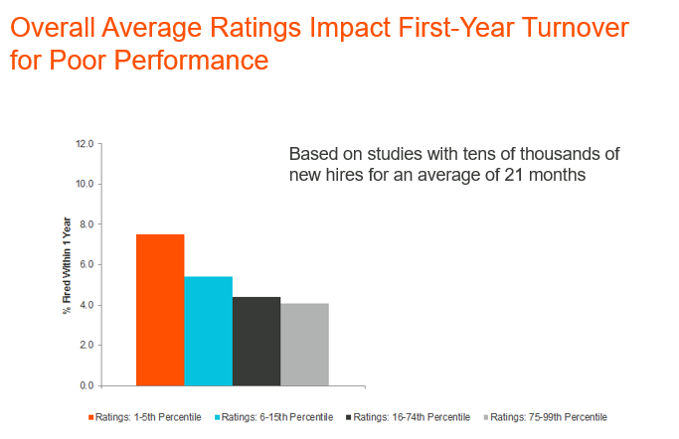

This means that Candidates who fall within the 1st – 5th percentile, if hired, are the most likely to turn over for cause within the first year of hire, Candidates in the 6-15th percentile are the next most likely, Candidates in the 16-74th percentile are the next most likely, and those in the 75th – 99th percentile are the least likely.

**—**

# University of Wyoming Instructions – How to use this report

# In these reports, there are thresholds depicted by different colors above the 1 to 7 rating scales.

# We are featuring 2 colored-coded ranges and have labeled them as follows:

Range 1: Red=High Risk

Range 2: Green=Low Risk

# —

# Executive Summary

Customer feedback was taken into consideration in creating the Executive Summary. This summary features all the key information and high-level results you need, presented in the first few pages of the report.

* Predictive Analytics
* Competency Cluster Summary
* Average Rating by Each Individual Reference
* Open-Ended Comments Provided by References
* Timeline

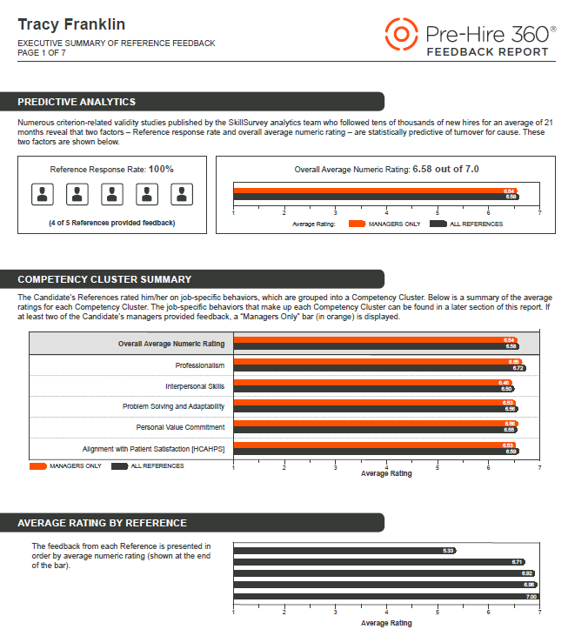

### Predictive Analytics

We begin with two of the most critical parts in the report, Reference Response Rate and Overall Average Numeric Rating. We call this section “Predictive Analytics” because our research indicates that these two factors are predictive of whether a Candidate will have a successful first year on the job. Specifically, these two factors are predictive of whether a Candidate will be fired for cause within the first year.

The orange bar represents an average of “Managers Only” ratings. A minimum of two managers must respond in order to show a “Managers Only” orange bar. The black bar represents an average of “All References,” including Managers. See company instructions for information on the thresholds indicated by different colors above the 1-7 rating scale.

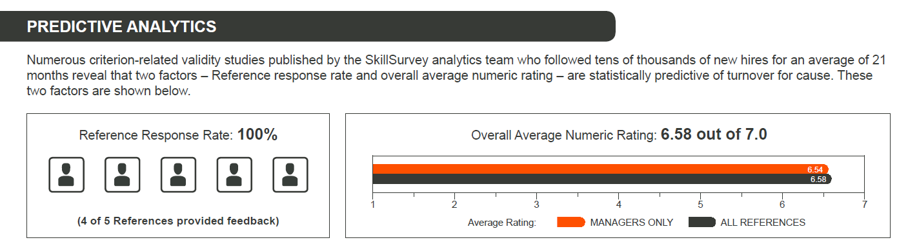

### Competency Cluster Summary

Next, we feature a summary of the References’ average ratings for each of the job-specific behavioral competency areas. You’ll be able to see detailed results for each competency cluster later on in the report.

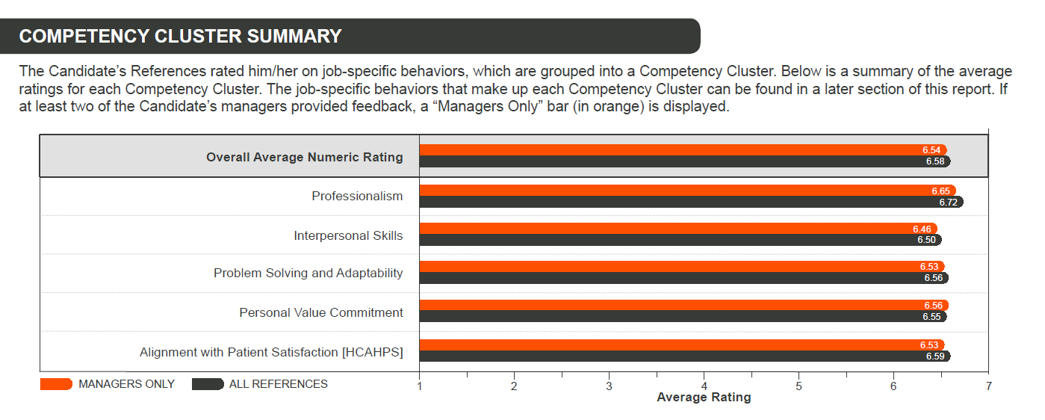

### Average Rating by Reference

Now see the ratings by each individual Reference to get even more insight.

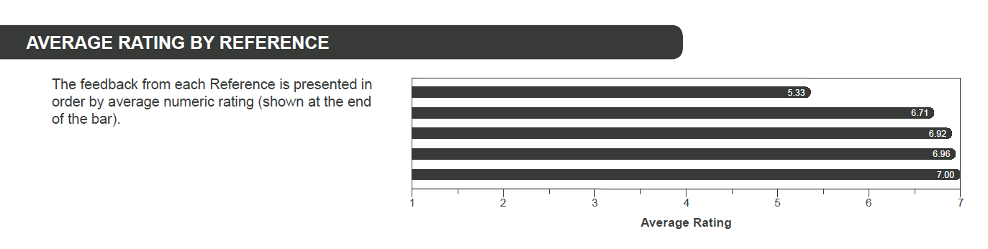

### Reference Comments

### References are given the option to provide open-ended feedback on the Candidate’s areas for improvement, as well as their strengths at work. As with the behavior ratings, feedback from an individual Reference is kept confidential.

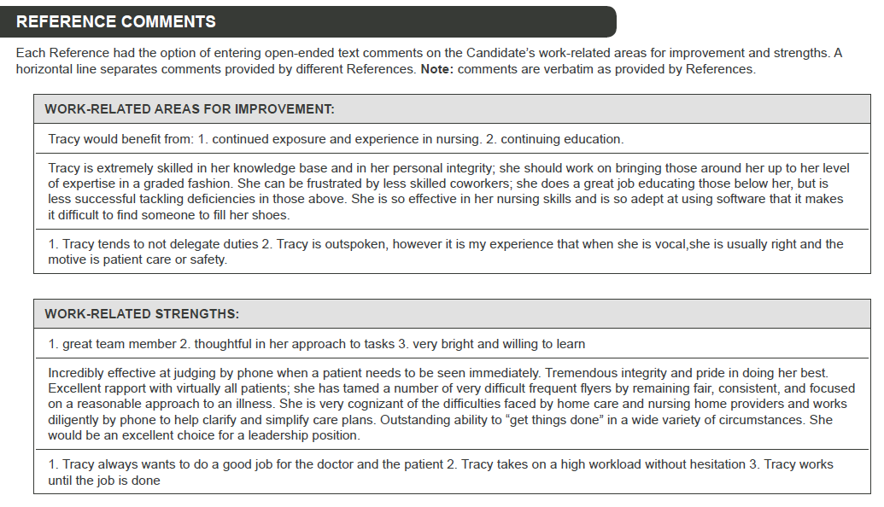

Timeline

The Timeline provides information on the key dates and response times for when Candidates and References first responded, and when the report was ready to be finalized, or generated, by you or your team.

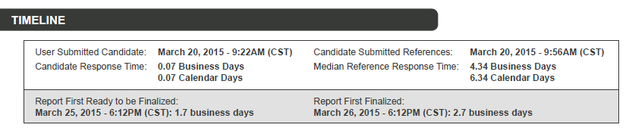

# —

# Competency Clusters

References rate Candidates on behaviors that are specific to the job for which they are applying. In turn, the questions are then grouped into competency clusters such as:

* Professionalism
* Interpersonal Skills
* Problem Solving and Adaptability
* Personal Value Commitment
* Alignment with Patient Satisfaction [HCAHPS] (if applicable)

Competency clusters feature the average ratings provided by all References for each behavior-rated question. The numbers shown in the “R” column indicate the level of agreement between Reference ratings. For example, the 1’s and the 3 below show the differential between the highest and lowest rating on that behavior.

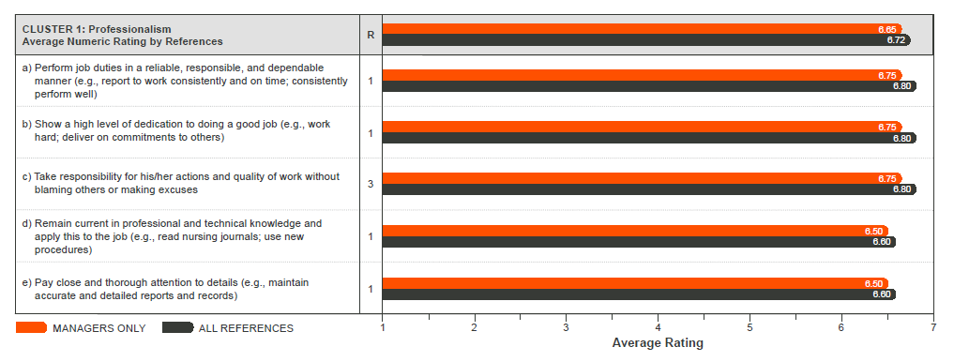

# —

# Additional Reference Feedback

The following are two questions that are asked on every survey.

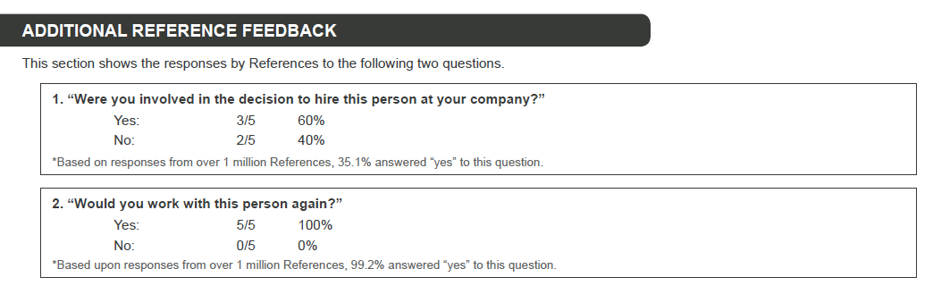

# —

# Reference Contact Information

Reference contact information features all References who were invited by the Candidate to participate in the survey. Those who have responded are shown with a **green** checkmark.

