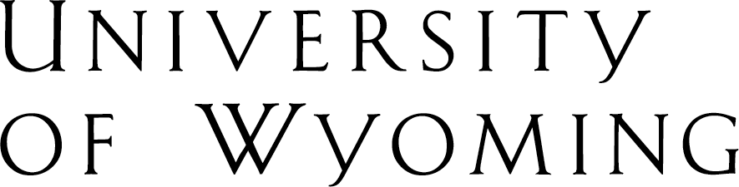
Human Resources Department
Dept. 3422 • 1000 E. University Ave. • Room 139, Wyoming Hall • Laramie, WY 82071
(307) 766-2215 • fax (307) 766-5607 • www.uwyo.edu/hr

May 14, 2014

Frequently Asked Questions regarding Self-Identification

As of March 24, 2014, due to changes in federal law, the University of Wyoming is required to invite applicants and employees to self-identify their status as a member of certain protected groups. Current employees may voluntarily and confidentially self-identify as members of certain ethnic groups, veterans or individuals with disabilities utilizing Self-Service on PeopleSoft HRMS.

There are no benefits or penalties for choosing or declining to self-identify. Self-identifying is voluntary, confidential, and entirely self-reported. No one will follow up to verify if you are a veteran, have a disability, etc.

Below are some frequently asked questions regarding self-identification. It is our hope that the answers here provide more information for those with questions about the process. Any other questions or concerns can be addressed by contacting Human Resources or the Office of Diversity and Employment Practices.

- Q. If I self-identify as a member of a protected class, who will see it?

A. Self-Identification will not be seen by hiring managers, supervisors, or co-workers. The only departments with access to this information will be Human Resources and the Office of Diversity and Employment Practices. This confidential information will not be attached to personnel records, evaluations or any other records in our system.

- Q. If I self-identify as an individual with a disability, will someone contact me to see if I need an accommodation or to verify that I do, indeed, have a disability?

A. No. Checking the box to self-identify is like raising your hand to be counted and then putting it back down. The process is completely confidential and will not begin any other processes for accommodation or verification. To request a reasonable accommodation for a disability, please contact the Human Resources Benefits Office.

- Q. Will applicants/employees receive preference if they self-identify as a certain protected class?

A. No. Hiring managers will not know who among their hiring pools or staff members has identified as a member of a protected class. All applicants and employees are to be treated equally and fairly.

- Q. How will we know who is in a protected class?

A. You won’t. We all just need to be aware of our obligations under federal law to provide equal opportunity. All employees and applicants are to be treated equally and fairly.

- Q. If hiring managers know that someone has identified as a protected class, are they required to give them preference?

A. No. Hiring managers should not assume that individuals are or are not self-identifying as a protected class member. Everyone is to be treated fairly and given equal opportunity.

- Q. Why is there no way to self-identify as a military spouse?

- We are not currently required to track military spouses.

- Q. How will I know if I am a “protected” veteran?

A. The definition of “protected veteran” is available on the self-identification page. For further clarification, please feel free to contact Human Resources or the Office of Diversity and Employment Practices.

