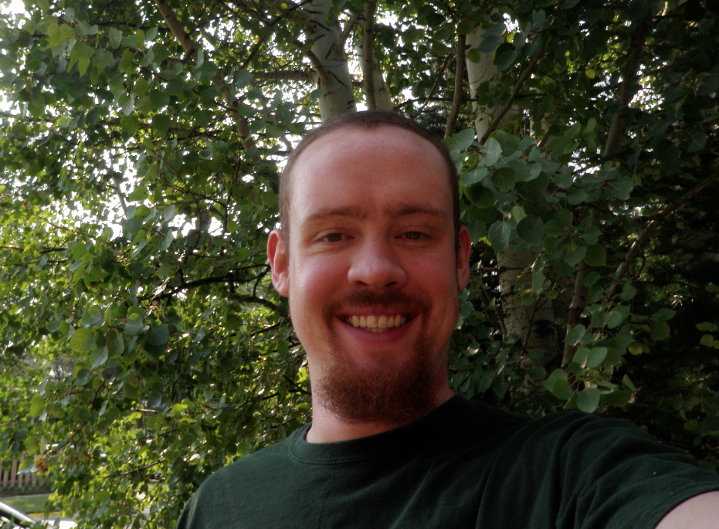

An automatic transmission for a bike. Each biker has a particular cadence that they like to pedal with, and they shift gears in order to maintain that cadence. The automatic transmission would be able to do nothing (remain manual), suggest a shift (with a light up arrow), or shift the bike for you automatically.

**If you could invent anything, what would it be?**

##### Rob Streeter

NASA. Just the mention of it is enough to intrigue both Sarah and myself as Rob begins to answer the background questions we created. He delves into the idea behind his current project, a sensor that mimics a fly’s eye. Now being designed, constructed, and tested, the sensor should hopefully be able to measure wing deflection on a fixed wing aircraft, which will aid in increasing flight efficiency. His engineering work is fascinating, Rob’s enthusiasm for the project is infectious as he shows and explains pictures of toaster ovens, light rooms, and circuit boards.

Rob discovered engineering by attending a summer camp at UW the summer before his senior year of high school. Working under John Benson, he was given the independence to figure out problems on his own. Rob found the idea of doing something no one has done before to be fascinating, though he admits, “if there’s the foggiest chance something will go wrong, it does.” When talking about research setbacks, Rob grins and refers to Thomas Edison’s quote: “I have not failed 1,000 times. I have successfully discovered 1,000 ways to not make a light bulb.”

Though the combination of now being regarded as the “big dog” in the lab, doing outreach work with Wyoming classrooms, advising the engineering honors society, and being involved with other student groups sounds glamorous, Rob’s credits his success to his upbringing. Growing up in Saratoga, Rob guided rafting and fishing trips through his family business. Being placed into a leadership position at a young age allowed him to develop his leadership skills and problem solving abilities, which when coupled with his strong work ethic, have driven his success at UW.

Rob believes growing up in small town Wyoming is actually an advantage when applying to college. Large schools are looking to balance their demographics and students from Wyoming bring a unique perspective not found in many other places. He encourages students to work hard, reminding them skills and concepts learned in high school create the foundation for the work done in college. Though he is also quick to state that “you don’t have to be good at math to succeed in engineering, you just have to get along with it.”

This positive attitude is one that Rob brings to students who are not excited about science. He encourages students to think about what they are passionate about and to explore all aspects of it that relate back to science or scientific research. Rob urges students to dive into what they are interested in and utilize that as a catalyst for learning in all subject areas.

Special thanks to Dr. Steve Barrett, Dr. Cameron Wright, Leslie Roth, and The National Science Foundation for their generous support of Rob and his projects at the University of Wyoming.