University of Wyoming
HRMS
Employee Self Service
(HRMS-UWESS)
User Guide

Revised May 2014

University of Wyoming HRMS Employee Self Service Guide (HRMS-UWESS)
INTRODUCTION |  | 1
About this Guide |  | 1
Purpose |  | 1
Typographical Conventions |  | 1
GETTING STARTED |  | 2
Overview |  | 2
Help with HRMS - UWESS |  | 2
Logging into HRMS – Self Service Only from On Campus |  | 2
Logging into HRMS – Self Service Only from Off Campus |  | 2
Logging into HRMS – HRMS Users for functions other than Self Service |  | 4
Logging Off HRMS |  | 4
HRMS Home Page |  | 5
Home Menu Bar |  | 5
Menu Box |  | 5
Main Menu Page |  | 5
Section Page |  | 6
Sub-Section Page |  | 6
NAVIGATING THE SYSTEM |  | 7
Self Service |  | 7
My Personalizations |  | 7
Benefit Changes/Qualifying Events |  | 8
Personal Information |  | 8
Payroll and Compensation |  | 9
Benefits |  | 9
ACTIONS PERFORMED IN HRMS – UWESS
Viewing Benefits Changes/Qualifying Events |  | 10
Viewing Personal Information Summary |  | 10
Entering Address Information |  | 12
Entering Phone Numbers |  | 13
Entering Emergency Contact Information |  | 14
Entering Marital Status |  | 17
Entering Preferred Name |  | 18
Entering Ethnic Group |  | 18
Viewing Issued Check/Advice Information |  | 19
Viewing Voluntary Deductions |  | 20
Viewing Direct Deposit |  | 21
Viewing Compensation History |  | 21
Entering W-4 Tax Information |  | 21
Viewing W-2 Tax Information |  | 22
Requesting Reprint of W-2 Tax Form |  | 23
Viewing Benefit Summary |  | 24
Viewing Dependent Benefit Summary |  | 25
Viewing Leave Balances |  | 25

INTRODUCTION

This User Guide provides information about viewing and updating employee information. It explains how to add, modify, and view personal employee information.

HRMS is a table-driven web based system. HRMS reference tables provide UWESS with a central source of data used for viewing. In addition, changes may be made to an employee’s information by completing the appropriate HRMS-UWESS document.

ABOUT THIS GUIDE

This guide is provided by the Central Business Analysis Office and is intended only for use with the University of Wyoming Employee Self Service system.

PURPOSE

This guide provides step-by-step instructions for the most often used features of Employee Self Service. Understanding how to use these features will help the user to add, modify, and view personal employee information.

TYPOGRAPHICAL CONVENTIONS

The following typographical conventions are used in this guide:

Style | Area | Definition and Examples
Bold | Fields | “Type in User Name and Password”
 | Buttons | Press Enter or select the Submit button.
 | Links | Select the View Printable underlined link.
 | Checkboxes | Contact has the same address as the employee
 | Menu | Select Personal Information from the Section Page

GETTING STARTED

The University of Wyoming Self Service (UWESS) is a component of the University’s Human Resource Management System (HRMS).

OVERVIEW
• Help with HRMS - UWESS
• Logging into HRMS
• Logging Off HRMS

HELP WITH HRMS - UWESS
• UWESS User Guidehttp://www.uwyo.edu/oia/cba1/
• IT Help Desk email: userhelp@uwyo.edu
• IT Help Desk phone: 307-766-4357, option 1
• IT Help Desk hours: Monday thru Friday, 7:30 am to 5:30 pm (winter hours)
Monday thru Friday 7:30 am to 4:30 pm (summer hours)
Saturday and Sunday, closed
• If you have questions regarding the information within HRMS, please contact Payroll at 766-2217 for issues concerning pay and taxes; or Human Resources at 766-2215 for issues related to benefits, addresses or names.

LOGGING INTO HRMS - UWESS (ON CAMPUS)
Use the following steps to sign on to HRMS

- Open a web browser window.
- Go to the University of Wyoming Home Page, www.uwyo.edu
- Click on the WyoWeb link on the right side of the page:
- Click on Human Resources:

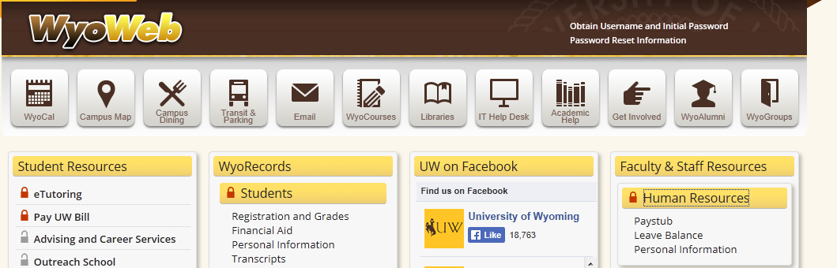

- Log in using your normal network username and password:

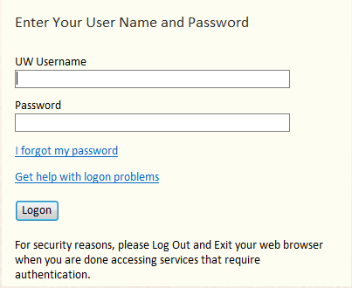

LOGGING INTO HRMS - UWESS (OFF CAMPUS)

- Open a web browser window.
- Go to the University of Wyoming Home Page, www.uwyo.edu
- Click on the WyoWeb link on the right side of the page:
- Click on WyoSecure:

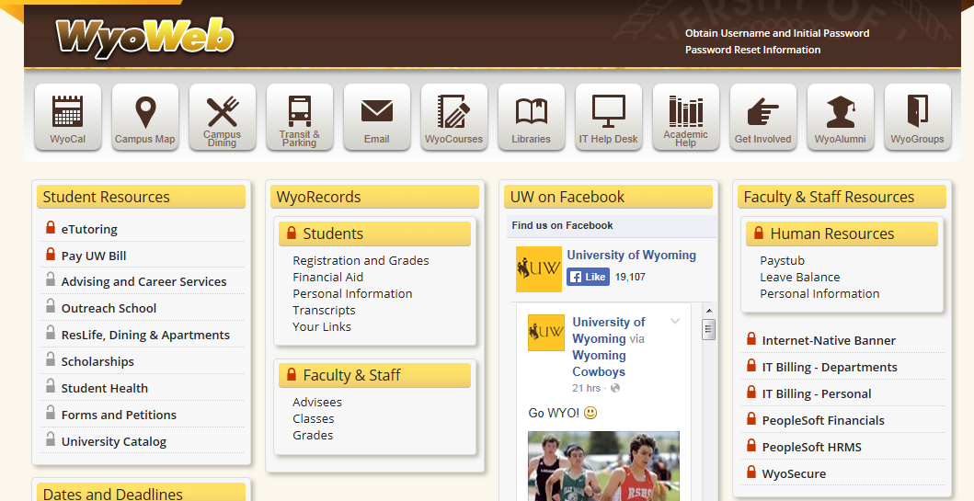

- Log in using your normal network username and password:

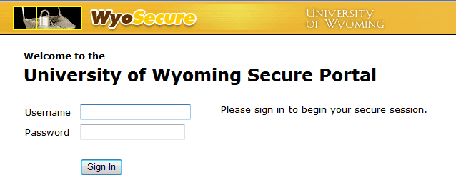

- Click on UW Employee Self Service

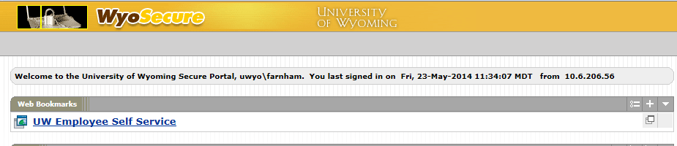
LOGGING INTO HRMS – UWESS (For HRMS Users)
Those employees who use HRMS for functions other than Self Service will have two links (see illustration below). Use the link for “Human Resources” to access the Self Service functions. NOTE: If you are logging in from off campus, all other menu items will not function. Off campus access requires the use of Remote Desktop.

To use the HRMS functions (Time Entry, Employee Data, PAR’s, etc.) click on the “PeopleSoft HRMS” link. The “Self Service” menu item will appear with all the other menu items. NOTE: If you are logging in from off campus, this option will not function. Off campus access requires the use of Remote Desktop.

Click here to access HRMS
Click here to access UW Self Service

LOGGING OFF HRMS
Use the following steps to sign out of HRMS.

Select the Sign out link, located on the upper right corner of the Home Menu Bar or close the web browser by selecting the ‘X’ in the top right hand corner of the web page.

HRMS HOME PAGE

The HRPRD Home Page is the first page a user sees after logging into the HRMS system. A user can return to the Home Page from any page in HRMS by selecting the Home link located in the Home Menu Bar in the upper right corner of the page. The Home Menu Bar enables a user to:

• Return to the HRMS Home Page
• Sign out of HRMS

HOME MENU BAR

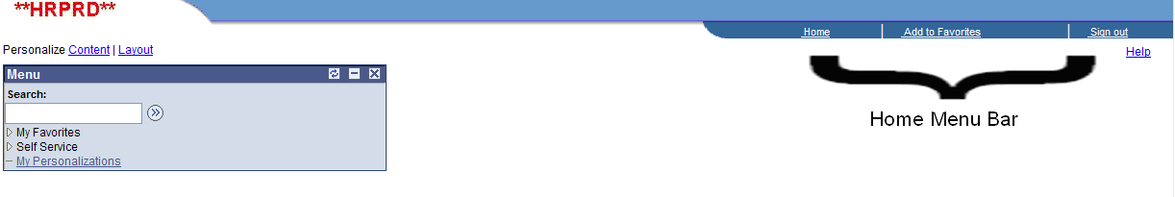

The Add to Favorites link is not usable for employees with Self Service only access.

The Menu Box is the starting place for navigating to the specific pages.

MENU BOX

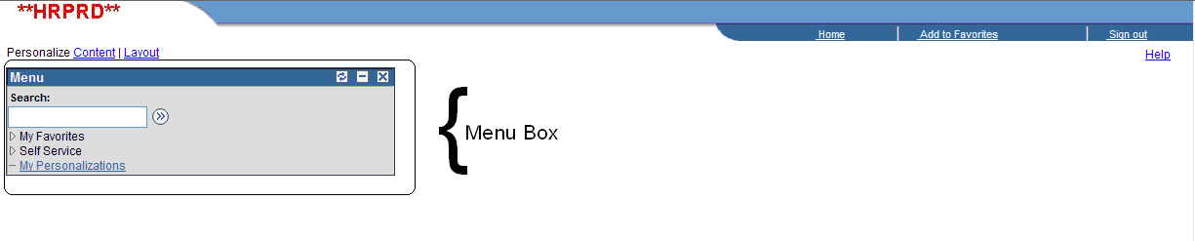

The Main Menu Page shows the different Section and Sub-Section pages

MAIN MENU PAGE

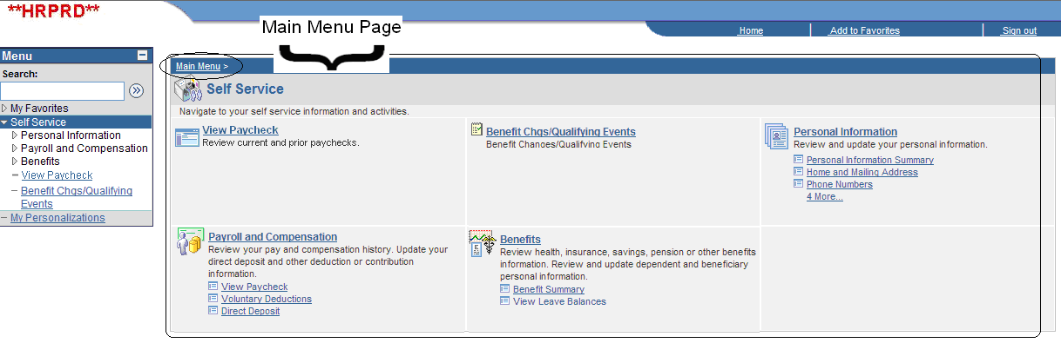

The Section Page shows the Self Service Menu items, along with some of the individual pages.

SECTION PAGE
Section
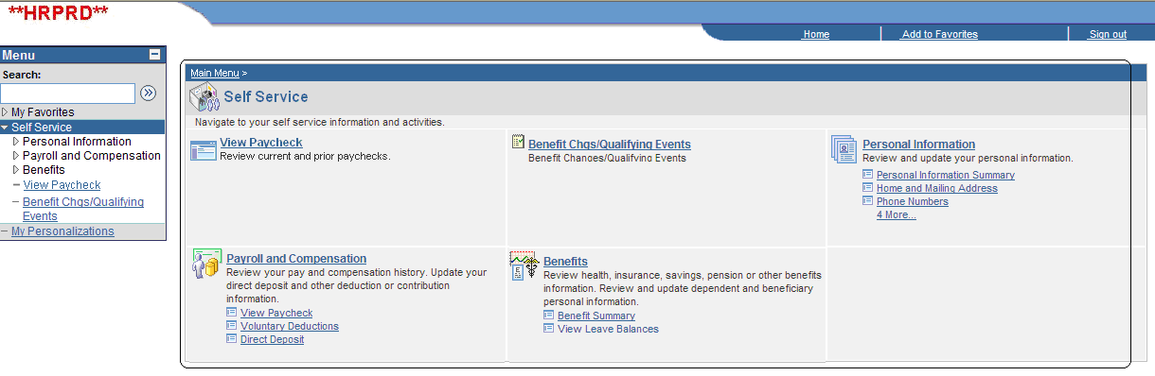

The Sub-Section Page shows the available pages for a specific menu item.

SUB-SECTION PAGE
Section
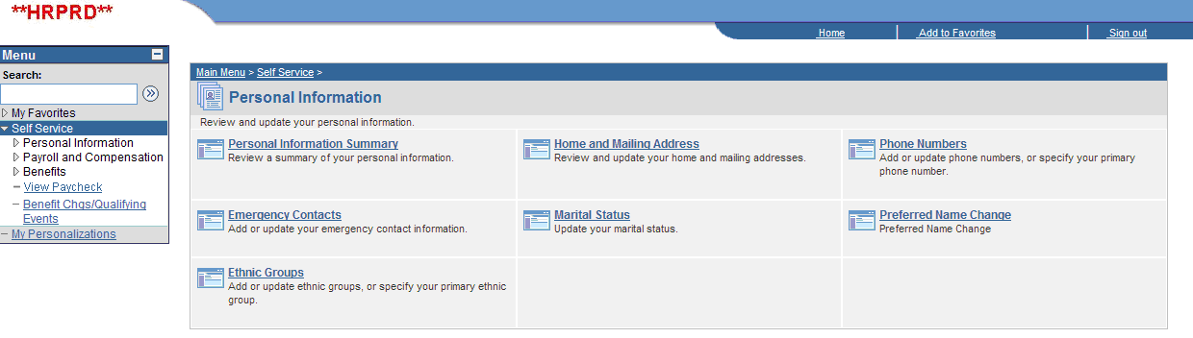
Sub-Sections

Finally, the actual self service page selected.

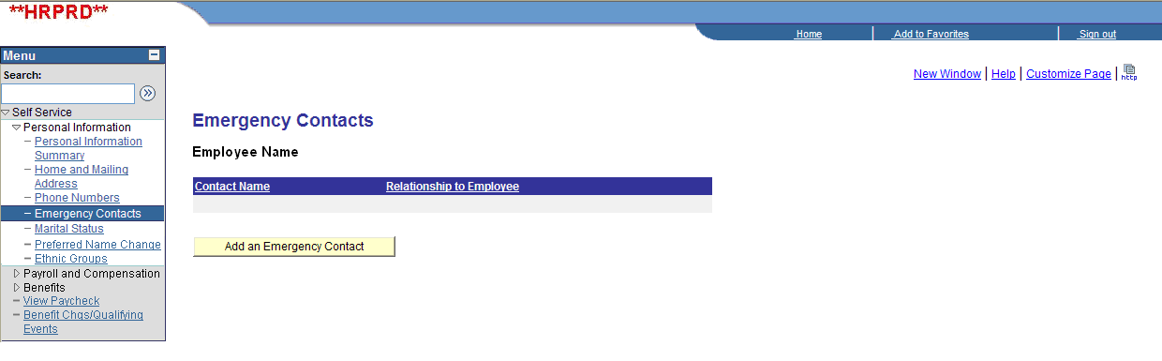
NAVIGATING THE SYSTEM

The first page or Home Page of HRMS displays the Home Menu Bar and the Menu Box.

The Menu Box shows:

• Self Service menu item
• My Personalization’s

SELF SERVICE

By selecting the Self Service Menu item from the Menu Box, the Main Menu Page will display the following Sections:

• Benefit Changes/Qualifying Events
• Personal Information
• Payroll and Compensation
• Benefits

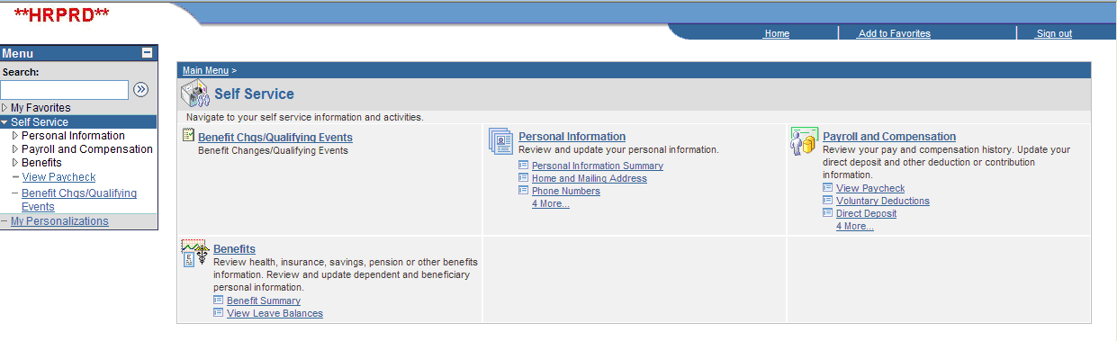

MY PERSONALIZATIONS

This lets you change the way fields or data is displayed. Examples are displaying date/time based on a 12 hour clock (default) or a 24 hour clock; receiving a Save Warning any time you select Save (default is Yes).

BENEFIT CHANGES/QUALIFYING EVENTS

The Benefit Changes/Qualifying Events section enables a user to view life events that may allow an employee to change deductions.

Qualifying Events listed are:

• FTE Change
• Marriage/Divorce
• Birth/Adoption
• Dependent turning 19 or 25

By selecting a specific Qualifying Event, the system will display further information on the sub-section page.

To exit this section, select Home from the Home Menu Bar or select Self Service from the Menu Box.

PERSONAL INFORMATION

The Personal Information section enables a user to view details pertaining to an employee’s address, phone, emergency contact, etc.

These are the available Personal Information sub-sections:

• Personal Information Summary (includes all of the data listed below)
• Home and Mailing Address
• Phone Numbers
• Emergency Contacts
• Marital Status
• Preferred Name Change
• Ethnic Groups

By selecting a specific sub-section, the system will take you to that Page. The current information for the item selected will be displayed, along with the ability to add or change the information.

To exit this section, select Home from the Home Menu Bar or select Self Service from the Menu Box.

PAYROLL AND COMPENSATION

The Payroll and Compensation section enables a user to view details pertaining to paycheck/advices received from the University, Voluntary Deductions, Direct Deposit, etc. An employee can also retrieve printable copies of paycheck/advice stubs. The only Payroll information an employee is able to update on-line is the W-4 Tax Information.

These are the available Payroll and Compensation sub-sections:

• View Paycheck
• Voluntary Deductions
• Direct Deposit
• Compensation History
• W-4 Tax Information
• W-2 Information
• W-2 Reissue Request

By selecting a specific sub-section, the system will take you to that Page. The current information for the item selected will be displayed; currently the only Payroll Information available for online change is W-4 Tax Information

To exit this section, select Home from the Home Menu Bar or select Self Service from the Menu Box.

BENEFITS

The Benefits section enables a user to view current elections for Insurance, Supplemental Retirement Plans, etc., and view current Leave Balances. You will not be able to change any current authorizations online as most authorizations still require a form with an actual signature.

These are the available Benefits sub-sections:

• Benefit Summary
• Dependent Benefit Summary
• View Leave Balances

To exit this section, select Home from the Home Menu Bar or select Self Service from the Menu Box.

VIEWING BENEFIT CHANGES/QUALIFYING EVENTS

The Benefit Changes/Qualifying Events section displays specific life events that may allow you to change deductions or coverage.

1. From the Home Page, select Self Service.

2. Select the Benefit Changes/Qualifying Events underlined link from either the Menu Box or the Main Menu Page.

3. Select a Qualifying Event underlined link.

Qualifying Events are:

• FTE Change
• Marriage/Divorce
• Birth/Adoption
• Dependent turning 19 or 25

4. The sub-section page will expand to show the individual deductions that pertain to the selected Qualifying Event.

5. To the right of each deduction is a “Current Info” link, that, when selecting it, will open a new page showing the current information for that deduction.

6. Close the new page by selecting the ‘X’ in the top right hand corner of this web page.

7. If you need more assistance on these deductions, to the right of the Current Info link is Payroll or HR Benefits contact information.

8. To exit this section, select Home from the Home Menu Bar or select Self Service from the Menu Box.

VIEWING PERSONAL INFORMATION SUMMARY

The Personal Information Summary page lists all of the items available under Personal Information on one page. You can also navigate to the Personal Information sub-section pages from this summary page.

1. From the Home Page, select Self Service.

2. Select the Personal Information Summary underlined link, located under the Personal Information section of the Main Menu page.

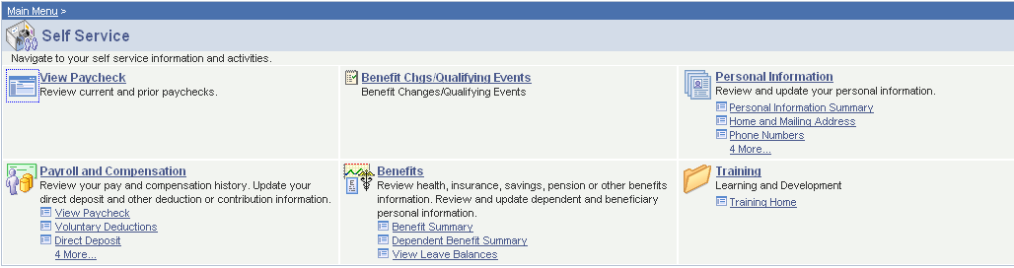

3. Personal Information will be displayed; select the yellow button to go to the specific sub-section page to make changes.

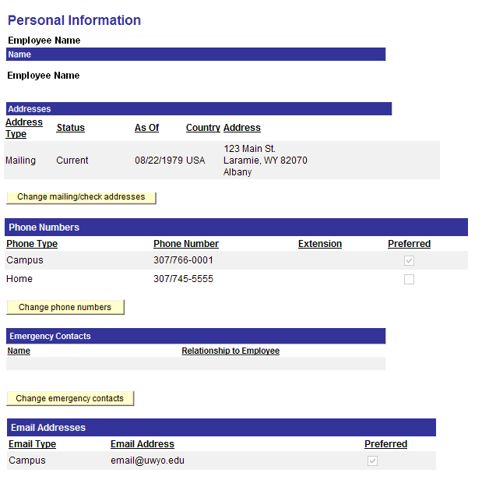

4. To exit this section, select Home from the Home Menu Bar, or select Self Service from the Menu Box.
ENTERING ADDRESS INFORMATION

The Home and Mailing Address page is used to record an employee’s Mailing Address (W-2) and Check Address (if paychecks/stubs are to be mailed to an address different from the W-2 address).

1. From the Home Page, select Self Service.

2. Select the Home and Mailing Address underlined link, located under the Personal Information section.

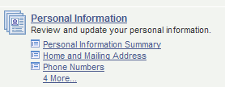

3. Current address information will be displayed. If you need to inactivate a check address, contact Human Resources at 766-5610.
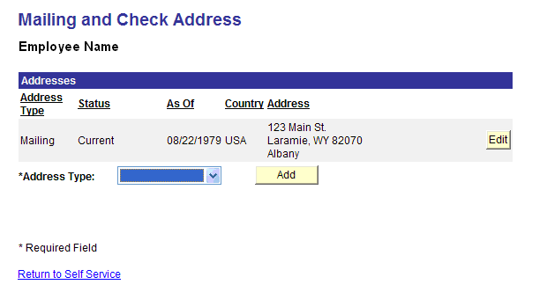
4. To change an existing address, select the Edit button to the right of the Address

• The Country will default to USA. If needed, select the Change Country underlined link then select the Country from the displayed list. If the desired Country does not appear, contact Human Resources at 766-5610 for assistance.
• Enter the Address 1.
• Enter the Address 2, if applicable.
• Enter the Address 3, if applicable.
• Enter the City.
• Enter the State/Province or you may select the magnifying glass to the right of the State field to find an appropriate state/province.
• Enter the Postal Code. The five digit or nine-digit code can be entered
• Enter the County.
• Enter the Date this address change is to take effect. This date must be today’s date or later; prior effective dates are not allowed.

5. Select Save (or Cancel).

6. You will receive an email verifying an address request was submitted. The request must be approved by Human Resources before the information will be updated. You will receive another email with the approval (or denial) of the address change.

7. To add a Check Address select the down arrow next the Address Type, select Check, then select the Add button. (This address is used to mail the paychecks or stub advices if an address different from than the W-2 address is needed.)

• The Country will default to USA. If needed, select the Change Country underlined link then select the Country from the displayed list. If the desired Country does not appear, contact Human Resources at 766-5610 for assistance.
• Enter the Address 1.
• Enter the Address 2, if applicable.
• Enter the Address 3, if applicable.
• Enter the City.
• Enter the State/Province or you may select the magnifying glass to the right of the State field to find an appropriate state/province.
• Enter the Postal Code. The five digit or nine-digit code can be entered
• Enter the County.
• Enter the Date this address change is to take effect. This date must be today’s date or later; prior effective dates are not allowed.

8. Select Save (or Cancel).

9. You will receive an email verifying an address request was submitted. The request must be approved by Human Resources before the information will be updated. You will receive another email when the request has been approved (or denied).

11. To exit this section, select Home from the Home Menu Bar or select Self Service from the Menu Box.

ENTERING PHONE NUMBERS

The Phone Numbers page is used to record an employee’s Campus and Home phone number.

1. From the Home Page, select Self Service.

2. Select the Phone Numbers underlined link, located under the Personal Information section.

3. Current phone information will be displayed.

4. An employee does not have to have phone number information recorded in the system, but if you have existing entries, you cannot delete all of them as the system will require one entry, and that entry must be checked as “Preferred”.

5. To change an existing Phone Number – enter the new number in the *Telephone field next to the appropriate phone type.

6. To add a Phone Number, select the Add a Phone Number button, select the down arrow under the Phone Type then select the Phone Type.

7. Enter the new number in the *Telephone field next to the new phone type.

8. One of the Phone Numbers must be checked “Preferred”, change this as needed.

9. Select Save.

10. Select OK.

11. You will receive an email verifying a phone number request was submitted.

12. To exit this section, select Home from the Home Menu Bar or select Self Service from the Menu Box.

ENTERING EMERGENCY CONTACTS

The Emergency Contacts page is used to record the individuals to contact in case of an emergency involving the employee.

1. From the Home Page, select Self Service.

2. Select the Personal Information section underlined link.

3. Select the Emergency Contacts sub-section underlined link.

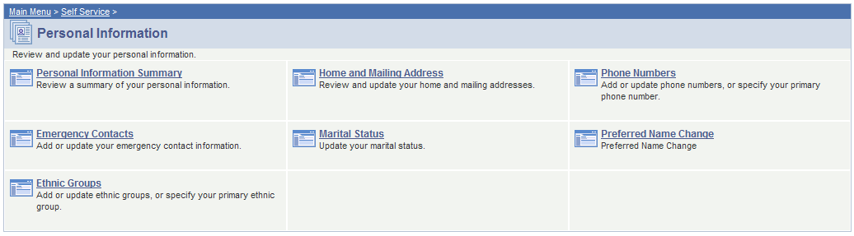

3. Current Emergency Contacts will be displayed.

4. An employee does not have to have emergency contact information recorded in the system, but if you have existing entries, you cannot delete all of them as the system will require one entry, and that entry must be checked as “Primary Contact”.

5. To change an existing Emergency Contact, select Edit to the right of the Contact Name

6. Enter the new Contact Name

7. Select the Relationship to Employee by using the drop down arrow.

8. Select the 1st check box if the Contact has the same address as the employee.

9. If you selected the 1st check box, select the Address Type of Mailing to change the displayed address to the Employee’s Mailing Address.

9. Select the 2nd check box if the Contact has the same phone number as the employee

10. If you selected the 2nd check box, select the Phone Type of Home to change the displayed phone number to the Employees Home Phone.

11. If you want an address different from the employee’s leave the 1st check box unmarked, then select the Edit Address underlined link.

• The Country will default to USA. If needed, select the Change Country underlined link then select the Country from the displayed list. If the desired Country does not appear, contact Human Resources at 766-5610 for assistance.
• Enter the Address 1.
• Enter the Address 2, if applicable.
• Enter the Address 3, if applicable.
• Enter the City.
• Enter the State/Province or you may select the magnifying glass to the right of the State field to find an appropriate state/province.
• Enter the Postal Code. The five digit or nine-digit code can be entered
• Enter the County.

12. If you want a phone number different from the employee’s leave the 2nd check box unmarked, then enter the number in the Telephone field.

13. To add an additional Contact phone number, select the Add a Phone Number button, select the down arrow under the Phone Type then select the Phone Type.

14. Enter the new number in the Phone Number field.

15. Select Save.

16. Select OK.

17. You will receive an email verifying that you submitted an Emergency Contact change.

18. To Add an Emergency Contact, select the Add an Emergency Contact button at the bottom of the page.

19. Enter the new Contact Name

20. Select the Relationship to Employee by using the drop down arrow.

21. Select the 1st check box if the Contact has the same address as the employee.

22. If you selected the 1st check box, select the Address Type of Mailing to change the displayed address to the Employee’s Mailing Address.

23. Select the 2nd check box if the Contact has the same phone number as the employee

24. If you selected the 2nd check box, select the Phone Type of Home to change the displayed phone number to the Employees Home Phone.

25. If you want an address different from the employee’s leave the 1st check box unmarked, then select the Edit Address underlined link.

• The Country will default to USA. If needed, select the Change Country underlined link then select the Country from the displayed list. If the desired Country does not appear, contact Human Resources at 766-5610 for assistance.
• Enter the Address 1.
• Enter the Address 2, if applicable.
• Enter the Address 3, if applicable.
• Enter the City.
• Enter the State/Province or you may select the magnifying glass to the right of the State field to find an appropriate state/province.
• Enter the Postal Code. The five digit or nine-digit code can be entered
• Enter the County.

26. If you want a phone number different from the employee’s leave the 2nd check box unmarked, then enter the number in the Telephone field.

27. To add an additional Contact phone number, select the Add a Phone Number button, select the down arrow under the Phone Type then select the Phone Type.

28. Enter the new number in the Phone Number field.

29. Select Save.

30. Select OK.

31. You will receive an email verifying that you submitted an Emergency Contact change.
32. To change the Primary Contact, select the Change the primary contact button.

33. Select the down arrow and choose one of the contacts listed.

34. Select Save.

35. Select OK.

36. To delete a Contact select the Delete button next to the Contact Name. Note that you cannot delete all of the contacts – one must exist and must be identified as the Primary Contact.

37. Select the Yes-Delete button or No – Do Not Delete.

38. If you selected Yes-Delete the system will automatically save the delete and you will not receive a confirmation email.

39. To exit this section, select Home from the Home Menu Bar or select Self Service from the Menu Box.

ENTERING MARITAL STATUS

The Marital Status page is used to record the individuals current Marital Status. This information is not required and not used for any processing within the HRMS system.

1. From the Home Page, select Self Service.

2. Select the Personal Information section underlined link.

3. Select the Marital Status sub-section underlined link.

3. Current Marital Status will be displayed – if no information has been reported this will show blank.

4. Enter the date for the Marital Status change.

5. Select the down arrow next the *Change Marital Status To: and select the appropriate item.

6. Select the Submit button.

7. Select OK.

8. You will receive an email verifying that you submitted a Marital Status change.

9. To exit this section, select Home from the Home Menu Bar or select Self Service from the Menu Box.

ENTERING PREFERRED NAME

The Preferred Name Change page is used for employee’s that desire to use a different first and/or middle name for their email display name and in the email global address list. It does not refer to your legal name (the name on your social security card) which must be used in the system for your paycheck/stub and W2’s.

1. From the Home Page, select Self Service.

2. Select the Personal Information section underlined link.

3. Select the Preferred Name Change sub-section underlined link.

4. Enter the desired preferred First Name.

5. Enter the desired preferred Middle Name.

6. Select Save.

7. This message box should appear:

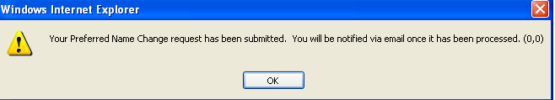

Select OK.

8. You will receive an email verifying a Preferred Name Change was submitted. The request must be approved by Human Resources before the information will be updated. You will receive another email when the request has been approved (or denied).

9. To exit this section, select Home from the Home Menu Bar or select Self Service from the Menu Box.

ENTERING ETHNIC GROUPS
Ethnic Group information is voluntarily self-reported by employees. The information obtained will be kept confidential and when reported, data will not identify any specific individual.

1. From the Home Page, select Self Service.

2. Select the Personal Information section underlined link.

3. Select the Ethnic Groups sub-section underlined link.

4. Select the down arrow to the right of the Ethnic Group box to display valid values.

5. Select the appropriate value.

6. Select Save.

7. Select OK.

8. You will receive an email verifying that you submitted an Ethnic Group change.

9. To exit this section, select Home from the Home Menu Bar or select Self Service from the Menu Box.
VIEWING ISSUED CHECK/ADVICE INFORMATION

Images of Check/Advice stubs can be viewed in UWESS as a PDF (Adobe Acrobat file).
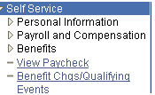
1. From the Home Page, select Self Service.

- Select the View Paycheck underlined link, located directly under
“Benefits” or from the Payroll and Compensation section of the
Main Menu page.

3. The page will return the most current Paycheck/stub advice issued.

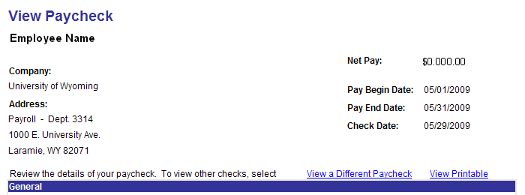

4. To view a different payment, select the View a Different Paycheck underlined link. This will return a list of all check/advices that an employee has received since October 2003 (when UW went live with the Peoplesoft system). Select a highlighted date to see a specific payment.
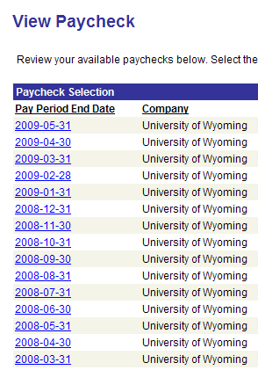

5. To view a printable copy of a paycheck/stub, select the View Printable underlined link. A new window will open with the printable form. You can save this form to your computer by selecting File:Save a Copy, then selecting a folder; you can also print the form by selecting File:Print (the printed form is 8 ½” X 14”). Please Note that while you can view all of the paychecks issued, we only keep the last 13 months available online for employees to print. If you need a check/stub copy earlier than this, contact the Payroll Office at 766-2217 or email payroll1@uwyo.edu.

6. To close the .pdf, select the ‘X’ in the top right hand corner of the web page.

7. To exit this section, select Home from the Home Menu Bar or select Self Service from the Menu Box.

VIEWING VOLUNTARY DEDUCTIONS

Examples of voluntary deductions are Medical Reimbursement, Dependent Care, Parking Permit, and United Way.

1. From the Home Page, select Self Service.

2. Select the Voluntary Deductions underlined link, located under the Payroll and Compensation section of the Main Menu page.

3. The page will display any current “voluntary” deductions that you have authorized, show they current deduction amount, a goal amount if applicable, and the amount paid towards the goal, if applicable.
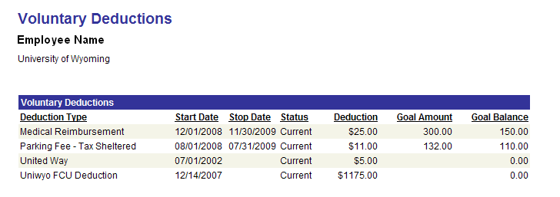
4. If you need more information or would like to make a change to a voluntary deduction, contact the Payroll Office at 766-2217 or email payroll1@uwyo.edu. Medical Reimbursement and Dependent Care deductions have specific rules for changes, so contact the Benefits Office at 766-4220 or email hrbenofc@uwyo.edu for further information on them.

5. To exit this section, select Home from the Home Menu Bar or select Self Service from the Menu Box.

VIEWING DIRECT DEPOSIT

1. From the Home Page, select Self Service.

2. Select the Direct Deposit underlined link, located under the Payroll and Compensation section of the Main Menu page.

3. The page will display the current direct deposits that you have authorized. Employees with an HSA deduction will see two rows – one showing the amount and institution for the HSA deduction and the other is where the balance of the employee’s net pay is deposited.

4. The Bank Name is displayed, but not the routing number.

5. Only the last three digits of the Account number is displayed.

6. For questions on Direct Deposits, contact the Payroll Office at 766-2217 or email payroll1@uwyo.edu.

7. To exit this section, select Home from the Home Menu Bar or select Self Service from the Menu Box.

VIEWING COMPENSATION HISTORY

1. From the Home Page, select Self Service.

2. Select the Payroll and Compensation section underlined link.

3. Select the Compensation History sub-section underlined link.

4. The page will display all rows since July 1, 2002 (when UW started on Peoplesoft) that reflect a change in the employee’s payrate. The data shown will be the effective date of the transaction, the transaction type (Pay Rate Change, Rehire, Hire) and the Annual Salary.

5. To exit this section, select Home from the Home Menu Bar or select Self Service from the Menu Box.

ENTERING W-4 TAX INFORMATION

Employees that have state taxes or international employees claiming a tax treaty are not allowed to update W-4 information online. Please contact the Payroll Office at 766-2217 or email payroll1@uwyo.edu for assistance.

1. From the Home Page, select Self Service.

2. Select the Payroll and Compensation section underlined link.

3. Select the W-4 Tax Information sub-section underlined link.

4. The page will display the employee’s current W-4 information.

5. To change the number of allowances, enter the new number in the allowance box:

6. To Add or change an additional amount being deducted, enter the new amount in the Additional Amount box:

7. To change the Marital Status (for withholding purposes only) select the appropriate radio button:

8. To have the taxes calculated using the Single rate instead of the Married rate (which results in more taxes being deducted from your check) check this box:
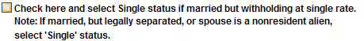

9. For employees that wish to claim exemption from withholding you will need to enter the calendar year you are requesting:
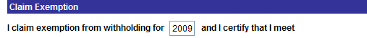

And check this box:

10. Once you have made all of the changes, select the Submit button.

11. Enter your current password to confirm this request.

12. Select OK.

13. You will receive an email verifying that you submitted a W-4 change.

14. To exit this section, select Home from the Home Menu Bar or select Self Service from the Menu Box.

VIEWING W-2 INFORMATION

This will display the W-2 information reported to the IRS.

1. From the Home Page, select Self Service.

2. Select the Payroll and Compensation section underlined link.

3. Select the W-2 Information sub-section underlined link.

4. The page will display the most current reported year. To see data for a prior year use the scroll arrow to the right of the W-2 Status line:

5. To request a copy of a W-2 select the Request Reprint of W-2 Statement underlined link.

6. A new page will open.

7. Your current mailing address will be displayed.

8. Enter the Calendar Year of the W-2 you need reprinted:

9. Select where you want the reprinted W-2 delivered. There are three delivery options:

1. Mailing Address (shown above)
2. Pick Up at the Payroll Office
3. 3rd Party Address – an address different from your mailing address

10. If you choose 3rd Party Address, additional fields will display at the bottom of the page for you to enter the information on where the form is to be mailed.

• Enter the Parties Name if being sent to someone other than you
• Enter the Address
• Enter the City, State and Postal Code

11. Select Submit when everything has been entered.

12. Select OK.

13. You will receive an email verifying that you submitted a W-2 reprint and the option for delivery.

14. To close the new page, select the ‘X’ in the top right hand corner of the web page.

15. To exit this section, select Home from the Home Menu Bar or select Self Service from the Menu Box.

REQUESTING W-2 REPRINT

1. From the Home Page, select Self Service.

2. Select the Payroll and Compensation section underlined link.

3. Select the W-2 Reissue Request sub-section underlined link.

4. Your current mailing address will be displayed.

5. Select where you want the reprinted W-2 delivered. There are three delivery options:

1. Mailing Address (shown above)
2. Pick Up at the Payroll Office
3. 3rd Party Address – an address different from your mailing address

6. If you choose 3rd Party Address, additional fields will display at the bottom of the page for you to enter the information on where the form is to be mailed.

• Enter the Parties Name if being sent to someone other than you
• Enter the Address
• Enter the City, State and Postal Code

7. Select Submit when everything has been entered.

8. Select OK.

9. You will receive an email verifying that you submitted a W-2 reprint and the option for delivery.

10. To exit this section, select Home from the Home Menu Bar or select Self Service from the Menu Box.

VIEWING BENEFIT SUMMARY

This displays insurance and supplemental retirement deductions and other required and optional benefits.

1. From the Home Page, select Self Service.

2. Select the Benefit Summary underlined link, located under the Benefits section of the Main Menu page.

3. The page will display the Deduction/Benefit, whether or not it is Tax Sheltered, the amount per month that the employee pays and the amount per month that UW pays.

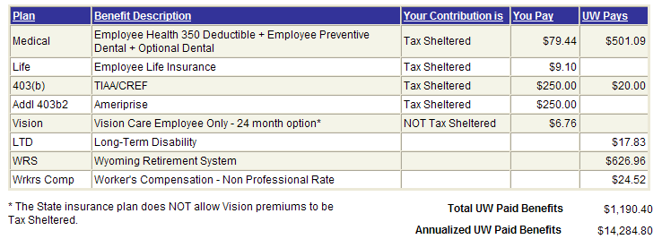

4. The bottom right corner of the page shows the total UW monthly contribution and the total UW Annualized contribution.

5. For questions regarding Medical, Life, Vision Deductions, or Worker’s Compensation contact the Benefits Office at 766-4220 or email hrbenofc@uwyo.edu; for all other questions contact the Payroll Office at 766-2217 or email payroll1@uwyo.edu.

6. To exit this section, select Home from the Home Menu Bar or select Self Service from the Menu Box.

VIEWING DEPENDENT BENEFIT SUMMARY

This displays dependents covered by health and/or dental insurance.

1. From the Home Page, select Self Service.

2. Select the Dependent Benefit Summary underlined link, located under the Benefits section of the Main Menu page.

3. The page will display any dependents on your health and/or dental insurance, with spouse first (if covered), then other dependents by age.

4. To view the covered dependents for a prior date, change the date and select Go.

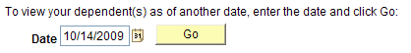

5. For questions regarding dependent benefit summary information contact the Benefits Office at 766-4220 or email hrbenofc@uwyo.edu.

Please Note: The appearance of a dependent's name on this page does not ensure that the dependent is covered. All requirements for eligibility must be met and can only be verified by Employees' Group Insurance.

VIEWING LEAVE BALANCES

1. From the Home Page, select Self Service.

2. Select the View Leave Balances underlined link, located under the Benefits section of the Main Menu page.

3. Page will display Sick and Vacation Balances for the current calendar year. Columns are hours earned, hours taken, pending hours taken, and remaining balance. Pending taken are hours that have not been processed by Payroll (entered after the last payroll was finalized). Sick Leave also has a column that shows any Donated Sick Leave that an employee has received.

4. Employees are only allowed to use the total hours from the balance for the previous month. You are not allowed to use the hours during the month that you accrue them. For example, if you have a balance of 24 hours at the end of June and earn 6 hours in July, you may only use in July the 24 hours available at the end of June.

5. To see the transactions/balances for a previous calendar year select the Return to Search from the bottom left of the page.

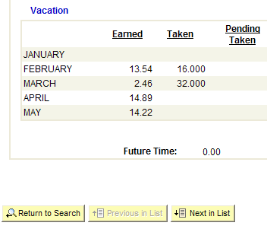

6. The page will return all of your valid calendar years – select the year desired.

7. For questions regarding sick and vacation balances, please contact Ned Feldbush in Human Resources at 766-5609 or email feldbush@uwyo.edu.

8. To exit this section, select Home from the Home Menu Bar or select Self Service from the Menu Box.

