University of Wyoming
HRMS
Employee Self Service
(HRMS-UWESS)
Viewing Paycheck/Advice Stub
User Guide

HELP WITH HRMS - UWESS
• UWESS User Guide: http://www.uwyo.edu/oia/cba1/
• IT Help Desk email: userhelp@uwyo.edu
• IT Help Desk phone: 307-766-4357, option 1
• IT Help Desk hours: Monday thru Friday, 7:30 am to 5:30 pm (winter hours)
Monday thru Friday 7:30 am to 4:30 pm (summer hours)
Saturday and Sunday, closed
• If you have questions regarding the information within HRMS, please contact Payroll at 766-2217 for issues concerning pay and taxes; or Human Resources at 766-2215 for issues related to benefits, addresses or names.

Revised May 2014

LOGGING INTO HRMS - UWESS (ON CAMPUS)
Use the following steps to sign on to HRMS

- Open a web browser window.
- Go to the University of Wyoming Home Page, www.uwyo.edu
- Click on the WyoWeb link on the right side of the page:
- Click on Human Resources:

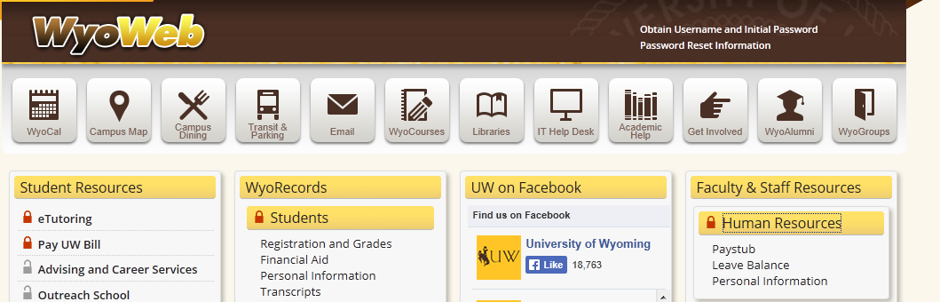

- Log in using your normal network username and password:

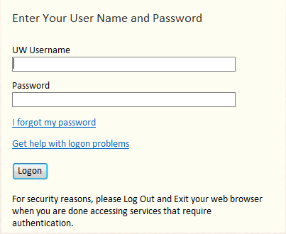

LOGGING INTO HRMS - UWESS (OFF CAMPUS)

- Open a web browser window.
- Go to the University of Wyoming Home Page, www.uwyo.edu
- Click on the WyoWeb link on the right side of the page:
- Click on WyoSecure:

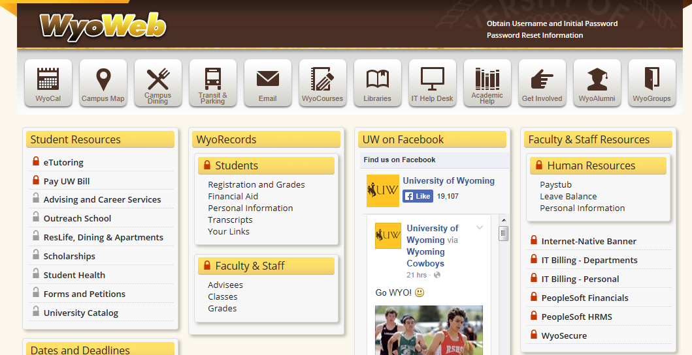

- Log in using your normal network username and password:

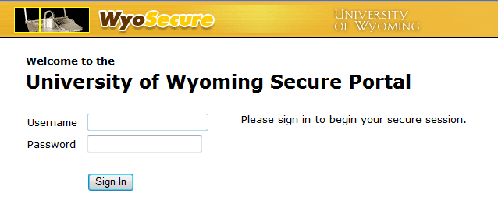

- Click on UW Employee Self Service

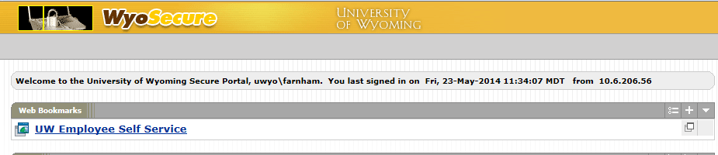
You should now be in HRMS:

VIEWING ISSUED CHECK/ADVICE INFORMATION

Images of Check/Advice stubs can be viewed in UWESS as a PDF (Adobe Acrobat file).

1. From the Home Page, select Main Menu, then Self Service.

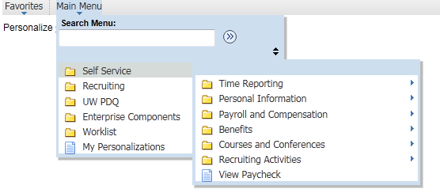
2. Select View Paycheck.

3. The page will display a list of all check/advices that an employee has received since October 2003 (when UW went live with the Peoplesoft system). Select a highlighted date to see a specific payment.

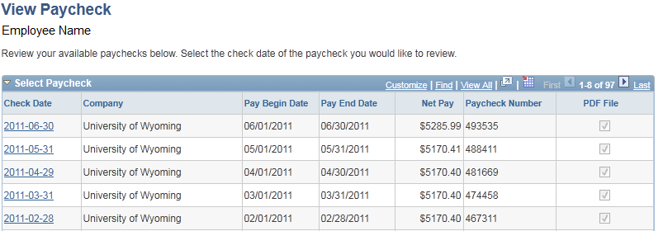

4. If the check that you have selected also has the PDF File box is checked, the form will open a new window and be a printable .pdf copy of your check/advice.

If the check that you selected is prior to June 2010 it will not be a .pdf form and you can only view the information. Contact the Payroll Office if you need a printed copy of any form prior to June 2010.
If a new window does not open, it may be stopped by a pop-up blocker. Look at the top of your web browser to see if you have one of these messages:

Firefox users will see this:

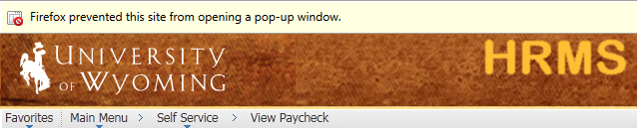

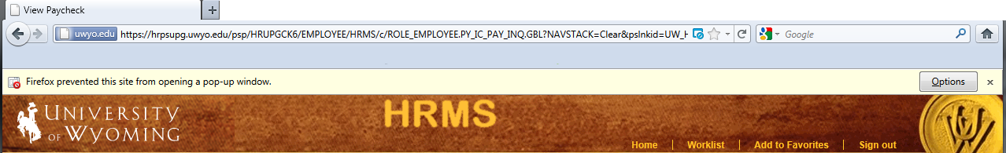

Click on options

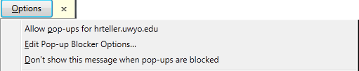

Select Allow pop-ups from hrteller.uwyo.edu

Internet Explorer users will see this:

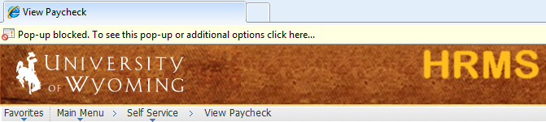

Click anywhere on the yellow bar

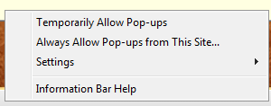

Select Always Allow Pop-ups from This Site

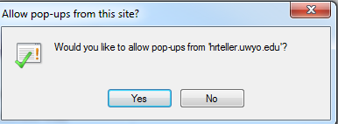

Select Yes

Once you have pop-ups turned off, click again on the Check Date link.

A new window should now open with the check/advice form.

5. You can save this form to your computer by selecting File:Save a Copy, then selecting a folder; you can also print the form by selecting File:Print.

6. To close the .pdf, select the ‘X’ in the top right hand corner of the web page.

7. To exit this section, select Home from the Home Menu Bar or select Self Service from the Menu Box.

