Summer Astronomy Challenge
Activity Book
Presented by the Harry C Vaughan University of Wyoming Planetarium
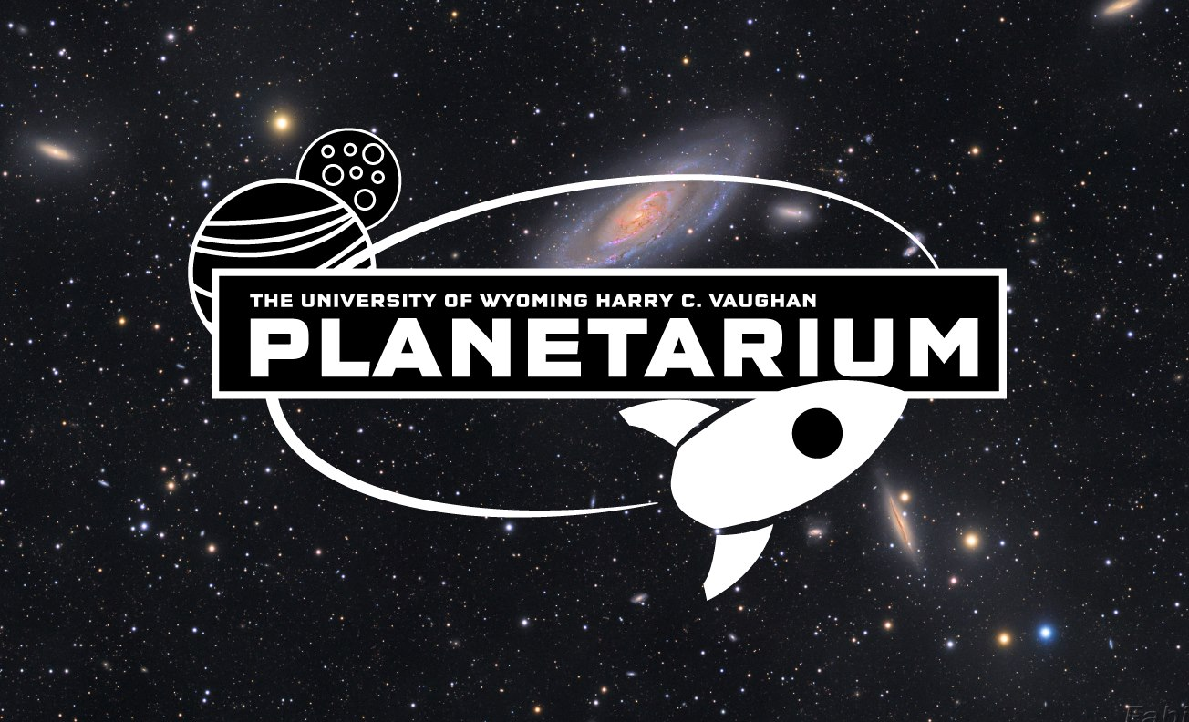

Moon Rank
Planet Rank
Star Rank
Galaxy Rank

Summer 2016

Instructions
Thank you for participating in our planetarium summer challenge! Most of the challenges are designed so that they can be completed using only your eyes, pencils, and crayons.
The challenges are rated by difficulty. Challenges of one star are the easiest and five star challenges can be difficult.
Many of the challenges have the following shapes. The half oval represents the horizon and part of the sky. In the example below we added direction markers (East, South, and West) that are left for you to add in the challenges. The circle represents the view through a telescope or binoculars, and the direction is not necessary.
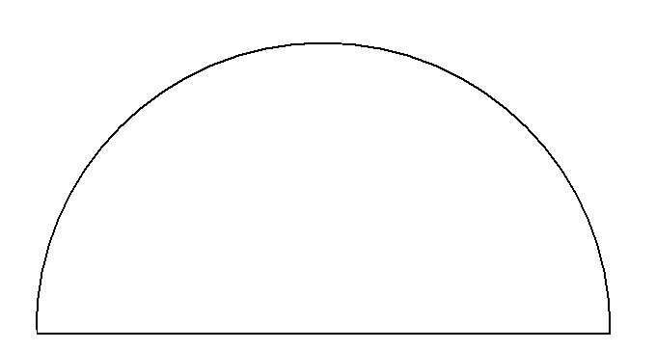

E S W

Feel free to use extra paper. Please do not feel as if you should limit yourselves to the space we provided.
The staff at the planetarium is happy to help with any questions you might have about any of the challenges. Please ask before or after shows or contact us through email at planetarium@uwyo.edu.
To redeem completed challenges please come to a planetarium show and will we mark the number of stars completed on the front page. You can also mark them yourself but we would be happy to see your hard work! If you have completed a certain number you can receive a stellar award!
If you are unable to make it to a show and have challenges or awards to redeem please contact us at planetarium@uwyo.edu or 766-6150 and we will be happy to work with you.
There are awards for each rank achieved:
Moon Rank (5 stars): Stellar Goodie Bag
Planet Rank (15 stars): Your choice of two NASA space posters
Star Rank (30 stars): A deck of constellation playing cards.
Galaxy Rank (50 stars): A fun and informative book on astronomy.

The last day to redeem awards is Saturday September 10th.

For information about our planetarium schedule please visit uwyo.edu/physics and look for the “Planetarium Schedule and Ticket Information” link on the left.

Constellation in the Sky
Do this challenge as many times as you like!

Challenge: Find and sketch a constellation.
What is the name of the constellation you have sketched? Are any of the stars different colors?

Date_______________ Time_____________ Location______________________

Planetarium!

Do this challenge as many times as you like!
Challenge: Come see a show at the Harry C Vaughan University of Wyoming Planetarium.
We love to have guest come to our shows so we can share with you some of the really cool things in our Universe.
We really enjoy when you have questions or when you want to share with us your favorite thing about astronomy!

Colors in the Sky

Challenge: Sketch and color part of the sky. Do this twice at different times of the day or even on different days.
Pay particular attention to the colors you see.
Some interesting times to do this challenge might be: Sunrise or Sunset, at night, at dusk, or dawn, after a storm or on a cloudy day.

Date_______________ Time_____________ Location______________________

Date_______________ Time_____________ Location______________________

The Color of Stars

Challenge: Make a list of the different star colors you can see.
Some stars are different colors! The color tells us their surface temperature. White and blue stars are the hottest. Orange and red stars are the coolest (but still very hot!).
Date_______________ Time_____________ Location______________________

Astronomy All Around Us

Challenge: List as many things as you can think of that are named after astronomical objects.
Hint: Think about candy bars, cars, movie characters….

Meteors!

Do this challenge as many times as you like!
Challenge: Relax and watch the stars. You might see a “shooting star” if you watch long enough. Count how many shooting stars you see tonight.
Meteors occur every night not just during a meteor shower. Most meteors are very small rocks from space – the size of a pebble to a large rock – that burn up when they enter our atmosphere.
How long did you watch for meteors? _______________
How many did you see? ____________________
Date_______________ Time_____________ Location______________________

Star Light Star Bright

Challenge: Find the brightest star in the sky! Find out the name of the star.
Be careful! That may be a planet and not a star. The internet is full of useful star charts to help you with this one. Also, there are many excellent and free apps that will show you exactly what you are looking at.
Hint: Planets do not twinkle as much as stars. They appear as solid spheres of light whereas stars are twinkling points of light.

Date_______________ Time_____________ Location______________________

The North Star

Challenge: Find the North Star (also known as Polaris) and sketch some of the stars or constellations around it.

Date_______________ Time_____________ Location______________________

A Constellation Just For You

Do this challenge as many times as you like!
Challenge: Create your own constellation!
Use your imagination and any stars you want. Sketch your constellation and come up with a short story or mythological tale about it.
Date_______________ Time_____________ Location______________________
Story:

The Closest Star

Sun Warning! Do not stare directly at the Sun as that could cause permanent eye damage. We have specifically designed filters that allow one to look safely at the Sun.
Challenge: Observe and sketch the Sun through a telescope.
After some of our Saturday planetarium shows will we take guest to our rooftop where we have safe methods of looking at the Sun through telescopes. Please check our schedule or webpage for information on dates.
As you look at the Sun, do you notice any Sunspots (dark circular regions on the surface) or Solar prominences (wispy features on the edge of the Sun)?

Date_______________ Time_____________ Location______________________

It’s a plane, it’s a bird, it’s a Satellite!

Challenge: Spot a satellite moving across the sky.
There are over 3000 satellites that orbit Earth! How do you know if what you see is a satellite? Consider these questions:
Is it moving? Satellites often look like airplanes moving across the sky.
Is it blinking? Airplanes have lights that blink. Satellites do not. You can see satellites because they reflect sunlight.
Describe what the satellite you see looks like.
Date_______________ Time_____________ Location______________________

View Through a Telescope

Do this challenge as many times as you like!
Challenge: Look through a telescope and sketch what you see.
If you do not have access to a telescope or binoculars (a spotting scope may work also) come to our free STAR observatory tours. These tours occur on most Fridays around 9pm during the summer on the rooftop of the Physical Science building. See our planetarium schedule or webpage for more information.

Date_______________ Time_____________
Location______________________

Date_______________ Time_____________
Location______________________

Milky Sky

Challenge: Observe and sketch the Milky Way. Sketch either the entire Milky Way or just a section.
The Milky Way is full of features that may not be apparent at first glance. As you sketch the Milky Way, look for areas that are brighter and also areas that are dark and very black.
Date_______________ Time_____________ Location______________________
Date_______________ Time_____________ Location______________________

Mighty Gas Giants

This challenge can be completed twice, once for each planet.
Challenge: Observe and sketch either Jupiter or Saturn while looking at them through a telescope or binoculars.
You might see storm bands on Jupiter, the shadow of the rings on Saturn. Look closely and you might even see some moons orbiting these massive gas giant planets.
If you do not have access to a telescope or binoculars (a spotting scope may work also) come to our free STAR observatory tours. These tours occur on most Fridays around 9pm during the summer on the rooftop of the Physical Science building. See our planetarium schedule or webpage for more information.

Date_______________ Time_____________
Location______________________

Date_______________ Time_____________
Location______________________

Light Pollution

Challenge: Find and sketch a constellation in two different locations. One location should be in a town and the other location should be outside of town (away from city lights).
Is the constellation harder to find in the city? Are the stars brighter in town or in the countryside?
Date_______________ Time_____________ Location______________________
Date_______________ Time_____________ Location______________________

The Moon Wanders Across the Sky

Challenge: Observe the Moon over at least four nights and sketch the Moon’s position relative to the background stars.
Describe your observations and consider the following question: Does the Moon move relative to the background stars?
Night 1: Date_______________ Time_____________ Location______________________
Night 2: Date_______________ Time_____________ Location______________________

Night 3: Date_______________ Time_____________ Location______________________

Night 4: Date_______________ Time_____________ Location______________________

Around and Around Polaris

Challenge: Make two observations separated by at least two hours (you have to stay up late for this one!). Stand in the exact same spot for both observations.
Observation 1: Observe and sketch the Little Dipper and the Big Dipper. Label the North Star. Also, sketch and label something that is along your line of sight as you look towards the North Star. This could be a tree, lamppost, or part of a house. This object will be your reference point for the second observation.
Observation 2: Observe and sketch the Little Dipper and Big Dipper again using the same reference object that you used for the first observation.
What did you observe about the location of the North Star compared to the other stars?

Date_______________ Time_____________ Location______________________

Date_______________ Time_____________ Location______________________

The Many Faces of the Moon

Challenge: Observe and sketch the Moon on at least five different nights.
For an even greater challenge, sketch any surface features you might be able to see, especially any craters so you can see around the terminator (the terminator is the region between the lit side of the Moon and the dark side of the Moon.

Date_______________ Time_____________ Location______________________

Date_______________ Time_____________ Location______________________

Date_______________ Time_____________ Location______________________

Date_______________ Time_____________ Location______________________

Date_______________ Time_____________ Location______________________

Nightsky Wanderers

Challenge: Observe and sketch a planet wandering among the stars. Make at least four observations spread over at least two months.
The ancient Greeks called planets wandering stars. This is because the planets move differently across the night sky than the stars.
This “wandering” motion is noticeable only over a long time so start this one early and stick with it!
Hint: The closer the planet is to the Sun the more noticeable the motion will be. Jupiter is bright and easy to find but will move very little over the summer. Mars is probably a better choice and will be rising in the south east towards the end of May.
Second hint: Sketch the planet and any stars that are nearby it. You should notice that the planet changes its position within the stars.

Planet: ______________
Date_______________ Time_____________ Location______________________
Date_______________ Time_____________ Location______________________
Date_______________ Time_____________ Location______________________
Date_______________ Time_____________ Location______________________

Drifting Sunrise and Sunset

Sun Warning! Do not stare directly at the Sun as that could cause permanent eye damage. Dark sunglasses are recommended for this activity.
Challenge: Observe that the Sun does not always rise exactly in the East nor set exactly in the West. Make at least four observations of either Sunrise or Sunset. Whichever you chose, all four observations should be of the same (if you chose Sunset then observe the Sunset all four times).
Your observations should span two months. If you do this before and after the summer solstice (June 20th) you might notice something interesting….
Make all four observations from the exact same spot. Sketch the location of the Sun from your spot along with a reference. The reference can be a tree, lamppost, or part of a house. This object will be your reference point for all your observations.
Date_______________ Time_____________ Location______________________
Date_______________ Time_____________ Location______________________
Date_______________ Time_____________ Location______________________
Date_______________ Time_____________ Location______________________

Astronomy Challenge Survey

Challenge: Please take a moment to complete this survey and return it to us or email it to us at the planetarium. (Yes, this does count as a challenge point)
- Did you learn anything fun or interesting while completing these challenges?

- What did you and your family enjoy most about this summer’s Astronomy Challenge?

- What did you like least/what can we improve on?

- What would you like to see from the Planetarium next summer?

- Do you have any suggestions for shows or activities throughout this coming school year?

