Mood Lifters: An evidence-based mental wellness program built at the University of Michigan designed to help university communities improve the mental wellbeing of their students, staff, and faculty.
Problem: Mental illness has reached epidemic proportions with 80% of the population reporting mental illness or severe stress at some point in their lifetime. And it is on the rise. Current mental health solutions are either ineffective, expensive, non-evidence-based, inaccessible or a combination of the above.

Solution: Mood Lifters is a rapidly scalable, low-cost, peer-led group mental wellness program. Mood Lifters removes the current barriers to mental health care while improving outcomes and helping participants make real changes across biological, psychological, and social aspects of their lives. We have served 1300+ members, 135 groups, and 30+ organizations, including the University of Michigan, Beaumont, UM, Henry Ford and Devos Health systems, and many YMCAs.

Product: The program consists of 12-15 week, 1-hour group meetings teaching research-backed skills that participants put into practice to earn points, which provides motivation and keeps participants actively engaged. The program is modular and therefore is easy to adapt and includes state-of-the-art research. The Mood Lifters program combines extensive research, clinical guidelines, and behavior change functionality with a relaxed and efficacious approach. The program covers five modalities: Behavior, Mind, Body, Mood, and Social and includes a points-system to help motivate participation.

Proof of Concept: Mood Lifters participants show statistically and clinically significant decreases in depressive and anxiety symptoms and negative emotions and increases in flourishing, social functioning, and positive emotions. Improvements are strongest in those experiencing moderate to severe depression or anxiety. In these groups, we see a 50+ percent symptom reduction in anxiety and depressive symptoms, superseding the 25% change “gold standard” in behavioral intervention research.

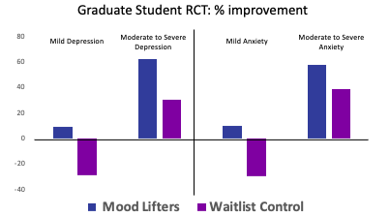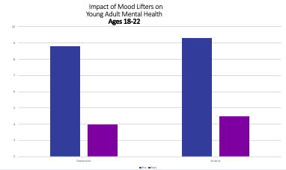

Advantages:
- Availability of Providers: Mood Lifters utilizes trained peer leaders to increase the number of potential providers and online Zoom meetings to increase geographical coverage.
- Stigma: By using peer leaders (i.e., someone who has “been through it”), offering it at schools, onsite, and online, participants feel accepted and understood. Research suggests that working with peers reduces stigma.
- Cost: With peer leaders in a group setting, costs are drastically lower than individual and group psychotherapy and primary care or psychiatry visits with medication.
- Desire to Improve on One’s Own Self: the main reason people do not seek care is that they want to fix their own problems. Mood Lifters gives individuals the most rigorously tested biopsychosocial techniques and encourages individuals to work on it on their own.
- Scalable: Standard manualized processes and automation to train Group Leaders and set up Groups, enables Mood Lifters to scale to large volumes quickly.

Team:
Dr. Patricia Deldin, CEO and founder, is a professor of Psychology and Psychiatry at the University of Michigan and Deputy Director of the Depression Center at the University of Michigan, one of the top psychology programs in the world. Prior to this position, she was a Professor at Harvard University. She is the Founding Board member of the National Network of Depression Center and has published nearly 120 peer-reviewed articles on Mood Lifters, depression, bipolar disorder, and schizophrenia with a focus on the neural correlates of major depression.
Dr. Cecilia Votta, CSO and co-founder, is a postdoctoral fellow at The University of Michigan Clinical Psychology Program. Her dissertation was on mental health care accessibility and the randomized control trial of Mood Lifters and currently has four papers under peer review on mental health treatment and accessibility.
Cheryl Anderson, COO, is a global senior executive in Business Strategy and Operations. Prior to founding Experience Impact, she was the Global/North America Director Strategy & Transformation for Brambles, as well as the USA Director of Business Operations & Global IT Program Manager for CHEP Global.
Advisors:
Maria Martinez, COO and Executive VP, CISCO; BoD, McKesson, and Cue Health Inc
John Greden, Former Dir. of U of Michigan Depression Center; Found. Chair, Nat. Network of Depression Centers
Wendy Heller, Prof. Psychology & Former Dept. Head, Psychology Dept. U of Illinois, Urbana-Champaign
Vicki Politis, Founder, DoubleP Consulting; BoD, International Social Service-USA, and York College

*Mood Lifters is a woman-owned and minority-owned company

