New Search Page

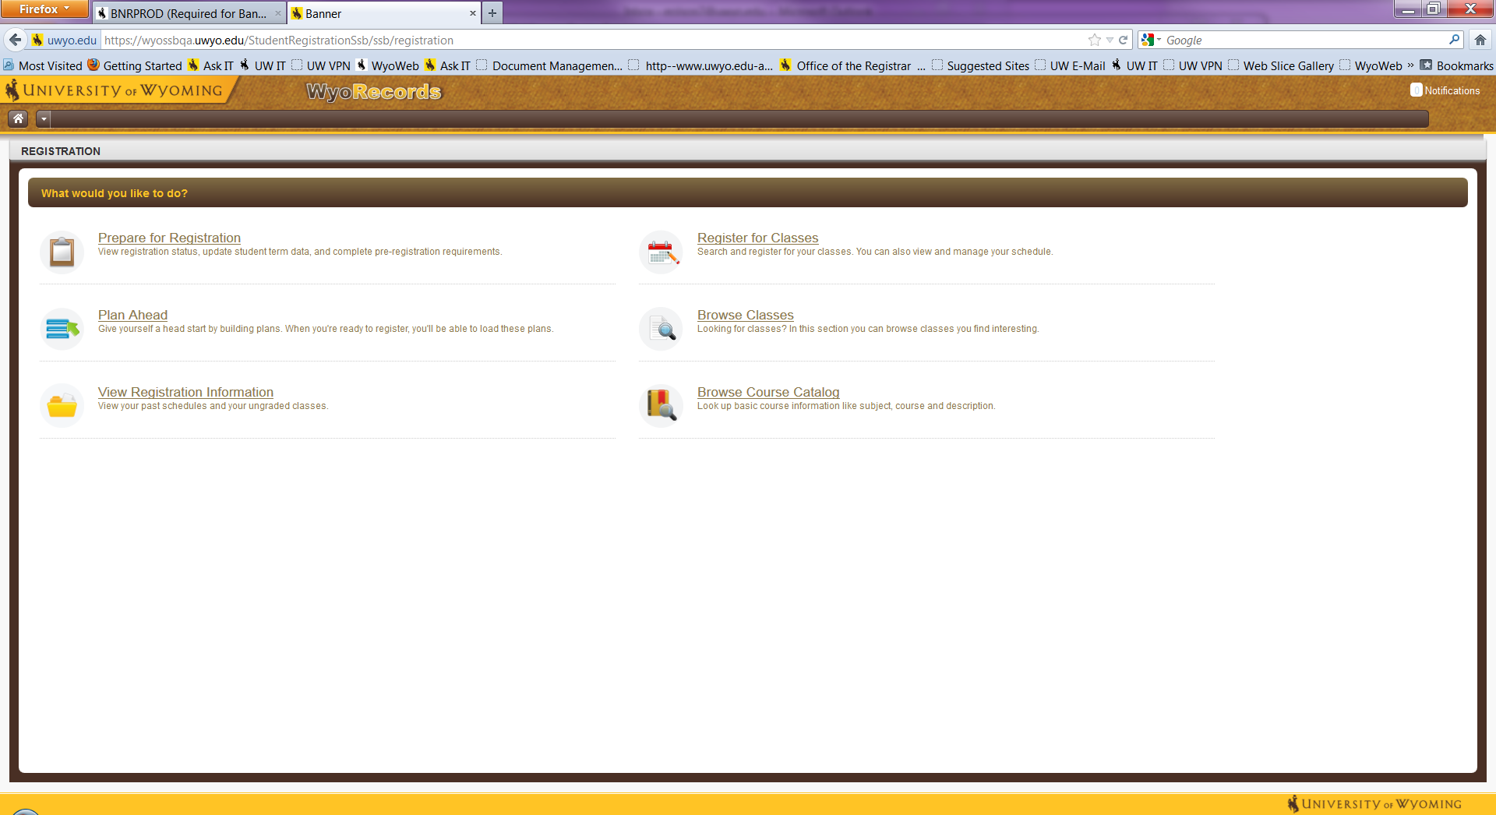 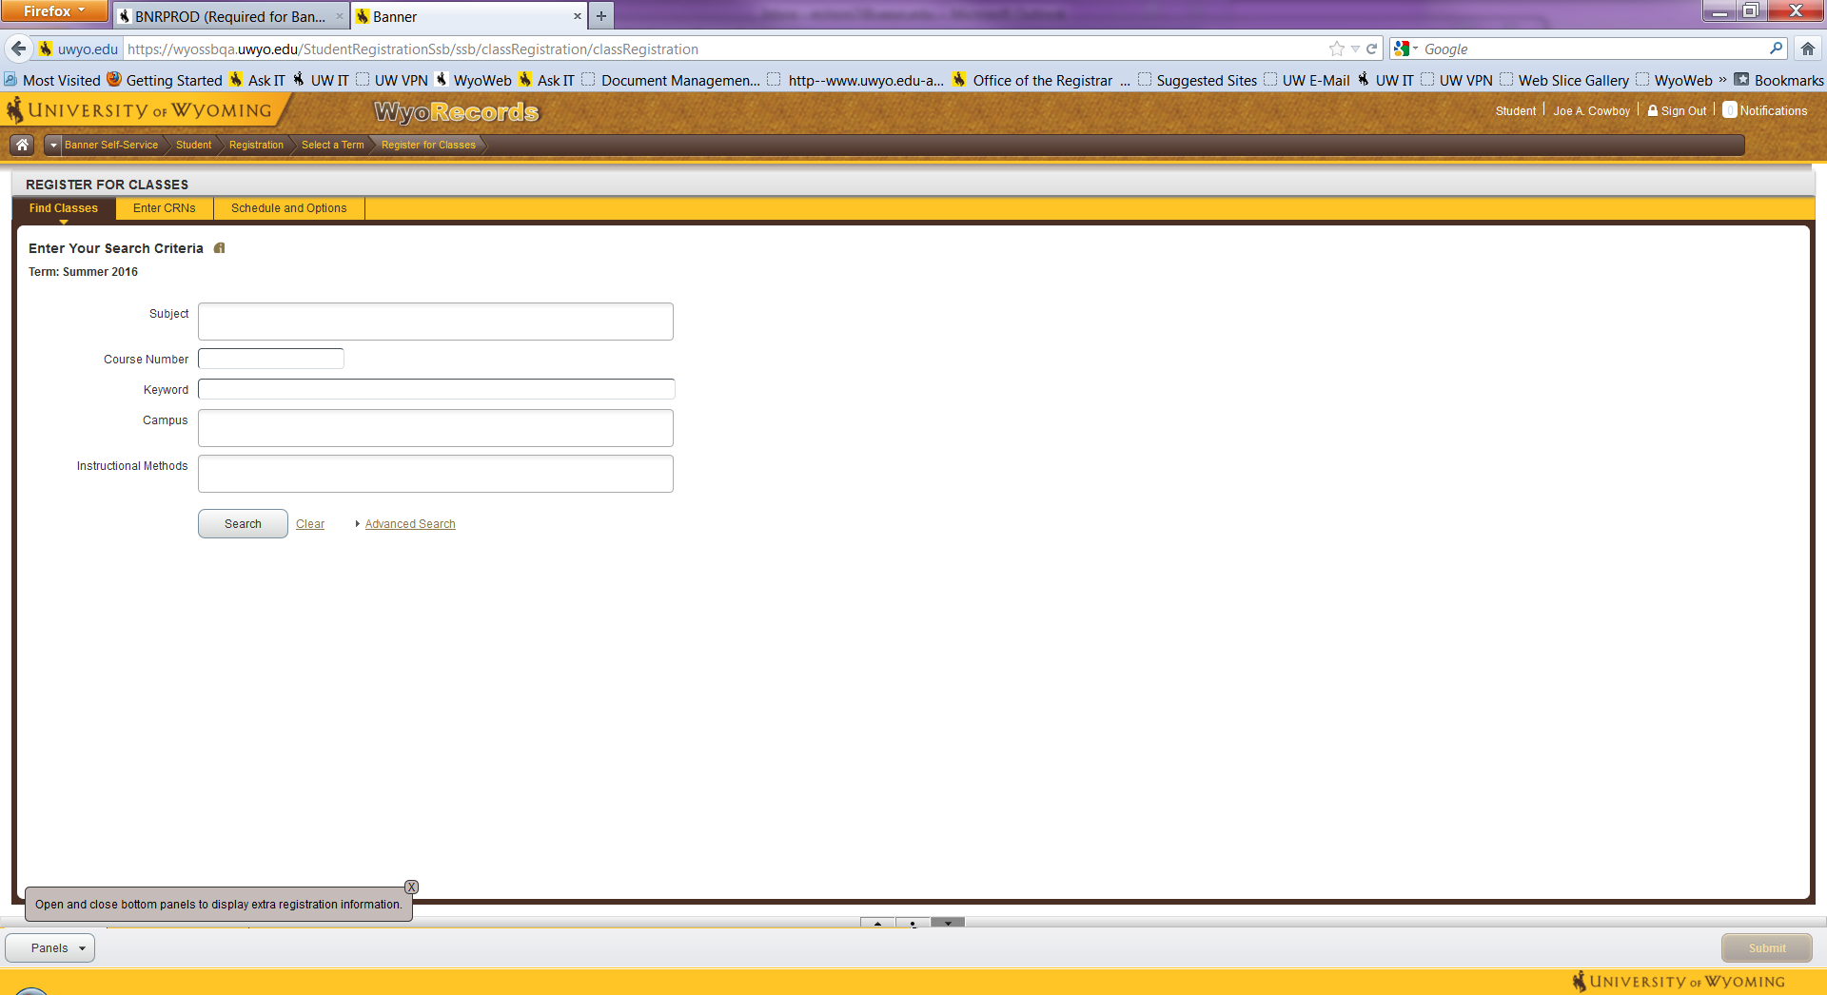

The **Register for Classes** screen will display up to three panels. These are outlined in red below. Search Results will be on the top, the schedule on the left and the Summary panel on the bottom right. Once you find a course you’d like to enroll in click the Add button for the course. This adds the course to your Summary panel. **You are not fully registered in a course until you hit Submit and the Status column changes to Registered.**

New Home Page

