Instructions – AUTOMATIC WAITLISTING

Previous waitlist processes varied widely by department. UW has implemented an automatic waitlisting process beginning with spring 2015 registration.

How does automatic waitlisting work?
A class section waitlist is not available to students until the section’s enrollment cap is reached. Students who attempt to register for a closed section may add their names to the waitlist for that section. If a seat in the section becomes available, the student at the top of the waitlist is notified at their uwyo.edu email address. The student will then have 24 hours, from the time the notification is sent, to log in to his or her WyoWeb account and add the class. If the student has opted into text message notification, he or she will also receive a notification via text.

The open seat will be reserved solely for the student at the top of the waitlist: no other student may register for the seat during the 24-hour time period. If the student at the top of the waitlist does not add the class within the 24-hour period, he or she will be removed from the waitlist and the next student on the list will be notified.
General Guidelines
- Waitlisting is based on a first-come, first-served basis
- The student in the first position will be notified once a seat becomes available
- Waitlisting is available up to the last day to add a class on WyoWeb
- Waitlisting does not guarantee a seat in the class
- Waitlisting holds a spot in line should a seat become available
- Waitlisting does not mean the student is registered into the class
- Provides registration error checking before adding to Waitlist
- Automatic email and optional text message notification when seat opens
- Has a 24 hour time limit after email notification
  - Does NOT automatically enroll the student in the course

The Basics
Student attempts to enroll in a closed class that has the waitlist option
1. Student receives the “Closed, There are # student(s) on the waitlist for this class” registration error when they try to enroll
2. The student has the option to elect to waitlist into the closed section
a. If student elects to waitlist, this does not mean they are registered
3. A student drops the class, making a seat available
4. The student who is first in line is notified via email (and text message if opted in)
a. The student then has 24 hours to complete the registration process through WyoWeb
5. If student decides not to register or the 24 hour time limit expires, the next student in line is notified and the process starts over

Waitlist Tutorial

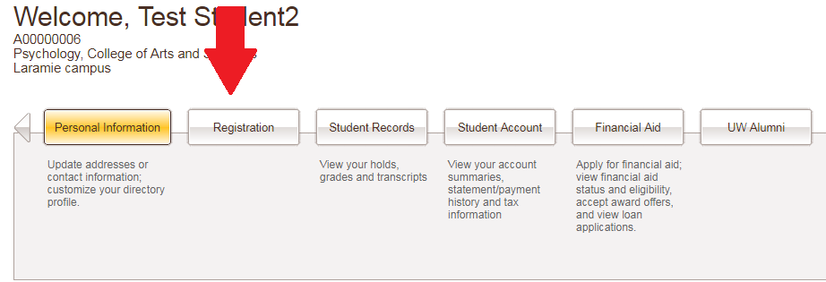
Log into WyoRecords and click the Registration tab to Add or Drop Courses. Then you will select Register for Classes.

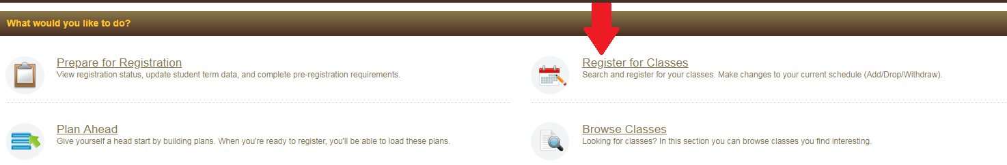

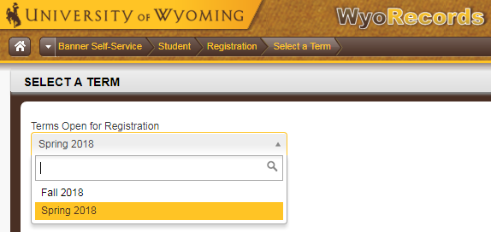
Select the term you would like to register for after choosing Register for Classes.
If the section you’ve selected is closed, and a waitlist is available you will see this with a blue triangle with a white exclamation mark under the remaining seats. This will also tell you how many waitlisted seats are available. Click “Add” to put the course in your summary.
*More information related to waitlist errors is at the end of this tutorial

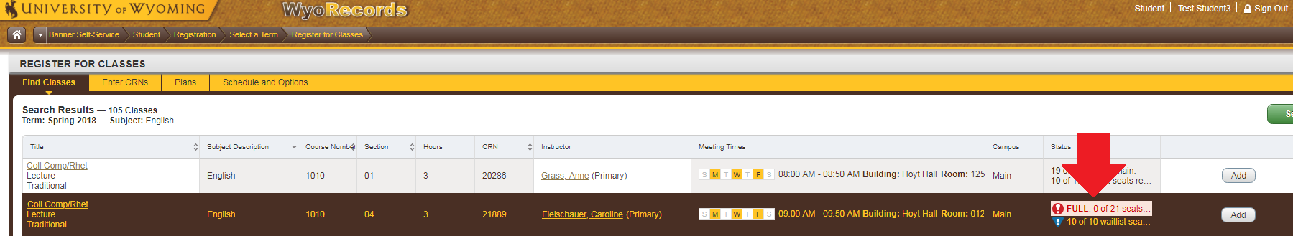

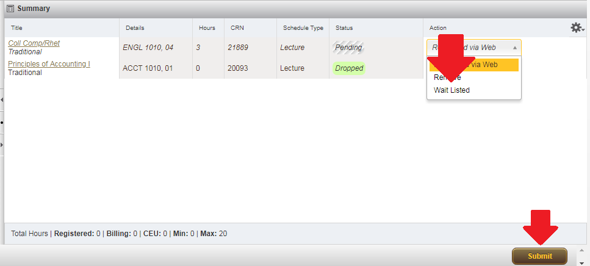
In the Summary window, click under Action and select “Wait Listed” then click submit. The “Status” will change from “Pending” to “Waitlisted” if you have been successfully added.

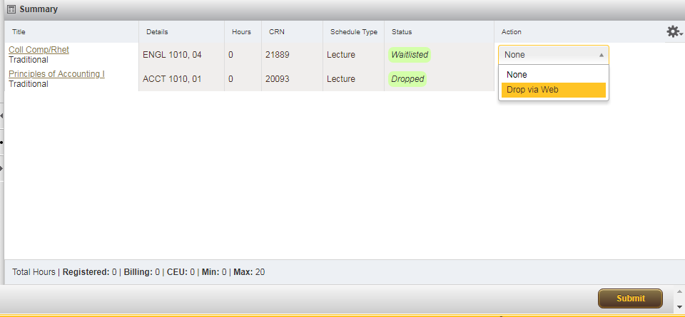
To drop a waitlisted course
- Go to the Register for Classes link
- Select the Drop via Web option from the Action column drop-down menu
- Submit Changes

Notification and accepting a seat
When a seat becomes available, the student who is first on the waitlist will receive an email notification. If the student has opted in, he or she will also receive a notification via text message. The student will only be notified at the start of the 24 hour time period. No additional notifications will be sent.
- The student will have exactly 24 hours to register from the time the email was sent to enroll in the course.
- If the student takes no action to register after 24 hours, he or she will be removed from the waitlist. The student could add themselves to the waitlist list again, but he or she would be placed last on the list.
- Only one notification will be sent regarding the availability of a seat in the class. Students must be checking their email on a regular basis or they may miss the chance to get a seat. If they do not register within 24 hours they will be dropped from the waitlist.
If you do not register within 24 hours the window will expire and your name will be automatically removed from the waitlist, and the next person will be notified.
Email Notification Example

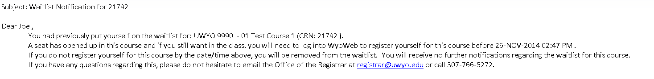
Once a student receives notification he or she can log into WyoWeb and enroll through Register for Classes. Note that after selected “Registered via Web” the student will have to click “Submit” in the bottom right to commit their choice.

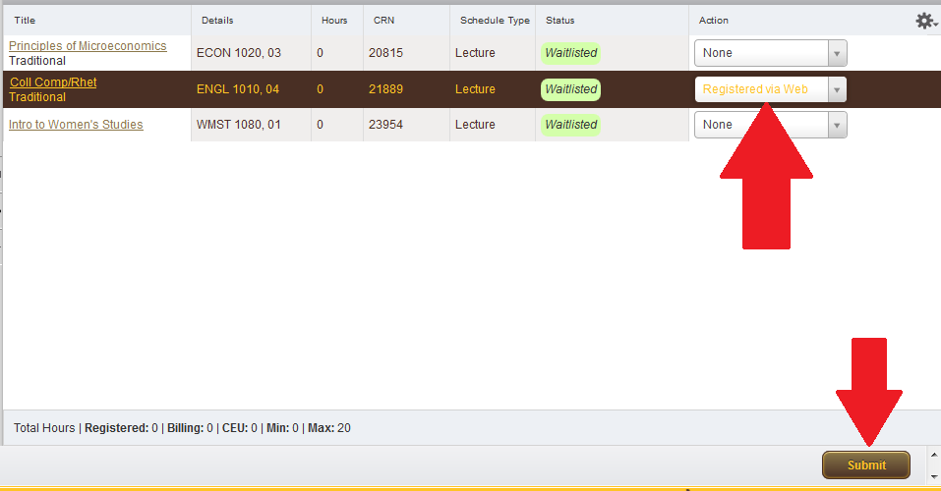

After clicking “Submit” the Status will change from “Waitlisted” to “Registered” once the student has successfully been added.
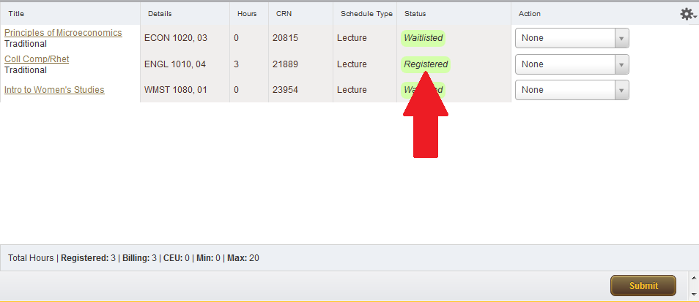

Office of the Registrar – contact information

- Email – registrar@uwyo.edu
- Phone – 307-766-5272 or 307-766-3137

