Banner Course Scheduling Manual

Main Campus Courses

Office of the Registrar
University of Wyoming
March 2018

Contents
Creating New Course Sections 3
Explanation of Term Codes 4
Adding a New Course Section 5
Link Identifiers for Lectures/Labs/Discussions 8
Setting Enrollment Limits 9
Setting Meeting Times/Locations 10
Standard Meeting Times 11
Adding an Instructor or Instructors 13
Changing and Instructor 14
Cross-Listing Courses 15
Finding a Cross List Identifier 15
Comments and Notes 17
Course Prerequisites 18
Course Section Restrictions 19
Basic Course Information 20
Cancelling a Course 22
Performing a CRN Query 23
Finding the CRN for a Course 23
Deleting a Course 25
Duplicating Course Sections 26

Creating New Course Sections
Getting Started
Go to: https://wyoinb.uwyo.edu/welcome-index.html

Click on Production Database [BNRPROD], found under Banner 9 Admin Pages
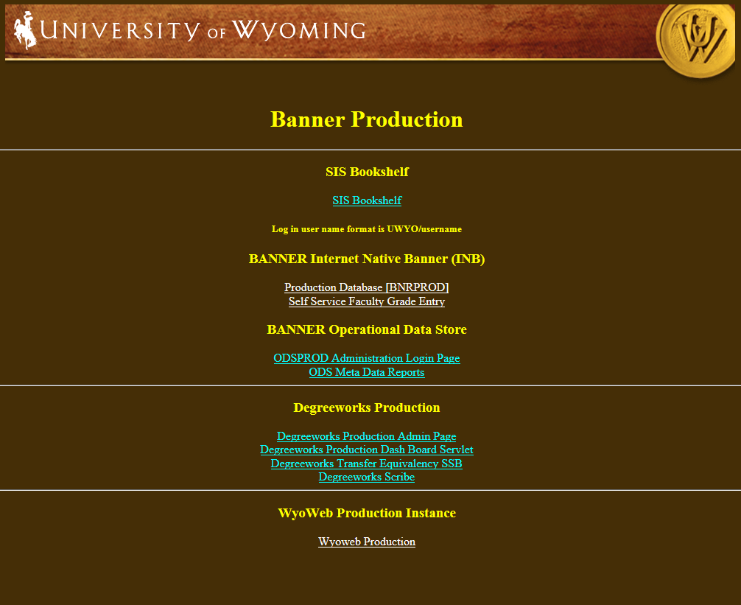
Log in with Banner user ID and password

Please note: the login process for creating and updating all types of course sections will begin with logging into Banner.

Log in with User ID and password

Go To… SSASECT, press ENTER
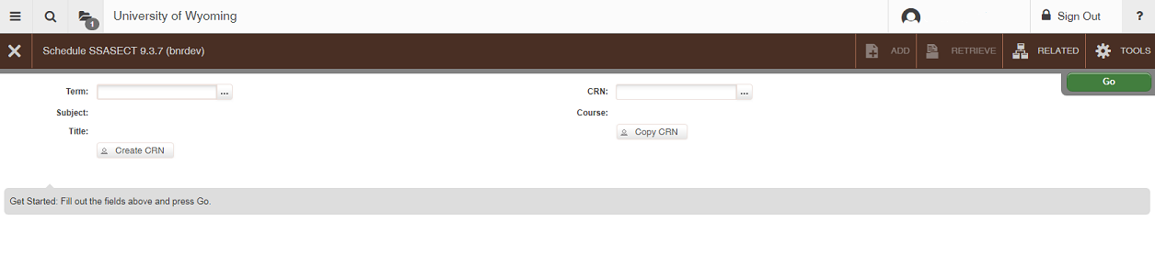

TERM:
  - Explanation of Term Codes
- Terms are six-digit numbers and are based upon the calendar year in which an academic year ends (Academic years begin with fall and end with summer)
- Fall = 10; Spring = 20; Summer =30
  - Examples:
Fall 2018 = 201910 Fall 2019 = 202010
Spring 2019 = 201920 Spring 2020 = 202020
Summer 2019 = 201930 Summer 2020 = 202030
  - Adding a New Course Section

- Term: Enter the term for the course
- CRN: Type ADD in the box and then Next Section (Alt + Page Down), or click the Create CRN: button
- Subject:
  - Fill in with appropriate course prefix
- Course Number:
  - Fill in with appropriate course number
- Title:
  - The course title will automatically appear as default. DO NOT CHANGE THE TITLE OF A COURSE UNLESS IT IS A TOPICS OR SEMINAR COURSE. If the course does belong to one of these categories, indicate this by adding Tp: or Sem: before the course title.
- Section:
  - Fill in the appropriate course section number (01, 02, 03, etc.).
    - If the course section is highlighted in blue and Banner does not let you proceed, that number already exists.
- Cross List:
  - Skip for now
- Campus:
  - M = Main; OS = Outreach School; UWC = UW/Casper College Center
- Status:
  - A = Active; C = Cancelled
- Schedule Type:
  - LEC = Lecture; LAB = Laboratory; DIS = Discussion; PRA = Practicum; IND = Independent Study, etc. Press F9 for options if unsure
- Instructional Method:
  - TR = Traditional and applies to most courses; NT = Non-traditional (should not be used).
- Grade Mode:
  - Leave this field empty unless it is a laboratory, discussion, or Satisfactory/Unsatisfactory Only section. This will allow students to enroll in letter-grade courses for S/U or Audit credit. A-F courses may be offered as S/U only; S/U only courses may not be offered A-F.
  - If this section is for a laboratory or discussion, enter N for “non-graded.”
  - If this section is graded Satisfactory/Unsatisfactory only, enter S. This will automatically create a Satisfactory/Unsatisfactory Only comment on the course schedule.
- Session:
  - Skip
- Special Approval:
  - Y = Special Approval Required.
An asterisk ( * ) will appear after the CRN, indicating that students must contact the department for registration approval.
- Duration:
  - Skip
- Part of Term:
  - 1 = Full Term; 2 = First Half Term; 3 = Second Half Term
(be sure to tab through these fields once you have entered the correct term code)
  - Summer Session parts of term are different. See the Summer Session memo for more detailed information.
- Registration Dates:
  - Skip
- Start Dates:
  - Skip
- Maximum Extensions:
  - Skip
- Credit Hours (Line 1):
  - The first line will default to the approved credit hours for the course. This comes from SCACRSE.
  - For a fixed credit hour course, ‘None’ will be indicated, meaning that there are no variances in the hours.
  - If the course has a lecture and laboratory/discussion component, the course will appear as 0.000 Or 4.000 (or 3.000 depending on the course)
  - NOTE: Variable credit hours cannot be modified. For example, if a course is 1-8 credits, it can either be offered for fixed hours (1 or 2 or 3, etc.) or 1-8; it cannot be offered for 1-6
- Credit Hours (Line 2):
  - If the section is the lecture part of a lecture/lab combination, enter the credit hours for the course. If the section is a laboratory or discussion, enter 0 credit hours.
  - If the has variable credit hours, but the department will be offering it for fixed hours in a specific semester, enter the fixed number of hours (e.g. 3)
- Billing Hours (Lines 1&2):
  - See above (repeat)

  - Contact hours: This information will default; it is not necessary to enter any information
  - Lecture: This information will default; it is not necessary to enter any information
  - Lab: This information will default; it is not necessary to enter any information
  - Other: This information will default; it is not necessary to enter any information

- Prerequisite Check Method:
  - Skip
- Link Identifier: Please see section on Link Identifiers for Lectures/Labs/Discussions in this manual

- Attendance Method:
  - Skip
- Weekly Contact Hours:
  - Skip
- Daily Contact Hours:
  - Skip

- Print:
  - A check-mark in this box indicates that this section will print in online class schedules. Removing the check-mark will prevent the section from printing and from showing up in the Schedule_Change folder.
- Voice Response and Self-Service Available:
  - A check-mark in this box indicates that registration through WyoWeb is available. This does not override controlled enrollment. If this box is unchecked, the course will not appear on a WyoWeb class search.
- Gradable:
  - A check-mark in this box indicates that a grade will be required for this section. Remove the check-mark in this box for laboratory, discussion, and activity sections that are not graded.
- Tuition and Fee Waiver:
  - Skip
- SAVE
  - Save your work by clicking the SAVE icon or pressing F10. A CRN will appear in the CRN: box.

Link Identifiers for Lectures/Labs/Discussions
The Link Identifier connects lectures with their corresponding laboratory or discussion sections. This is part 1 of a 2-part process to link sections. Departments only have access to the first part. The second part must be done in the Link Connector field on SSADETL. The designations are as follows:

- One Lecture with one laboratory/discussion/location/activity
  - Lecture = A1
  - Laboratory = L1
  - Discussion = D1
- Two or more Lectures with specific laboratories/discussions/locations/activities
  - Lecture = A1/A2/A3
  - Laboratory = L1/L2/L3
  - Discussion = D1/D2/D3

- Part 1 is the identification of that particular section as a lecture, laboratory, or discussion. This is done in the Link Identifier field on SSASECT.
- Part 2 connects the lecture, lab, or discussion with its counterpart, which will force student to enroll in both a lecture and a laboratory/discussion. This is done in the Link Connector field on SSADETL.
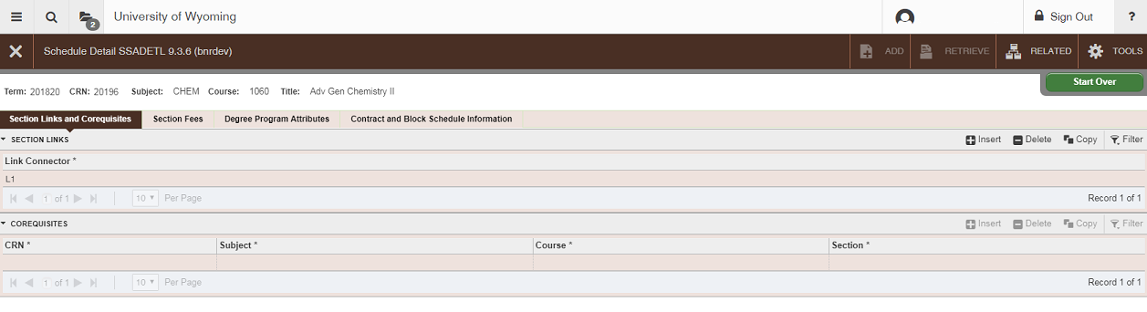

Setting Enrollment Limits
Alt + Page Down, or click on Section Enrollment Information tab

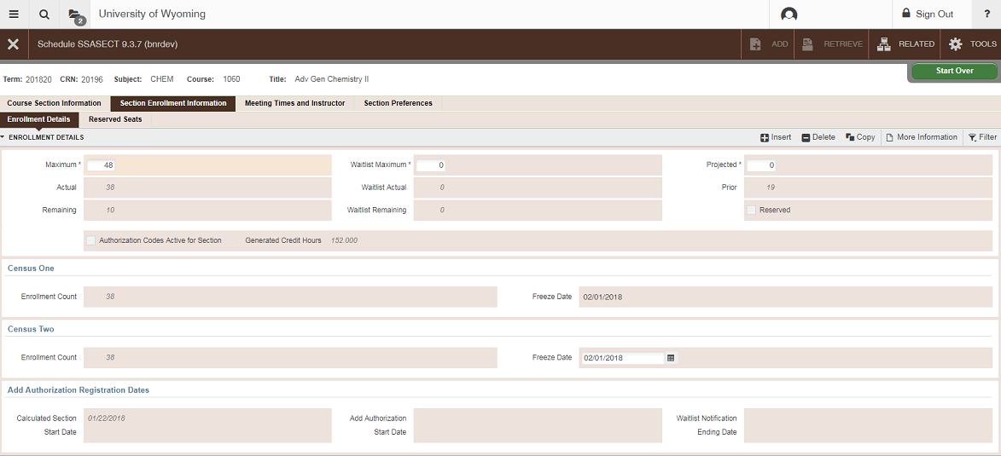
Maximum: Enter the maximum enrollment number for this course. If the course is cross listed, this number should be the total for all combined sections. (For example, a course with 25 undergraduate seats and 5 graduate seats should be set at 30). These may need to be adjusted to match the max for all sections during room assignments and then set back or the room scheduling software may assign the smaller of the two instead of the larger.
- Waitlist Maximum: This is where waitlists are set up. Enter the number of waitlist spaces you would like to allow for this course. Please note that waitlists are automatically controlled. Please visit http://www.uwyo.edu/registrar/_files/docs/waitlistinfoadvisors.pdf for information on Automatic Waitlists.
  - Linked courses (i.e. lecture-laboratory, lecture-discussion) should have the waitlist placed on the laboratory or discussion section.
- SAVE: Save your work by clicking the SAVE icon or pressing F10.

Setting Meeting Times/Locations
From SSASECT Section Details form

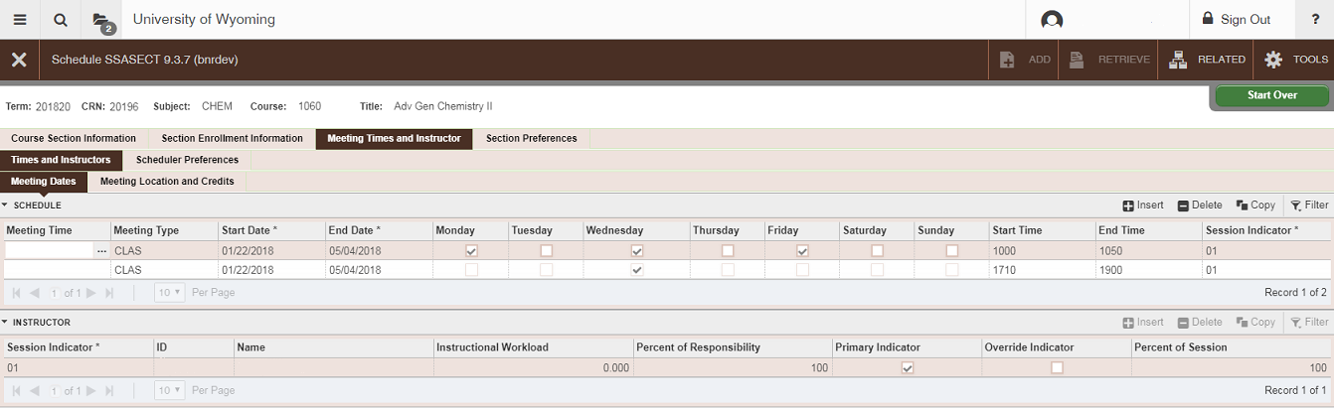
Next Section (Alt + Page Down) twice or click the Meeting Times and Instructor tab
- Meeting Time
  - By clicking the drop down box or pressing F9, you may bring up a list of codes for standard meeting times. Select one by highlighting it and double clicking your mouse (or Alt + S). This will automatically populate the Start Date, End Date, Day, Start Time, and End Time fields.
  - The codes below can also be used to set days/times. Enter the code in the Meeting Time field, tab through the start and end dates, and save.
  - If the course meeting pattern does not appear on the query, tab to days and choose the appropriate ones either by clicking on the boxes, or pressing your space bar. Meeting Type, Start Date, and End Date fields will be populated.
- Start Time/End Time
  - Course start and end times in Banner appear in military or European time.
8:00am = 0800
9:00am = 0900
10:00am = 1000
11:00am = 1100
12:00pm = 1200
1:00pm = 1300
2:00pm = 1400
3:00pm = 1500
4:00pm = 1600
5:00pm = 1700
6:00pm = 1800
7:00pm = 1900
8:00pm = 2000
9:00pm = 2100
10:00pm = 2200
11:00pm = 2300

  - Enter the appropriate Start Time and End Time for the course.

  - Standard Meeting Times
To avoid conflicts for students, courses should be scheduled during these standard meeting times.

Code Days Times
01 MWF 0800-0850
02 MWF 0900-0950
03 MWF 1000-1050
04 MWF 1100-1150
05 MWF 1200-1250
06 MWF 1310-1400
07 MWF 1410-1500
08 MWF 1510-1600
09 MWF 1610-1700
10 TR 0810-0925
11 TR 0935-1050
12 TR 1100-1215
13 TR 1320-1435
14 TR 1445-1600

- Building
  - Click on the Meeting Location and Credits tab
  - Enter the building the course will be offered in ONLY if you have permission to pre-assign a space; otherwise, leave this blank.
- Room
  - Enter the room the course will be offered in ONLY if you have permission to pre-assign a space, otherwise, leave this blank.
- Schedule Type
  - This field is populated by the Schedule Type field on the Section Details form
- Hours Per Week
  - This field is populated based on the meeting days and times you have filled in.
- Override Indicator
  - Skip – Never override a room conflict unless the following exception applies.
  - Exception: If the course is cross listed and pre-assigned into a room, an O may be entered here to override a room conflict. If the cross listed sections are not pre-assigned into a room do not place an O in this field.
- Session Credit Hours
  - This field is populated by the Session Credit Hours field on the Section Details form
- Partition Details
  - Skip
- Room Attribute Details
  - Skip
- SAVE
  - Save your work by clicking the SAVE icon or pressing F10.
  - Check the notes at the bottom of the form to verify that the transaction has been processed and saved.
- For a TBA course
  - Tab through the Start Date and End Date fields. Save. You will automatically be taken to the Hours per Week field. Enter the credit hours for the course. SAVE.
  - If you don’t load at least Start Date and End Date there are other parts of the course that may not display properly on WyoWeb (such as special approval flags and section text).
- SAVE
  - Save your work by clicking on the SAVE icon or pressing F10.
  - Check the notes at the bottom of the form to verify that the transaction has been processed and saved.

Adding an Instructor or Instructors
From SSASECT Section Details form

Click on the Meeting Times and Instructor tab; click on the first line of the Instructor field
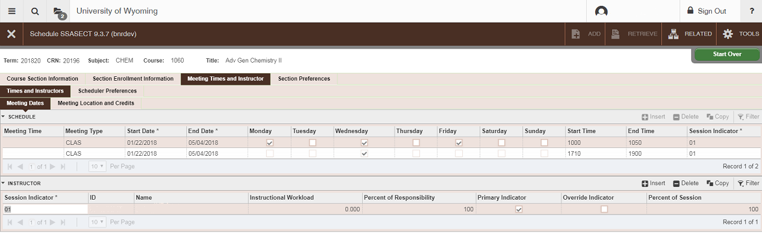

- Session Indicator: Tab through
  - ID: If you know the instructor’s W ID number, enter it here. Tab
  - SAVE
    - Save your work by clicking the SAVE icon or pressing F10.
    - Check the notes at the bottom of the form to verify that the transaction has been processed and saved.
    - If the course is cross listed, you may receive an ‘Instructor Schedule Conflict’ error. If this occurs, click the ‘Override Indicator’ box and save.
    - NOTE: In some cases, Banner may give an inaccurate ‘Instructor Schedule Conflict’ error for TBA courses. If this occurs, click the ‘Override Indicator’ box and save.
  - If you do not know the instructor’s W ID number, click on the drop down box, or press F9 for a query.

- Faculty/Advisor Query
  - Next Section (Alt + Page Down)
- ID
  - Skip; tab to next field
- Last Name
  - Enter the faculty member’s last name (this field is case sensitive) or a partial last name followed by a % to search
  - Press F8 to begin the search
  - Highlight the appropriate instructor
  - Double click or press Alt + S to select. You will be returned to the previous page.
- Multiple Instructors
  - If multiple instructors are added, the Percent of Responsibility field may be modified to reflect the correct information.
- Percent of Responsibility
  - If there is just one instructor, set this at 100. If there are two, set each at 50, and so on, unless the department states otherwise.
- Primary Indicator
  - If multiple instructors are added, one must be chosen as the primary.
- Override Indicator
  - For cross listed courses, click in this box to override the instructor time conflict.
- Percent of Session
  - If there is just one instructor, this will default to 100. If there are two, set each at 50, and so on.
- SAVE
  - Save your work by clicking the SAVE icon or pressing F10.
  - Check the notes at the bottom of the form to verify that the transaction has been processed and saved.
  - If the course is cross listed, you may receive an ‘Instructor Schedule Conflict’ error. If this occurs, click the ‘Override Indicator’ box and save.
  - NOTE: In some cases, Banner may give an inaccurate ‘Instructor Schedule Conflict’ error for TBA courses. If this occurs, click the ‘Override Indicator’ box and save.
- To EXIT
  - Click on the Course Section Information tab to return to the Section Details form

  - Changing and Instructor
- Remove the instructor by either clicking Record, then Remove, or by clicking on the Remove Record icon.
- Enter the correct instructor’s “W” ID number and SAVE.

Cross-Listing Courses
Cross listing a course in Banner indicates to the room scheduling system that only one room is needed for the cross listed courses and it adds a note in the class schedule. All course information must be added for all cross listed sections by each department. To cross list courses in Banner, from the main SSASECT page, go to:
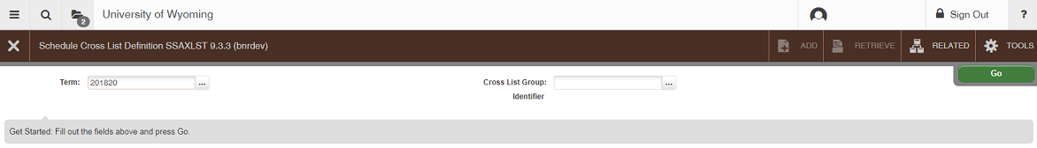
- Related + Cross List Definitions (Alt + Shift + R , Cross List Definitions)
  - Finding a Cross List Identifier
  - Enter the correct term in the field.
  - Cross List Group Identifier: F9 or click the drop down box
  - With only the term field filled in, press F8 to see a list of identifiers already in use. Each cross listed group of courses must have a unique identifier. Always check this before creating a new group. Identifiers are two characters and should be alpha-numeric:
    - A0 to A9
    - B0 to B9
    - C0 to C9, etc.
  - The Cross List Section field at the bottom of the form will show which courses are combined under each identifier.
  - When searching for a cross list identifier, you should be looking for one of two options:
    - An identifier that has no courses listed beneath it;
    - A break in the pattern of identifiers. For example, in the list: A1, A2, A3, A4, C9, There is a break between A4 and C9. This means that A5, A6, A7, A8, A9, B0, B1…C8 are all available for use.
  - Once an unused identifier has been found, make a note of which identifier you would like to use, and press X or Ctrl + Q to quit this query
- Enter the Cross List Group Identifier you have chosen
  - Perform a Next Section (Alt + Page Down)
- Set the combined maximum enrollment for the cross listed courses. This number is the end-all of enrollment limits. This means that no matter what each of the individual sections are set at, this number is the maximum enrollment limit. For example, if each section is set at 100, but this limit is set at 50, no more than 50 will be able to enroll.
  - Perform a Next Section (Alt + Page Down)
- CRN
  - Enter the CRN for each cross listed section
- SAVE
  - Save your work by clicking the SAVE icon or pressing F10.
- EXIT
  - Click the X to exit or press Ctrl + Q

If a cross list group identifier has already been created for a group, a new course may be added to that group simply by entering the identifier in the Cross List field on the main SSASECT page.

When cross list groups are created, an automatic note is generated listing all courses in the group. Departments should not add a ‘Cross listed with’ note manually.

Comments and Notes
Banner has only two automatically added notes; all other notes must be manually entered.
Automatic notes (do not need to be added): Cross listed with…
Satisfactory/Unsatisfactory only
- Related + Course Section Comments (Alt + Shift + R + Course Section Comments)
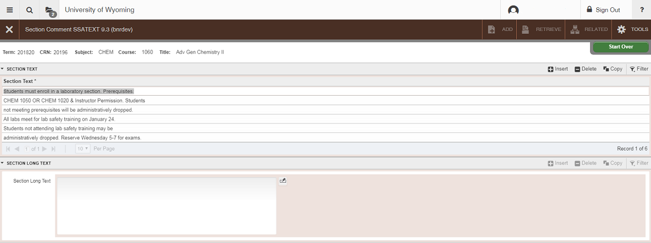
  - Next Section (Alt + Page Down)
- Section Text (Please note that you will not be able to view notes already loaded until you perform a Next Section).
  - Notes may be typed in these fields. These lines do not scroll; when you reach the end of a line, you will not be able to type further. Use your arrow down key to go to the next line and continue typing. Please use proper grammar. Some standard notes should be entered as follows:

    - Meets Non-Western Certification for A&S
    - Meets A&S Core Global
    - Meets A&S Core Diversity
    - Students must enroll in a laboratory section
    - Students must enroll in a discussion section
    - Students on waitlist must attend first lecture

  - Please note that Satisfactory/Unsatisfactory Only and Cross listed with: should not be entered here. These notes will automatically print based on how the course is set up on SSASECT. Do not add notes such as Dual listed with: or Identical to:
- Section Long Text: Next Section again to see this text. This text is used for any Distance Education classes which involve On-Site Meetings.
- SAVE: Save your work by clicking the SAVE icon or pressing F10.
- EXIT: Click the X to exit

Course Prerequisites
Departments do not have access to load course prerequisites. This must be done in the Registrar’s Office. Please note that only those prerequisites which have been approved by the University Course Committee (and which appear in the University Catalog) may be loaded. To see the prerequisites set up for a course, from the main SSASECT page, go to:
- Related + Schedule Pre-Requisites (Alt + Shift + R + Course Prerequisites)
- Next Section (Alt + Page Down) Twice
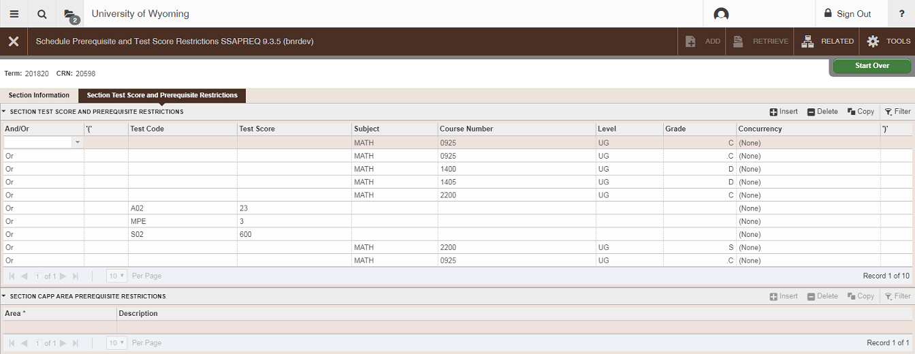
  - Course and test prerequisites are listed here.

- EXIT
  - Click the X to exit or press or Ctrl + Q

Course Section Restrictions
Departments do not have access to load course section restrictions (such as major, class standing, college restrictions). To have restrictions loaded to a course, please contact the Office of the Registrar. To see the restrictions set up for a course:
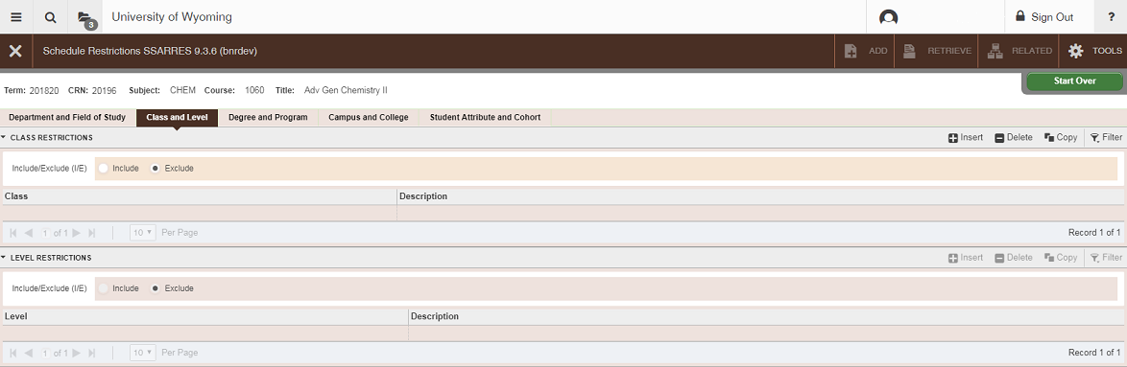
- Related + Schedule Restrictions (Alt + Shift + R + Schedule Restrictions)

- To check all restrictions, click the tabs across the top of the page.
- EXIT
  - Click the X to exit or press or Ctrl + Q

Basic Course Information
To see basic course (catalog) information:
- Related + Basic Course Information (Alt + Shift + R + Basic Course Information)
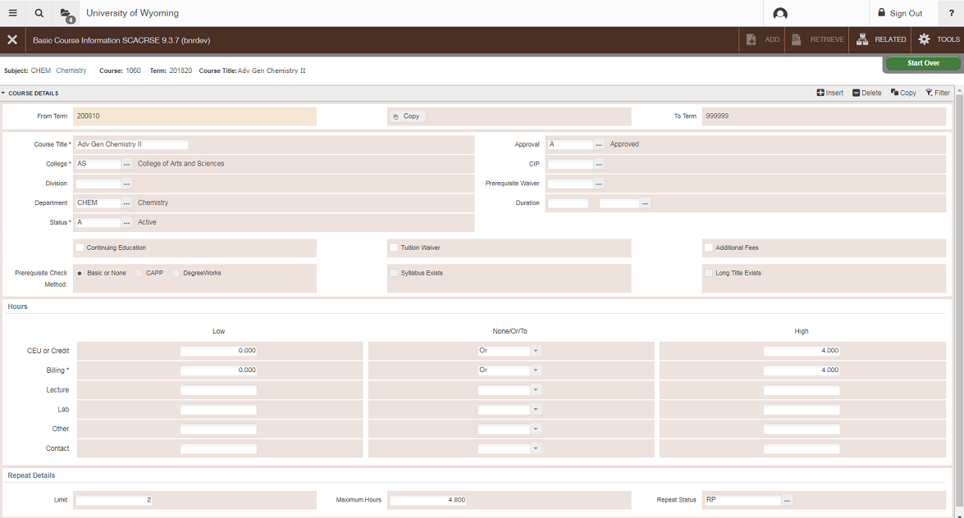
  - This will take you to SCACRSE and show catalog information such as course title and approved credit hours.
- EXIT
  - Click the X to exit or press or Ctrl + Q
- To see the Course Description, go to Related, Course Details [SCADETL]
  - Perform a Next Section
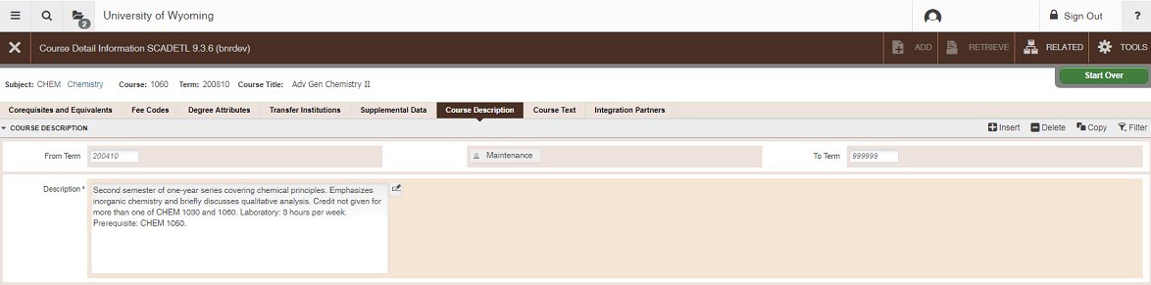
  - Click the Course Description tab
- EXIT
  - Click the X to exit or press or Ctrl + Q

Cancelling a Course
Note: Enrolled students must be dropped prior to cancellation of a course. Be sure to email all students to notify them of the cancellation.

For instructions on how to drop students from a course, see the SFAMREG instruction page.

Once all students have been dropped from the course:

Go To… SSASECT, press ENTER

Enter the correct Term

Enter the correct CRN

- Click the Meeting Times and Instructor tab; click on the instructor line
  - Delete the Instructor (Delete icon, or Shift + F6)
  - SAVE
- Click on the days/times line
  - Delete the Meeting Time information (Delete icon, or Shift + F6)
  - SAVE
- Click on the Course Section Information tab
  - Tab to Status
  - Change from A (Active) to C (Cancelled)
- SAVE
  - Save your work by pressing F10 or clicking the SAVE icon
  - Check the notes at the bottom of the form to verify that the transaction has been processed and saved.

Performing a CRN Query
Go To… SSASECT, press ENTER

Enter the correct term

Tab to the CRN: field
- Press F9 or click on the drop-down box; to open a query
- Once the query is open, verify that the term is correct, change as necessary
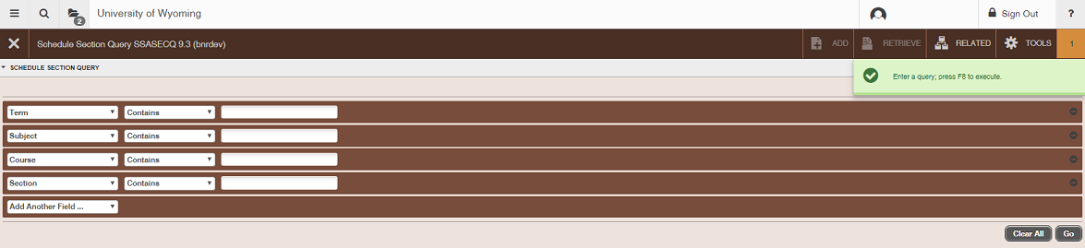
- Click the “Add Another Field…” dropdown to select query fields.

  - Finding the CRN for a Course
- Tab to Subject: Enter the prefix for the course
- Tab to Course: Enter the course number
- Tab to Section*: Enter the section number for the course
- Press F8 to execute a query
- The course you are searching for should appear. To select it, either press Alt + S or double-click on the course title. If the course does not appear, it has not been built for that term.
*Skip this step if you would like to bring up a listing of all sections for a specific course.

To Check for Cancelled sections:
- Tab to Subject: Enter the prefix for your courses
- Tab to Section Status: Enter C (Cancelled)
- Press F8 to execute a query
- Scroll down the page, making note of the CRNs for the courses that need to be changed. If no courses appear on the list, there are no problems.

Deleting a Course
PLEASE NOTE: Courses should ONLY be deleted in the preliminary stages of course scheduling. Once the Class Schedule has been posted online, courses should never be deleted. If they are not being offered, they should be cancelled.

Go To… SSASECT, press ENTER

Term: enter the correct term for the course

CRN: enter the correct CRN for the course (or press F9 to search)

- Next Section (Alt + Page Down)

- Delete the course by performing a Delete Record (Delete icon, or Shift + F6)

- SAVE
  - Save your work by clicking the SAVE icon or pressing F10.
Check the notes at the bottom of the form to verify that the transaction has been processed and saved.

Duplicating Course Sections
This process is used to create multiple sections of the same course. For example, multiple thesis or dissertation research sections, or multiple laboratory sections.

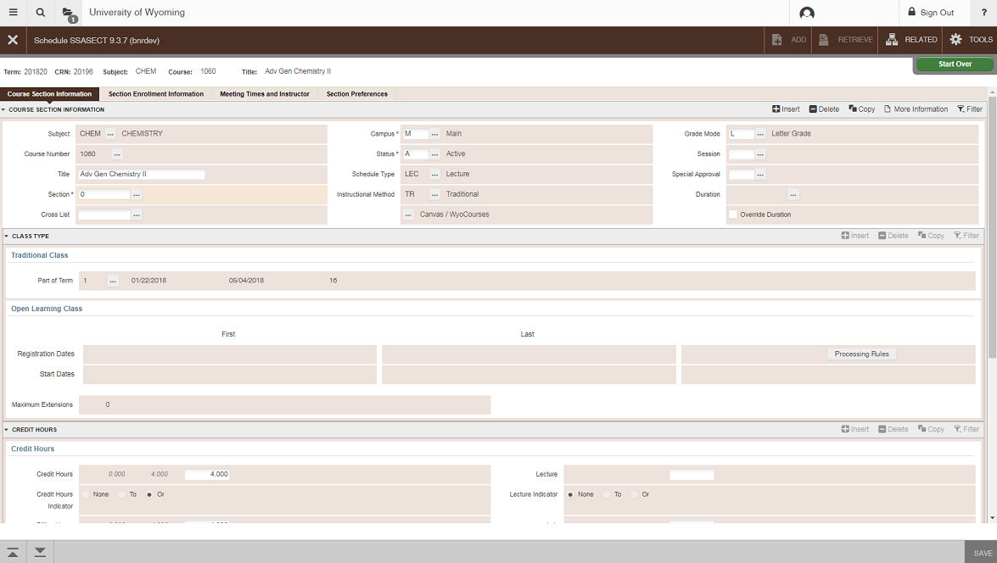
Go to SSASECT and open section 01 of the course you wish to duplicate.

Section: change the section number of the course from 01 to 0

SAVE your changes by clicking the SAVE icon or pressing F10

**Be sure to make sure that this section is set up the way you want the duplicates to be. If you want the duplicates to have controlled enrollment, set it on section 0. If they should not appear in the printed schedule, uncheck the “print” box. Set the enrollment number as you would like it to be in the duplicates.

Write down the CRN for this course

Perform a rollback (F5 or click the Start Over button)

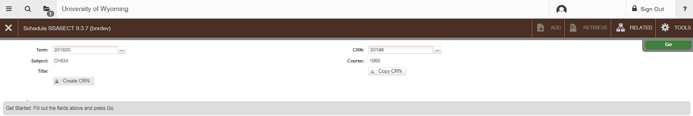
Click the Copy CRN button

Default Term: this field should default to the term you are working on

Default CRN: enter the CRN of the section you changed to 0 (above)

Perform a Next Section (Alt + Page Down or click the Go button)

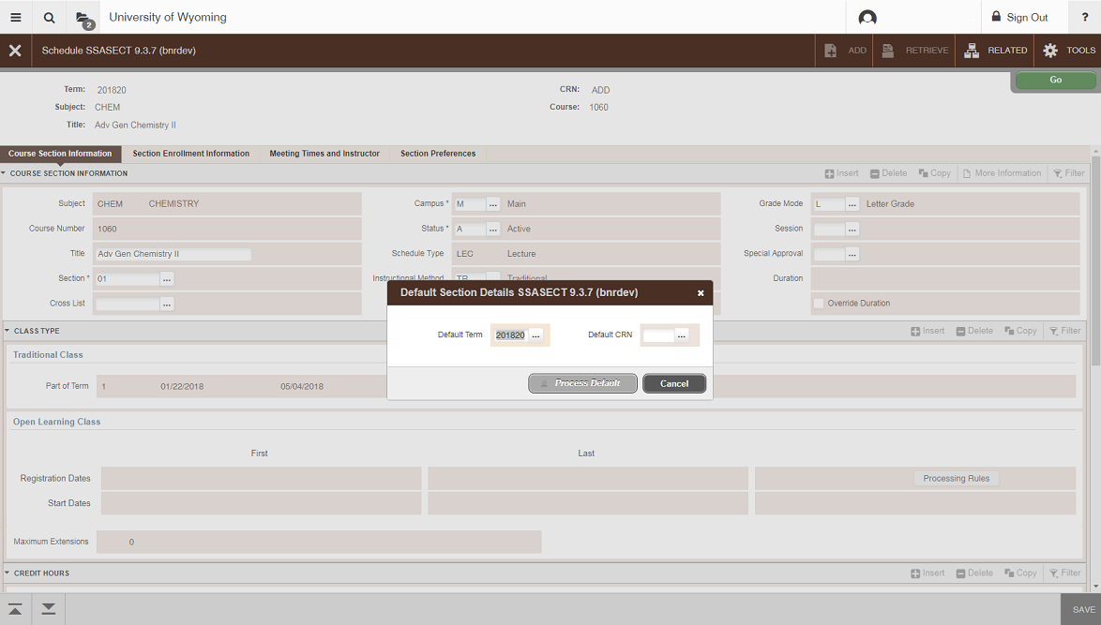
Section: enter the appropriate section number, beginning with 02 (because 01 already exists)
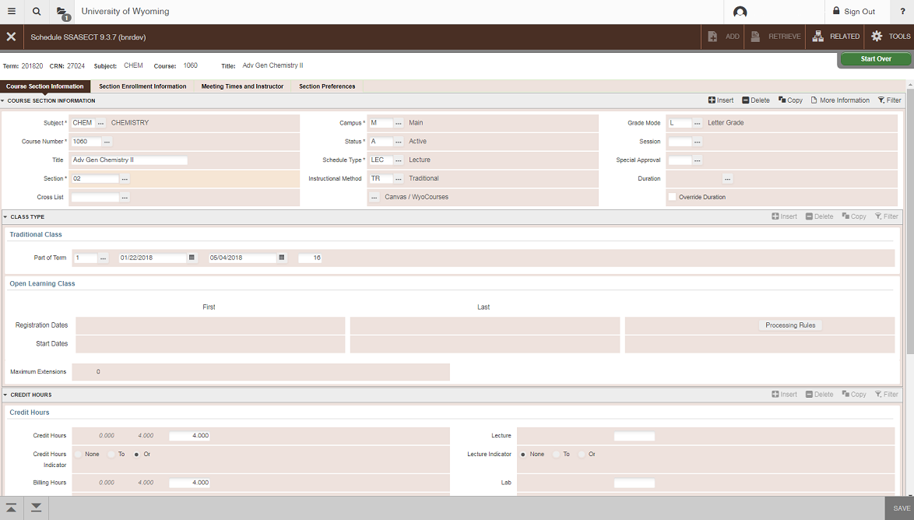
You will now have a duplicate course that looks just like section 0, but with a new CRN. Change the section number from 0 to what it should be, beginning with 02, because section 01 is your original (section numbers should be 02, 03, . . . 09, 10, etc.). You will need to enter the day/time and instructor information for these duplicated sections.

Repeat the steps to add new sections as many times as needed.

Return to the original course section on SSASECT

Section: change the section number from 0 back to 01

SAVE your changes
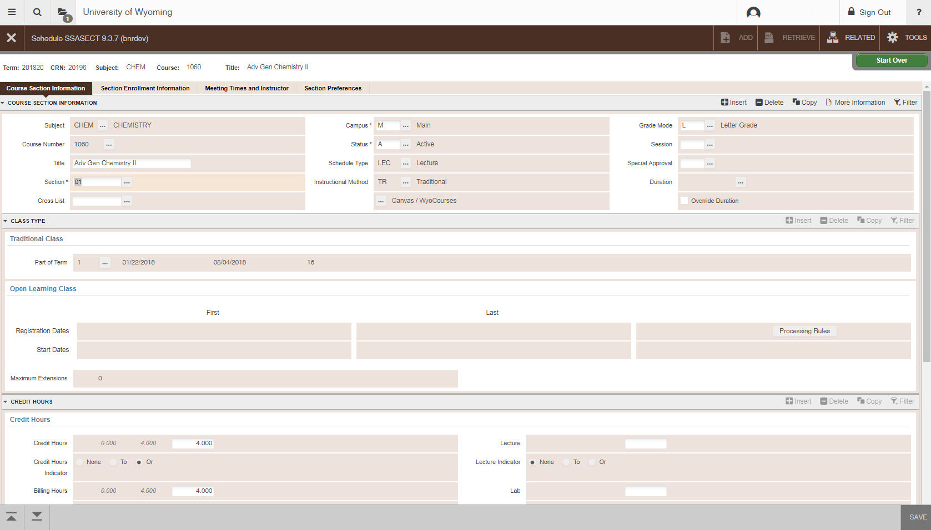
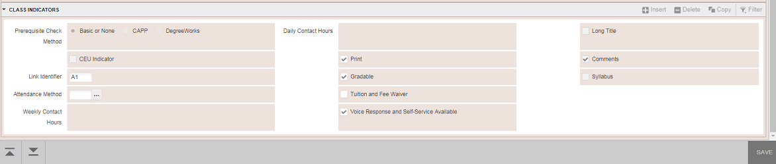
Once you have duplicated all of the sections that you need, go back to your original section (the CRN you wrote down). Change the section number from 0 back to 01 and save. If you want this course to print in the class schedule, be sure to check the “print” box.

