Banner Student Registration

Instructions

Office of the Registrar
University of Wyoming
March 2018

Contents
Creating Enrollment Overrides ...........................................................................................3
Explanation of Term Codes ............................................................................................3
Dropping All Students from a Course ................................................................................5

Transferring Students from One Course or Section to Another .........................................9
PERC Number ....................................................................................................................18
Registration Date and Time ................................................................................................19
Changing an Advisor ..........................................................................................................20

Finding an Advisor’s W Number ........................................................................................22
Checking for Student Holds ...............................................................................................23
Finding a Student’s W Number ..........................................................................................24

Creating Enrollment Overrides

Creating overrides for closed classes and controlled enrollment courses. NOTE: Departments should not enroll students in courses. This screen should be used to allow students to enroll personally.

Go to: SFASRPO

• ID: Enter the student’s W Number

• TERM: Enter the appropriate term

Explanation of Term Codes
o Terms are six-digit numbers and are based upon the calendar year in which an
academic year ends (Academic years begin with fall and end with summer)
o Fall = 10; Spring = 20; Summer =30
o Examples:
Fall 2018 = 201910 Fall 2019 = 202010
Spring 2019 = 201920 Spring 2020 = 202020
Summer 2019 = 201930 Summer 2020 = 202030

• Perform a Next Section (Alt + Page Down)

• Permit: Enter the appropriate code

  - CNTRL = Controlled Enrollment course, or restrictions
  - PRERQ = Prerequisite Override
  - CLOSED = Closed Course Override
  - TIME = Time Conflict Override (to be performed by the Registrar’s
  - Office only)
  - DUPL = Duplicate Section override
  - SPECIAL = Instructor Approval

• CRN: Enter the CRN of the course (Subject, Course Number, and Section will automatically be filled in
or
• Subject: Enter the course prefix for the course

• Course Number: Enter the course number for the course

• Section: Enter the section of the course (Optional. If no section number is entered, the student will be able to enroll in any section of that course)

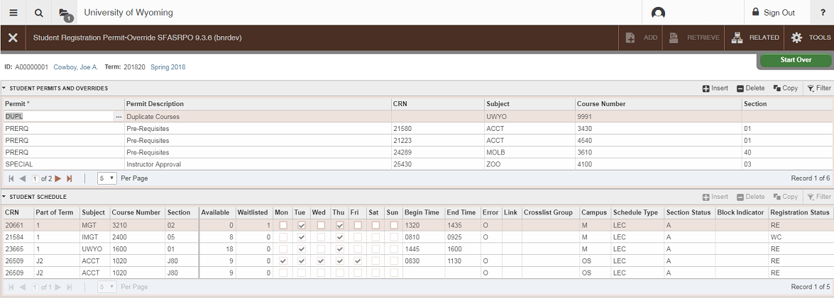
• SAVE: Save your changes by clicking the SAVE icon of pressing F10.

Dropping All Students from a Course

*Before performing these steps, be sure to email the entire class and inform them of the cancellation.

Go To… SFAMREG, press ENTER
• On the Search tab, enter the term
• Tab to Search Criteria
• Enter the term
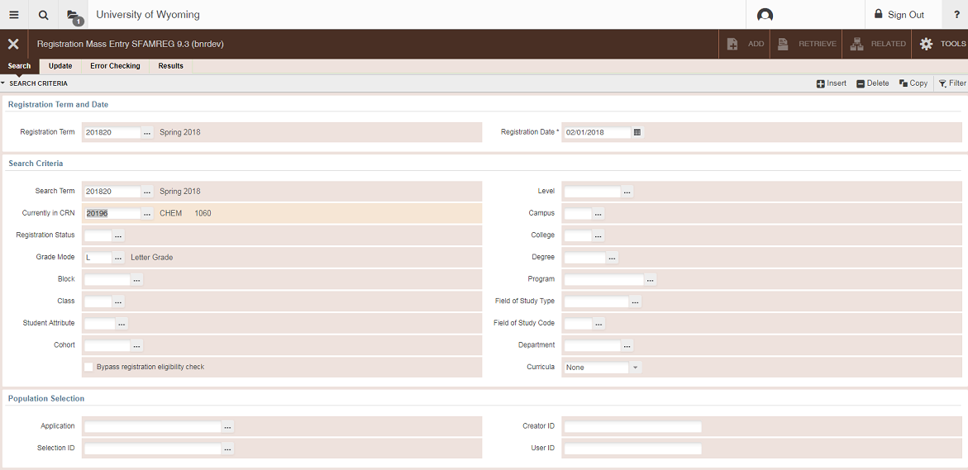
• Enter the CRN

Go to the Update tab
• Go to Registration Course Drop Values
• CRN: Enter the CRN for the course
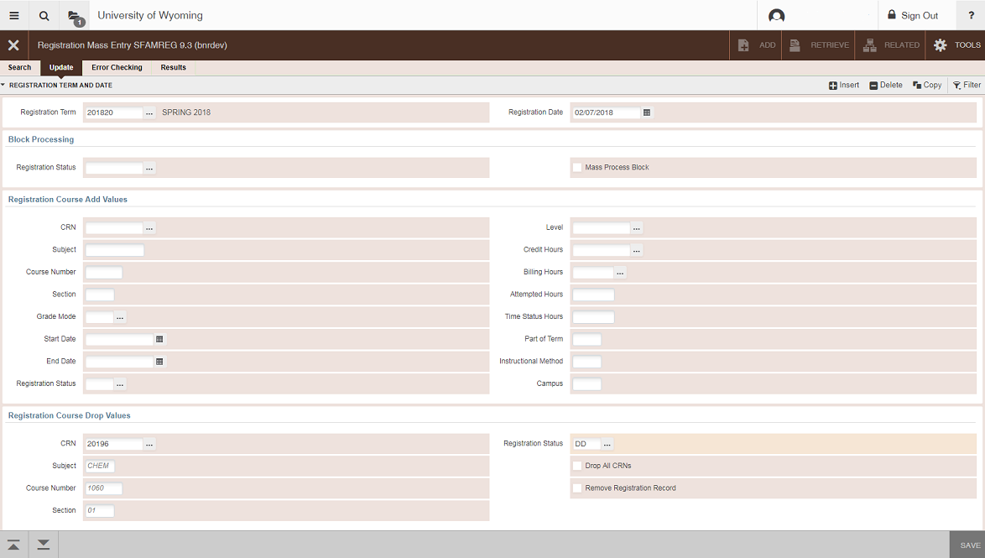
• Registration Status field: Type in DD

Go to the Error Checking tab
• Student Options Box: Click ‘No Check’ for all categories
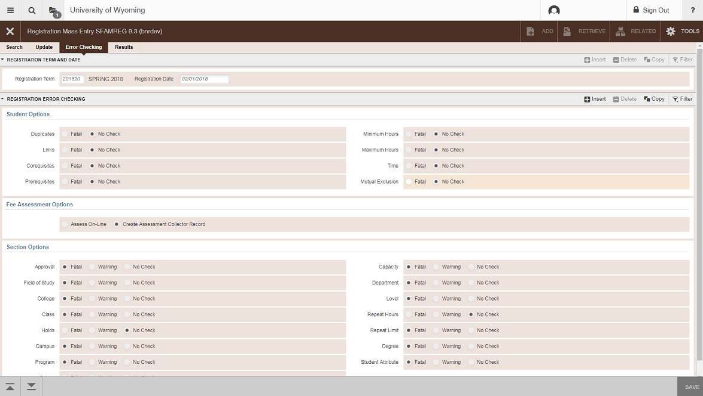
• Section Options Box: Find the ‘Holds’ option on the right side of the screen. Click ‘No Check.’

Go to the Results tab
• Results: Click ‘Select All’
• Click Submit in the Submission box at the bottom of the screen
• Save. Once the process is complete, all students in the section will be dropped.
• Verify that all students have been dropped by checking the course list on
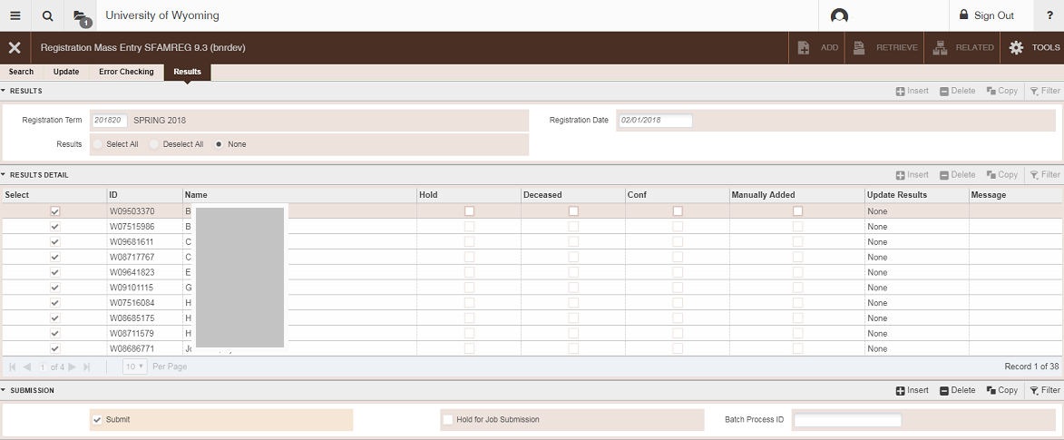
SFASLST.

Transferring Students from One Course or Section to Another

Go To… SFAMREG, press ENTER
• On the Search tab, enter the term
• Tab to Search Criteria
• Enter the term
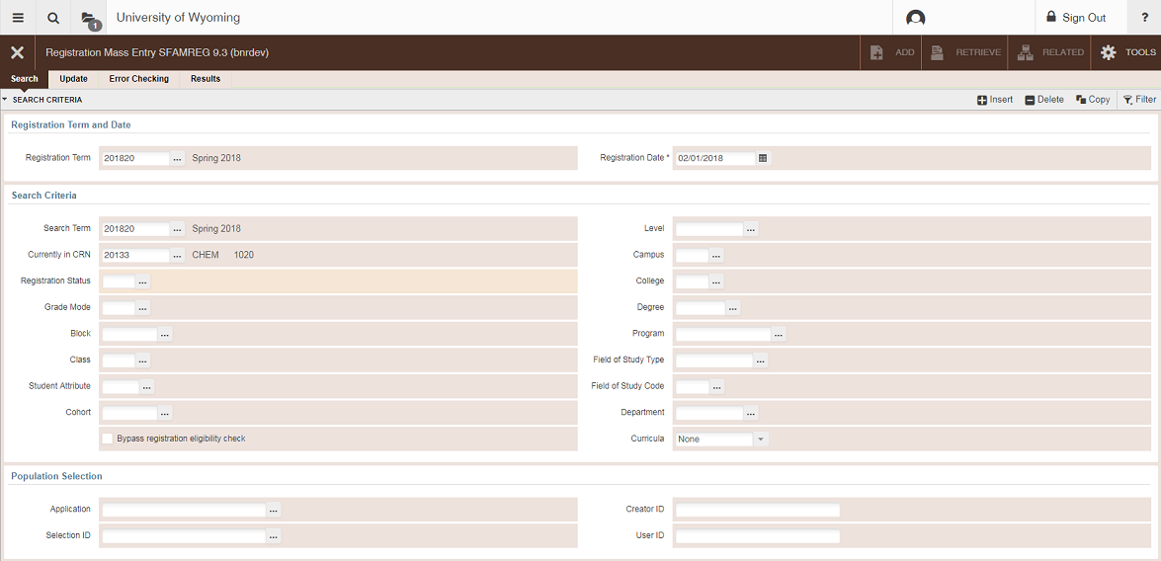
• Enter the CRN of the course that the students are currently in

Go to the Update tab
• Go to Registration Course Add Values
• Enter the CRN of the course you want to move students into
• Enter the Grade Mode for the course (L = letter grade)
• Go to Registration Course Drop Values
• Enter the CRN of the course you are moving/dropping students from
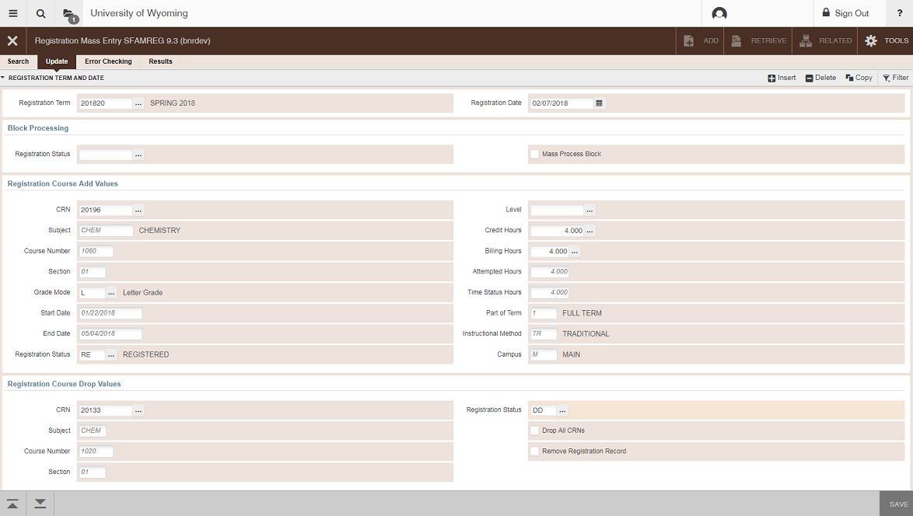
• Enter DD in the Registration Status field

Go to the Error Checking tab
• Click ‘No Check’ for all categories in the Student Options box.
• Find the ‘Holds’ option under Section Options on the right side of the screen.
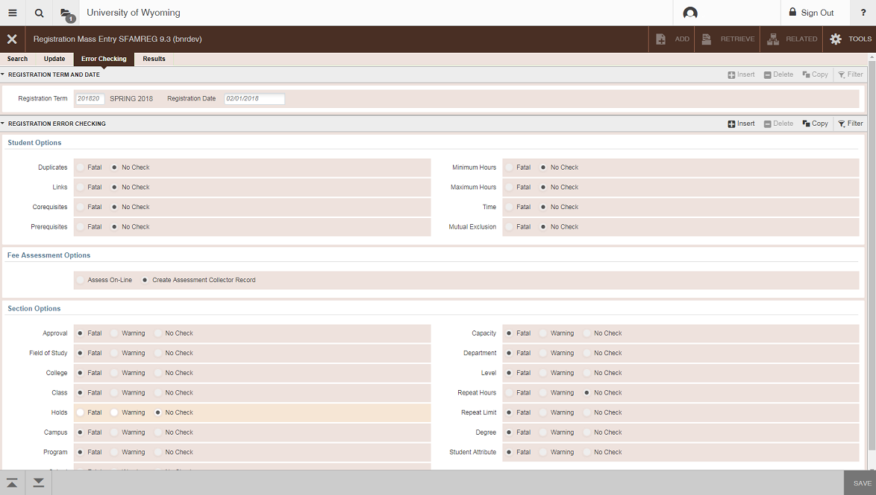
Click ‘No Check.’

Go to the Results tab
• Click ‘Select All’ next to Select Indicator
• Click Submit in the Submission box at the bottom of the screen
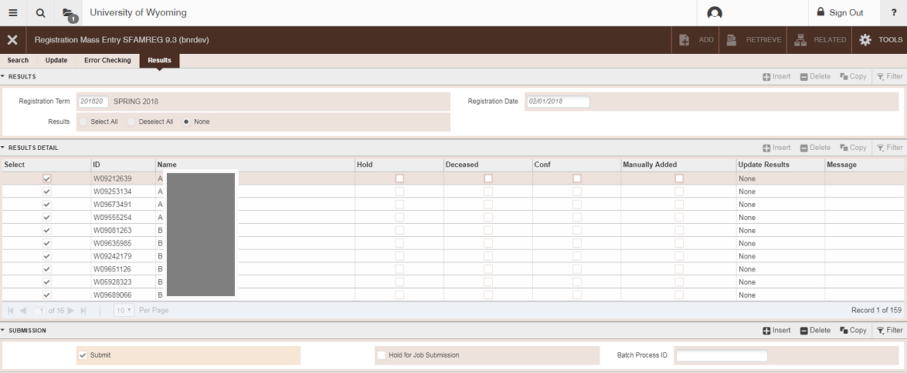
• Save. Once the process is complete, all students in the section will be dropped.

Once the process is complete, verify that all students have been moved by checking the course list on SFASLST.

You can also move a single student from one course to another. For example, if an undergraduate student has enrolled in a graduate-level course, and you would like to move the student into the appropriate section.
Go To… SFAMREG, press ENTER
• On the Search tab, enter the term
• Tab to Search Criteria
• Enter the term
• Enter the CRN of the course that the students are currently in
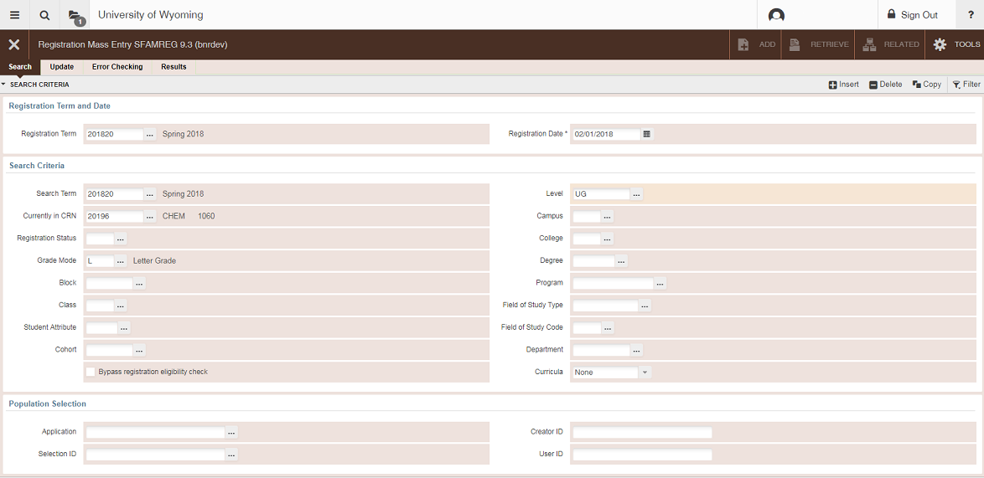
• Enter the level (UG, GR, etc.) of the student(s) you want to move
Go to the Update tab
• Go to Registration Course Add Values
• Enter the CRN of the course you want to move students into
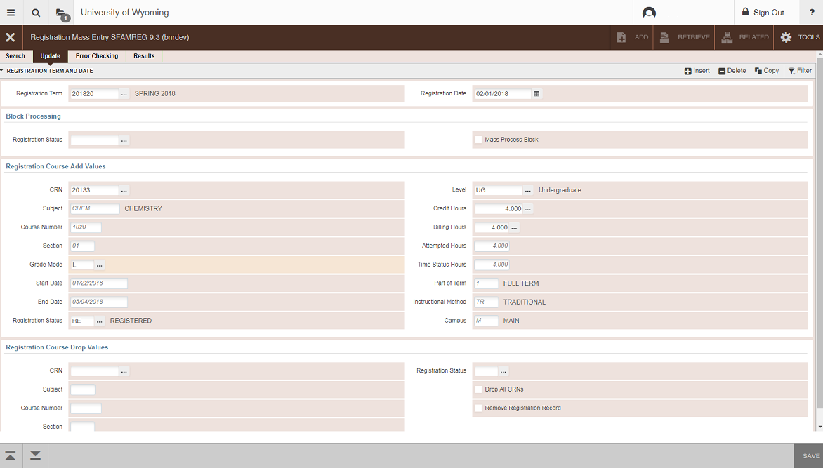
• Enter the correct level (UG, GR) for the student(s)
• Enter the Grade Mode for the course (L = letter grade)

In the Registration Course Drop Values box:
• Enter the CRN of the course you want to drop the student(s) from (the course of current enrollment)
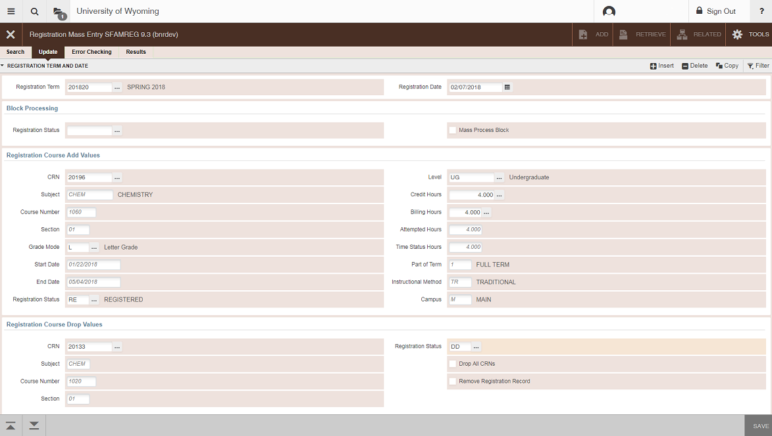
• Enter DD (Drop/Delete) in the Registration Status field

Go to the Error Checking tab
• Click ‘No Check’ for all categories in the Student Options box.
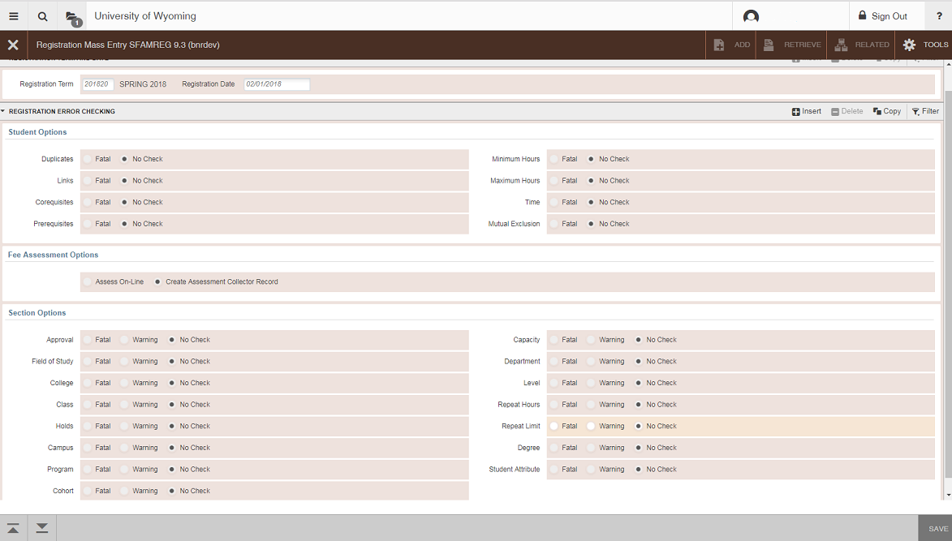
• Click ‘No Check’ for all categories in the Section Options box

Go to the Results tab
• Click ‘Select All’ next to Select Indicator
• Click Submit in the Submission box at the bottom of the screen
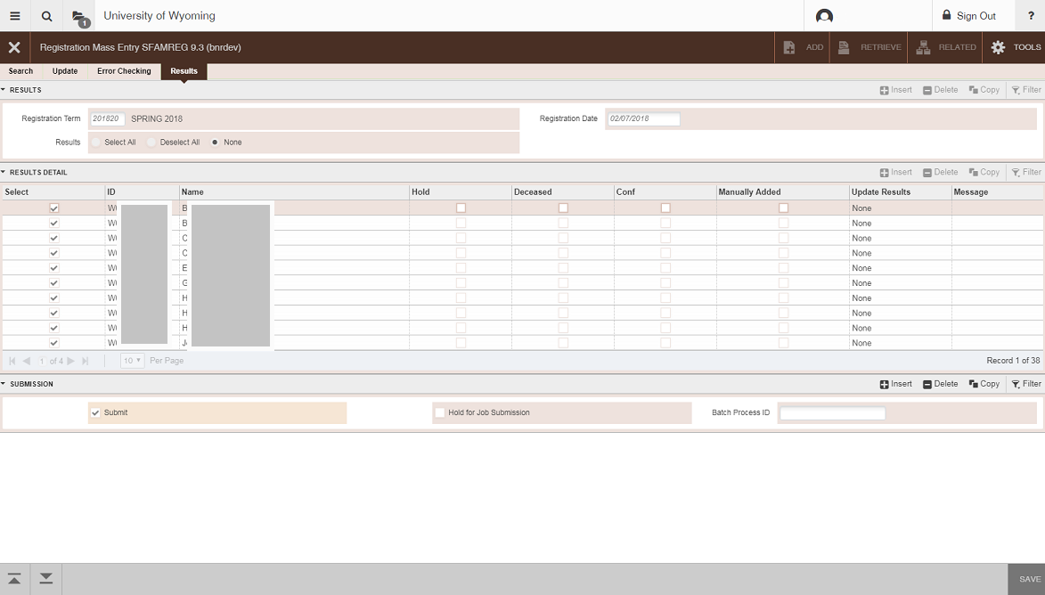
• Save. Once the process is complete, all students in the section will be dropped.

Once the process is complete, verify that all students have been moved by checking the course list on SFASLST.
PERC Number

Form Name: SPAAPIN
• From Term: Enter the term for which you need the PERC
• ID: Enter the student’s W Number
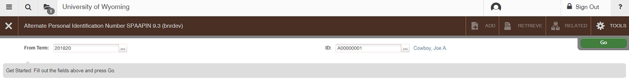
• Hit “Go” (Alt, Page Down)
• The student’s PERC number is listed in the Alternate PIN column. If no PERC
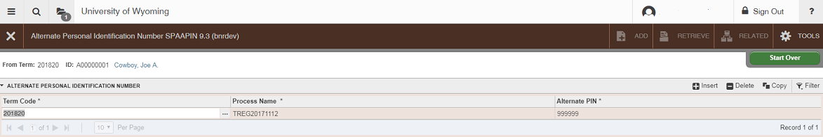
is listed, contact the Office of the Registrar.

Registration Date and Time

Go to: SFARGRP
• ID: Enter the W Number for the student
• Term: Enter the registration term code
• Perform a Next Section (Alt, Page Down)
• Registration Groups are assigned by student classification in the following order
o Graduate Students, Athletes, Students with Disabilities, Pharm-D and Law
o Seniors
o Freshmen
o Juniors
o Sophomores
o By the last digit of their student W number (the priority of this number is changed each semester)
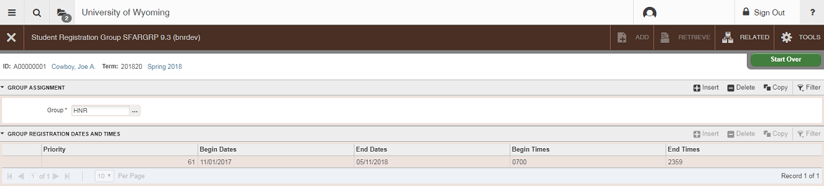

Changing an Advisor

Go to: SGAADVR
• ID: Enter the student’s W Number
• Term: Enter the term in which the change will become effective
• Perform a Next Section (Alt, Page Down)
• If changing an advisor for the current term, if the term at the top of the page matches the From Term
o Remove the incorrect advisor (Delete icon, or Shift + F6)
o SAVE your changes by pressing F10 or clicking the Save icon
o Enter the W Number of the new advisor
o Indicate the Advisor Type (MAJR, MINR)
o SAVE changes by pressing F10 or clicking the Save icon
• Indicate which advisor is Primary by clicking in the Primary Indicator box.
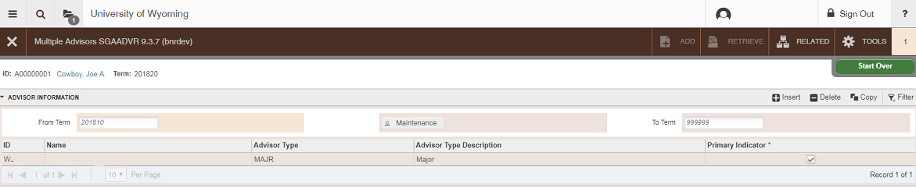
o Note: only one advisor can be listed as Primary.

If changing an advisor for a term other than the one listed in the From Term field, click on the Maintenance button (above the Advisor Type field)
• ID: Enter the student’s W Number
• Term: Enter the term in which the change is to become effective
• Perform a Next Section (Alt-Page Down)
• Click on the Maintenance button (above the Advisor Type field)
• Click on End Advisor in the dialogue box
• Perform a rollback (F5 or click the Start Over button)
• Perform a Next Section (Alt-Page Down)
o The new effective term will now appear in the From Term field
• Enter the W number of the new advisor
• Enter the advisor type
• Indicate Primary Advisor
o Note: only one advisor can be listed as Primary.
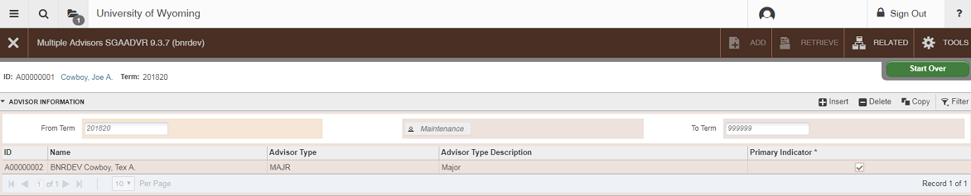
• Save changes by clicking the SAVE icon or pressing F10.

Finding an Advisor’s W Number

Go to: SIAIQRY
This query screen will allow you to search for instructor or advisor W numbers
• Term: Enter the most current registration term
• Click on either Faculty or Advisor, based on the information you need
• Perform a Next Section (Alt, Page Down or click the Go button)
• Click the “Add Another Field …” dropdown and click Last Name.
o Type in the last name of the instructor or advisor
o This field is case sensitive, so be sure to capitalize the first letter
o For a hyphenated name, type in the first part, followed by %
• Leave all other fields empty
• Press F8 to execute a query
• A list of names will appear
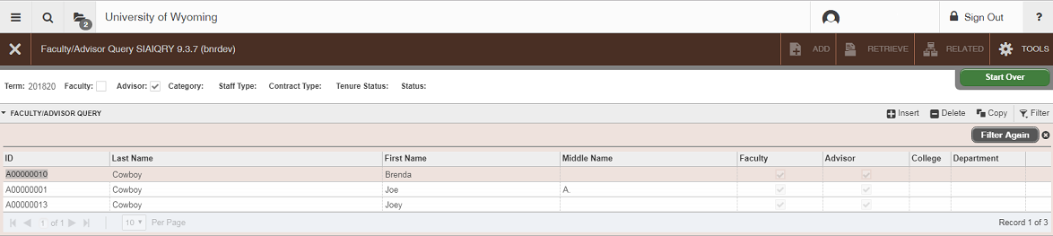
o Choose the correct name and either double-click on it, or highlight the name and press Alt + S

Checking for Student Holds

Go to: SOAHOLD
• ID: Enter student’s W Number or name
• Perform a Next Section (Alt, Page Down)

Active holds are those holds that have a To: date later than the current date.

Note: The Student Medical Hold is active for all domestic students who have not made a selection regarding the UW Student Medical Insurance coverage. Students can clear this hold by making an Insurance selection on WyoWeb.

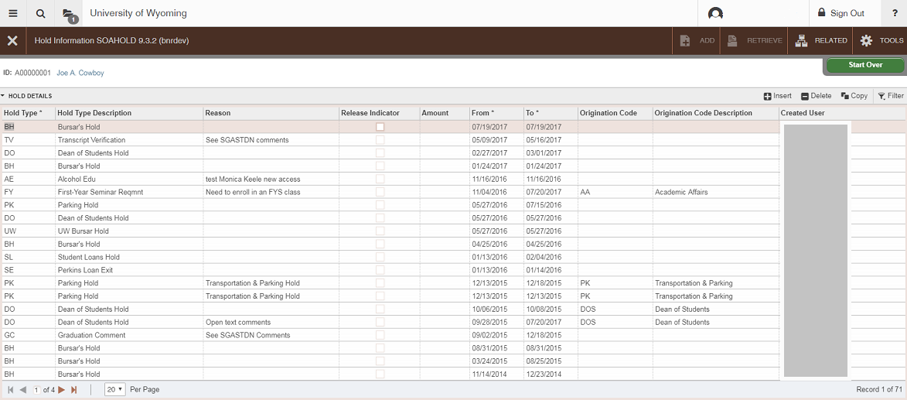
You will NOT be able to register any student who has an active hold on their account.

Finding a Student’s W Number

If you do not know the student’s W number, you can perform a search from any student-related screen.
• Next to the ID field, click the the “…” button.
• Choose “Person Search (SOAIDEN)”
• From the “Add Another Field …” dropdown select a search field
• Enter the search criteria depending on the field selected, % can be used as a wildcard
• A list of options will appear
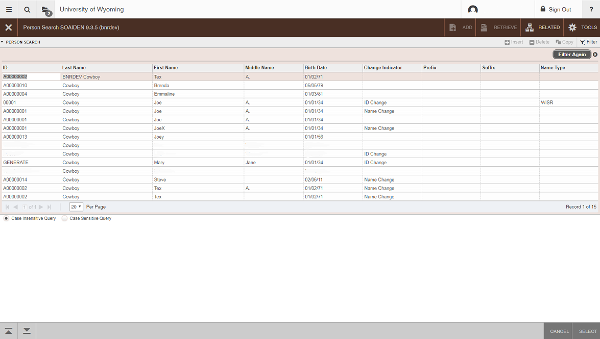
o Choose the correct student from this list, choose “Select” in the bottom right

