Office of the Registrar
Dept 3964, 1000 E. University Avenue • Laramie, WY 82071-3964
(307) 766-5272 • fax (307) 766-3960 • email: registrar@uwyo.edu • www.uwyo.edu/registrar

TO: UW Faculty Members
FROM: Lane Buchanan, Registrar
DATE: October 14, 2016
SUBJECT: Mandatory Mid-Term Grades: Due Wednesday, October 26, 2016 at 12 pm

Grade submission for fall 2016 midterm grades is now available through WyoWeb. The following is included in this memo:
- information about midterm grades
- directions for submitting midterm grades
- information about assistance in grade submission

Also please note that even if you entered Early Alert grades for your classes, it is still mandatory to enter midterm grades.

A partial screenshot of entering midterm grades follows:

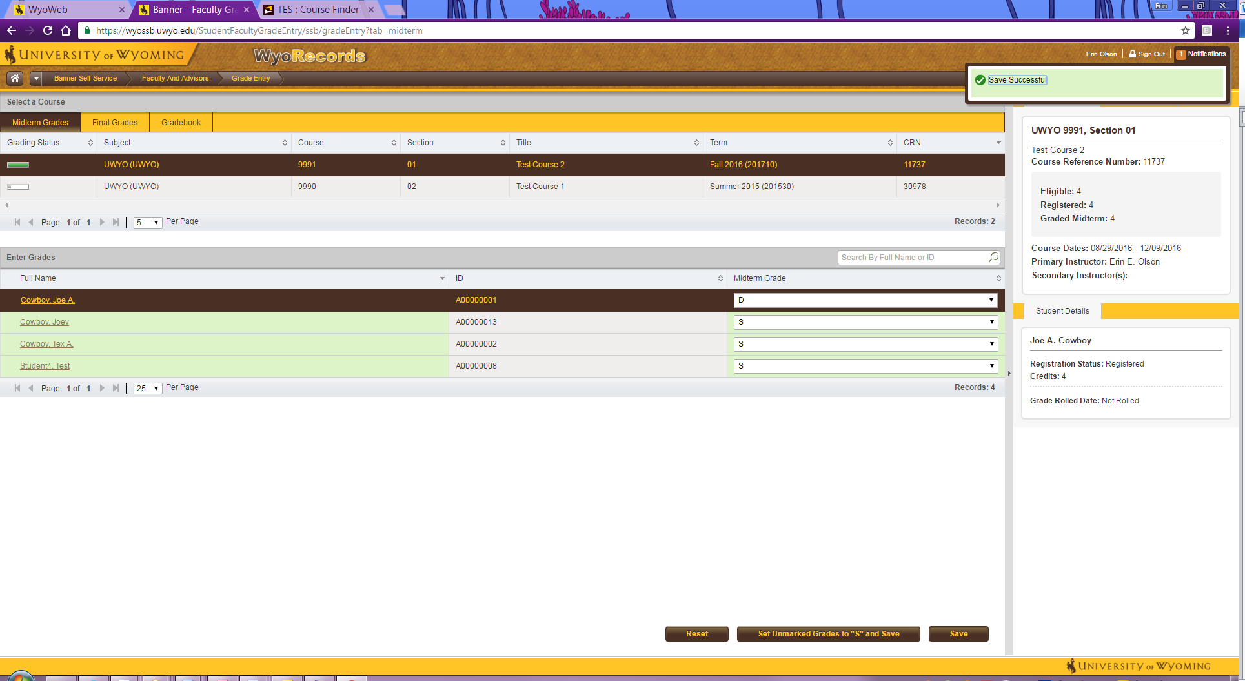
When Eligible and Graded Midterm are the same value, all midterm grades have been entered for this course.

Midterm Grades Tab
Click on Course you are grading
Enter D, F, U grades
Click on Set Unmarked Grades to “S” and Save

- Midterm Grade Information

UW Regulation 6-722 mandates the reporting of midterm grades for all courses numbered below 5000 for main campus, outreach and online courses. Please note that the reporting of midterm grades in courses numbered 5000 and above is optional. Midterm grades serve three purposes:

- To alert students to their academic progress
- To provide instructors with up-to-date official class enrollments
- To provide students with their official course enrollments

UW Regulation 6-722 indicates that the following grades may be assigned at midterm:

S = Satisfactory (equivalent to a C or better [B or better in courses numbered 5000 or above]; may be assigned only in courses designated S/U or in courses which the student has requested S/U)
D = Poor
F = Failure (may be assigned as a grade for failure to attend, for academic dishonesty, or to indicate failure to formally withdraw)
U = Unsatisfactory (equivalent to a D or F [C, D, or F in courses numbered 5000 or above]; may be assigned only in courses designated S/U or in courses which the student has requested S/U)
UK = Unable to determine midterm grade
NONE=Automatically assigned by the registrar’s office when a grade is not reported

The grade report accessible by students contains the statement “The mid-semester grade received in any particular class reflects the assessment of student performance during the first portion of the semester only.”

2. How to submit Midterm Grades through WyoWeb

- Go to WyoWeb - https://wyoweb.uwyo.edu/
- Click on the Faculty & Staff link in the WyoRecords column (The 2nd of 4 columns with gold headers)
- Log in
- Select Midterm Grades under ‘Quick Links’ on the upper left-hand side of the page
- Select course to grade
- Enter the grades by either typing the correct grade in the grade box to the right of the student or by using the drop-down arrow to select the grade. Note: You only need to manually-enter grades of D, F, or U.
  - You may upload grades from a spreadsheet. See “Uploading Final Grades from Excel” at http://www.uwyo.edu/registrar/faculty_and_staff/ for instructions with screenshots.
- Once all D, F, and U grades have been entered, use the

You may submit numerous times. You may enter grades for all or a portion of the students in your class. You may update midterm grades for courses that were previously graded up until the deadline for submission of midterm grades – October 26th.

- Assistance with Grade Submission

If you need assistance submitting your grades through WyoWeb, please contact the Office of the Registrar 766-5272 or stop by our office in the west wing of Knight Hall
Note: Students may withdraw from individual courses through WyoWeb until 11:59 p.m. Friday, November 11, 2016.
Please do not hesitate to contact our office with any questions.

Your cooperation is appreciated!

