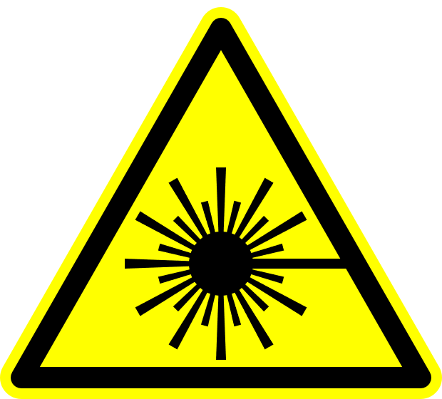

**WARNING**

**!**

**Class 4 Laser Controlled Area**

**AUTHORIZED PERSONNEL ONLY**

**Avoid eye or skin exposure to direct or scattered radiation.**

**Laser eye protection required: OD ≥ 5 @ 532 nm**

**Freq. Doubled Nd:YAG laser, 532 nm**

**10 watts maximum average power**

**Laser Supervisor: Phone:**

**Laser Safety Officer:** Jim F. Herrold **Phone:** 766-2638