How to Use Inspire Teaching and Learning
- Go to https://www.inspireteaching.org/
- Click Online Learning Portal
- Scroll down and click Register Now For Free
- Once you’re logged in, go to Inspire

- Use the Implementation Resources
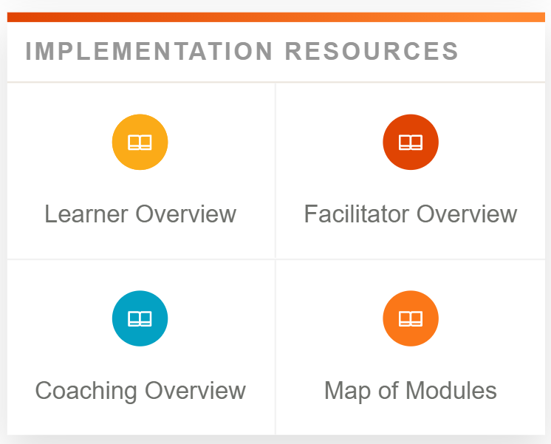
- Select a Pathway or search for a Module
- Module resources:
  - Certificate of Completion
  - Transcripts
  - Coaching Guide – has discussion questions!

