Mentor Teacher Modules Information-Hand out
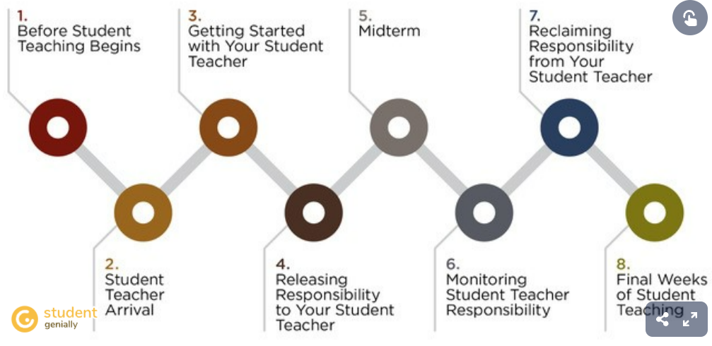
The modules follow a chronological path of the student teacher’s semester. Each module follows a specific section of that timeline and is broken down into the following sections:
- Relationship Building
- Collaborative Planning & Teaching
- Observation
- UW Logistics
These sections include videos, interactive lessons, and activities along with resources and contact information that correspond to the student teaching timeline of that module.
This course is free for all mentor teachers just by signing up.
To access the mentor teacher support and development course please click on the link below.
https://uwyo3.catalog.instructure.com/
WyoLearn - Instructure
The Malcolm Wallop Civic Engagement Program was launched in 2017 to support three program areas – funding student research/internships, faculty engagement projects, and community event programming.
uwyo3.catalog.instructure.com
Once there click on the continuing education block.
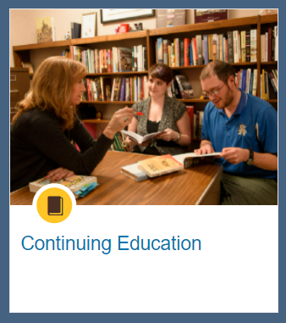

Then click on the course.
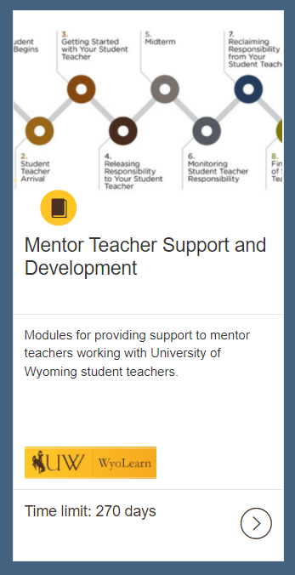
It will ask you to provide a name and email address.
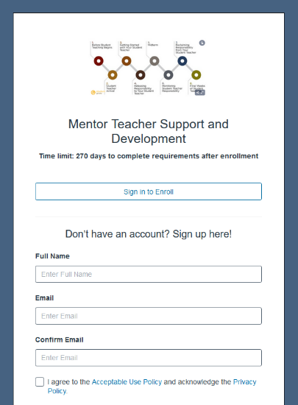
Once you have provided that you should be able to access all the materials.

Office Hours Information
Held every Wednesday from 3-4 PM via zoom.
Zoom Link: https://uwyo.zoom.us/j/93550828682
These hours are held for mentors and supervisors who have questions or concerns specifically related to student teaching during the semester.
I am also available via email or phone.
Email: emcmaha2@uwyo.edu
Phone Number: 307-766-6385
Create powerpoint to show while presenting

