How to get PTSB Credit for doing an Inspire Module
- Log in to Inspire: https://mylearningportal.org/
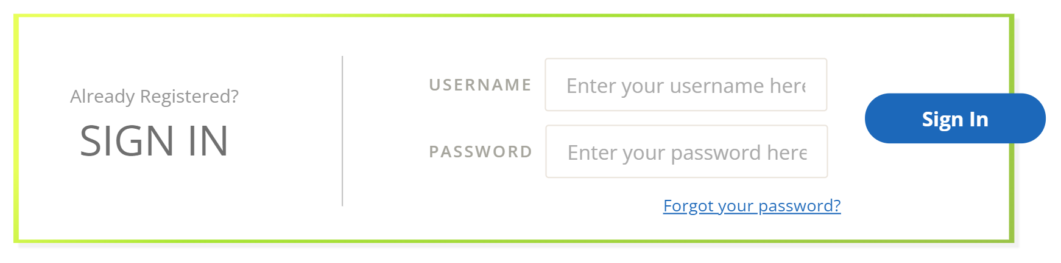

- Go to My Reports

- Select the Completed tab
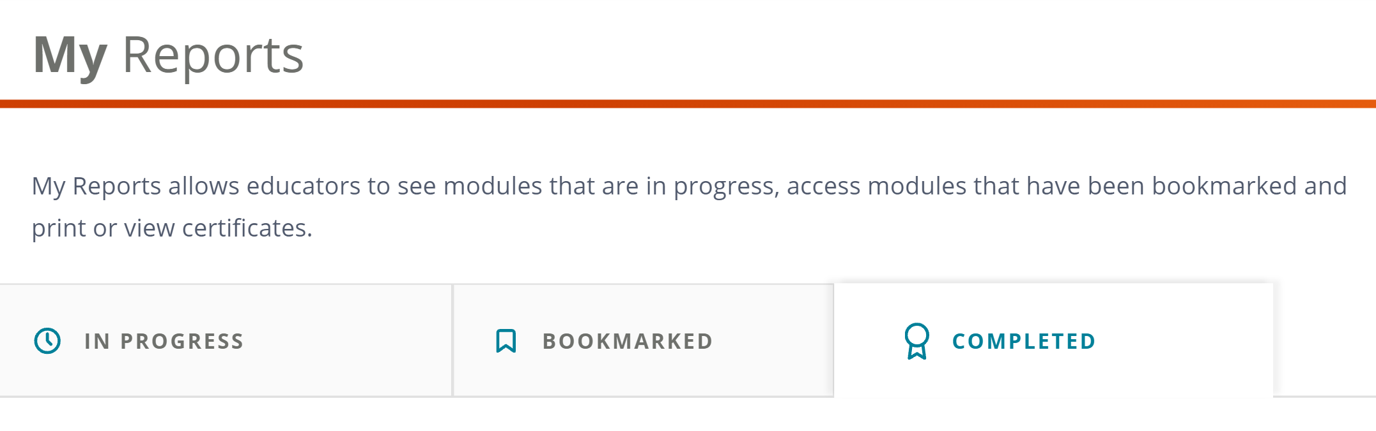

- Pick the module you want and click on “View Certificate”
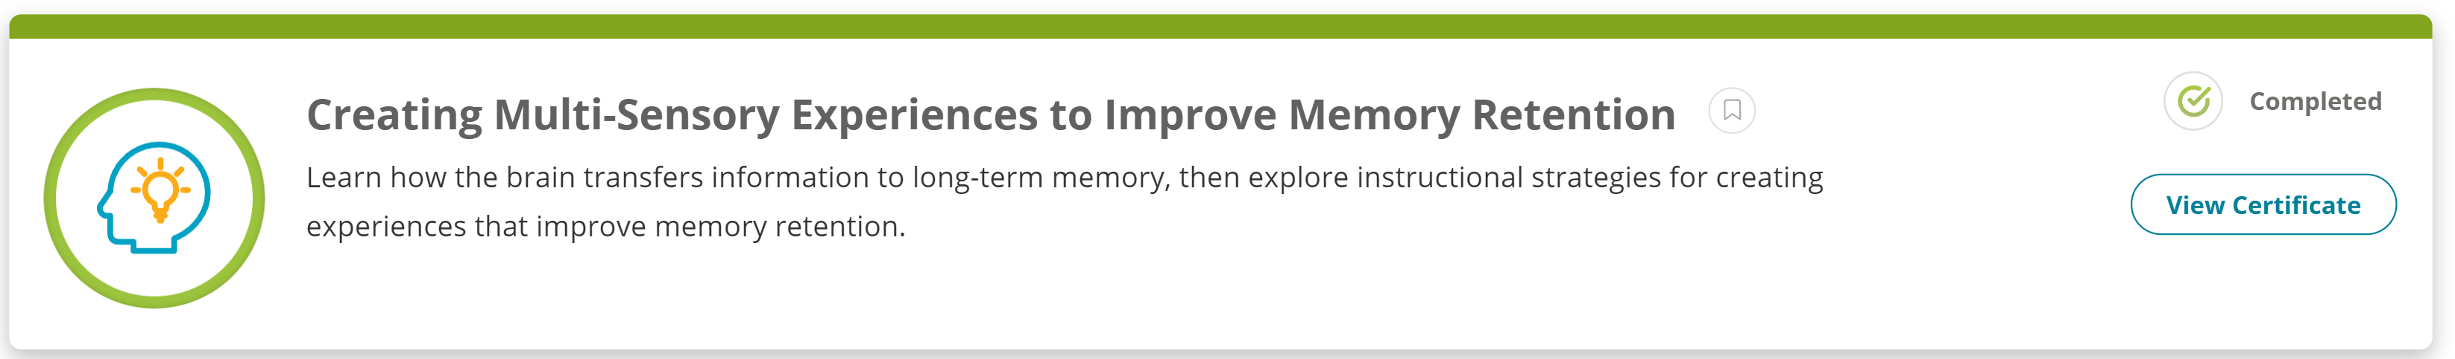

- Download the certificate as a PDF
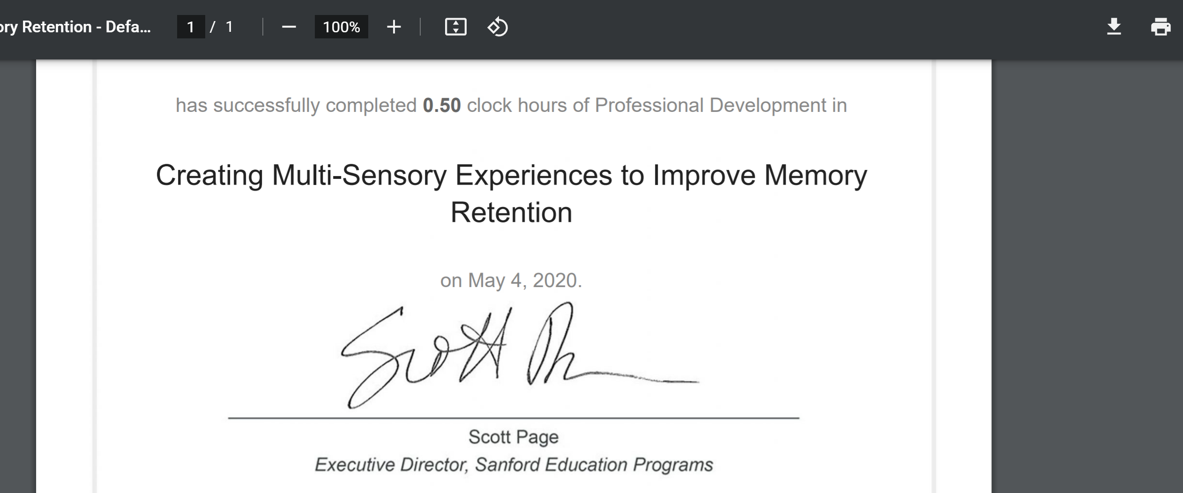

- Each module is worth 0.5 or 1 clock hour. Credits from PTSB available for the following amounts:
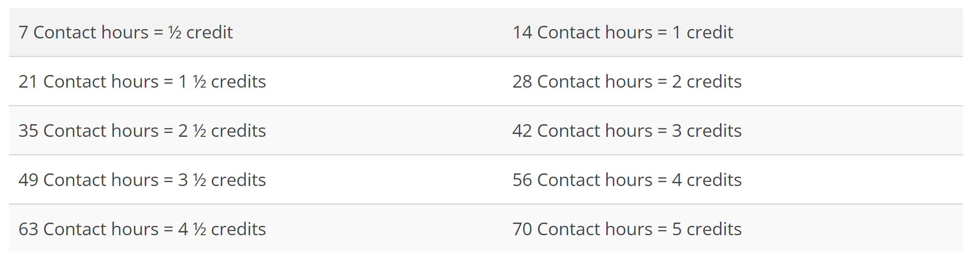

- After you’ve completed 7 clock hours (or any of the above time increments), compile your certificates and send them to ptsbworkshoprequests@wyo.gov with your name and PTSB number. They will then be added to your file.

