Potential Team Practicums

The following are potential practicums that could be used in the Team Activity portion of the contest. For each practicum the contestants will be given the “Scenario” however the full “Criteria” will only be provided to the judges when applicable.

List of Current Practicums

* Artificial Insemination
* Artificial Insemination vs Live Cover Cost Analysis
* Bandaging
* Bovine Pregnancy Check
* Cuts of Meat Identification
* Ear Notching
* Electric Fence Building
* Foot Rot Treatment
* Halter Tying
* Medication Injection
* Parts of the Pig Identification
* Parts of the Lamb Identification
* Sheep Aging



**Scenario**

Today is Artificial Insemination (AI) day on the ranch where you and your friends are helping work cattle. This year you will take a more active role in the process and each team member will be assigned a role.

**Each contestant must do one of the following tasks**

* Prep and Load AI Gun for the Angus Cow
* Follow AI Procedure for the Angus Cow Additional resources:<https://www.youtube.com/watch?v=E0Q6zZCvMpI>
* Prep and Load AI Gun for the Hereford Cow
* Follow AI Procedure for the Hereford Cow

|  |  |  |
| --- | --- | --- |
| **Criteria** | **Points**  **Possible** | **Points**  **Earned** |
| Team works together to assign each individual a task | **9** |  |
| **Prep and Load AI Gun**: Follow the steps outlined to properly load an AI gun   * Remove the correct semen straw from tank **(1pt)** * Place straw in warming bath for 30 to 60 secs **(1pt)** * Warm AI gun to body temp **(1pt)** * Take straw out of water dry with paper towel **(1pt)** * Use sidle cutter to remove the tip of the semen straw (opposite cotton plug) **(1pt)** * Insert straw into sheath keeping the cow end of the sheathsterile **(1pt)** * Insert AI gun (at Body Temp) into the straw/ sheath **(1pt)** * Push straw and gun to the top of the sheath making sure not to depress plunger or remove sterile packaging **(1pt)** * Lock the gun **(1pt)** * Keep gun warm and sheath sterile until ready to be used **(1pt)** |  |  |
| Angus Cow (10 total), Hereford Cow (10 total) | **20** |  |
| **Follow AI Procedure:** Identify key landmarks in the female reproduction system and the follow the steps outlined below for AI procedure:  ~ Vagina **(1pt) ~** Cervix **(1pt) ~** Uterine Horn **(1pt) ~** Bladder **(1pt)** | **4** |  |
| I Procedure   * Apply palpation glove and (pretend) lube **(1pt)** * Remove feces from digestive tract **(1pt)** * Insert the AI gun into the vagina and locate rectally with opposite hand **(1pt)** * Locate cervix **(1pt)** * Manipulate and pass the AI gun through the cervix **(1pt)** * Deposit Semen **(1pt)** |  |  |
| Angus Cow (6 total), Hereford Cow (6 total) | **12** |  |
| Judges Questions | **5** |  |
| Total Score | **50 pts.** |  |



**Scenario**

You and your team run a moderate sized cow calf operation with 100 cows and 15 first time heifers. You are trying to determine if it will be more cost effective to purchase bulls for live cover or use artificial insemination to breed your females (leasing bulls is not an option for your operation). Using the information below answer the following questions.

|  |  |  |  |  |
| --- | --- | --- | --- | --- |
| **Live Cover Costs** | |  | **Artificial Insemination Cost** | |
| Average purchase price of bulls | $2,750/ head | Drug cost for Synchronization | $15/ head |
| Salvage value of bulls | $1,700/ head | Semen cost | $25/ straw |
| Useful life of bulls | 3 years | Technician cost | $10/ head |
| Annual bull maintenance | $650/ head | Semen tank cost | $950/ 20 yrs |
| Bull to cow ratio | 1:25 | Liquid Nitrogen | $30/ month |

* 1. Determine how much it will cost you for live cover per year knowing that you will own the bull for multiple years and expecting your herd size to stay the same. Be sure to include a risk of loss factor using the following formula: 0.2[(Average Purchase Price of Bull + Salvage Value)/2]. **(15 points possible)**

|  |  |  |
| --- | --- | --- |
|  | Per Bull | Per Year |
| Bulls needed is (cows + heifer) times bull to cow ratio  (100 + 15)/25 = 4.6 = 5 |  | (Per bull x 5) |
| Bull Cost is (Purchase-Salvage)/years of use  (2750-1700)/3 | $350 | $1750 |
| Maintenance | $650 | $3250 |
| Risk of loss 0.2[(Avg Price of Bull + Salvage Value)/2] 0.2[(2750+1700)/2]  0.2(4450/2)  0.2(2225) | $445 | $2225 |
| **Total** | **$1445** | **$7225** |

* 1. Determine the cost of AI per year for the next three years. **(15 points possible)**

|  |  |  |
| --- | --- | --- |
| Drug cost for Synchronization | $15/ head | $1725 |
| Semen cost | $25/ straw | $2875 |
| Technician cost | $10/ head | $1150 |
| Semen tank cost | $960/ 20 yrs | $48 |
| Liquid Nitrogen | $30/ month | $360 |
| **Total** |  | **$6158** |

* 1. Based on the values found in answers 1 and 2 what is the more cost effective route for your operation. **(5 points possible)**
     1. Artificial insemination is cheaper by 1,067
  2. Verbally explain to your stake holders which direction you would like to take your operation and why? **(10 points possible)**
     1. Feel free to be creative in your answers. You can choose not to go with the cheapest route as well especially if you explain your reasoning!
  3. Judges questions **(5 points) Total Score 50 pts.**

# TEAM PRACTICUM



**Scenario**

You and your team work in a small community vet clinic and you have been called out on a farm check. Once you arrive, the ranch hand tells you that he has two injured sheep that need attention. The first is a 3-year-old ewe that cut both of her front legs on some barbed wire fencing. The large animal veterinarian from your clinic has already been out to suture and treat this ewe when she was injured and now the bandages need to be removed. The second sheep is a yearling ram that was bitten by a neighbor’s dog. Your clinic’s veterinarian has already treated this buck as well, since then the ram has managed to tear off the bandages and re-open the wounds.

**You and your team must split into pairs and treat the two sheep at the same time. One sheep needs bandages removed on two legs while the other needs re-bandaged on two legs. Decide which team member will do each leg on each animal. Note your animal’s ID number and what treatment was performed on each animal in the “Animal Record”. Be sure to include the Contestant #s for both members that worked on the same sheep. The team that removes bandages will be given bandage scissors and gloves and will be graded on their removal technique. The team that applies bandages will be given gloves, cleaning supplies, and fresh bandages and will be graded on their application.**

|  |  |  |
| --- | --- | --- |
| **Criteria** | **Points Possible** | **Points Earned** |
| Team works together (with equal effort) to determine what each team member does, and all participate in the scenario. | **5** |  |
| Note the treatment that was performed on each sheep in the “Animal Record”. | **10** |  |
| Cleans up work area. | **5** |  |
| Gently swipe the area clean with fresh gauze soaked in a chlorhexidine solution  (clean the wound up and down, then side to side, then in circles) before patting dry with dry gauze. | **5** |  |
| Unroll the Vet-Wrap in a loose roll around hand and cut to appropriate length. Apply fresh gauze to the wound and gently wrap over the wound and gauze with  unrolled Vet-Wrap. Should be able to fit two fingers comfortably between the animal’s leg and bandaging tape. | **10** |  |
| Keep the bandage scissors’ blade flush against the leg and keep the tip raised  upward in contact with the bandage. | **5** |  |
| Gently cut the bandages away from the leg and remove old bandages and gauze. | **10** |  |
| **Total Score** | **50 pts.** |  |



**Scenario**

You recently attended a beef workshop with your teammates learning how to preg test cows. Your neighbor has a small herd and would like your team to come practice on his herd and preg. test his cows.

**With your team, plan out a procedure to check the cow for pregnancy. Then, once your procedure is planned, each member of your team must use the palpation dummy to check the cow for** pregnancy. Use proper gloving while palpating. You will be scored on how you determine the cow’s

pregnancy and your teamwork as a group.

|  |  |  |
| --- | --- | --- |
| **Criteria** | **Points Possible** | **Points Earned** |
| Your team works together (with equal effort) to create a procedure. | **5** |  |
| All team members participate in the palpating. | **5** |  |
| Each student calls the cow correctly pregnant or open. | **20** |  |
| Each student demonstrates correct gloving technique. | **10** |  |
| **Follow AI Procedure:** Identify key landmarks in the female reproduction system and the follow the steps outlined below for AI procedure:  ~ Vagina **(1pt) ~** Cervix **(1pt) ~** Uterine Horn **(1pt) ~** Bladder **(1pt)** | **5** |  |
| Judges Questions | **5** |  |
| **Total Score** | **50 pts.** |  |



|  |  |  |  |  |  |  |
| --- | --- | --- | --- | --- | --- | --- |
| Requirements | Points Available | Points Received |  | Requirements | Points Available | Points Received |
| Equal Participation | 10 |  | Rump Roast | 2 |  |
| Arm Pot Roast | 2 |  | Shank Cross Cut | 2 |  |
| Blade Roast | 2 |  | Short Ribs | 2 |  |
| Bottom Round | 2 |  | Skirt Steak | 2 |  |
| Flank Steak | 2 |  | T-Bone Steak | 2 |  |
| Mock Tender Roast | 2 |  | Tenderloin Steak | 2 |  |
| Petite Tender | 2 |  | Tip Steak | 2 |  |
| Porter House Steak | 2 |  | Top Sirloin Steak | 2 |  |
| Ribeye Roast | 2 |  | Tri-Tip Roast | 2 |  |
| Ribeye Steak | 2 |  | Whole Brisket | 2 |  |
|  |  |  | **Total Score** | **50pts.** |  |

**Scenario**

Together with your team you will correctly ID the following cuts of the beef (next page)

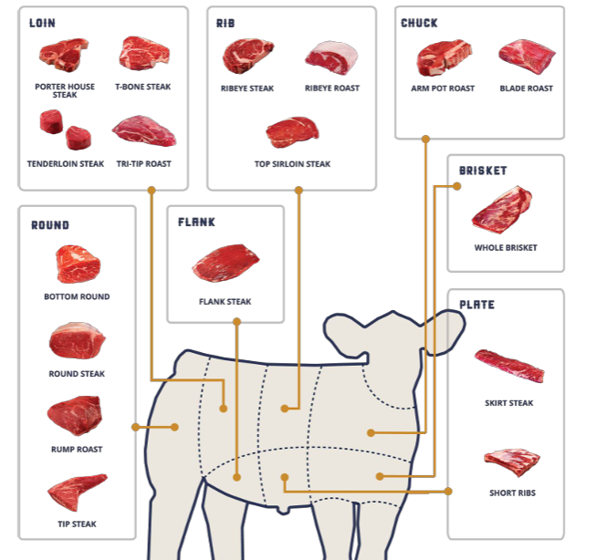



**Scenario**

You are students who are helping a producer move pigs out of the crate and into nursery. The producer uses notching as the primary means of identification.

**Part 1 -** Three student will notch one pig based on the breeder’s information.

**Part 2 -** After working in the nursery your team goes and take a look at the show pig prospects and each identify one hog you would like your advisor/ 4-H Leader to take a look at while you’re at school next week.

|  |  |  |  |
| --- | --- | --- | --- |
| **Part 1 - Each member will ear notch a piglet based on the information provided - examples** | | | |
| Piglet 1 | 7th born in the 4nd litter |  |  |
| Piglet 2 | 10th born in the 5rd litter |  |  |
| Piglet 3 | 11th born in the 3rd litter |  |  |
| Piglet 4 | 2nd born in the 9th litter |  |  |
| **Part 2 - Three members will correctly read and label a prospect hog’s ear notches- examples** | | | |
| Hog 1 | Hog 2 | Hog 3 | Hog 4 |

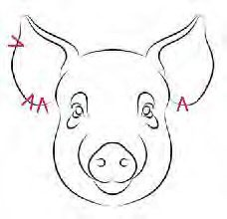 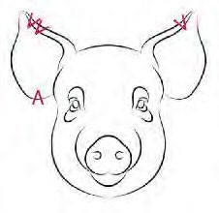 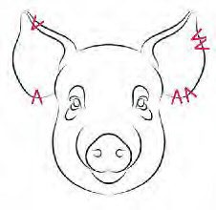 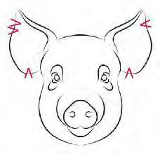

|  |  |  |
| --- | --- | --- |
| **Criteria** | **Points Possible** | **Points Earned** |
| Team works together (with equal effort) to determine what each team member does and all participate in the scenario. | **10** |  |
| Three team member correctly notches the appropriate piglet. | **15**  **(5/ea)** |  |
| Three team member correctly identifies the appropriate prospect hog. | **15**  **(5/ea)** |  |
| All Items are cleaned and returned to their proper places. | **5** |  |
| Judges questions | **5** |  |
| **Total Score** | **50 pts.** |  |



**Scenario**

The local fencing company is short-handed and has hired your team to build an electric fence. The equipment has all been purchased and part of the fence had been started but it needs to be completed. The business owner must run to town to pick up more equipment and your job is to finish building this 3 wire electric fence to completion. In order to get paid the fence must work after you have completed it

|  |  |  |
| --- | --- | --- |
| **Criteria** | **Points Possible** | **Points Earned** |
| Team works together (with equal effort) to determine what each team member does and all participate in the scenario. | **5** |  |
| Place unit on fence post | **5** |  |
| Connect 3 grounding rods in the ground | **5** |  |
| Attach Grounding wire to unit using clamps | **5** |  |
| Run 3 lines of electrical fencing the length of the posts | **5** |  |
| Stretch and attach lines | **5** |  |
| Connect the 3 wires with 10 -14 ga wire | **5** |  |
| Run insulated wire from the top wire to the control panel | **5** |  |
| Check fence line, then ask the rancher to turn on the charger | **5** |  |
| Judges questions | **5** |  |
| **Total Score** | **50 pts.** |  |



**Scenario**

You’re family has a small flock of Dorset sheep. While you are out feeding for the night, you notice three of your sheep displaying signs of lameness. After further examination of the sheep, you find that in the interdigital cleft (the space between the two claws of a cloven-hoofed animal) there is a grey pasty scum, separation of horn around heel, sole and toe, along with inflammation. You recognize this to be Dichelobacter nodosus (or footrot). Of the affected sheep, one is pregnant and one is a market lamb headed to slaughter in 30 days. You’ve invited your friends to come help you decide which treatment option is the best for these three sheep. The sheep that are lame are:

|  |  |
| --- | --- |
| Sheep 1 | Pregnant with lambs, weighs 1805 lbs. |
| Sheep 2 | Market lamb heading to slaughter in 30 days, weighs 150 lbs. |
| Sheep 3 | Open and dry ewe, weighs 165 lbs. |

**Each member will evaluate one sheep and record in the “Animal Records” the course of treatment or health of animal. Two sheep will require treatment. Splitting into pairs use the label of the chosen treatment, calculate the correct dosage for each sheep’s weight, and the correct way to administer the treatment. Inform herdsmen of proper care and follow up.**

|  |  |  |
| --- | --- | --- |
| **Criteria** | **Points Possible** | **Points Earned** |
| Team works together (with equal effort) to determine what each team  member does and all participate in the scenario. | **5** |  |
| Note the treatment that was performed on each sheep in the “Animal Record”. | **15**  **(5/ea)** |  |
| Mix the solution in the correct ratio   * 9L water:1kg ZnSO4 10% Place effected area in the solution | **20**  **(10/ea)** |  |
| Tell the herdsmen the required soak time as well as the immediate after care   * 5-10 minutes soaking * 1 hour clean hard surface to dry | **5** |  |
| Judges questions | **5** |  |
| **Total Score** | **50 pts.** |  |

**Additional sources:**

* [https://www.lls.nsw.gov.au/ data/assets/pdf_file/0019/1263340/foot-bathing-fact-sheet.pdf](https://www.lls.nsw.gov.au/__data/assets/pdf_file/0019/1263340/foot-bathing-fact-sheet.pdf)



**Scenario**

You and the other youth from your county are getting ready to wash your sheep at the Wyoming State Fair. You have decided that the best course of action is to prepare your sheep to be washed is to tie them up at the wash rack on the west side of the sheep barn. It was decided that a quick release knot would work best. Often times this wash rack has to be shared with other species, so you want to ensure if your sheep is spooked you can untie it quickly. (To ensure that there is not a loose sheep running around the grounds use the extra steps)

**Three members of the team will need to tie a sheep up at an appropriate height and distance away from the fence. After the sheep has been tied, a team member will untie the halter. Each member of the team must contribute to either the tying or untying of the sheep**

|  |  |  |
| --- | --- | --- |
| **Criteria** | **Points**  **Possible** | **Points**  **Earned** |
| The correct knot was used | **15**  **(5/ea)** |  |
| The sheep is tied at an acceptable height and distance from the fence | **15**  **(5/ea)** |  |
| Youth were able to release the sheep quickly | **5** |  |
| The sheep were tied in a timely manner | **5** |  |
| All members of the team contributed to the practicum. | **5** |  |
| Judges questions. | **5** |  |
| **Total Score** | **50 pts.** |  |

**Additional sources:**

* <https://www.youtube.com/watch?v=fG6LiX10hlU>



**Scenario**

You run a small family sheep operation that consists of 40 Hampshire ewes and 20 Dorper. ewes and lambs. While you are out feeding for the night, you notice five of your sheep have diarrhea and seem to be extremely stiff and are limping. You recognize this to be White Muscle Disease. Of the affected sheep, one is pregnant, and one is a market lamb headed to slaughter in 30 days. The only appropriate medication you have on hand is Bo-Se, but you have enough needles and syringes to administer to the affected sheep immediately.

|  |  |
| --- | --- |
| Sheep 1 | Pregnant Hampshire ewe with lambs, weighs 180 lbs. |
| Sheep 2 | Market lamb heading to slaughter in 25 days, weighs 150 lbs. |
| Sheep 3 | Open and dry ewe, weighs 165 lbs. |
| Sheep 4 | Hampshire Ram, weighs 250 lbs. |
| Sheep 5 | Pregnant, Dorper ewe weighs 150 lbs. |

**Read the given label for Bo-Se and determine a treatment plan for your affected sheep. Using the Bo-Se label, calculate the correct dosage for each sheep’s weight and if the medication should be given subcutaneous, intramuscular, or intravenous. Write out your treatment plan in the “Animal Record”. Once you have determined a treatment plan, draw out the appropriate dosage of Bo- Se to give to each sheep. Each member of your team will dose one sheep.**

|  |  |  |
| --- | --- | --- |
| **Criteria** | **Points Possible** | **Points Earned** |
| Team works together (with equal effort) to determine the treatment plan. Each member contributes to treating one of the animals. | **10** |  |
| Determines an appropriate treatment plan for each sheep, including calculating  the appropriate amount of medication for each sheep. Note this treatment plan in the “Animal Record”. | **10** |  |
| Clean top of bottle with an alcohol wipe. Insert the appropriate air to the bottle of  Bo-Se before drawing out the correct amount into the syringe. Remove air from syringe and inject orange intramuscularly (at a 90-degree angle). | **20**  **(10/ea)** |  |
| Correctly recap and remove needle from syringe, then place in sharps container after use. | **5** |  |
| Judges Questions | **5** |  |
| **Total Score** | **50 pts.** |  |



**Scenario**

Together with your team you will correctly identify the following parts of the pig.

**Criteria**

|  |  |  |  |  |  |  |
| --- | --- | --- | --- | --- | --- | --- |
| Requirements | Points Available | Points Received |  | Requirements | Points Available | Points Received |
| Equal Participation | 5 |  | Jowl | 2 |  |
| Judges questions | 5 |  | Knee | 1 |  |
| Belly | 2 |  | Loin | 2 |  |
| Cannon | 2 |  | Neck | 2 |  |
| Chest | 2 |  | Pastern | 2 |  |
| Dew Claw | 2 |  | Rear Flank | 2 |  |
| Face | 2 |  | Rump | 2 |  |
| Feet | 1 |  | Shoulder | 2 |  |
| Forearm | 2 |  | Side | 2 |  |
| Fore Flank | 2 |  | Snout | 2 |  |
| Ham | 1 |  | Stifle | 2 |  |
| Hock | 2 |  | Tail | 1 |  |
|  |  |  | **Total Score** | **50 pts.** |  |

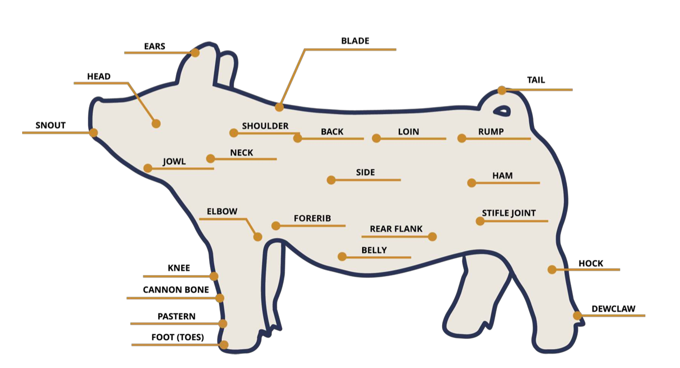



**Scenario**

You have a flock of 25 Suffolk ewes and it’s time for you to go off to college. Your parents have agreed to retain 90% of the flock after you leave, they feel a few less ewes to lamb out will help with barn space. The first cull criteria for the 10% will be based on age. Some of your records got wet in the barn and are destroyed, so you and your friends will have to physically age a group of your ewes to decide which ones to sell.

**You will be given a sample group from the flock. Each team member will use proper gloving technique and check the age of each of the ewes. Once the age has been determined, record the results in your “Animal Records”. Then specify which ewe if any that you will be culling. Using the scenario above determine how many total ewes from the whole flock will be culled.**

|  |  |  |
| --- | --- | --- |
| **Criteria** | **Points Possible** | **Points Earned** |
| As a team determine the total number of ewes that will culled from the flock | **5** |  |
| All ewes will be aged correctly, Members must do at least one. | **20**  **(4/ea)** |  |
| Each team member records the ewe’s age in the “Animal Records” | **15**  **(3/ea)** |  |
| Correctly determine which ewe should be culled | **5** |  |
| Judges questions | **5** |  |
| **Total Score** | **50 pts.** |  |

