Major Matthew Clark
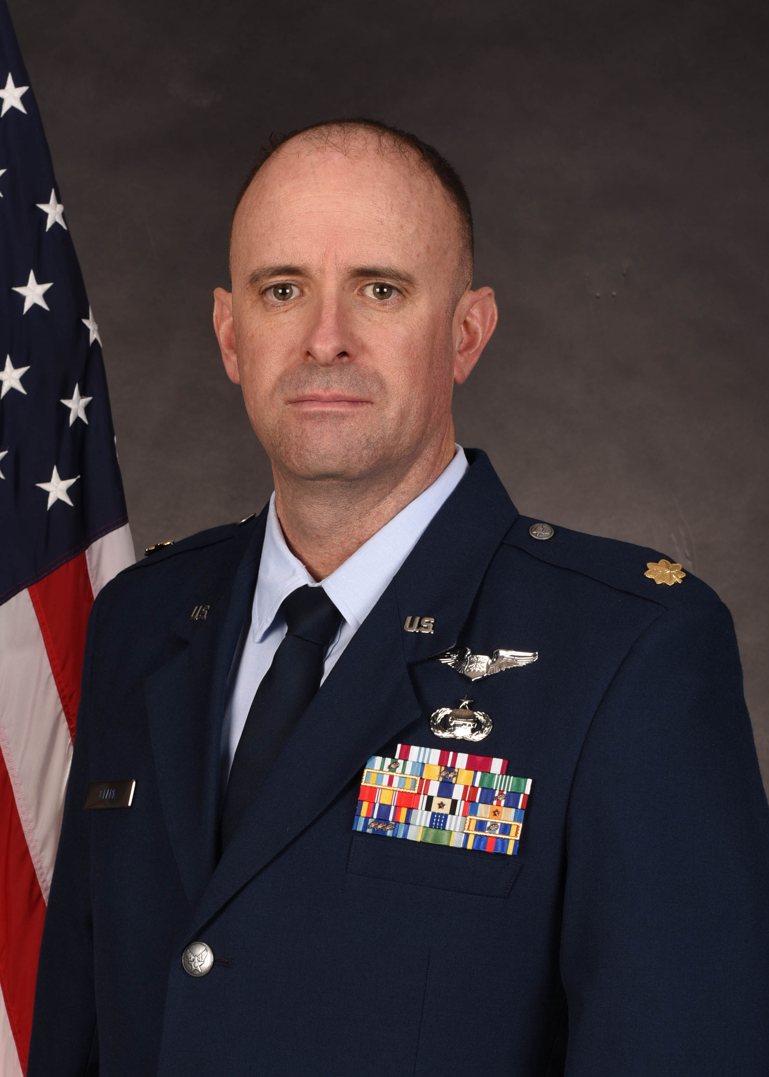
Major Matthew R. Clark is the operations flight commander, Detachment 940, University of Wyoming, Laramie Wyoming. As the operations flight commander, he is responsible all detachment training functions and oversees leadership laboratory and physical training for all cadets. Additionally, Major Clark is an Assistant Professor of Aerospace Studies, where he instructs Aerospace 301/302, Leading People and Effective Communication.

Maj Clark received his commission in 2004 through the Air Force Reserve Officer Training Corps upon graduation from Utah State University with a degree in Political Science. He obtained a master’s degree in Military Operation Art and Science through the Air Force’s Air Command and Staff College’s online master’s program.

Major Clark is a rated navigator and has served most of his career as an intelligence officer. He has deployed five times in support of Operation Iraqi Freedom, Operation Inherent Resolve and in support of the U.S. Embassy Mexico City, Mexico.

EDUCATION
2004 Bachelor of Arts degree in Political Science, Utah State University, Logan Utah
2010 Squadron Officer School, Maxwell AFB, AL
2012 Master’s degree in Military Art and Science, Air Command and Staff College, Maxwell AFB, AL
2015 Air Command and Staff College, correspondence
2017 Joint Professional Military Education II, The Joint and Combined Warfighter School, Norfolk, VA

ASSIGNMENTS or CAREER CHRONOLOGY
- Jun 2004 – May 2006, Student, Undergraduate Navigator Training, Naval Air Station Pensacola, Pensacola, FL
- May 2006 – Aug 2006, Student F-15E WSO, 333rd Fighter Squadron, Seymour Johnson AFB, NC
- Aug 2006 – Feb 2008, Officer in Charge of Construction, 4th Force Support Squadron, Seymour Johnson AFB, NC
- Feb 2008 – Feb 2009, Food Service Officer, 4th Force Support Squadron, Seymour Johnson AFB, NC
- Feb 2009 – Feb 2010, Section Commander, 4th Aircraft Maintenance Squadron, Seymour Johnson AFB, NC
- Feb 2010 – Dec 2011, Instructor, Aerospace Basic Course, Squadron Officer College, Maxwell AFB, AL
- Dec 2011 – Jul 2012, Instructor, Squadron Officer School, Squadron Officer College, Maxwell AFB, AL
- Jul 2012 – Jun 2013, Student, Intelligence Officer Course, 315th Training Squadron, Goodfellow AFB, TX
- Jun 2013 – Jun 2016, Mission Director and Assistant Director of Operations, 9th Intelligence Squadron, Beale AFB, CA
- Jun 2016 – Jun 2017, Analysis, Correlation and Fusion Team Chief, 609th Air Operations Center, Al Udeid AB, Qatar
- Jun 2017 – Jul 2018, Korea Strategic Weapons Team Chief, Joint Intelligence Operations Center, Pearl Harbor, HI
- Jul 2018 – Jul 2019, Korea Geopolitical Team Chief, Joint Intelligence Operations Center, Pearl Harbor, HI
- Jul 2019 – Aug 2020, Korea Branch Chief, Joint Intelligence Operations Center, Pearl Harbor, HI
- Aug 2020 – June 2022, Chief of Intelligence to Force Protection, Air Force Life Cycle Center, Hanscom AFB, MA
- June 2022 – Present, Instructor and Operations Flight Commander, AFROTC Detachment 940, Laramie, WY

MAJOR AWARDS AND DECORATIONS
Defense Meritorious Service Medal
Meritorious Service Medal with one oak leaf cluster
Joint Service Commendation Medal with one oak leaf cluster
Air Force Commendation Medal with two oak leaf clusters
Army Commendation medal
Iraq Campaign Medal
Inherent Resolve Campaign Medal

EFFECTIVE DATES OF PROMOTION
Second Lieutenant: May 30, 2004
First Lieutenant: May 30, 2006
Captain: May 30, 2008
Major: Apr 1, 2014

(Current as of Jan 2025)

