N E L T J E R E S I D E N C Y
Call for Applications
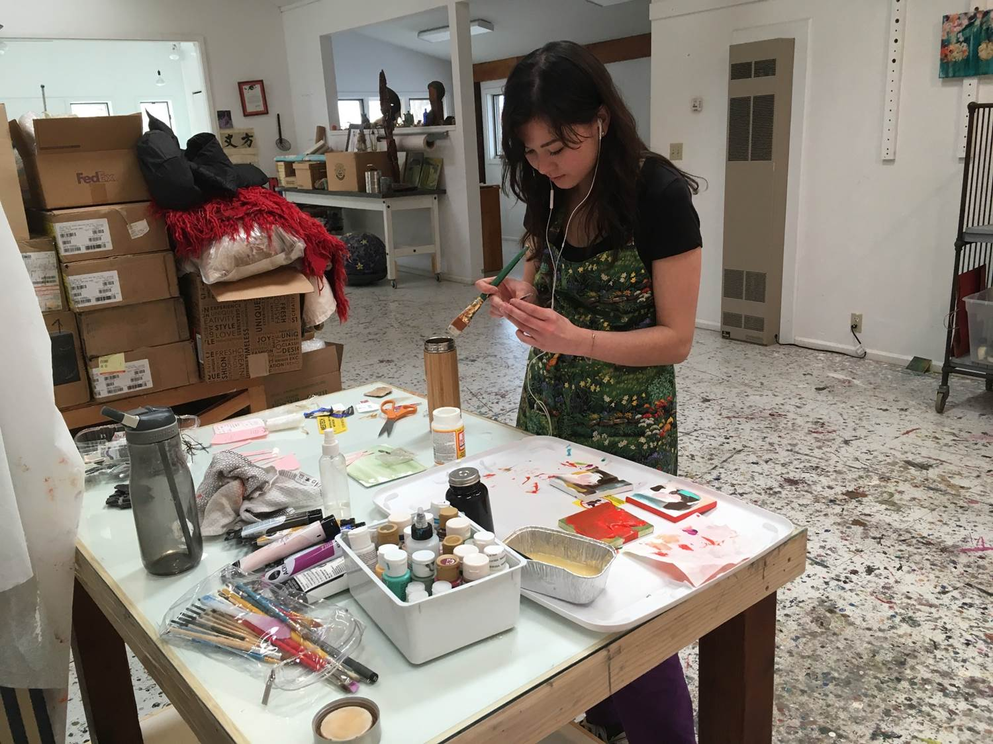

The University of Wyoming Department of Art and Art History is currently seeking applications for a student artist-residency program at the home of Neltje, outside of Banner, Wyoming. The four-day residency will coincide with the beginning of the 2019 spring break, March 15 – 19. Selected participants will receive room, and transportation from Laramie to Banner and will have focused studio work-time and access to Neltje’s private in-home collection of contemporary art. A group exhibition of resulting works will be scheduled for the late spring and all participants will be required to participate in several follow-up discussion sessions to plan for future student residencies and programs at Neltje’s home.
Application Due:
February 1st, 2019 (by 5pm)
** Submit all materials by email to Ricki Klages, rlk@uwyo.edu
Include: Five attached images of recent works (from the beginning of the current fall 2018 semester) and a one page statement discussing how you would plan to do creative work with minimal studio facilities. Facilities for creative work are limited and do not include equipment for ceramics, sculpture, photography, or other specific technical processes.
Include your name as it appears on WyoCourses, W#, and current GPA at the top of the statement, and the names of three Department of Art and Art History references.
Selection will be based on proven ability to complete projects, personal and artistic maturity, quality of recent work and written statement. Priority will be given to seniors and post baccalaureate students.

