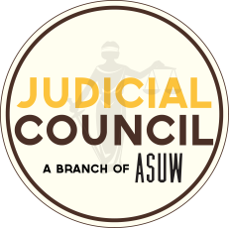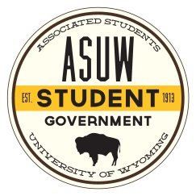Official Opinion of the ASUW Judicial Council

Majority Opinion handed down on February 27, 2019 by Justice Fried:

Chief Justice Richardson, Justices Bellamy, Stromberg, Pauling, and Bergman concurring:

Justice Vinluan did not take part in this decision.

**Request for interpretation of the ASUW By-Laws  Article 1. Section 1.01 Clause E.  
The President may veto, within ten (10) days of its passage, any action of the ASUW Senate, but such veto may be overridden by a two-thirds (2/3) vote of all the voting Senators at either of the two (2) regular ASUW Senate meetings following the veto.**

Question

On February 21, 2019 the Judicial Council received a request to interpret the ASUW By-Laws  Article 1. Section 1.01 Clause E: “The President may veto, within ten (10) days of its passage, any action of the ASUW Senate, but such veto may be overridden by a two-thirds (2/3) vote of all the voting Senators at either of the two (2) regular ASUW Senate meetings following the veto.”

The task of the Judicial Council is to additionally answer the following question:

In interpreting the word “action” is the President’s power limited to only legislation or are there other instances in which this power can be exercised.

In full consensus of the Justices present, the Judicial Council’s official interpretation is that absent any other clarification or modifiers to the word “action,” it must be taken at face value. There is nothing in the documents that the Council could use to define this term any more narrowly. The power is thus not simply constrained to vetoing legislation. It is important to clarify that this means that the President may *veto* any action of the ASUW Senate, but that does not mean that every action has to be *approved* by the President.