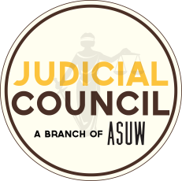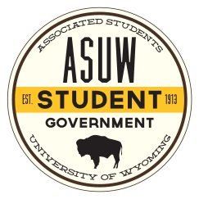Official Opinion of the ASUW Judicial Council

Majority Opinion handed down on February 27, 2019 by Justice Fried:

Chief Justice Richardson, Justices Stromberg, Bellamy, Pauling, and Bergman concurring:

Justice Vinluan did not take part in this decision.

**Section 5.02 Subsection 8 of the ASUW Finance Policy:**

**8. The ASUW Judicial Council’s authority with regards to RSOs’ funding requests shall be limited to denial or approval of a RSO’s appeal. If the ASUW Judicial Council approves a RSO’s appeal for funding that was denied by the ASUW Senate, the Judicial Council will remand the decision with findings, to the ASUW Senate for consideration and for corrective action.**

Question

On February 21, 2019 the Judicial Council received a request to interpret Section 5.02 Subsection 8 of the ASUW Finance Policy: “8. The ASUW Judicial Council’s authority with regards to RSOs’ funding requests shall be limited to denial or approval of a RSO’s appeal. If the ASUW Judicial Council approves a RSO’s appeal for funding that was denied by the ASUW Senate, the Judicial Council will remand the decision with findings, to the ASUW Senate for consideration and for corrective action.”

The task of the Judicial Council is to answer the following questions:

1. Does this clause also apply to RSO’s appealing for funding that was denied by RSO Funding Board?
2. If it does apply, what will the Judicial Council be able to recommend to Senate, specifically is it a recommendation to hear the appeal or a directive?
3. In the event that the JC rules that Senate either has to hear the appeal or recommends it, does 6 hour notice need to be given or not?

In full consensus of the Justices present, the Judicial Council’s official interpretation is that in answering the first question, it is pertinent to look at where the RSO Funding Board derives its power. Per Article 3, Subsection 3.01, Clause 2 of the Finance Policy the “The ASUW Senate through the RSO Funding Board possesses sole authority to allocate ASUW funds directly to RSOs…” The Justices agreed that this wording explicitly states that the RSO Funding Board is simply a hand connected to the body of the Senate. The Funding Board partially carries out the Senate’s work, and is not an independent entity.

Because the Funding Board is a unit of the Senate, and the Senate is a unit of the student government, the answer to the second question is that the Judicial Council can indeed issue a directive to hear an appeal directly to the RSO Funding Board. This power derives from ASUW By-Laws Article III, Section 3.01, Subsection 3, Clause E: “The Council may assign or refer any matter, which is within its jurisdiction and which has been appropriately brought to the Council, back to the ASUW body, unit or committee of original decision for such action or consideration as the Council determines is required.” Therefore, the Council can hand down a directive to hear an appeal straight to the RSO Funding Board if it stands as the unit of original jurisdiction.

In answering the third question, the Judicial Council finds that in order to maintain the efficiency of the ASUW Senate, the Judicial Council must notify the full Senate and the ASUW Vice President of an appeal hearing directive, in writing, at least (6) hours before the next regularly scheduled meeting of the unit of original jurisdiction, whether it be the ASUW Senate or RSO Funding Board.