**SENATE RESOLUTION #2603**

**TITLE:** ASUW Support of Fraternity/Sorority Life’s Redevelopment of Greek Week

**DATE INTRODUCED:** March 6, 2018

**AUTHOR:** Chief of Legislative Affairs Jones

**SPONSORS:** Senator Blazovich, Fried, Means, Mueller, and Stromberg; College Panhellenic Council

1. WHEREAS, it is the duty of the Associated Students of the University of Wyoming (ASUW)
2. Student Government to represent our fellow students accurately; and,
3. WHEREAS, the Interfraternity Council (IFC) and College Panhellenic Council (CPH) are
4. both strategic partners of ASUW that are an integral part of campus culture at the University
5. of Wyoming; and,
6. WHEREAS, recognized chapters through the Fraternity/Sorority Life (FSL) community
7. garnish value-based leaders that have helped develop ASUW and the University of Wyoming
8. communities; and,
9. WHEREAS, the general direction of the FSL community is moving toward a more unified
10. community between recognized chapters to promote one another through growth and
11. development, building connections, leading with integrity, and giving back to the
12. community; and,
13. WHEREAS, IFC has recently redeveloped their focus on the betterment of member
14. fraternities through education, advocacy, and collaborate between one another; and,
15. WHEREAS, CPH and their affiliated chapters are focused on having university involvement,
16. leadership development, and service initiatives within their body through community service
17. activities, educational events, and philanthropy to promote positive growth within the FSL
18. community; and,
19. WHEREAS, in the past, Greek Week would develop relationships between chapters through
20. competitive events and cooperation between FSL Chapters; and,
21. WHEREAS, these developments of connection between chapters felt restricted between
22. individual chapters and competitive teams, not allowing as many opportunities for
23. networking and developing relationships beyond pre-established groups; and,
24. WHEREAS, the scheduled events for this year’s Greek Week are more focused on the values
25. of IFC, CPH, and the FSL community by promoting events involving service leadership,
26. academics, and educational programing rather than just athletic competitions; and,
27. WHEREAS, the revised focus and intent of Greek Week 2018 is only one of many
28. steps the FSL community is planning to further develop their community to become more
29. interdependent and cooperative leading to more meaningful connections within the FSL
30. community and further develop leadership opportunities for the FSL community, ASUW,
31. and the University of Wyoming;
32. THEREFORE, be it resolved that the Associated Students of the University of Wyoming
33. (ASUW) Student Government support the initiative and new direction of the Fraternity and
34. Sorority Life Community; and,
35. THEREFORE, be it further resolved that the ASUW Student Government also supports the
36. initiative and events of the 2018 Greek Week as outlined within Addendum A.

**Referred to:** ________Program and Institutional Development________________

**Date of Passage**:  **Signed**:

**(ASUW Chairperson)**

**“Being enacted on** **, I do hereby sign my name hereto and**

**approve this Senate action.”**   **ASUW President**

**Addendum A**

**Greek Week Schedule 2018**

March 24th – 29th 2018

**Community Service Fundraiser – All Week**

In partnership with United Way, we will be collecting change at individual chapters throughout the week. All money will be due one hour prior to the start of the talent show in order to receive points.

**Instagram Challenges – All Week**

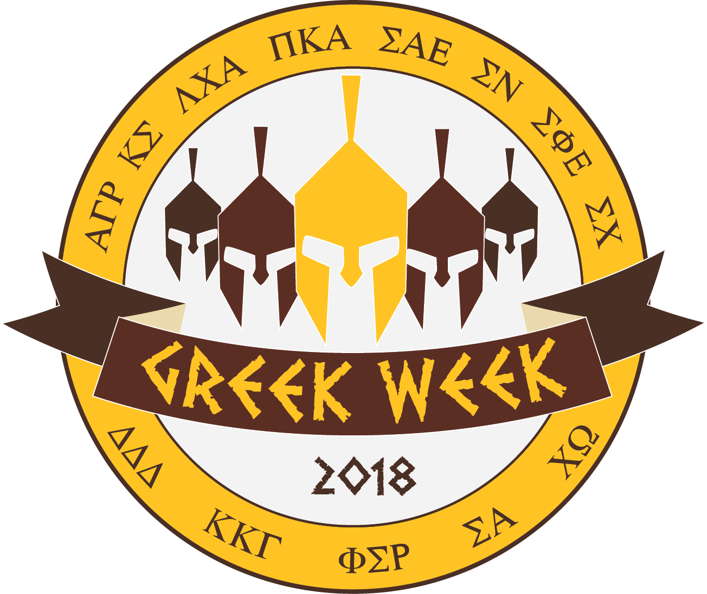Each day there will be an Instagram challenge for teams to earn extra points. In order to do so, team members must be dressed in the outfit of the day and post using the specific hashtags.

**Banner Competition – All Week**

The banner competition will be held throughout the week to promote Greek Week within the community.

**Athletic Competitions – Saturday, March 24th. Starting at 10:00AM**

The brotherhood and sisterhood committee will host one day of athletic competitions for teams to compete against each other in.

**BBQ – Saturday, March 24, 2018**

There will be a community wide BBQ to kick off Greek Week!

**Community Service Event – Saturday, March 24, 2018 11:00AM**

In partnership with the Laramie community, the Greek Week Leadership Team is offering a variety of community service opportunities.

**FSL Feud – Monday, March 26, 2018 - 6:30PM Union Ballroom**

Each team will be allowed to have a total of 6 people at this event which should include 5 chapter members and 1 UWYO Faculty and/or Staff members in a time to honor faculty and staff for their service to the university and the Fraternity & Sorority Life community. Teams will compete in a game similar to Family Feud.

**Leadership Programming Event – Tuesday, March 27, 2018 7:00PM Union Ballroom**

Leadership is an essential component of the Fraternity and Sorority experience. Leadership is not always about the positions held, but rather the way in which individuals, whether with designated positions or not, respond to the adversity of programs and events, build relationships, empower others, and communicate. We will be hosting a leadership speaker who will speak to the qualities of a true leader and how those that have the greatest and most long-term impact are servant leaders.

**Talent Competition & Greek Week Awards – Thursday, March 29th 6:30PM A&S**

Greek Talent will allow teams to showcase their talents while continuing to raise money for United Way.

The Greek Week Awards Ceremony will immediately follow the Greek Talent Competition. Awards will be given for several individual Greek Week events as well as name an overall Greek Week Team.