**SENATE RESOLUTION #2627**

**TITLE:** ASUW Support of Huron Tuition Recommendations

**DATE INTRODUCED:** April 10, 2018

**AUTHOR:** President Wetzel

**SPONSORS:** Chief of Staff Thomson-Lichty; Senators Conard, Defebaugh, Mulhall, Rubino, and Westlake

1. WHEREAS, it is the duty of the Associated Students of the University of Wyoming (ASUW)
2. Student Government to serve our fellow students in the best manner possible; and,
3. WHEREAS, Huron Consulting conducted an in-depth analysis of the University of
4. Wyoming’s academic capacity, institutional capacity, program costs, prospective student
5. perceptions, and price elasticity to determine and recommend the optimum levels of
6. enrollment as well as tuition ranges for increased recruitment and retention of out-of-state
7. students; and,
8. WHEREAS, Huron’s price elasticity recommendations included lowering out-of-state tuition
9. to competitive levels with our comparator universities as outline in Addendum A; and,
10. WHEREAS, the University of Wyoming, in an effort to increase transparency regarding
11. tuition costs and to aid recruitment efforts, will be deciding the 2019-2020 tuition rates at the
12. September 2018 Board of Trustees meetings; and,
13. WHEREAS, the University Administration will be working throughout the summer to utilize
14. the information from Huron’s price elasticity modeling to recommend a lowered out-of-state
15. tuition rate to be competitive with our comparator markets; and,
16. WHEREAS, the ASUW Senate in the 106th Administration will not have sufficient time to
17. review proposals and provide a resolution regarding the University Administrations
18. recommendation for the 2019-2020 tuition rates.
19. THEREFORE, be it resolved by the Associated Students of the University of Wyoming
20. (ASUW) Student Government that the ASUW Student Government supports the principles
21. recommended in the Huron Price Elasticity modeling to lower out-of-state tuition to be
22. competitive with our comparator universities; and,
23. THEREFORE, be it further resolved that the ASUW Student Government does not support
24. lowering the price of out-of-state tuition to a point that it devalues the high-quality education
25. of the University of Wyoming or damages the academic integrity of our classrooms; and,
26. THEREFORE, be it further resolved that the ASUW Student Government supports the
27. Executive Branch of the 106th Administration working with the Intersession Oversight
28. Committee to form a well-researched opinion on the 2019-2020 tuition rates as
29. recommended by the University of Wyoming Administration in the timeline approved by the
30. Board of Trustees in Addendum B.

**Referred to:** Advocacy, Diversity, and Policy

**Date of Passage: Signed:**

**(ASUW Chairperson)**

**“Being enacted on , I do hereby sign my name hereto and**

**approve this Senate action.”   
 ASUW President**

**Addendum A**

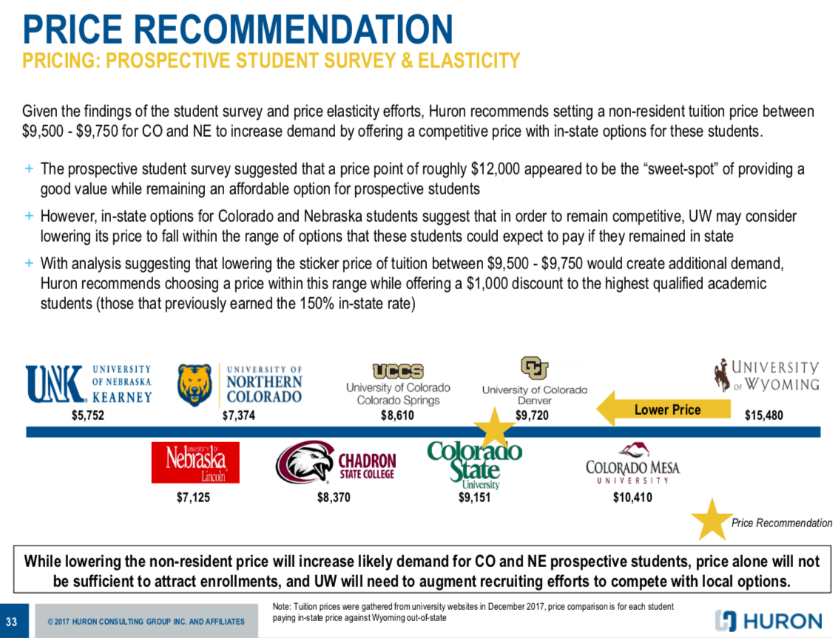

**Addendum B**

