**SENATE RESOLUTION #2635**

**TITLE:** ASUW Support of Transgender, Nonbinary, & Otherwise Gender Non-Conforming Students

**DATE INTRODUCED:** November 6, 2018

**AUTHOR:** Senator Pierson; Director of Diversity McVicker; SAL Titus

**SPONSORS:** Senators Garcia and Marchese; Chief of Staff Harris, Director of Governmental and Community Affairs Houghton; University of Wyoming Spectrum

1. WHEREAS, the mission and responsibility of the Associated Students of the University of
2. Wyoming (ASUW) Student Government is to serve our students in the best manner possible
3. through accurate representation, professional interaction with campus programs and
4. organizations, and responsible, effective, leadership; and,
5. WHEREAS, Article 5, Section 5.01 of the ASUW Student Government By-Laws states that
6. ASUW seeks to, “promote the interests and wellbeing of all students, regardless of ... sex,
7. sexual orientation, ... political belief, ... or gender identity.[...] respect the integrity, dignity
8. and worth of individual students and will recognize and acknowledge the differences in each.
9. […] be sensitive and protective of the liberties and respect to which each individual student
10. is entitled. We will refrain from and discourage behaviors that threaten these ideals, freedom,
11. and civility that every individual deserves”; and,
12. WHEREAS, transgender people, and especially transgender people of color, are at a higher
13. risk of violence and suicide than the cisgender population with major risk factors including
14. discrimination and ill treatment within healthcare systems as outlined in Addendum A; and,
15. WHEREAS, the University of the Wyoming, as the only public four-year institution of the
16. state, should ensure equal opportunity to all students to flourish academically, socially,
17. culturally, and professionally; and,
18. WHEREAS, gender non-conforming students at the University of Wyoming reported higher
19. instances of sexual assault, attempted or completed rape, sexual harassment, and intimate
20. partner and dating violence as outlined in Addendum B; and,
21. WHEREAS, as outlined in Addendum C, the current administration of the United States of
22. America has released a memo to redefine and thus remove protections of transgender
23. individuals guaranteed in Title IX, the federal civil rights law banning discrimination on the
24. basis of gender in education programs receiving federal assistance.
25. THEREFORE, be it resolved by the Associated Students of the University of Wyoming
26. (ASUW) Student Government that we, as a body of elected and appointed student leaders
27. supporting faculty advisors, ex-officios, etc. will fulfill our mission and uphold the Code of
28. Ethics as previously described; and,
29. THEREFORE, be it further resolved that the ASUW Student Government acknowledges that
30. the data from Addendum B indicates a failure of the University of Wyoming to protect
31. transgender and gender non-conforming students; and,
32. THEREFORE, be it further resolved that the ASUW Student Government acknowledges the
33. memo in Addendum C as an attack on transgender, nonbinary, and gender
34. nonconforming people and students at the University of Wyoming, and the proposed actions
35. within Addendum C directly conflict with the ASUW mission statement and Code of Ethics
36. as described; and,
37. THEREFORE, be it further resolved the ASUW Student Government will continue to uphold
38. its mission and Code of Ethics by issuing this statement of support; and,
39. THEREFORE, be it further resolved the ASUW Student Government encourages the
40. University of Wyoming President Laurie Nichols and other governing University faculty
41. members, bodies, etc. to issue a similar statement of support for transgender, nonbinary, and otherwise gender non-conforming students.

**Referred to:** _________Advocacy, Diversity, and Policy_________________________

**Date of Passage:** **Signed:**

**(ASUW Chairperson)**

**“Being enacted on** **, I do hereby sign my name hereto and**

**approve this Senate action.”**

**ASUW President**

**Addendum A**

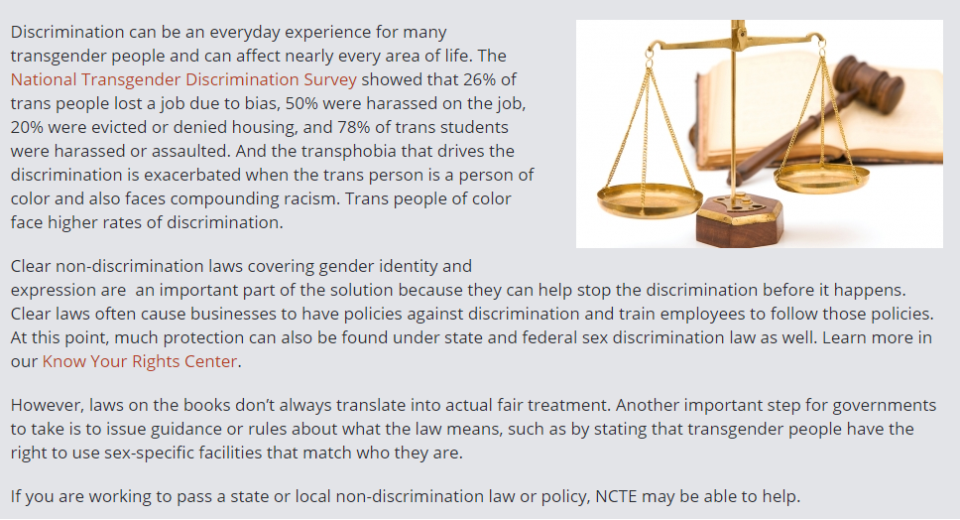

(https://transequality.org/issues/non-discrimination-laws)

**Addendum B**

**University of Wyoming Campus Climate Survey Results – 2018**

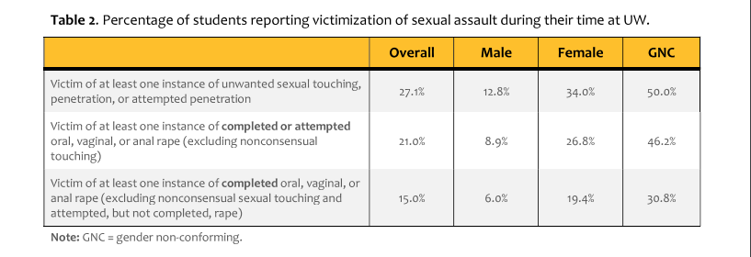

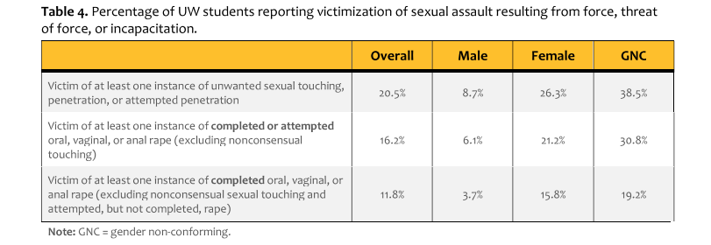

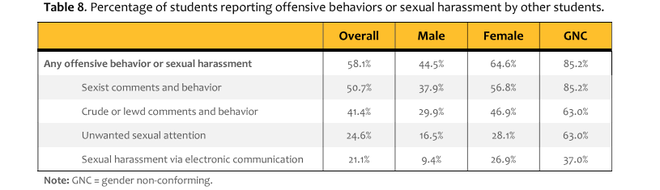

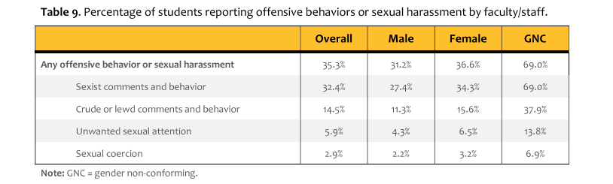

**Addendum C**

**New York Times:**

**‘Transgender’ Could be Defined Out of Existence Under Trump Administration**

By Erica L. Green, Katie Benner and Robert Pear

October 21, 2018

WASHINGTON — The Trump administration is considering narrowly defining gender as a biological, immutable condition determined by genitalia at birth, the most drastic move yet in a governmentwide effort to roll back recognition and protections of transgender people under federal civil rights law.

A series of decisions by the Obama administration loosened the legal concept of gender in federal programs, including in education and health care, recognizing gender largely as an individual’s choice and not determined by the sex assigned at birth. The policy prompted fights over bathrooms, dormitories, single-sex programs and other arenas where gender was once seen as a simple concept. Conservatives, especially evangelical Christians, were incensed.

Now the Department of Health and Human Services is spearheading an effort to establish a legal definition of sex under Title IX, the federal civil rights law that bans gender discrimination in education programs that receive government financial assistance, according to a memo obtained by The New York Times.

The department argued in its memo that key government agencies needed to adopt an explicit and uniform definition of gender as determined “on a biological basis that is clear, grounded in science, objective and administrable.” The agency’s proposed definition would define sex as either male or female, unchangeable, and determined by the genitals that a person is born with, according to a draft reviewed by The Times. Any dispute about one’s sex would have to be clarified using genetic testing.

“Sex means a person’s status as male or female based on immutable biological traits identifiable by or before birth,” the department proposed in the memo, which was drafted and has been circulating since last spring. “The sex listed on a person’s birth certificate, as originally issued, shall constitute definitive proof of a person’s sex unless rebutted by reliable genetic evidence.”

The new definition would essentially eradicate federal recognition of the estimated 1.4 million Americans who have opted to recognize themselves — surgically or otherwise — as a gender other than the one they were born into.

“This takes a position that what the medical community understands about their patients — what people understand about themselves — is irrelevant because the government disagrees,” said Catherine E. Lhamon, who led the Education Department’s Office for Civil Rights in the Obama administration and helped write transgender guidance that is being undone.

The move would be the most significant of a series of maneuvers, large and small, to exclude the population from civil rights protections and roll back the Obama administration’s more fluid recognition of gender identity. The Trump administration has sought to bar transgender people from serving in the military and has legally challenged civil rights protections for the group embedded in the nation’s health care law.

Several agencies have withdrawn Obama-era policies that recognized gender identity in [schools](https://www.nytimes.com/2017/02/22/us/politics/devos-sessions-transgender-students-rights.html?module=inline), [prisons](https://www.nytimes.com/2018/05/11/us/politics/justice-department-transgender-inmates-crime-victims.html?module=inline) and [homeless shelters](https://www.nytimes.com/2017/02/22/us/politics/devos-sessions-transgender-students-rights.html?module=inline). The administration even tried to remove questions about gender identity from a 2020 census survey and a national survey of elderly citizens.

For the last year, the Department of Health and Human Services has privately argued that the term “sex” was never meant to include gender identity or even homosexuality, and that the lack of clarity allowed the Obama administration to wrongfully extend civil rights protections to people who should not have them.

Roger Severino, the director of the Office for Civil Rights at the department, declined to answer detailed questions about the memo or his role in interagency discussions about how to revise the definition of sex under Title IX.

But officials at the department confirmed that their push to limit the definition of sex for the purpose of federal civil rights laws resulted from their own reading of the laws and from a court decision.

Mr. Severino, while serving as the head of the DeVos Center for Religion and Civil Society at the Heritage Foundation, was among the conservatives who blanched at the Obama administration’s expansion of sex to include gender identity, which [he called “radical gender ideology.”](https://www.dailysignal.com/author/roger-severino/)

In [one commentary piece](https://www.dailysignal.com/2016/05/23/3-ways-conservative-lawmakers-should-fight-obamas-bathroom-directive/), he called the policies a “culmination of a series of unilateral, and frequently lawless, administration attempts to impose a new definition of what it means to be a man or a woman on the entire nation.”

“Transgender people are frightened,” said Sarah Warbelow, the legal director of the Human Rights Campaign, which presses for the rights of lesbian, gay, bisexual and transgender people. “At every step where the administration has had the choice, they’ve opted to turn their back on transgender people.” After this article was published online, transgender people took to social media to post photographs of themselves with the hashtag #WontBeErased.

The Department of Health and Human Services has called on the “Big Four” agencies that enforce some part of Title IX — the Departments of Education, Justice, Health and Human Services, and Labor — to adopt its definition in regulations that will establish uniformity in the government and increase the likelihood that courts will accept it.

The definition is integral to two proposed rules currently under review at the White House: One from the Education Department deals with complaints of sex discrimination at schools and colleges receiving federal financial assistance; the other, from health and human services, deals with health programs and activities that receive federal funds or subsidies. Both regulations are expected to be released this fall, and would then be open for public comment, typically for 60 days. The agencies would consider the comments before issuing final rules with the force of law — both of which could include the new gender definition.

Civil rights groups have been meeting with federal officials in recent weeks to argue against the proposed definition, which has divided career and political appointees across the administration. Some officials hope that health and human services will at least rein in the most extreme parts, such as the call for genetic testing to determine sex.

After more than a year of discussions, health and human services is preparing to formally present the new definition to the Justice Department before the end of the year, Trump administration officials say. If the Justice Department decides that the change is legal, the new definition can be approved and enforced in Title IX statutes, and across government agencies.

The Justice Department declined to comment on the draft health and human services proposal. The Justice Department has not yet been asked to render a formal legal opinion, according to an official there who was not authorized to speak about the process.

But Attorney General Jeff Sessions’s previous decisions on transgender protections have given civil rights advocates little hope that the department will prevent the new definition from being enforced. The proposal appears consistent with the position he took in an [October 2017 memo](https://www.justice.gov/ag/page/file/1006981/download) sent to agencies clarifying that the civil rights law that prohibits job discrimination does not cover “gender identity, per se.”

Harper Jean Tobin, the policy director of the National Center for Transgender Equality, an advocacy group, called the maneuvering “an extremely aggressive legal position that is inconsistent with dozens of federal court decisions.”

Health and human services officials said they were only abiding by court orders, referring to the rulings of Judge Reed O’Connor of the Federal District Court in Fort Worth, Tex., a George W. Bush appointee who has held that “Congress did not understand ‘sex’ to include ‘gender identity.’”

A 2016 ruling by Judge O’Connor concerned a rule that was adopted to carry out a civil rights statute embedded in the Affordable Care Act. The provision prohibits discrimination based on race, color, national origin, sex, age or disability in “any health program or activity” that receives federal financial assistance.

But in recent discussions with the administration, civil rights groups, including Lambda Legal, have pointed to other court cases. In a legal memo presented to the administration, a coalition of civil rights groups wrote, “The overwhelming majority of courts to address the question since the most relevant Supreme Court precedent in 1998 have held that antitransgender bias constitutes sex discrimination under federal laws like Title IX.”

Indeed, the health and human services proposal was prompted, in part, by pro-transgender court decisions in the last year that upheld the Obama administration’s position.

In their memo, health and human services officials wrote that “courts and plaintiffs are racing to get decisions” ahead of any rule-making, because of the lack of a stand-alone definition.

“Courts and the previous administration took advantage of this circumstance to include gender identity and sexual orientation in a multitude of agencies, and under a multitude of laws,” the memo states. Doing so “led to confusion and negative policy consequences in health care, education and other federal contexts.”

The narrower definition would be acutely felt in schools and their most visible battlegrounds: [locker rooms and bathrooms](https://www.nytimes.com/2017/02/24/us/transgender-bathroom-law.html?module=inline).

One of the Trump administration’s first decisive policy acts was the rescission by the Education and Justice Departments of Obama-era guidelines that protected transgender students who wanted to use bathrooms that correspond to their gender identity.

Since the guidance was rescinded, the Education Department’s Office for Civil Rights has halted and dismissed discrimination cases filed by transgender students over access to school facilities. A restrictive governmentwide definition would cement the Education Department’s current approach.

But it would also raise new questions.

The department would have to decide what documentation schools would be required to collect to determine or codify gender. Title IX applies to a number of educational experiences, like sports and single-sex classes or programs where gender identity has come into play. The department has said it will continue to open cases where transgender students face discrimination, bullying and harassment, and investigate gender-based harassment as “unwelcome conduct based on a student’s sex” or “harassing conduct based on a student’s failure to conform to sex stereotypes.”

The Education Department did not respond to an inquiry about the health and human services proposal.

Ms. Lhamon of the Obama Education Department said the proposed definition “quite simply negates the humanity of people.”