**SENATE RESOLUTION #2635**

**TITLE:** ASUW Support of Transgender, Non-binary, & Otherwise Gender Non-Conforming Students

**DATE INTRODUCED:** November 6, 2018

**AUTHOR:** Senator Pierson; Director of Diversity McVicker; SAL Titus

**SPONSORS:** Senators Garcia and Marchese; Chief of Staff Harris, Director of Governmental and Community Affairs Houghton; University of Wyoming Spectrum, United Multicultural Council

1. WHEREAS, the mission and responsibility of the Associated Students of the University of
2. Wyoming (ASUW) Student Government is to serve our students in the best manner possible
3. through accurate representation, professional interaction with campus programs and
4. organizations, and responsible, effective, leadership; and,
5. WHEREAS, Article 5, Section 5.01 of the ASUW Student Government By-Laws states that
6. ASUW seeks to, “promote the interests and wellbeing of all students,” regardless of sex,
7. sexual orientation, political belief, or gender identity and to, “respect the integrity, dignity
8. and worth of individual students and will recognize and acknowledge the differences in each.
9. As well as to, “be sensitive and protective of the liberties and respect to which each
10. individual student is entitled” and to, “refrain from and discourage behaviors that threaten
11. these ideals, freedom, and civility that every individual deserves”; and,
12. WHEREAS, transgender people, and especially transgender people of color, are at a higher
13. risk of violence and suicide than the cisgender population with major risk factors including
14. discrimination and ill treatment within healthcare systems as outlined in Addendum A; and,
15. WHEREAS, gender non-conforming students at the University of Wyoming reported higher
16. instances of sexual assault, attempted or completed rape, sexual harassment, and intimate
17. partner and dating violence as outlined in Addendum B; and,
18. WHEREAS, the University of the Wyoming, as the only public four-year institution of the
19. state, should ensure equal opportunity to all students to flourish academically, socially,
20. culturally, and professionally; and,
21. THEREFORE, be it resolved by the Associated Students of the University of Wyoming
22. (ASUW) Student Government that we, as a body of elected and appointed student leaders
23. supporting faculty advisors, ex-officios, etc. will fulfill our mission and uphold the Code of
24. Ethics as previously described; and,
25. THEREFORE, be it further resolved that the ASUW Student Government acknowledges that
26. the data from Addendum B indicates shortcomings in the policies of the University of
27. Wyoming to protect transgender and gender non-conforming students; and,
28. THEREFORE, be it further resolved the ASUW Student Government will continue to uphold
29. its mission and Code of Ethics by issuing this statement of support; and,
30. THEREFORE, be it further resolved the ASUW Student Government encourages the
31. University of Wyoming President Nichols and her administration and other governing
32. University faculty members, bodies, etc. to issue a similar statement of support for
33. transgender, non-binary, and otherwise gender non-conforming students.

**Referred to:** _________Advocacy, Diversity, and Policy_________________________

**Date of Passage:** **Signed:**

**(ASUW Chairperson)**

**“Being enacted on** **, I do hereby sign my name hereto and**

**approve this Senate action.”**

**ASUW President**

**Addendum A**

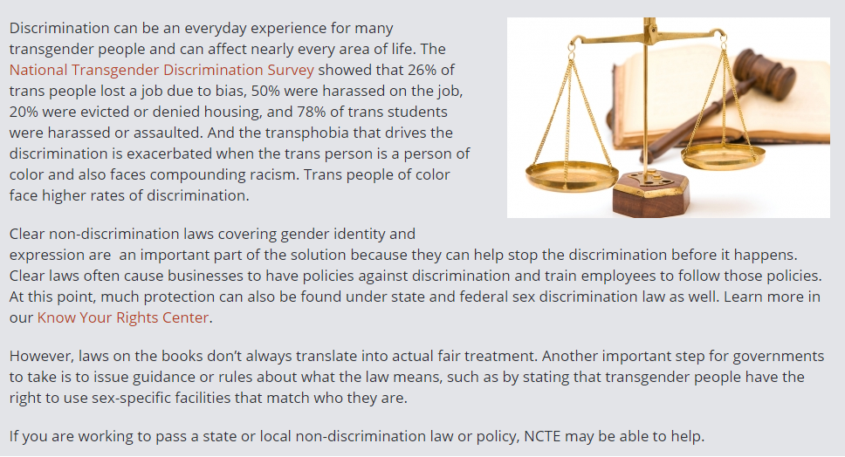

(https://transequality.org/issues/non-discrimination-laws)

**Addendum B**

**University of Wyoming Campus Climate Survey Results – 2018**

