SENATE RESOLUTION #2642
TITLE: ASUW Recommendation on Proposed Mandatory Student Fee Increases for FY20
DATE INTRODUCED: November 27, 2018
AUTHOR: Vice President Mulhall
SPONSORS: Senators Conard, Herold, Lyle, Regnell, Strock, and Wilkins; First-Year Senators Diamond, Greig, and Williams
- WHEREAS, the purpose of the Associated Students of the University of Wyoming
- (ASUW) is to serve our fellow students in the best manner possible through accurate
- representation, professional interaction with campus programs and organizations, and
- responsible, effective leadership; and,
- WHEREAS, the ASUW Mandatory Student Fee Committee hears from university fee
- units annually to formulate recommendations on mandatory student fee requests; and,
- WHEREAS, the proposals for Fiscal Year 2020 (FY20) aim to maintain and expand
- student resources at the University of Wyoming (UW); and,
- WHEREAS, the ASUW proposal for FY20 will fund raises and internal development
- that will help ASUW further serve the student population; and,
- WHEREAS, the proposal for an increase in the Consolidated Student Services (CSS) fee
- will provide funding to help expand important student resources like Student Health
- Services and Campus Recreation; and,
- WHEREAS, the proposal to expand the CSS fee to part-time students will expand
- resources to a larger population of students; and,
- WHEREAS, the proposed increase of the Transit Fee will help to maintain transit
- resources by funding increased salaries and benefits; and,
- WHEREAS, the ASUW Mandatory Student Fee Committee found that all of the
- proposals for FY20 would benefit the student population and create positive change at
- UW.
- THEREFORE, be it resolved by the Associated Students of the University of
- Wyoming (ASUW) Student Government that the ASUW Student Government recommends
- and supports the
- Fiscal Year 2020 Mandatory Student Fees outlined in Addendum A; and,
- THEREFORE, be it further resolved that the ASUW Student Government recommends and
- supports the proposal for changes in the Consolidated Student Fee as outlined in Addendum
- B.

Referred to: Budget and Planning; Programs and Institutional Development
Date of Passage: Signed:
(ASUW Chairperson)
“Being enacted on , I do hereby sign my name hereto and

approve this Senate action.”
ASUW President

Addendum A
 | FY 19 Actual Fee | FY 20 Proposed Fee Increase Per Semester | Percent Increase Per Semester | ASUW FY 20 Total Fee Recommendation
ASUW | $ 43.19 | $ 2.50 | 5.79% | $ 45.69
Consolidated Student Services | $ 402.28 | $ 10.81 | 2.61% | $ 413.09
Intercollegiate Athletics | $ 125.00 | ----------------------- | 0.00% | $ 125.00
Music/Theater | $ 6.05 | ------------------------ | 0.00% | $ 6.05
Recycling | $ 10.12 | ------------------------ | 0.00% | $ 10.12
Student Media | $ 21.19 | ------------------------ | 0.00% | $ 21.19
Student Success | $ 28.00 | ------------------------ | 0.00% | $ 28.00
Transit Fee | $ 53.96 | $ 2.37 | 4.3% | $ 56.33
Total | $ 689.79 | $ 15.68 | 2.23% | $ 705.47

Addendum B
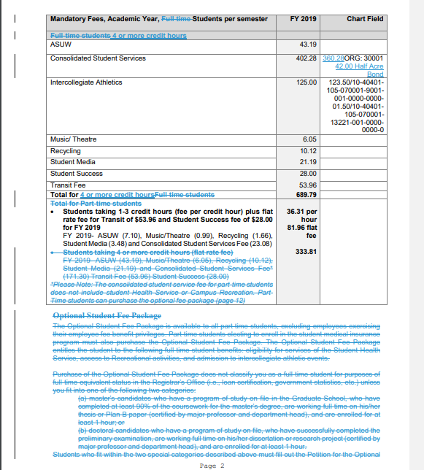
5 or more credit hours
1-4
