**SENATE RESOLUTION #2660**

**TITLE:** ASUW Concealed Carry Recommendation

**DATE INTRODUCED:** April 9, 2019

**AUTHOR:** Vice President Wilkins; Senator Savage

**SPONSORS:** Senators Mueller, Trent, Welsh, Woodward

1. WHEREAS, it is the purpose of the Associated Students of the University of Wyoming
2. (ASUW) Student Government to serve our fellow students in the best manner possible
3. through accurate representation; and,
4. WHEREAS, concealed carry on college campuses is a heavily debated subject and has been
5. discussed by the University of Wyoming (UW) and most recently by the State of Wyoming
6. Legislature in House Bill 0183; and,
7. WHEREAS, carrying concealed firearms on the UW campus is currently prohibited by
8. University Regulation 2-178, Section 6D; and,
9. WHEREAS, Senate Resolution #2533 (SR2533) discussed the benefits and drawbacks of
10. concealed carry at the University; and,
11. WHEREAS, there has been an increase in new students on the UW campus since
12. the passage of SR2533; and,
13. WHEREAS, the ASUW Student Government produced a survey in January of 2019
14. to garner student opinion on concealed and open carry on the UW campus; and,
15. WHEREAS, there was a total of 1220 respondents to the survey; and,
16. WHEREAS, the results of this survey were taken into account when determining the ASUW
17. Student Government’s recommendation on concealed carry policies on the UW campus; and,
18. WHEREAS, Addendum A displays the results of the survey and a variety of
19. student comments; and,
20. WHEREAS, the survey results showed 57% of respondents favor concealed carry on the
21. UW campus with 70% of respondents being in favor of “firearm owners having more
22. extensive gun safety training before being permitted to carry weapons on the UW Campus”;
23. and,
24. WHEREAS, only 45% of respondents favored open carry on UW Campus; and,
25. WHEREAS, these results also suggest that 51% of respondents are in favor of vesting the UW
26. Board of Trustees (BOT) with the power to allow concealed firearms into University-owned
27. living facilities including but not limited to: residence halls, UW apartments, and Fraternity
28. and Sorority chapter facilities, on a facility-by-facility basis and,
29. WHEREAS, various student comments on the survey, however, suggest that guns be allowed
30. in University-owned living facilities except for the residence halls; and,
31. WHEREAS, Fraternity and Sorority chapter facilities do not allow firearms
32. due to policy enacted by national chapters; and,
33. WHEREAS, 45% of respondents were not in support of allowing concealed firearms in the
34. UW Lab School and 10% were unsure of allowing firearms in the Lab School; and,
35. WHEREAS, allowing firearms in the Lab School could cause conflict with Albany County
36. School District policy; and,
37. WHEREAS, the UW Lab School is a very unique and open environment that is housed within
38. the College of Education; and,
39. WHEREAS, allowing firearms in the building could affect the learning environment for the
40. UW Lab School students and jeopardize the accreditation of the College of Education; and,
41. WHEREAS, 49% of respondents voiced concerns with allowing firearms into events on
42. campus that did not relate to firearms (i.e. athletic events, concerts, sporting events, etc.); and,
43. WHEREAS, student comments noted a fear of combining firearms
44. and alcohol in a densely-populated and stressful environment such as sporting events; and,
45. WHEREAS, SR2533 addressed concerns with allowing firearms into laboratory
46. environments; and,
47. WHEREAS, SR2533 also stated that various institutions, “noted
48. multi-million dollar costs” related to infrastructural updates, “including metal
49. detectors, storage lockers, additional training, counseling, and personnel”.
50. THEREFORE, be it resolved by the Associated Students of the University of Wyoming
51. (ASUW) Student Government that the ASUW Student Government does not support any
52. change of policy regarding concealed carry on the University of Wyoming (UW) campus
53. without additional safety provisions and restrictions; and,
54. THEREFORE, be it further resolved that the ASUW Student Government only supports policy
55. vesting the UW Board of Trustees (BOT) with the ability to allow concealed firearms into
56. University-owned living facilities if the BOT does not allow concealed
57. firearms into residence halls and Fraternity and Sorority chapter facilities; and,
58. THEREFORE, be it further resolved that the ASUW Student Government does not support
59. any policy allowing firearms into the UW Lab School; and,
60. THEREFORE, be it further resolved that the ASUW Student Government does not support
61. any policy allowing firearms into laboratory environments; and,
62. THEREFORE, be it further resolved that the ASUW Student Government does not support
63. any policy allowing firearms at any school, college or professional athletic event not related
64. to firearms on the UW Campus; and,
65. THEREFORE, be it further resolved that the ASUW Student Government does not support
66. a policy change unless said policy thoroughly addressed solutions for every concern
67. and specification mentioned above; and,
68. THEREFORE, be it further resolved that all data as shown in Addendum A be taken into
69. consideration if any policy changes are to take place.

**Referred to:** Programs and Institutional Development; Student Outreach and Programming

**Date of Passage:** **Signed:**

**(ASUW Chairperson)**

**“Being enacted on** **, I do hereby sign my name hereto and**

**approve this Senate action.”**   **ASUW President**

**Addendum A**

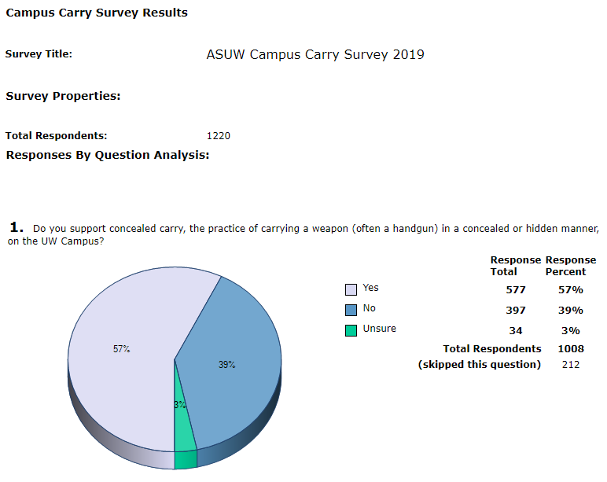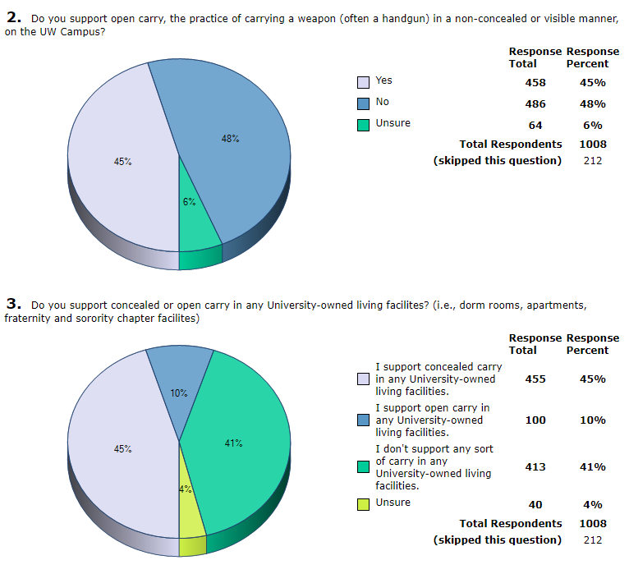

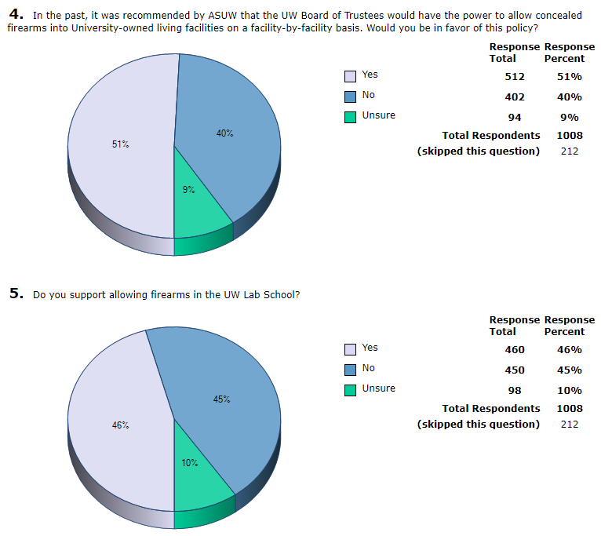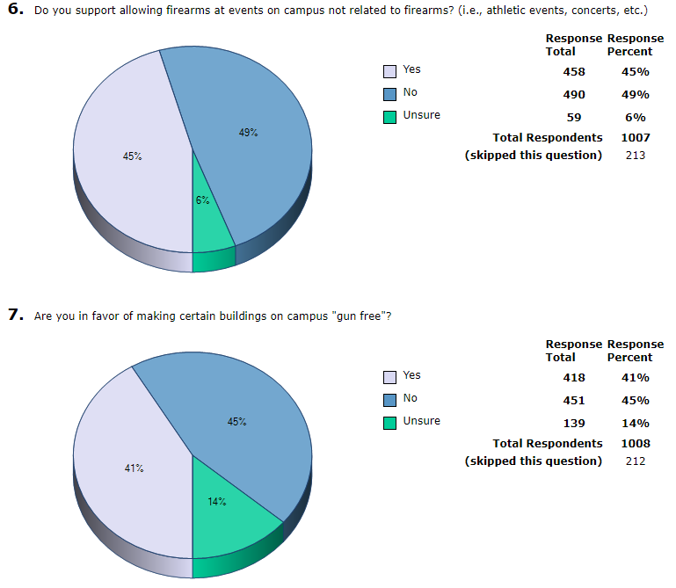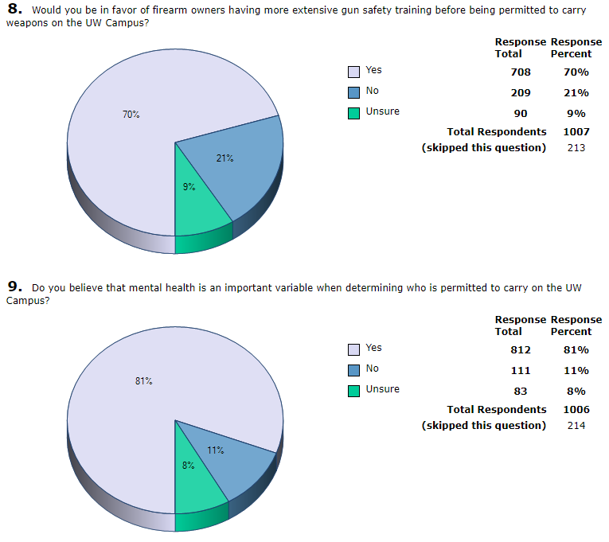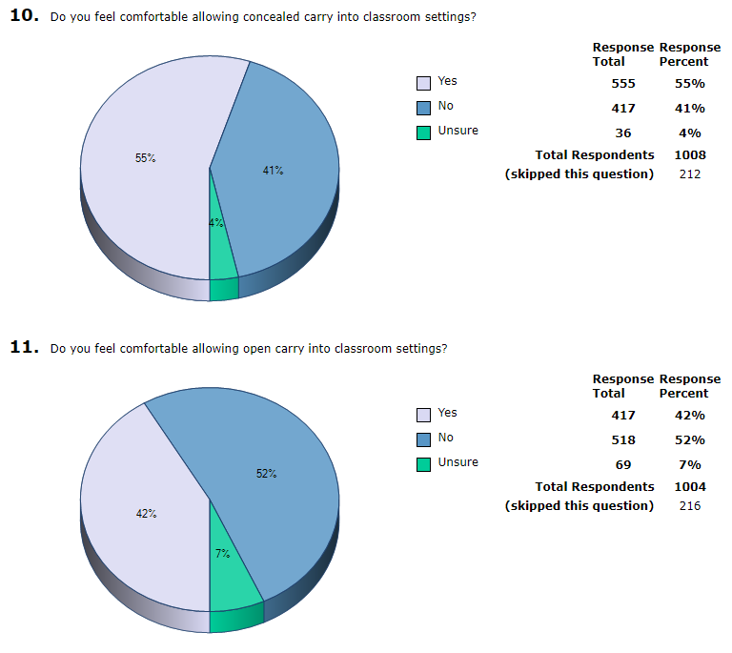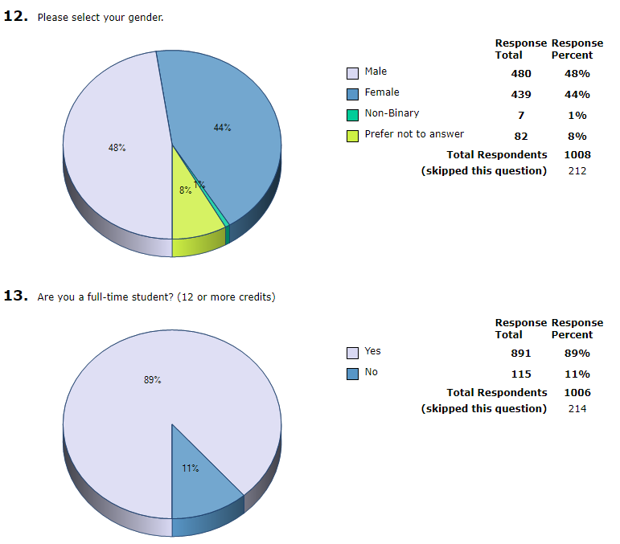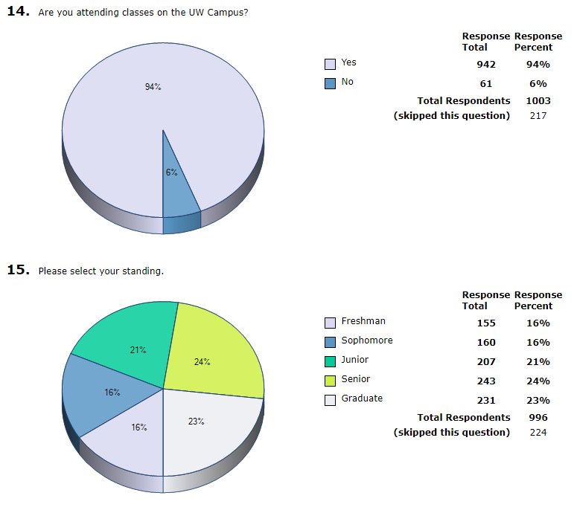

|  |
| --- |
| **16.**  Please leave any comments regarding concealed or open carry on the UW Campus below. |

|  |  |  |
| --- | --- | --- |
| 1. | Having guns on campus is a recipe for an accident or disaster. If guns are allowed on campus that makes me feel unsafe and would consider transferring to another university if this is allowed. |  |
| 2. | I’ve never understood how a private entity can restrict my constitutional rights. Leftists never can connect the dots between gun free zones and mass shootings, they go hand in hand. They say the road to hell is paved with good intentions and gun free zones only make target rich environments for people who already intent to break laws and do harm. If Utah can allow firearms ion campuses and in government buildings why can’t we. Do we really want to let Utah outdo us? That’s just weak. |  |
| 3. | My largest concern is the high rate of suicide by firearm. I'm hesitant to allow any firearms on campus due to this, especially in the living facilities. I want law-abiding citizens to have access but realistically the age group and gender most likely to complete suicide are also the ones most likely to have access to firearms. I would like an age requirement for conceal and carry on campus to be at least 24 years of age. With the high incidences of alcohol consumption and suicide on campus (and Wyoming) I am concerned for the safety of the gun owners, not to mention other students. I also have a smaller concern about threatening behavior and sexual assault that is rampant. To feel that firearms are safe, I would need other requirements to be able to carry one, such as no record of DUI, underage drinking, sexual misconduct, or no past idealization of suicide. this becomes complicated because many of our students may have committed these offences while they were minors. I would need to see a thorough and rigorous vetting process for those who want to conceal carry. Also, many of the students come from out of state where they have not had regular exposure with firearms. I think all students should feel safe and open carry could injure law-abiding gun owners ability to have them. It's best not to cause people to feel strongly about firearms when they're not in danger. |  |
| 4. | The claim that there is some need for protection that would be provided by having more guns around seems simply ridiculous. The reality of chilling effects on speech, intimidation of minorities or those with non-majoritarian views, potential for accidents and escalation of situations would be very real. Pandering to the fear and misinformation from the gun lobby at cost of increased risks for all is outrageous and unethical. |  |
| 5. | Guns have no place in a University setting. Wyoming, as a state, has a different culture surrounding gun ownership and safety compared to other places but that should have no bearing on the acceptablity of firearms in the classroom. Regardless of student support for this idea, strict gun regulation should be enforced while on campus. Some environments are just not fit for guns. |  |
| 6. | No. 9: I think mental health is important but the terms need to be defined. I see "mental health" becoming a rubber stamp.   Without the 2nd, the rest don't matter. |  |
| 7. | I am fully supportive of both open and concealed carry. As someone who knows that more attacks on universities have been occurring, I feel much more comfortable with the knowledge that someone who has been trained how to handle a firearm is carrying. Furthermore, I am aware that the concealed carry permit requires extensive training including learning how to diffuse a situation before firearms are necessary. |  |
| 8. | I have my concealed carry permit and training through Colorado. It makes me upset that I cannot concealed carry on campus, especially being female and walking to and from my car at night after evening classes or meeting. I feel much safer when carrying my pistol. I have proper trainings and credentials to carry and I believe I have the right to do so on campus too. |  |
| 9. | I believe we have the right to carry as long as the individual is legally trained and has the mental stability to do such in order to protect themselves and the students. However, in areas of combustible material and of social events like theatrical events or official meetings, I would like to think there is an unsaid agreement that they should not be armed. |  |
| 10. | I think this is one of the most idiotic ideas I have heard in a while. Allowing any kind of guns on campus in light of the many school shootings is a stupid idea for what should be obvious reasons so, no you do not have my support. |  |
| 11. | I would consider transferring if UW began to allow people to carry firearms on campus. Most people argue that you should feel more safe around people who carry firearms, when I in fact feel less safe allowing people to carry firearms. |  |
| 12. | Guns are not the issue, Mental health is the issue. Training and psychological evaluation should be required for any carry permission. But people should be aloud to store firearms in their residence and their vehicle. |  |
| 13. | I have been threatened by a student who was going to blow my head off if I made him mad again. I do not support guns on campus as it would impede on the quality of my education. What makes gun carriers more important to my education and life? A right should not infringe on another persons right. No way could UW make sure that people carrying guns have completed background checks or have gone through training. I would feel that I have to keep my thoughts to myself in order not to make a gun carrier angry. Hows that for education? |  |
| 14. | Allowing firearms on campus carried by responsible individuals can be a very effective deterrent against potential criminals. The key words in that sentence are responsible indiciduals. Open carry often makes others feel uncomfortable or unsafe, so concealed would be a much better alternative. However, if people that are unqualified or unfit to carry are suddenly allowed to, it may create more problems. An extensive safety and competence program, as well as some kind of psychological/mental health evaluation, should be established for those that wish to carry. |  |
| 15. | I believe the only place where one should not be allowed a weapon is at large events such as concerts and athletic events. This is where if the wrong person has a weapon, things could go horrible. Anywhere else is fine. But people should not be allowed to have them when that many people are so close together and it isn't possible for people to be as aware of their surroundings. |  |
| 16. | I want to be alive thanks |  |
| 17. | Any situation where there could be a conflict over grades or tenure could create unsafe situations for instructors and/or students if these conversations take place around firearms. |  |
| 18. | As a state agency, UW should retain the ability to restrict possession of firearms on campus. West of campus (on Lewis street) due to a parking conflict, one of the homeowners displayed a firearm to get me to move my car. After calls to both UW PD and Laramie PD, it was decided that his actions were legal. He wasn’t on campus, and he wasn’t waving it around threateningly. I still can’t believe his actions were deemed legal. Allowing guns on campus (let alone near campus) doesn’t seem necessary. |  |
| 19. | I would feel much safer on the UW campus with conceal carry permitted. Students, faculty, and staff need to be able to defend themselves from those who disregard campus rules and/or state laws and who intend mass or individual harm. At a minimum, I feel strongly that conceal and open carry should be allowed in any living facilities. I received training while attaining my conceal carry permit and I think my permit should be accepted anywhere on campus as well. |  |
| 20. | Once again, it is surprising that a school that is having issues with money, staff, parking, and a whole list of other problems, is more concerned about letting Timmy bring his lethal weapon to school like a 6 year old bringing a toy for show and tell. Nice job prioritizing student concerns ASUW. |  |
| 21. | Students will be showing off their firearms to others, and many will not practice proper gun safety while doing this. The dorms would be especially dangerous, as there is far too much alcohol consumed by freshman who are acting irresponsibly due to their new-found freedom. I lived on the floor with the most police visits for that year (second place wasn't even close). With all the alcohol and other substances being consumed every night, someone would have ended up getting shot had there been guns involved. |  |
| 22. | In question 4 I would support open and concealed carry in any living site except for the dorms. My main reason for this is so that the people in these location can own and gun on the property. I am against guns in the dorms as it come to close to a "high population density area" that I personally define. I define high population density area as an event, classroom (college or otherwise), or in this case the dorms. |  |
| 23. | I feel completely unsafe knowing people even want firearms on campus. I feel as though UW has a very safe campus and anyone wanting to carry a firearm onto would do so for show or doesn't value the work the university police does. I would never vote for any ASUW candidate that would recommend any kind of firearm be ok campus outside of the police. |  |
| 24. | The biggest factor that makes carrying a weapon unsafe is the mental stability of the carrier |  |
| 25. | I believe that there is no logical reason to allow open or concealed carry of firearms on campus or in University housing, and that permitting the carry of firearms will just increase the risk of injury and/or death of students on campus from accidental discharges alone. |  |
| 26. | I do not think guns belong on college campuses. Allowing concealed or open carry of firearms would be detrimental to the university and should not be allowed. |  |
| 27. | I was in a school shooting and the idea of having guns on campus terrifies me. |  |
| 28. | I can't even believe this is being considered. I flatly reject any argument for guns on campus. Concealed carry has never produced any so-called "heroes" in horrific situations, and only add kindling to the fire. For all students safety, for ALL MEMBERS OF CAMPUS' safety, please please please take these, and all recommendations, seriously. |  |
| 29. | I feel safe on campus. If something needs to be done to make other students feel more comfortable, I would feel much safer with stronger police presence on campus rather than students, faculty, or staff carrying weapons. |  |
| 30. | I'm glad this is a topic of conversation now. I do not carry myself, but am glad when others around me (who have taken the time to arm themselves and train) have done so. It makes the world a safer place. Not from a place of aggression, but from prevention. Please do something with this poll and do not let it go to the wayside of policies at the University of Wyoming. Thanks. |  |
| 31. | Take a look at The University of Kansas’ data on the subject. In the last 3 years since allowing Concealed carry on campus there has been one singular incident in which an individuals firearm was visible. In the press release he proceeded to conceal it from view and that was the end of it. Law Abiding, licensed individuals are NOT the problem. Please allow us to exercise our rights. I have been fighting for this for 4 years now. |  |
| 32. | I think this is a great idea, and I am glad a survey is being taken. I think it would help people have a more sense of security on campus. I do believe anyone who wishes to carry on campus should go through further training through the UW PD, and by doing so gain a permit for on campus carry. |  |
| 33. | There have been far too many firearms-related incidents at schools and campuses in the recent future to allow for concealed or open carry in campus classrooms and common spaces. I recognize that UW has a large number of outdoors-men and -women who may need access to firearms for hunting, shooting trap, and other such activities. These students should certainly have access to firearms for these activities, but this is distinct from carrying firearms in classrooms or other common spaces, where firearms should not be allowed. |  |
| 34. | I feel that allowing open-carry on campus will do more harm than good |  |
| 35. | Any sort of carry on campus would make me feel extremely uncomfortable and not welcome. I would be constantly worried about shootings. If there is no gun present then no gun can be fired. This is a place for education and I feel having guns on campus could inhibit that be making students more anxious. Leave the gun carrying to the police and potential gun-related athletes. |  |
| 36. | This survey doesn't specify if this would apply to students or just faculty. The students on this campus frequently attend class drunk and--let's face it-- they're idiots. I would be incredibly uncomfortable being around drunken idiots with guns. However, I don't think I would mind having armed faculty. |  |
| 37. | As long as training is available and given to students I am ok with firearms on campus. |  |
| 38. | I do not want any guns on campus and do not feel comfortable with them in any regard. |  |
| 39. | I would never attend a university that allows guns to be carried on campus |  |
| 40. | I do not think guns should be on campus at all. |  |
| 41. | If this isn't a problem now, then people have no need to have guns on campus. This would just provoke issues that are unneeded. |  |
| 42. | There should be no guns on campus, whether it be concealed or open. The university is a place for learning. If people need protection, there are police on campus to handle this. |  |
| 43. | Please allow our campus to remain a safe space and not let it be infiltrated by weapons. The solution to gun violence is not to allow more guns. Please let our campus remain fun free, and therefore violence free. |  |
| 44. | N/A |  |
| 45. | Please refer to the second amendment of our constitution. "Shall not be infringed" :) thank you and have goodun |  |
| 46. | More extensive classes and screening is a must. |  |
| 47. | Na |  |
| 48. | You bunch of idiots! Couldn’t you get this survey right the first time???  Are you all that stupid?  By the way a lot of people already conceal carry on campus. We have a very safe campus because if that! |  |
| 49. | I am in favor of requiring a person to have a conceal carry permit in order to carry a gun on campus. While Wyoming does not require a permit to conceal carry, I believe that it is a sensible option to allow conceal carry on campus vs. the current outright ban. |  |
| 50. | Everywhere but the dorms. If you can legally concealed carry then you should be allowed to. Maybe need extra permit for on campus. Living places should allow firearms as long as the person is legally able to own or posses the firearm |  |
| 51. | This act of concealed or non concealed carry would make me feel safer on campus. |  |
| 52. | Please allow at LEAST concealed carry on campus. I would feel much safer knowing that I, or someone else, could defend me if need be. |  |
| 53. | I am in favor of all buildings on campus being "gun-free." I think all gun owners need more training. However, no amount of training will make me comfortable with any kind of carry on campus. Mental health should be a consideration for all gun owners, however, no amount of mental health screening will make me comfortable with any kind of carry on campus. |  |
| 54. | One concern is, how will the University monitor who will have permission to carry a firearm on campus on an everyday basis? Anyone can just bring a firearm on campus and say they have permission to when they don’t. |  |
| 55. | We need more training (more frequent and more extensive) for owners of firearms in general. Those with more experience generally agree because they respect the power these implements hold. An inexperienced person with a gun in a violent or chaotic situation is not helpful and is only likely to cause more destruction and/or death. |  |
| 56. | The right of the people to keep and bear arms shall not be infringed. |  |
| 57. | Great way to allow student to exercise their rights |  |
| 58. | GUNS HAVE NO PLACE IN AN AREA FOR ACADEMIA |  |
| 59. | Question 7-9 are terrible questions. I do not believe any building should have weapons allowed. I believe that the only people that should have guns on campus are law enforcement officers. |  |
| 60. | Criminals do not follow laws and would disregard gun free zone signs, where as law abiding citizens do, and would therefore be defenseless against armed assailants. |  |
| 61. | Even CSU allows conceal carry on campus |  |
| 62. | Open carry would be distracting to me and make me feel a little meh. However concealed carry wouldn’t distract me, in fact it would make me feel more safe. |  |
| 63. | My stance is: the only people who are stopped from using weapons by prohibiting them are those who would defend themselves and others against those with criminal intent. Prohibiting weapons won't stop people who intend to hurt people with them, and if such a person wants to shoot or stab me or someone else, I want to be allowed shoot or stab them back. |  |
| 64. | I do not wish to have firearms on campus. Off campus is fine but I do not need to see firearms everywhere I go on campus. Also I do not support the idea of the UW Board of Trustees making decisions on behalf of the students. The ASUW should be reponsible for this decision not the Board. |  |
| 65. | I didn't know how to answer the questions about different rules in different buildings. I don't think there should be any guns allowed on campus (the only people allowed to carry guns on campus should be the police and military personnel). |  |
| 66. | I feel law enforcement agents should be the only ones permitted to carry on campus. Others, even when well-trained and vetted, open the door to tempers, fears, mental health issues, and other situations causing unnecessary deaths on our campus, including suicides. |  |
| 67. | I believe firearms should be allowed on campus across the board, with almost no restrictions. UWYO is already very generous compared to most other schools with its current firearms policy related to the UWPD and their firearms storage, but pursuing an unrestricted carry environment would better align the university with the values and norms of Wyoming as a very free area to live. There are some potential risks with allowing firearms in campus living facilities, but if the current storage method involving UWPD is maintained while allowing open/concealed carry on campus, it isn’t really allowing carry freely. It is simply allowing you to transport firearms through campus. Allowing students to store their firearms in their living space would make it easier for those who own firearms to maintain them and utilize them for hunting and recreation whenever they wish, without having to make visits to the UWPD station. For those who do not have another residency in town, it can be hard to find a place to maintain your firearms or work on them in a safe environment. |  |
| 68. | For those who can legally carry, especially those with a CCW permit, carrying on campus should be allowed. |  |
| 69. | question 9 is not appropriately worded in the same manner or regards to the other questions on this survey. It is a politically charged and ignorant question. No one logically wants someone with mental health issues to have firearms at their disposal. If someone qualifies for the conceal/open carry permit then they have satisfied the requirement as stated by the state or governing body who administers that permit. |  |
| 70. | In general, I would support gun safety courses on campus, but not as a condition of allowing concealed/open carry. I would not support guns on campus in any fashion whatsoever--not even for UWPD. |  |
| 71. | I'm for both concealed and open carry on the UW campus. |  |
| 72. | As long as students/faculty pass certain requirements like mental evaluations, accuracy and time spent practicing with the gun, and have appropriate holsters in some areas of the school to prevent, say a young child, from grabbing a gun or someone from accidentally dropping their gun if bumped in to by a bicyclist while walking to class. With appropriate safety precautions in place guns can make campus even safer. I do believe certain areas should NOT be allowed to have guns held by the public/students if the danger levels are too extreme as in bars/alcohol areas or a medical area where prescription drugs are sold. I also do not think the guns should be allowed to have a bullet in the chamber when on campus as it is not as safe as keeping the chamber empty. This is Wyoming and students will still concealed carry whether or not it is allowed, so why not allow it but make those that wish to carry pass certain requirements and follow certain regulations as is permitted with pocket knives. It may even be beneficial to have gun permits where the UWPD can have information on the gun owner and keep track of their practice times while still being able to ask students for said permit to determine if they registered their handgun. That could be used to ticket unregistered handgun carriers. |  |
| 73. | Mental health is important, however who decides what is healthy and what isn’t? |  |
| 74. | I would not be comfortable with open or concealed carry on the University of Wyoming. This is an environment for learning, not weapons. |  |
| 75. | I don’t think anybody who is not campus police needs to be able to carry a gun on campus. |  |
| 76. | The world needs less guns. |  |
| 77. | In my high school (out of state), there were several (mostly male) students who brought guns to school illegally. Most of those people were very flippant about gun safety, and very confrontational, and I don't think a few months between high school and college will change that, even with additional education. I especially disagree with allowing guns in campus housing (including Greek life housing), where there may be parties involving excessive drinking. There may be students who break these rules, but at least they have disciplinary action taken against them. In high school, if those students were not chastised, they would bring guns all the time, and we could do nothing about it. |  |
| 78. | I would not feel safe on campus and I feel that my ability to learn would be sacrificed if weapons were allowed on campus. The University is obligated to support each student’s learning, and I believe having weapons on campus would do more harm than good. The facts are clear that the harm done by the “bad guys with guns” far, far outweighs any good brought about by the “good guys with guns.” |  |
| 79. | Schools should be a safe place and allowing guns concealed or open is a dangerous situation. Students need to feel safe being in class and all it takes is one wrong comment or choice and a student could be faced with a gun. I support concealed carry and open carry in other aspects but never in a school setting where there are too many variables and unknowns. Students and teachers need to feel safe at all times! |  |
| 80. | This should not even be a poll. The University needs to allow it's students out second amendment right as Americans. |  |
| 81. | As a fulltime staff member and a graduate student at the University of Wyoming, I do not feel comfortable or safe with allowing firearms (concealed or open carry) in any element of the university setting (classroom, events, dorms, etc...). There is absolutely no reason why firearms should be allowed on campus. If there is a security concern, then UW should hire more UW campus police or resource officers for campus. I know many individuals, including myself, that if the university were to permit firearms (concealed or open carry) on campus, we will be looking for employment elsewhere. |  |
| 82. | Thank you for considering this. Gun free zones are easy targets for shooters and students have no way of defending themselves. If folks want to responsibly carry on campus, make sure they can legally own a firearm, and I am supportive of having training or a class to allow for concealed/open carry on campus. This will give students a way to defend themselves while still having the training and knowledge to do it safely. Thanks! |  |
| 83. | It would make me very uncomfortable to have concealed or open carry allowed on campus. |  |
| 84. | Guns should not be allowed on any college campus, which are places where the majority of the population is under 25 years old and this have brains not yet fully developed and are unable to make good snap decisions. Also, campuses where developing brains are more susceptible to mental health issues like depression, and young people facing new living conditions for the first time which can also lead to depression, where putting guns in their hands would be a bad idea. Last year there was a real threat of a former student, who ended up sadly killing a deputy before he was killed, who just as easily come and shot up the school. When threats like these with former students are already present, at least take away a bit of the possibility of a current student doing the same. |  |
| 85. | I know of many people who already disregard the conceal carry rules, I am not one of them, however, this is a situation in which the rules are already being disregarded, and no one can actually catch any of the rule breakers becaus the weapons are concealed... meaning the only people who are obeying the rules, are people who have a lot of training, and afraid of losing our General right to carry, and value not being allowed to finish our education. |  |
| 86. | It needs to happen |  |
| 87. | I believe allowing students to carry is the best way to protect us against outside threats. The argument for carrying on campus is paralleled with the argument for constitutional carry across this country. |  |
| 88. | I do not support guns on campus or campus-affiliated buildings in any manner or case. |  |
| 89. | I do not see any reason for allowing weapons of any kind on campus at all |  |
| 90. | I feel that it is up to the student or individual who is on campus weather or not they carry a gun. Weather it is open or concealed carry. It is up to them as to how they chose to protect them selves on campus. |  |
| 91. | I strongly oppose having guns on campus. They do not make me feel safer. (Just the opposite in fact.) |  |
| 92. | There is no history of violence suggesting the need to allow students, faculty or visitors to open or conceal carry. |  |
| 93. | Cops are always minutes away when seconds count. The Supreme Court already ruled it's not a police job to keep us safe, as we all saw in the Florida school shooing when deputies coward outside while kids were being shot. It's our responsibility to protect ourselves and will carry regardless of your unconstitutional decisions. I also support any teacher that wants to get trained and carry as well. Again more people carry on campus than you know anyways and you have never had an issue, think anout |  |
| 94. | Questions 7 and 8 are somewhat misleading, as they are dependent on some form of carry being legal. I do not approve of any carry on campus except by certified peace officers with valid badges. The only place I would consider potentially acceptable for firearms is university owned apartments. In which case, the owner would absolutely have to go through screening and safety training. |  |
| 95. | Carriers should be approved through a UW police vetting)training process. |  |
| 96. | My biggest concern is accidental discharges that can cause injury or death being more likely if guns are on campus |  |
| 97. | Other than UW PD, US should not have guns on campus period! |  |
| 98. | Make carrying a weapon allowed on campus, both open and concealed |  |
| 99. | The board of trustees should not make decisions regarding guns and campus safety. This body has demonstrated that it does not make executive decisions that are in the best interest of students, faculty, or staff. Given the political nature of the board of trustees in Wyoming, there is too much room for outside influence to dictate their position.   Further, THERE IS ABSOLUTELY NO EVIDENCE to support that more guns on campus would result in more safety for students, but there is evidence that demonstrates guns increase the risk of death and serious injury in a variety of settings. I own guns, I enjoy shooting them for sport, but I do not want them in my learning and working environment. Unless each person who brings a gun on campus has received special-ops training and is heavily trained in active-shooter situations AND passes an extensive mental health examination every two years, guns have no place on campus. |  |
| 100. | It is important to allow firearms because in the event of a shooting on campus, those who are carrying are able to defend immediately, as opposed to waiting for first responders to arrive. |  |
| 101. | na |  |
| 102. | Im for concealed Cary in the apartments and also fine with the board being able to decide on a facility-by-facility basis but I think the dorms should be a gun free zone. |  |
| 103. | I do not support carrying firearms in the school campus except by authorized personnel. |  |
| 104. | I understand that people have the right to own firearms and that many individuals believe that carrying a firearm can help prevent violence by allowing bystanders to intervene. Research, however, indicates that civilians carrying firearms do not actual decrease levels of violence. I think it is critical that the school acknowledge that denying open or concealed carry on campus is not a violation of one's right. Guns are symbols of violence and are often triggering to many individuals. Further, the school should take note that guns do not prevent mass shootings, guns do not prevent rape, and guns do not prevent other forms of violent acts. I further believe that allowing concealed and open carry guns on campus may further intimidate marginalized populations on campus, a population that has already been shown via the Campus Climate Survey to experience more forms of violence on our campus. We do not need further intimidation factors on our campus. I do not support any civilian (i.e., student, faculty, or staff member outside of campus police) to possess a firearm on campus. |  |
| 105. | guns have no place on our campus PERIOD. |  |
| 106. | As a female, I got my concealed carry permit to protect myself. Unfortunately for me the school has rules preventing me from exercising my right to protect myself. |  |
| 107. | Alcohol and firearms NEVER mix is a fact that has been proven over and over again. Children and firearms NEVER mix is another fact that has been proven over and over again. Firearms can be extremely dangerous if the situation is created that way. However, people with concealed carry must take extra courses to ensure firearm safety. |  |
| 108. | I think this is a very difficult topic and needs to be long researched because there are people that I know could pass some gun safety training classes that I wouldn’t trust with guns. But my friends and myself more than deserve to concealed carry a gun to protect ourselves or our class. Maybe an increased police presence would be more useful than gun carrying abilities for student |  |
| 109. | As a female student, I believe that I should be granted the right to defend myself in any situation. Because 1 in 4 women on college campuses fall victim to sexual assault, I wish I would have the ability to prevent becoming another statistic. |  |
| 110. | As far as question 7 goes, I would like to state that I believe that ALL buildings on campus should be “fun free”. Questions 8 and 9 both seem to assume that the respondent is in favor of any sort of carry—having more extensive training and taking into consideration mental health status are great things when looking at who should own a firearm, and would be great things to consider/implement IF any sort of carry is permitted on campus. That being said, I DO NOT support any kind of carry on campus, nor in campus-related facilities, nor at campus related events. As a student and as an instructor, I believe that permitting the presence of any sort of firearm on campus is reckless and will only make campus feel unsafe. Being at college is supposed to allow students to grow and to be exposed to different viewpoints and opinions, which is something that could be stunted by the presence of a weapon. Should the pretense of firearms be allowed on the Univesity of Wyoming campus, I will have to carefully consider continuing my education at this educational institution |  |
| 111. | My only concern with allowing firearms in living facilities is the presence of alcohol. |  |
| 112. | I do not support any guns on campus. If it’s something that gets allowed I will look for other schools to transfer to that do not allow any type of weapons on campus, concealed or not. I do not believe open carry a reasonable alternative because it would be a distraction for other especially me. A school campus is to facilitate learning. This would just promote distractions. |  |
| 113. | I am a firm supporter of students' right to carry firearm, even on campus. I did not attend secondary or primary schools in the US and during my time outside the US, this was a very common practice, with armed staff, security and students above the age of 18. |  |
| 114. | Concealed and open carry do not have much place in the University facilities, and would ultimately serve to make students feel much less safe on campus. We can't pretend our country doesn't have an epidemic of school shootings, and we shouldn't facilitate that risk. |  |
| 115. | I believe individuals should have the right to carry firearms on any property as long as they have the proper licences and training. |  |
| 116. | Allowing carry on campus would make me feel unsafe enough that I would look at transferring away from UW. I also have a job on campus, and would not feel safe at work or in class. Personal carry will not make campus safer, but may escalate already unsafe situations and create more danger. I trust UWPD to keep me safe far more than any random student with a gun. I also know that I would feel uncomfortable sharing my opinions in class discussions and attending events that may be considered "controversial" if I knew that someone in the class with me or at the event with me had a gun on their person.  I am open to allowing students to keep ammunition in certain designated university housing facilities (not all), but I would still want those students to be required to keep their firearms at the police station.  If guns are allowed in certain UW housing, I would need UT to put additional rules in place, like not allowing anyone to live in the apartment who is not legally allowed to own a gun. |  |
| 117. | “Gun free zones” don’t stop people from bringing in guns and shooting people. Just like strict gun laws don’t stop gun violence in Chicago. People who commit horrible crimes like that aren’t worried about whether or not they can have a gun, and they aren’t afraid of signs. But arm the people inside the room and any unfortunate incident will be cut short because the people can defend themselves. Don’t allow us to be sitting ducks. |  |
| 118. | I am a retired peace officer and a graduate student. I carry a firearm wvertywhere except I n the UW campus. I served as a SWAT operator for a number of years. I am literally the person who would be called to respond to an active shooter if one occurred, yet the blanket ban makes it unlawful for me to carry and thus to prevent such an incident on campus. At the very least, the policy should be updated to allow those with a LEOSA credential to carry a concealed firearm on campus. |  |
| 119. | You do not need a concealed carry permit to legally conceal carry in he state of Wyoming. However, there is one available. I believe those who have gone through the steps to achieve this should be allowed to conceal carry as they have gone through both state and federal background checks. I would be in support of additional training required to conceal carry on campus, but I believe it should be free of charge to full time students and staff and an affordable price for non full time students |  |
| 120. | As a graduate student teaching a class I DO NOT feel comfortable with allowing guns in academic buildings or any building on campus. If you allow this to happen, you’ll need to find someone else to teach my class because I’ll quit. |  |
| 121. | I know that Wyoming is a culture that values guns and hunting, but I think that Guns should remain in that sphere of culture, and for no reason should guns be entering a school setting. Maybe if the UW campus was a dangerous place I would think otherwise, but since UW is a safe campus, I see absolutely no reason to allow any type of carrying by anyone to be necessary. If safety is a priority, guns should never be allowed near campus. I can 100% say that is open or concealed carry was at UW, I would withdraw from the school and go somewhere where I didn’t feel constantly in danger. |  |
| 122. | Concealed carry allows someone who may otherwise be unable to defend themselves and those around them from a physical or armed attacker. Anyone who has the proper permit, training, and can safely operate a handgun to defend from an attacker of any size or strength. This would certainly be a way to improve the safety of students and faculty during a potential mass casualty attack, or from isolated single-victim crimes such as sexual assault and battery. The university should require anyone who wishes to carry to obtain a concealed carry permit from Wyoming (or a state who’s permit has reciprocity with Wyoming where the carrier is a legal resident) and then potentially take a class with a local Law Enforcement agency (UWPD) that discusses the responsibilities of a legal and responsible permit holder. Giving the students and faculty the right to defend themselves with equal force of an attacker is the responsible and moral decision for the University of Wyoming. |  |
| 123. | I think having "gun free" zones is unnecessary because I believe all of UW should be gun free and, therefore, specific zones would not be needed |  |
| 124. | I believe that allowing for concealed or open carry on campus is negligent, irresponsible, unnecessary, and dangerous. There is no reason to alter current policies. UW students take part in many gun-related activities off campus and are able to store firearms and weapons at UWPD. Given the current climate regarding firearms and campus shootings, allowing for guns on campus creates a dangerous situation when there does not need to be one. This would set a dangerous precedent in Wyoming and in other states. If this issue continues to come up, I will work to ensure that this does not pass. |  |
| 125. | I do not believe firearms will make campus safer. We do not need guns on campus in any capacity.   Question 7 could be ambiguous: No-I don't want to designate buildings as gun free because I don't want guns on campus. Yes-if guns must be legalized on campus, I do want gun free buildings. Poorly worded question... |  |
| 126. | I feel very strongly that firearms of any sort should not be permitted to students or staff on campus. The University of Wyoming is a facility for learning and the students who pay money to learn here should not have to worry about their safety at any given point of their education. Thank you. |  |
| 127. | No carry at all at football games |  |
| 128. | Jefferson said it best to mirror the 2nd amendment. “No freeman shall be debarred the use of arms.” Those who do evil will do so regardless of the legality. It is the removal of defense from those that would defend their peers that opens the door to tragedy. The existence of a ban on firearms in campus will not prevent somebody with bad intentions bringing a weapon (example: Casper college crossbow incident) but it does stop those that live by the laws and rules from being able to save themselves or others. It is my belief that it is against the values of the country and this state to strip those arms from law abiding citizens |  |
| 129. | For the lab school, I support staff and faculty to carry. |  |
| 130. | I would feel unsafe at a campus where guns were allowed. I'm fine with them in the town, but the recent school shooting spree makes me hesitant about allowing more guns |  |
| 131. | Don’t allow it, my safety doesn’t need to be compromised because someone wants to be a hero. |  |
| 132. | I believe that the practice of concealed carry on campus not only protects the individual carrying the firearm but also those around him or her. Every student should have the right to carry on campus and protect themselves with said firearm on campus if the need arises. The safety of everyone on campus should be the most important thing the University strives for and allowing students to carry on campus will only increase student and faculty safety.   That being said, I do believe that students who are allowed to carry on campus should have to take a course that not only trains them in how to carry properly on campus, but also on how to interact with the Univesity police. This is due to the fact that the University police are the ones who will be contacting students the most when they are carrying a concealed firearm on campus. |  |
| 133. | Let's disarm the campus police next. They don't need multiple magazines on their vests like they're venturing into a war zone. |  |
| 134. | The point of concealed carry is that people don't know about it, and there's nothing stopping people from doing it anyway--whether people with bad intentions, or those with good intentions who risk being punished as criminals. Restrictions inhibit people who are no threat to others in the first place, and empower those who are. |  |
| 135. | With school shootings plaguing our nation and America's international identity becoming more and more tarnished with each passing day; does allowing for open/concealed carry of firearms at a public institution of higher education really make our country look any better? What about our state? Do we really want to change our national status from 'place no one's ever been to' to 'laughing-stock'? Lastly, who's the victor in the scenario of open/concealed carry on campus? Certainly not the students or faculty who will be attending classes in fear. |  |
| 136. | Some of the questions are misleading, or have already predetermined what the correct course of action is, which will no taint the results of this survey.   The University of Wyoming is not currently a gun free campus. The UW administration has taken no steps to ensure that it is. A courtroom can be reasonably considered gun free because measures are taken to make sure that it is so. The University of Wyoming campus relies on the law-abiding to keep it gun-free (by not carrying on campus). If someone decided one day to carry on campus, and possibly harm someone, UW has done nothing to stop it, so lets dispense with this "gun free zone" garbage. If you want it gun free, put metal detectors and security at every entrance/exit and search people's bags. The "gun free" policy hasn't stopped the last two gun deaths on campus (one suicide, and one murder, both of which happened on the west side of White Hall).   The very people you want to be at your side when the crap hits the fan are the very people you are disarming with gun free zone policies!!!   When seconds count, law enforcement is only minutes away!   A well regulated Militia, being necessary to the security of a free State, the right of the people to keep and bear Arms, shall not be infringed. |  |
| 137. | It comes down to this - some apartments (not the dorms) should have no "gun ban" in them, partly because people probably already have guns in there. But also, we should NOT allow guns on the main campus because there's no real need for them. We also don't need any "Gun Free" signs on ANY buildings. That's a useless sign that a lame duck student "government" would waste money on and if they show up around campus, almost certainly they'll be vandalized/stolen/ignored. In short, about nothing needs to be done about this issue. |  |
| 138. | There is absolutely no reason for guns on campus or in any other school. There are too many variables and no guarantee that "trained" individuals will not make a mistake. Having guns on campus just makes everyone more vulnerable and makes UW more susceptible to stupid accidents. Fear is dangerous thing, and if we let fear control us we will destroy ourselves. |  |
| 139. | I believe this would have a significant negative impact on student's, faculty's, and staff's perceptions of their own personal safety on campus. I would be embarrassed if the University of Wyoming went ahead with allowing firearms on campus, but ultimately not that surprised, and would speak out publicly against it at every opportunity. |  |
| 140. | Stop this nonsense, please. |  |
| 141. | I don't want any of my students to be shot or threatened, and I don't want to be shot or threatened by a disgruntled student, either. That there's even consideration of allowing weapons on campus is absurd. |  |
| 142. | I feel like if someone has taken the concealed carry classes and passed their government background check they understand and follow all government regulations to obtain and keep their license. They don't flaunt or brag about it and are far safer than people who are not educated on fire arms. The key word is educated on fire arms weather you are for fire arms or are not. This is for everyone's safety. Wyoming people take their ownership for their fire arms very important. |  |
| 143. | We are presented with a world that can be extremely dangerous, and people understandably want protection from that. Firearms offer an accessible and robust method of protection, but a university campus is not the place for open or concealed carry by the general student body, the faculty, or the administration. The risk it presents is simply too high. If the university is concerned about safety in the event of a active shooter, they should research (it is an institution of higher-learning after all) the most effective way of securing their campus through a mix of technological improvements, greater support for people who need mental health services, and increased or upgraded police and security units; not begin a free-for-all arms race.   I do not think that firearms should be allowed in dorms, but do think that if people own firearms and live in a university apartment should be allowed to keep their guns on site (within reason - a stockpile of AR15s with thousands of rounds of ammo is absurd to have on university property).   I would like to mention I say all of this as a firearm owner. |  |
| 144. | The second amendment shall not be infringed. Fear does not out weigh a citizen's right. |  |
| 145. | Question 9 is to complex for yes or no. I do think mental health is an important factor when deciding if one should conceal carry or not. The problem is who declares us mentally fit or unfit. From what I see many of the ways that deem one unfit forgo our rights and because of that I am not okay with this question.   The university is a state institution and should not be allowed to deny us our rights to bear arms (conceal carry included in this). Furthermore the state of wyoming made a concious effort when writing our state constitution. In our states declaration of rights article 24 it states "The right of citizens to bear arms in  defense of themselves and of the state shall not be denied."  This seems pretty straight forward in my opinion. The university should stop denying our rights to bear arms. |  |
| 146. | I hope that guy wins the lawsuit. The only thing that stops a bad guy with a gun is a good guy with a gun. I have been a victim of a mass shooting at a hospital, which was a "gun free zone." Nothing stopped the criminal from bringing a gun in there and murdering who he wished. Bullies always pick the easiest targets whether they attack with words, fists, or bullets. Even a deranged person will think twice before opening fire on a crowd that can and will fire back. Currently, only the UW Police Chief can allow people to concealed carry on campus, and he notoriously has refused nearly everyone, including many rape victims. You will never be able to protect everyone, but at least afford people the right to protect themselves. At least give people the god-given, inalienable right to bear arms |  |
| 147. | Guns do not belong on campus. Period. |  |
| 148. | I think having extensive courses on gun safety for all students and a required training for people planning on carrying is necessary. I think there need to be rules about which buildings are allowed to have concealed/open carry. The College of Education should not be a permitted building due to the lack of security for the UW Lab school. Maybe allowing concealed/open carry on campus grounds, but not in certain buildings or student/campus events. No weapons should be allowed in the dorms or UW housing facilities. My freshman year we had a suicide in the dorm parking lot, freshman are vulnerable to lots of stress and I don't think the dorms, especially being roomed with strangers, are a safe place for firearms. As someone with lots of experience with using guns and family members that have concealed carry permits, I'm not against the idea, but we need to protect the student on campus. |  |
| 149. | I am strongly opposed to any allowance of firearms on campus and as a TA would be deeply uncomfortable teaching a class knowing students were carrying them. |  |
| 150. | There is already campus police that works hard to protect students on campus. There is no need for anyone to carry guns on campus. |  |
| 151. | I support gun rights, but college is a high stress environment and students are often not mature enough to safely handle a firearm in high stress environments. |  |
| 152. | Law-abiding citizens should not be restricted in any form from exercising their second amendment rights on the UW campus. |  |
| 153. | I don’t think any private citizen should be carrying weapons concealed or otherwise on campus. No one has ever stopped an active shooter situation or made one better because they were carrying. The only people who should be able to carry firearms on campus are law enforcement |  |
| 154. | As I stated in the first survey, I believe allowing any guns on campus is an insane idea. We need more gun control on campus, not less. Guns are not needed for education so they have no place being in a classroom or on campus. It has been proven time and time again that lax gun control laws lead to more gun violence. In a time when so many kids have been killed in mass shootings it disgusts me that the university is even considering allowing more guns on campus. If guns are allowed on campus I would seriously rethink attending this university. |  |
| 155. | I believe that supplemental classes and permitting through UW PD would also be appropriate. |  |
| 156. | Further clarification on some of there question would be helpful in the future |  |
| 157. | Please do not allow students and/or teachers to carry guns on campus. This would be dangerous and would detract from most people's learning experience. |  |
| 158. | Some of the questions seem to be leading in my opinion. It is almost as if the decision has already been made to allow some sort of carry permits and now it is just negotiating. Such as, should some buildings be designated as gun free? Or, should individuals be required certain levels of training before being permitted to carry? And, should mental health be considering when allowing certain people to be permitted to carry? I believe all these aspects are important to consider, yet it is irrelevant when I do not believe guns of any kind should be permitted on campus by private citizens. Trained professionals are going to be far more competent in a dangerous situation. Also, there are much better options for creating a safe and protected environment on campus than permitting inherently dangerous objects such as firearms to be carried by students or faculty. |  |
| 159. | Absolutely no guns on campus. None. No matter the training. No matter the screenings. |  |
| 160. | Everyone has a right to defend themselves. |  |
| 161. | I would feel safer knowing there are students and faculty who are armed and can respond and take out any shooters who show up to kill us. |  |
| 162. | Having firearms near the on-campus elementary school worries me. |  |
| 163. | I would honestly be afraid to go to class if i knew students had deadly weapons in their possession. I might be ok with concealed carry if there was very extensive background and mental health checks. However, it would still make me very uncomfortable. |  |
| 164. | Currently there is no law forbidding anyone from open carrying on campus. There is a law against concealed carry, but the only thing stopping anyone from open carry is university policy. This policy states that any "external user" cannot be in possession of any "weapon" while on university property. External user is defined as anyone who "is working towards the primary objective of the university" and weapon is defined as "any object that is designed to or can be used to bring harm to others" or something along those lines. So any random person who isn't a student or faculty can bring as many guns on campus as they want and any student can be expelled for carrying a pencil because it can technically be used as a weapon. There also is nothing in university policy or in the law that states students can carry a 3 inch blade or a 1 oz pepper spray. The weapon laws here are a joke and the sooner I can protect myself without being expelled, the better. And I specifically chose the word expelled because I couldn't be arrested for it because it isn't illegal. Even in the university policy it says all the police are allowed to do is confiscate your weapon and escort you off of university property where they have to give it back unless you were clearly trying to use it to hurt others. |  |
| 165. | Frist of all, your questions are too non-specific and allow too much up to interpretation and assumption. I chose other on facility by facility basis for living facilities because This is a second amendment issue in these cases and all living facilities should allow its residents to have access to a firearm concealed or open. One of your questions did not have an option for both open and concealed carry, rendering the question non beneficial to you. Please consider contacting Wyoming Survey and Analysis to see if you can get some help in creating your survey questions in a more professional manner. When it comes to mental health some should not be allowed. But It is too open to abuse of second amendment rights as many are properly treated for mental health issues and should have access to their right as citizens regardless of mental health labels. Many of these questions is a huge IT DEPENDS. The questions are too divisive to give any accurate responses. |  |
| 166. | i think that psych evals, mental health assesments and background checks are needed for anyone who wants to carry on campus. If all of those are passed and they are approved i would not be opposed to this. |  |
| 167. | I do not support any concealed or open carry without extensive training. The requirements for the state of Wyoming are too lenient for campus. I would only support any concealed arms initiative with substantial training and screening. I would not support any open carry as it would be a distraction from the main goal of the university: teaching and learning. I would also not support concealed or open carry at any sporting events. |  |
| 168. | Under no circumstances should guns be allowed on campus for any reason! |  |
| 169. | Please make classes mandatory for people that would want to carry guns on campus. Also, I don't think that students should be allowed to carry arms, just staff, faculty, and employees. |  |
| 170. | Evidence does not support campus carry. Students are less safe. Please consider the actual evidence over opinion. |  |
| 171. | concerned about firearms and alcohol |  |
| 172. | Anyone lawfully allowed to possess a firearm should be allowed to carry it either open or concealed. Right now we are a very soft target. If you wish to continue to allow us to be defenseless in a "gun free zone", please surround us with a battalion of Marines. It's the only way to make it truly gun free. At the very least we could allow staff to carry. I'm just going to say I told you so when the active shooter happens. It's a matter of when, not if. |  |
| 173. | I would feel extremely uncomfortable of any form of carry was permitted on campus. I would not be able to function properly in the classroom setting knowing that there are armed people present, and would feel very unsafe walking to classes and living in the dorms with firearms present. |  |
| 174. | As a public institution it should not be the judgement of a student organization to determine whether or not a citizen should be allowed to lawfully carry a firearm.  It gives unjust authority to teenagers and young adults of some collective legislative body to determine the "appropriate" situation in which a person can exercise their constitutionally guaranteed rights.  Forbidding students to conceal carry on a public campus not only cheapens the ideas of the founding principals,  it does not allow students to feel protected in unfortunate circumstances.  As long as students follow the strict rules and laws set by a greater legislative body than ASUW, or any university body, that surround conceal carry, I have no issues with a student who has a conceal handgun permit concealing a firearm on campus. |  |
| 175. | Firearms should never be allowed on campus under any circumstances. |  |
| 176. | The mere presence of guns in an environment raises violence. If guns are allowed on UW’s campus, our numbers of violent crime, suicide, and violent sexual assault will increase. I know those who are in favor of guns view it as a device of protection, but psychologically guns are proven to cause people to be more violent. Please keep our campus safe. |  |
| 177. | I feel as if the people who are for concealed carry will not answer this survey. Most of us have work and do not check school related emails. I think this survey will be skewed. |  |
| 178. | I personally don't think open carry is a great idea because it can be intimidating to some but I support the right to do so. I think it should be an individual decision. Trying to legislate common sense usually results in rights being taken away from everybody and it has far reaching consequences, usually in the form of making more rules to protect people from each other. The only way this will work is if people are no longer free to say what they want (freedom of speech), or do what they want (freedom of religion) because as long as these two freedoms are still in place, people will offend others by what they say and believe. Taking these rights away grants the security of communism. Freedom is not safe. There is no way to be able to have the freedom this country is known for without there being a risk. I am willing to take that risk and keep the country free. I support open and concealed carry because I believe both are protected by the second amendment to the constitution. It should be up to the individual to make the right decision. |  |
| 179. | As both a student and employee at UW, I can honestly say that I am appalled UW would even remotely consider this possibility. Open or concealed carry puts students and teachers alike at risk. Given that Wyoming is one of the worst states when it comes to mental health, I think it would be a brazen act of irresponsibility to allow open or concealed carry on the University campus. Have some common sense and moral decency. |  |
| 180. | 2nd amendment specifically states "shall not be infringed." I stand by that statement and support the god-given right to open and concealed carry. |  |
| 181. | It is my opinion as a special operations veteran that there be no allowance of concealed or open carry of firearms by the average student. I do believe there are some exeptions, but those ought to be extremely infrequent and judged by those whom can assess the overall safety of these exeptions. Gun violence cannot be stopped, however, gun accidents can be by not allowing the explicit permission of guns on campus as a whole. I do believe residency is an exeption as a viable place to store firearms for students could be diffucult as far as federal and wyoming laws overlapping with UW policy and storage at UWPD. Firearms have no place on our campus as they represent a gigantic health and safety problem which is currently solved. |  |
| 182. | With logical explanation I would find it acceptable to make certain locations/events/buildings gun free. |  |
| 183. | I believe open and concealed carry are great ideas for the University of Wyoming. |  |
| 184. | Gun free zones are sitting duck zones. |  |
| 185. | Allow at least 1 dorm building to be “gun free” so those who wish not to live around guns have that choice.  Labs handling flammable materials such as petroleum should be gun free |  |
| 186. | I consider myself to be very pro-gun. However, I do not feel that most college kids have the mental maturity to carry firearms on campus. Also, in the event of a school shooting, when cops arrive on scene all they are going to see is multiple people with guns. They won’t know who is the shooter & who is just trying to be a Good Samaritan. |  |
| 187. | I am unaware of the current policies regarding carrying on campus so if it is now legal to carry on campus and there have been no incidents I would not support any change to the current regulations. |  |
| 188. | Though I am not on UW Campus, I work at Gillette College and would feel fine with both concealed carry and open carry weapons on campus. |  |
| 189. | I don't support having guns on campus. What happens if a professor has to give a bad grade but knows that student carries a gun to class every day? Will they still give the grade? Will a female professor feel comfortable allowing young men with guns into her office? Plus, if there's a shooting, additional people with guns are more likely to be harmed than stop the attacker. It's just a terrible idea overall. |  |
| 190. | I believe guns have no place in the classroom as they are not needed in a learning environment. |  |
| 191. | As a professional staff member on this campus that does not carry, or have a panic button, I do not feel comfortable with students carrying on campus. |  |
| 192. | Guns do not belong on campus. Period. |  |
| 193. | we’re not allowed to have phones during class or graphing calculators in our math classes but allowing guns is something UW is considering? I’ve gone to school for 3 years and have literally never said to myself “wow i wish i had my handgun today” don’t fix what’s not broken. |  |
| 194. | I feel more comfortable with concealed carry on campus, which deters violent crime but doesn't instill fear in more sensitive students. |  |
| 195. | I am fully against any form of firearms being allowed on campus. |  |
| 196. | I trust UWPD and they should be the only ones on campus who should carry weapons. |  |
| 197. | Let's allow the U.S. Constitution to apply to all areas of our state- If I pay taxes in a state, I want the Constitution to apply to EVERYWHERE in that state. The right to bear arms SHALL NOT BE INFRINGED, not on a facility-to-facility basis, not on a gun training basis, and especially not on a mental health basis- who decides whether or not someone is in a mental capacity to own a gun? We don't do that with vehicles, and vehicles kill far more people than guns. |  |
| 198. | I will more safe on campus, with more certified law abiding gun owners on campus. |  |
| 199. | Guns are a tool used to inflict violence or enact a violent defense, and have no place in the educational environment outside of trained public safety officials. In fact, many colleges do not arm campus police, because they are expected to maintain student safety, not use violence to enforce laws. The arguments by the minority of pro-arms activists that carrying firearms on campus reduces incidence of active shooter situations is unproven. In fact, more active shooter situations are prevented by unarmed bystanders than by people with guns. I favor other non-lethal means of preventing active shooter situations like intruder drills, inexpensive door barriers, pepper spray, tasers, etc. The state of Wyoming and local governments have more than a century of history in legally regulating the usage of firearms, including banning them in certain places, and UW trustees should be allowed this authority. The second amendment allows for a well-regulated militia to bear arms. In this case, I would support ROTC members or a similar group with adequate public safety training to be allowed to carry weapons on campus in an official capacity. Otherwise, allowing weapons on campus increases public safety risks, particularly from accidents and suicides, which occur at a high rate in Wyoming largely because of the high rate of gun ownership. |  |
| 200. | In regards to question 7, I believe that all campus facilities should be "gun free". Both question 8 and 9 seem to assume that the respondent would be in favor of permitting some sort of carry on campus. I do think that having extensive training and taking into consideration mental health status are both imperative when determining who should own a firearm, and should any sort of carry be permitted on campus, these two things would be imperative. That being said, I DO NOT support any type of carry on campus. I believe that allowing open/concealed carry is reckless and it will make an otherwise safe and accepting environment less so. If open/concealed carry is permitted on the University of Wyoming campus, I would have to consider remaining at this institution. |  |
| 201. | As a student who personally uses firearms for recreational purposes, I feel it is better for the safety of students to not allow firearms on campus except for campus police and for the purpose of aiding the teaching of a class, if necessary. |  |
| 202. | There's no reason for guns on campus, period. Gun owners can get over it. |  |
| 203. | For questions 8 and 9, I answered "unsure" because I do not support anyone being permitted to carry firearms on campus, concealed or otherwise. Therefore, distinctions regarding safety training and mental health status are unnecessary. |  |
| 204. | I don't believe that an academic institution is an appropriate venue for carrying firearms. |  |
| 205. | MAKE IT LEGAL PLEASE |  |
| 206. | If you can already open carry legally, why should the university say that we cannot open carry. And since you can open carry, why not concealed carry? |  |
| 207. | I think any university owned dewelling except the dorms should allow firearms to be stored in safe manner (I.e. trigger locks required and verified with health and safety inspections) and ammunition stored separately in locked and secured location |  |
| 208. | For every one incident of a firearm being used improperly there are a hundred examples of firearms being used in a safe and proper manner. With proper regulation allowing firearms on the UW campus would allow for a safer student environment for all. |  |
| 209. | Please, no gun on the campus at all |  |
| 210. | I'm divided both ways on the issue. I do agree that the best defense against a mass shooter is to fight fire with fire. Toward that end however I believe we should begin employing security to man public buildings such as schools and university campuses. I feel that if guns are allowed to be carried anywhere by anyone, we merely increase the risk of a mass shooting. |  |
| 211. | Allowing for any sort of carry on campus simply disregards any of us who have witnessed and or been effected by gun violence. Allowing for carry only brings the possibility of triggering PTSD and further disruption to education. This proposal will bring many more problems and afflictions than any problem it could possibly “solve”. |  |
| 212. | Some of the above questions are not well thought out and will give you erroneous results ! As an example I answered NO to the question 9 "Do you believe that mental health is an important variable when determining who is permitted to carry on the UW Campus?" Because I do NOT feel anyone should be carrying a gun on campus ! AND that goes for a few other questions like that. Please you are representing the University of Wyoming and should be able to write effective questions !!!!!!!!!!!!! |  |
| 213. | I would feel paranoid if firearms were permitted on campus by anyone other than the campus police. Having more guns has never increased security, it only increases the chance for disaster. One stressed-out student could snap and much more easily be able to inflict damage. The university is a place for scholarship, and firearms don't promote that goal. |  |
| 214. | I don't think guns should be regularly accessed in the residence halls or in other places that are frequently visited by people. I would be happy if people were to check their guns in the lobby of residence halls, but I do not think they should be stored in rooms. As for guns in UW events, I think if guns are allowed, a person's alcohol intake should be limited (i.e. football games). |  |
| 215. | If this were to pass I would consider leaving UW |  |
| 216. | While in support of concealed carry as a law, I do not support open/concealed carry on campus and ESPECIALLY not in classroom settings. I do not support carry in residence facilities either due to the nature of students living with other students, where other situations may be more permissable. |  |
| 217. | I don't understand why I'm not able to carry my legally owned firearm on campus but I can if I go across the street. We honestly should look at what could happen if there was a shooter/bomber/violent person on campus. It could take minutes for police to get there and the students have no way of protecting themselves. |  |
| 218. | If anyone is to open carry, I recommend a level 3 retention holster. |  |
| 219. | Allowing firearms on campus would make me feel less secure and nervous about my ability to engage with others, knowing that any potential hostile encounters with other students could result in them using a firearm. Additionally, as a woman who is aware of college sexual assault rates, it is concerning that the threat of a concealed firearm could be used against peers. As a person of color(POC), it is also concerning that it is more likely that POC would face deadly force from police compared to white students if police were called to a confrontation involving two parties with firearms. Hearing about mass campus shootings also does not boost confidence in the presence of firearms, especially with proximity to the lab school. |  |
| 220. | If guns were allowed on the Laramie UW campus, I would leave the university. |  |
| 221. | I would feel much safer if firearms were allowed on campus, especially in an emergency. |  |
| 222. | I am in favor of allowing open and concealed carry in all portions of campus, however, I am also in favor of requiring individuals to attend firearm training before being permitted to carry on campus. I would feel more safe with allowing these firearms to be carried, for the reason that if anyone did decide to bring a firearm with the intent of harming another person, there are other weapons available to help protect the rest of the public. |  |
| 223. | This should absolutely be allowed as it is a right protected by state and federal constitutions and allows those who choose to carry a chance to defend themselves when necessary. Training should be encouraged and held regularly by local law enforcement. This also makes for a better police response by training people what to do when their team enters a scene with responsible carriers there. This also should not be in the hands of the board or school executives as they are not in the proper field to have any experience to make decisions about this. Local sheriff offices like in most states give permits to carry after a thorough background check (which includes mental health) and training and is how we should implement campus carry. With responsible and well trained people carrying on campus everyone is safer because we have an immediate response to a threat and can prevent them from doing more damage. |  |
| 224. | In situations that a firearm would be necessary, the response time of someone in immediate danger is much faster than the response time of law enforcement officers.  Additionally, the ability of individuals to carry a firearm is in the Wyoming constitution as well as the United States constitution so it is our right to carry in and on public facilities. |  |
| 225. | I believe that if the university allows well trained and cleared student to carry on campus, it will make the university safer as a whole |  |
| 226. | I would feel safer in all campus buildings if I could concealed carry |  |
| 227. | Please consider that some of us students are members of our nation's military and would be happy to ccw on campus |  |
| 228. | Needs to happen |  |
| 229. | It is the right of law abiding people to posses a weapon to protect themselves in case of an emergency. |  |
| 230. | Veterans should be first priority in this issue |  |
| 231. | The only issue I would have is with drunk people carrying weapons who do not know how to handle themselves. Thus why I would be skeptical of open or concealed carry at sporting events. |  |
| 232. | I believe that UWPD should be allowed to carry.  But students should not. |  |
| 233. | Unsure about guns being in chem lab dept, or somewhere that could cause issues with gunpowder reactions |  |
| 234. | I support campus carry. |  |
| 235. | Questions 7 8 and 9 are working under the assumption that I agree with allowing firearms on campus. If I answer Yes or No I am still stating that I agree to allow some form of firearms on campus. |  |
| 236. | When it comes to the training that someone concealed carrying or open carrying on campus needs I don’t believe that it should be any more extensive then what is required by state law. I personally would feel more secure and safe on campus if individuals had the option to either conceal or open carry on campus. |  |
| 237. | People who will use a firearm to commit a crime do not care if a area is a gun free zone or not, it is irreverent to them. If we as a school want to make the campus safer for all hands we need to look into the viability of allowing well trained people to conceal carry weapons. Unfortunately violent acts by mentally deranged people happen, the best line of defense is having the ability to respond with force. |  |
| 238. | Question 3's options are incomplete. There should be an option for both concealed carry (which happens all the time at UW and no one notices or even cares cause it is concealed!) and open carry at University-owned living facilities. |  |
| 239. | Response Clarifications:  Question 3) I support both open and concealed carry, creating separate rules for both creates legal issues/inconsistencies.  Question 4) All should be allowed, not just a select group.  Question 7) Besides it advertising victimhood, it is an excuse for legal persecution/prosecution on a building by building basis.  Question 8) Assuming a Wyoming Conceal Carry Permit is required, anything else is unnecessary.  Question 9) Mental health is not the issue, SSRI Drugs are. If it is not ruled in a state court by one's peers that someone is specifically barred from firearm ownership (irrespective of mental rulings), a person should not be legally treated otherwise.   I am tired of being legally treated like a lower class of a Wyoming Citizen when on UWYO Grounds. Thank you for doing this survey! |  |
| 240. | Strongly support concealed carry on campus. Also strongly support either additional training and/or registration with UWPD before being allowed to carry on campus. |  |
| 241. | I think that with training it should be a explored situation to alow open and concealed carry to be allowed on premises. I do think however it should be controlled on where and under what circumstances it is to be allowed. I do think that it should be facility based and be under an age limit as well as be required to have a permit on the carrier at all times. I think that it would be helpful to decrease the amount of time wasted on being scared of another mass shooting. |  |
| 242. | Gun free zones do not stop criminals, they only take away the ability of law-abiding citizens to defend themselves. |  |
| 243. | I personally do not know how to use a gun, and I feel that if I were in a dangerous situation I would want someone who does know how to properly handle a gun to be able to have it on them and able to use it. Authorization of carrying a gun should only come to those who can pass extensive physical and mental training and safety procedures. |  |
| 244. | I am for both concealed and open carry |  |
| 245. | I consider myself very pro gun, as I have a concealed carry permit myself and do carry a handgun on my person almost anywhere in public aside from campus. I do not feel that most college students are responsible enough to concealed carry in a campus setting. Plus if there ever were to be a school shooting event, it would be nearly impossible for law enforcement officers who were responding to tell the difference from a good samaritan acting to stop a shooter versus the shooter themselves. |  |
| 246. | Mental health is an important variable but it should not be used as a club to take away rights from law abiding students. Listen to the students. Not the few leftists that make the most noise. |  |
| 247. | Of all States, Wyoming should pioneer this ideology. |  |
| 248. | No carry of any sort at all. I have already lost a friend in a school shooting. This is unacceptable. |  |
| 249. | The right to bear arms is given by the constitution and it should not be infringed upon based on whether you are on or off campus. |  |
| 250. | Guns have no place on a university campus. |  |
| 251. | I fully support concealed and open carry anywhere on campus. |  |
| 252. | Restricting law abiding citizens from carrying firearms will do NOTHING to prevent a terrorist from shooting up a classroom or other facility at the University of Wyoming. A law abiding citizen with a firearm COULD keep a terrorist from shooting up a classroom. |  |
| 253. | The definition of concealed carry means that no one else knows you have the weapon. It would not distraction from the acidemic environment. Crime by legally carrying citizens is a statistical zero and serves as a serious deterrent to violence on campus. Please continue to allow concealed carry on UW campus and facilities. |  |
| 254. | I think carry in some housing would be acceptable, but not in classrooms or dorms because students cannot choose not to be in those settings. |  |
| 255. | It is a constitutional right that I am allowed to carry and protect myself, with the University stopping my God given right to defend myself, in the event of harm to me where I am not permitted to defend myself I will lawfully hold the University accountable. We all know that gun control does not work. If bad guys paid attention to signs and followed the rules they wouldn't be bad. So what is the University's policy on ensuring my safety since I am not allowed to do so myself? As far as mental health is concerned that is a very slippery slope you travel down. Who are you to dictate the mental well being of a person? |  |
| 256. | The only way to stop a bad person with a gun is by haing good person with a gun! |  |
| 257. | Both open and concealed carry are a fundamental right as put forth in the Constitution. I understand that in today's urban society gun owners may be uncommon and as such people may be uncomfortable around firearms. Carrying, both open and concealed, is important to the safety of my fellow classmates regardless of said feelings of others. |  |
| 258. | The right to bear arms is enshrined in our Constitution and is necessary for the common defense, both against tyranny and against individual aggression. Currently, there is nothing legitimitately stopping anyone with ill intentions, misguided aims, or a vendetta from coming to campus with a concealed weapon. The university cannot reasonably presume to prevent this, and we can never have enough cops to cover the entire campus economically, but an armed student body can prevent such a tragic event.   Additionally, firearms are an important and integral aspect of Wyoming culture, and our public facilities should respect that unique and beautiful heritage, just as we respect the heritage of Latino, Jewish, Muslim, LGBTQ, liberal, military, and other minority students and community members who are part of their particular diaspora, intersectional, or ideological communities. Denying adult Wyominites the opportunity to exercise their Second Ammendment tights and participate in their cultural traditions is not something this university should go down in history for.   Thank you! |  |
| 259. | College age students do not need to be carrying a gun regardless of their right to, especially on a college campus. UW is a party school with high rates of binge drinking, few mental health discussions, and beyond that, it is a school that hasn't handled other violent cases in a timely and appropriate manner. I can only imagine the nonsense administration would conduct in regards to a person using guns on campus. This is ridiculous that this is even being considered as if the thousands of school shootings across the country haven't shown the implications of inadequate gun and safety policies by adults who are supposed to protect us. This consideration is a real slap in the face to ALL people who have experienced and survived gun violence in and out of school. Do better UW! Protect your students and staff by keeping guns off campus and out of the hands of the predominant demographic of Wyomingites and school shooters! |  |
| 260. | My primary concern is the combination of alcohol and firearms and firearms in university housing where a round could go through a wall and hit someone. |  |
| 261. | I would feel safer as a female on a college campus at night. |  |
| 262. | Guns make me panic due to PTSD. I should not have to limit my options for classes because there are guns in the room. I would not be able to focus on anything besides my panicking to learn in those classes. |  |
| 263. | I highly support the idea of guns allowed on campus in some manner. I would definitely support those that wish to carry be required to take a short training course in order to know how to respond to such an event. I also would support professors being willing and encouraged to carry as well. I will be honest in saying that I have sat in classes before thinking of what I'd do in the event of such situation. In the event as campus policies currently stand I would be willing and I'm sure many others; yet regretfully forced to use physical abilities to attempt to subdue the person from taking more lives. However, I am well aware that this is most probable to be a personal death sentence and fear nothing more than how helpless this would feel but refuse to go down without a fight for my life or on behalf of others. Most ideally I'd like to habe the opportunity to respond to such threat in an appropriate and fair manner where I'd have a greater fighting chance to put a stop to the situation and not be faced with Grimm probabilities. |  |
| 264. | Please don't allow this. I would feel very uncomfortable if I sat down next to someone in class and saw that they were carrying a weapon. |  |
| 265. | Concealed carry is allowed on many campuses with much more liberal political climates. Allowing it on the Wyoming campus would bring us inline with these other school. |  |
| 266. | I think that if you were going to allow concealed carry on campus you should require the person to have a concealed carry permit for the state of Wyoming, even though it is not a requirement by the state. I think you should also work with UW police and local law enforcement to design an additional test and practice to be required before being allowed to conceal carry on campus. I don't believe in people being able to just go free range with this important responsibility, but I completely agree with people being able to protect themselves and others. Something additional should be required, but totally agree with allowing it! |  |
| 267. | PROFESSORS ONLY should be allowed CONCEALED carry on campus in my opinion. I don't believe any student should be allowed to, due to stress and immaturity in handling that stress. I like that the PD holds onto guns for students. I've heard of a student almost taking his life with a fire arm during finals because of stress. Let's prevent a rise in statistics. |  |
| 268. | Im assuming knives are included in these questions, as having the ability to carry a gun but not being able to have a kitchen knife longer than 3", like in the dorms, seems strange. I also think that question 9 is unclear, as there is a difference between mental issues like  extreme schizophrenia, and things like being medicated for depression, which is common among college students. |  |
| 269. | Gun free zones are just beacons to criminals. |  |
| 270. | Enforcing permits and following state and federal laws should be of the upmost importance and keeping those on campus safe. But the right to exercise the second amendment and protect oneself cannot be taken away. |  |
| 271. | Most people that carry, concealed or open, know what they're doing, and are well aware of the responsibility of their endevour. Firearms are tools, not weapons. They aught not be treated any different than a screw driver. |  |
| 272. | I am unsure about the extra training because of the uncertainty of whom the cost of it will fall upon. Making some buildings gun-free is somewhat concerning to me. It would be difficult to enforce, and the simple questions of where the students are meant to leave their fire arms when they go into those buildings and whether that somewhat destroys the purpose loom. Living facilities are honestly where I feel that I would be most comforted having them around. Also, if they are banned from living facilities, where are the students that live on campus supposed to keep their guns? |  |
| 273. | I believe there is no need for anyone to carry a gun on the UW campus. |  |
| 274. | Concealed or open carry on college campuses has been proven time and time again to not be worth the risk, and it is so stupid that we are discussing this again 2 years after students were vehemently against this idea. This would only create security issues, through active threats and accidental discharges. The common argument is that good people with guns are able to counteract bad people with guns, but that has never been proven to work, and there are countless stories of those types of situations being escalated by having multiple guns involved. This is unacceptable to even consider, and it is disheartening that our student government is being this up again when it is not in the best interest of students in any way. |  |
| 275. | I grew up around guns, I'm an active hunter and I'm very pro-gun! However, campus is not the place for it in my opinion. If this were to go through I would graduate with my undergrad but look elsewhere for masters programs to get away from this mess. |  |
| 276. | I believe students should be allowed to own firearms and store them appropriately with UWPD for free and check them out for off-campus use, but I don't believe firearms should be generally allowed on campus or in University dorms. Though I am currently off campus finishing my dissertation, I taught labs for three of my four years on campus and I would not have felt comfortable in the classroom if any of my students were carrying weapons, especially problem students I have had. As for allowing weapons in the dorms, I've seen firsthand how careless bored college students can be with firearms, no matter how "responsible" they say they are (i.e. loading a pistol and pointing it at a shared wall). If firearms are allowed in UW dorm facilities, it is a near guarantee that someone will choose to commit suicide with one. Didn't this already happen next to Washakie a few years ago even without firearms being allowed? Allowing firearms will only increase the number of guns in the dorms and increase the likelihood of suicides, to say nothing of deaths and injuries from accidental discharge. |  |
| 277. | Definitely need to be required to take training before allowed to carry in any manner. |  |
| 278. | N/A |  |
| 279. | UW Campus overall and all UW functions should be gun free zones. |  |
| 280. | I do not support guns on campus in any capacity |  |
| 281. | Outside of appropriate law enforcement, guns do not belong in the hands of individuals on the university campus. Gun rights are important right for the state of Wyoming, but they do not serve a greater purpose on campus. |  |
| 282. | I own firearms, shoot, and hunt, but I do not believe that allowing non-law enforcement personnel to carry firearms is a wise idea. |  |
| 283. | Carrying guns on campus is one of the most asinine ideas that exists in modern America. We don't need weapons on campus, we don't need them in the dorms or apartments and we don't need them in the lab school. We have UWPD for a reason, we have laramie pd for a reason, we have the sheriffs office for a reason. The last thing we need is people who think its cool to open carry on campus strutting around showing off their whack pistol when other people just want to get the education they're paying for. Keep guns at shooting ranges not the classroom building |  |
| 284. | There is no reason to carry a weapon in a university setting. We are not in war time. Police should be better trained and be available when the need of their presence arise. |  |
| 285. | I would feel extremely uncomfortable knowing students have guns on campus. With the staggering amount of shootings at schools, I'm not sure why we are even considering this. I don't want to have to worry about my safety when I am walking to/at class. Please do not bring dangerous weapons onto our safe campus when there is no reason for it. |  |
| 286. | I think gun control and having gun free zones is only asking for people with guns to come into our schools and social gathering places to have free reign. If someone doesn't know if someone is carrying or not then they are more likely to avoid shooting someone for any reason. |  |
| 287. | As an instructor, I would feel incredibly insecure having to teach to a room where someone is carrying a gun. If any sort of carry is supported on campus, I will resign from my GA duties. |  |
| 288. | Concealed carry and open carry in my opinion are one in the same. Those who choose to carry firearms (aside from it being an on-duty requirement) seemingly do so with a far greater need than I'll ever understand. American universities should uphold the same gun free school zones act applicable to elementary and high schools. Please read and ponder all the responses you receive. thank you. |  |
| 289. | Do not permit guns on or in UW facilities/properties, except those stored by UWPD for students who have guns for competitive purposes, hunting, or personal use. |  |
| 290. | Carrying a firearm is a right. The right to defend myself and those around me is important. The only thing that stops a bad guy with a gun is a good guy with a gun, cops take too long to respond in order to save lives. Statistics support defensive use of firearms. If the campus was truly concerned for the safety of it's students it would allow for the carry of firearms. At the least allow for concealed carry with a permit. |  |
| 291. | I am for our campus supporting the rights, to protect ourselves, and maintain peaceful environment without the threat of intruders or other dangerous situations placing us unnecessarily in harms-way.   As a teacher, I additionally consider the right to protect ourselves valuable determinant factor in deterring threats/individuals from considering harming us by removing the vulnerability that "gun-free zones" cause.   People who do not feel comfortable carrying a weapon will continue to be gun-less, and those who are able bodied will bare arms open or concealed permitting us to maintain a safe and secure campus/town.   I do consider the new alcohol promotion at UW games/events as a reason to limit carry at that time only if intoxicated. |  |
| 292. | I am a current part-time student and current full-time staff member. I am also a Republican (so this isn't a politically divisive response) and still believe that the reactionary panic is a furor exacerbated by political influencers, manufacturers, and the NRA--it is an issue of economic control, not personal freedom. Please don't let the fear-mongering conquer our state and campus. |  |
| 293. | This controversial issue of campus carry has a weak opposing argument. By not allowing students and faculty to carry weapons to protect themselves they are vulnerable to any person who illegally brings a weapon onto school grounds. A law not allowing firearms on school property is only effective is the law is obeyed. A person with an intention to carry out a school shooting will not terminate their plans because they aren't allowed to carry firearms on campus. Laws are only effective if they are followed. Those following the law are left helpless and defenseless during a shooting on campus because they legally do not have the means to defend themselves. |  |
| 294. | I would feel more safe knowing there are guns on campus |  |
| 295. | If any sort of policy is passed in which anyone but law enforcement is allowed to bring a firearm to campus, then all of you should lose your jobs in shame. The degree of stupidity on display right now is mind-boggling, and this should not even be a debate. As a proud, responsible gun owner, I can say this from a unique point of view: nobody should be able to bring a firearm to school. How stupid can people get that this would come even close the the realm of acceptability? |  |
| 296. | There should storage requirements if firearms allowed in UW living spaces (i.e. required to prove ownership of a small safe). Carelessness and unauthorized use are all too real possibilities. |  |
| 297. | These questions are very leading - poor survey. Also, using the excuse of mental health as a cause of gun violence is a useless argument. Stop trying to push this as it will result in more dangerous situations for students, staff, and faculty. |  |
| 298. | firearms are tools use to kill |  |
| 299. | it is better to have a defense item and not need it, than to need it and not have it. |  |
| 300. | I believe that students should be allowed to concealed carry on campuse, and be allowed to store their guns in where they live. And that campuse should have the same stipulations the the rest of the state has to concealed carry. If the legislation is like what it was 2 years ago the lab school would be the one exception because it is an Albany school district facility as well as a UW facility therefor, it would need other legislation. |  |
| 301. | Weapons of any kind do not belong in the educational setting, including sports or other activities on campus that involve alcohol … WEAPONS AND ALCOHOL DO NOT MIX!!!! If there were to be an emergency on campus, it can be very difficult for police to know who the "good guys" or "bad guys" are if everyone has a gun! |  |
| 302. | Schools should be gun-free environments. A study done by Johns Hopkins Bloomberg School of Public Health indicated Right to Carry laws do not decrease violent crime, do not reduce the number of victims in mass shooting events, and college environments are often not conducive to gun possession (young demographics/brains that aren't fully developed, often surrounded by drinking cultures, higher rates of depression/anxiety, etc). Please make UWyo a safe place for learning and make it a gun-free campus. |  |
| 303. | Guns at a party school is asking for trouble |  |
| 304. | I do not believe anyone should have a weapon on campus or in any of the dorms etc, unless it is security or teachers. No one 22 and younger would have the mental acuity and maturity to be responsible with a weapon, and if they are allowed to carry, it will be a matter of time before something tragic happens. |  |
| 305. | Whoever came up with gun free zones was mentally ill. Whoever enforces them is downright stupid. Do your homework. Guns save lives. |  |
| 306. | I believe that it would make campus a safer place by allowing students and faculty to carry. The news has broadcasted many school situations where a mass number of students were killed or injured due to a mass shooting. Many, if not all, of the schools had banned firearms on the premises prior to the shootings. By the time police can respond to a call related to a shooting, many students could be killed or injured by then. Allowing students and faculty to carry will not eliminate the possibility of a shooting but it could contain a mass shooting to fewer victims. It would also deter any one thinking of creating a mass shooting knowing that others may also be carrying. I also live alone in one of the campus housing units and wish I could protect myself. My husband and my permanent residency is 4 hours away. Some weekends I travel home and I wish I could have a firearm with me for the trip but because of how the regulations are right now on campus, I cannot do this. I feel it is our constitutional right to be able to protect ourselves. |  |
| 307. | I do not want to take classes in a situation where guns are concealed or obvious to me. Can you be sure that the weapon will be be used? I would feel my rights to learning would be jeopardized. |  |
| 308. | I am prior military, and I definitely DO NOT support students or faculty carrying guns on campus. Trained police and authorized security personnel are plenty. Academics and guns do not mix and DO NOT make sense. |  |
| 309. | Don't fucking give people permission to walk around what is supposed to be a safe space for all with deadly weapons when the same people who want this privilege are the ones consistently committing microaggressive behaviors. |  |
| 310. | I think it should be allowed for certain people, who meet a high standard of responsibility and training. |  |
| 311. | This is an issue that I am glad to see UW addressing. It is time that universities in general stop prohibiting students 2nd amendment rights to self defense. |  |
| 312. | I thought we settled this shit already |  |
| 313. | I fully support the right for anyone who is of stable mental health and physically able to properly handle a firearm to be able to concealed carry or open carry any firearm. |  |
| 314. | The second amendment shall not be infringed. Fear does not outweigh a citizen’s right. |  |
| 315. | Unless it is a class specifically designed to teach the use of guns the I believe that guns do not belong in a learning environment. |  |
| 316. | I believe that concealed or open carry have the ability to save lives in the event of an active shooter on campus and that not allowing them is creating a pen of lambs unable to protect themselves. |  |
| 317. | College students do not have a stable mental state due to added stress during finals week and other variables and therefore should not be able to have guns on campus |  |
| 318. | I think a permit-based concealed carry could be a viable option. The permit issuance though should involve extensive training as well as federal background checks and a mental health evaluation before allowing any kind of carry on campus. I also think a public database of who has carry permits as well as a method to report those who may be violating the right (bragging about having a firearm, making off-color jokes about having a firearm, etc) should be necessary. I think students living in University housing (not the dorms) should be allowed to have a firearm if that is something that makes them feel more comfortable. |  |
| 319. | NO GUNS, I DONT CARE IF IT IS WYOMING! I DONT WANT TO DIE |  |
| 320. | “The right of the people to keep and bare arms, shall not be infringed”. As a public university, the people provide the funding of this school. It is an unconstitutional infringement upon the students rights to carry a weapon on campus, if it is not allowed. Statistics have time and time again proven that “gun free zones” are much more likely to be challenged by derranged gun man, due to their own knowledge that no one their is able to fight back. People already carry on campus, a huge number of people actually. If you didn’t know that, good, you didn’t need to know. As we can see, our campus has not been attacked by a single one of our students. Even if not passed, students will continue to carry on campus because we all know there is nothing you can do about it and any court challenge to a student who carries a gun will be met with defeat and leave the school embarrassed. |  |
| 321. | I think that it is truly important that we preserve the classic university campus. Allowing firearms on our campus lead to reduced enrollment and would impact the nature of our campus. In the event that firearms are allowed on campus they should only be allowed in an open carry. Open carry will allow students to better manage conversations. |  |
| 322. | I feel safer when everyone has guns, I feel unsafe when we cannot defend ourselves if there is a time where we will have to, such as an active shooter. |  |
| 323. | I am not sure of laws about open carry but think that students who already own firearms and have just reasoning, who have gone through serious requirements and regulations, shouldn't be punished. |  |
| 324. | It would make for a safer campus if people knew that there were students carrying. It would be a major deterrent |  |
| 325. | Don't allow your students to be another statistic of gun violence. We have campus police officers who are very responsive in case of emergency. But banning student guns from campus will decrease the risk of shootings. Students have many places off campus they can go shooting. If they feel so unsafe on campus that they feel the need to bring a gun, the University should address the environment that makes them feel unsafe, first. Be the bigger person and recognize that college students are not as stable as you think. Many of us are in stressful times in our life and it would be irresponsible to put guns in the hands of those who are unstable. |  |
| 326. | Concealed carriers have a lower crime rate than the general population, and even lower than law enforcement.   Anyone who does wish harm isn't going to care about not being allowed to bring a firearm to a soft target. In fact they are more likely to target a soft target, like a gun free campus.   Furthermore, several states have campus carry, and have had it for years. Not all of them are in rural areas, for example Georgia and Colorado have campuses in big cities. None of them have had any major issues with it, despite what people who are opposed to campus carry say will happen. |  |
| 327. | Birds aren’t real. Have you seen any birds since the government shut down? Think about it |  |
| 328. | concealed and open carry is a good option when it is used by mentally healthy, stable, and responsible citizens. classes and a permit should be required as well as a mental health exam. if the right people are allowed to carry firearms it could better the safety of our campus |  |
| 329. | I feel that the stress students are constantly facing can lead them to make poor decisions, so allowin an overly stressed student to carry a gun is terrifying to think of in a classroom setting. Students can be irrational in many cases due to the stress that we are under from classes, so allowing students who are stressed and irrational to carry weapons on campus and in classrooms is very dangerous. This also could create compromising situations on campus when nobody is around, such as sexual assaults. |  |
| 330. | I will be attending UW campus for some of my classes in the future. I do not feel it is necessary to have concealed or open carry opportunities because it only makes law enforcement's job harder when they come to the scene of an active shooter. How will they be able to tell between the "good guy" and the shooter? And it will be a lot easier to recognize something is amiss if you notice a firearm on someone on campus where guns aren't allowed. |  |
| 331. | The Wyoming law should govern. There should be no case where the University of Wyoming or the UW Board of Trustees can add another layer of interpretation of Wyoming law. |  |
| 332. | Don't do this, this is a horrible idea. |  |
| 333. | This is a college campus, and there is no need to have something like this when there is campus specific security. Maybe that should be the focus, making that more commonplace. Not making students feel fine with other stressed out college students carrying weapons on campus. |  |
| 334. | I like the idea of allowing concealed carry on campus. I think students should have to take an additional class provided by the university to carry on campus, but I support this idea. |  |
| 335. | Obtaining a concealed carry permit is a rather rigorous process, one that should afford the holder to carry his or her forearm wherever. Wyoming has a safe gun culture, Persons who are at risk for suicide or homicide should not be allowed access to weapons of any sort, but basing gun rights on "mental health" alone is s dangerous practice. |  |
| 336. | Don’t let anyone on campus with a fucking gun. You are retarded for even thinking this is okay. Do not let anyone on campus with a gun. Don’t make this a mental health thing. Don’t make this a political thing. No one should be allowed on UW property with a fuckin gun. |  |
| 337. | Are you stupid? You really think it's a good idea to allow students, some of the most stressed and depressed people in the US, to carry weapons on campus? |  |
| 338. | When a potential attacker knows that someone could be armed, they are less likely to attack. |  |
| 339. | Question 3 is not thorough enough. There should be an option for supporting concealed AND open carry. |  |
| 340. | I hold the firm belief that carry on campus makes us safer |  |
| 341. | 1-3: I support the right of the individual to carry whatever weapon they so choose in whatever manner they so choose in order to defend themselves or their property.  4. This reads as though the idea is to group gun owners and non gun owners apart. I believe it is generally a poor idea to segregate via policy subsets of people for any reason.   5. Yes, especially by those members of staff who have the desire to take on the responsibility of concealed carry. Training opportunities should also be made available to said staff. There should also be an armed security officer assigned to the school.   7. I am in favor of all buildings on campus being "this is an inappropriate time to produce a weapon and if you do action will be taken" buildings.   8. Who does the permitting? who does the training? how accessible is it to students/staff? costs associated etc.. I think we should all be more trained but often times these stipulations are used more as economic or bureaucratic roadblocks. Why not offer a University class?   9. Who makes these determinations? What are the basis of said determinations?   10. yes   11. If you do this you're a tool but within your rights.   Thank you for putting out this survey, I'm sure this will be the source for many lively discussions. |  |
| 342. | I am unsure about concealed carry because why is there a need to conceal your weapon? I feel that guns should be allowed on campus if the owner has training on how to use, not use a gun as well as how to protect yourself from having someone come up and take it from you. |  |
| 343. | The first thing, I would only allow it to those holding conceal carry permits and maybe an extra bit of on school property training for conceal carrying only.  I am more against open carry on campus because I feel that most young people who open carry do it more for show and would probably be more apt to draw way too early on situations they "feel" are threatening. For example, one night a bunch of us college kids went out and had a bon fire. Me and my brother decided that we wanted to try to scare a couple people so we went and got my electric coyote call from my truck and he went and hid it about 70 yards away or so. He came back to the fire and I played a rabbit in distress sound. This kid who was open carrying immediately drew his gun. The sound was a ways away but it was not an immediate threat to anybody in the group so it was not necessary to draw the gun. And it was a rabbit sound. I know a couple others there were carrying concealed and they didn't do anything because it was not threatening.   Those who have conceal carry permits and conceal generally have a better sense of what is more threatening and they can plan and time their draw because the threat might not know they are carrying.   Back to my example, If I had played a wolf or a mountain lion sound, more guns would have appeared because yes, that could be a threatening situation. The point is, my biggest issues with open carrying is they are too quick to be the hero that they do not recognize when situations are life threatening or not and that can escalate really fast and cause a tragedy that would be really bad.   I think that if they are trained properly and the campus is known as a carrying campus, nobody will target the campus or people in it because it could be bad for them. In fact, I think it could help with sexual harassment and rape because now the offender doesn't know who is defenseless or not. |  |
| 344. | I do not support concealed nor open carry in any capacity on campus. |  |
| 345. | A benefit of concealed carry are the terms one needs to meet and maintain when it comes to actually receiving their concealed carry permit. My thoughts on concealed carry are positive when this is taken into consideration. |  |
| 346. | policing of campus carrying will be tricky and ultimately impossible. If the university is planning on letting people carry on campus then they will have to let everyone carry regardless of prior training or mental health. Having everyone walk around showing their credentials will be a security nightmare and ultimately fall victim to those who would rather not register. It is much simpler to determine who and who isn't allowed to carry on campus if everyone is either allowed to or prevented from possessing such materials on campus. |  |
| 347. | Please don't allow any guns on the UW campus!! Please!!! |  |
| 348. | I personally do not feel safe knowing that law-abiding students are barred from carrying defensive weapons on campus. |  |
| 349. | A university Campus is a dangerous place for a young women like me. Having the ability to defend and protect myself is critical and the constitution guarantees tis right to me. Please consult University of Wyoming PD crime statistics to learn shocking number of assaults against women occurring on this campus. Sadly the reported are far short of the actual. Our fantastic police department cant always protect me. |  |
| 350. | I will support almost any initiative designed to increase individual liberties. That being said guns are dangerous and deserve respect and careful treatment. People who cannot do this do not deserve to carry a weapon. |  |
| 351. | The right to bear arms is enshrined in our Constitution and is necessary for the common defense, both against tyranny and against individual aggression. Currently, there is nothing legitimitately stopping anyone with ill intentions, misguided aims, or a vendetta from coming to campus with a concealed weapon. The university cannot reasonably presume to prevent this, and we can never have enough cops to cover the entire campus economically, but an armed student body can prevent such a tragic event.   Additionally, firearms are an important and integral aspect of Wyoming culture, and our public facilities should respect that unique and beautiful heritage, just as we respect the heritage of Latino, Jewish, Muslim, LGBTQ, liberal, military, and other minority students and community members who are part of their particular diaspora, intersectional, or ideological communities. Denying adult Wyominites the opportunity to exercise their Second Ammendment tights and participate in their cultural traditions is not something this university should go down in history for.   Thank you! |  |
| 352. | Personally not the biggest fan of open carry due to its drawbacks compared to concealed carry but I’ll support people if they want it. |  |
| 353. | Yes. How do I leave my response?? |  |
| 354. | I do not support the carrying of firearms on campus in any capacity for the following reasons.   First and foremost, the University is a place where ideas are exchanged and often times hotly debated. If people are carrying firearms in classrooms and on campus it is far too easy for someone to lose their cool and shoot someone. This not only creates an immediate hazard for those in the room, but it also creates a chilling effect on speech. Professors and other students may not be willing to bring up controversial ideas or challenge the ideas of another person out of fear that someone could shoot them. This is antithetical to the purpose of a university.   Next, a University campus is a place with a high population density. This means that when someone has an accident with their gun or intentionally opens fire there is a greater likelihood that someone will be hit by that accidental or intentional firing of the gun. Additionally, given that most people carrying a gun will be carrying a hand gun with a short barrel, their accuracy is very low in general and in an emergency situation, a persons aim is even worse. This creates a hazard where when a hypothetical “good guy” is responding to a “bad guy” shooter, their chances of accurately hitting the bad guy is low (unless they are right next to them) and the chances of them missing hitting other people (directly in the room or through the wall) is high.   Finally, our campus is a safe campus, it is pure paranoia and ridiculous to think that anyone needs a gun to keep themselves safe. We live in a small close knit community here in Laramie and if some people do not feel safe for some reason, we should work to create more reasonable solutions to helping those people feel safe. If the carrying of guns were allowed on campus it would only make me feel less safe generally and nervous when debates happen in class.   For the above reasons, I strongly urge administrators to not allow the carrying of firearms in any capacity on campus. |  |
| 355. | No. |  |
| 356. | [No Answer Entered] |  |
| 357. | 2nd Amendment says shall not be infringed. Please allow guns on campus as I’d feel safer that way because 98% of mass shootings happen in gun-free zones. |  |
| 358. | I think that everything is good in moderation. While I support open carry on campus I think that conceal carry is better in general. Large events are a day to day think with which it is probably better to not mix guns and alcohol for those of appropriate age but people who are well trained and qualified should have the right to carry on campus for day to day |  |
| 359. | I am definitely in favor of both open and concealed carry on campus. I firmly believe in the second amendment and the right of citizens to protect themselves. It seems to me having "gun-free" zones is the easiest way to make our campus vulnerable to attack, as it is simply a way of showing that we have nothing to protect ourselves from danger. Just as with war, someone planning a violent attack isn't going to target an area full of armed citizens. They look for areas of weakness and vulnerability, a place were their intentions can be carried out to the fullest extent. In my eyes, an armed campus is a prepared and protected campus. |  |
| 360. | I believe you need to have proper training in order to carry, proof of taking a concealed carry class and possibly a UW permit to carry on campus therefore you have an idea of how many will be carrying and if someone feels strongly enough to carry on campus they will not mind having to get a UW permit. |  |
| 361. | I would feel safer knowing that in any and all UW events and buildings guns can be carried by lawful citizens (even outside of myself) in the deterrence of mass shooters and other criminal activity. |  |
| 362. | Allowing guns on campus in any capacity, concealed or open carry, will make our campus more dangerous and will statistically make it more likely for shootings to occur. |  |
| 363. | As a member of the LGBTQ+ community at UW I am extremely concerned with the possibility of hate crimes occurring more easily due to any level of allowed carry. I do not feel safe around people carrying guns, concealed or openly, and UW would not longer be a safe or welcoming place for me if there were concealed or open carry allowed. I would no longer consider UW for grad school if there is open or concealed carry. |  |
| 364. | I believe it is my constitutional right for protection of self and/or others, and I highly support both concealed and open carry on the UW Campus. |  |
| 365. | I do not see any need for anyone outside of law enforcement to carry a gun on the UW or any other campus. If feel that we are all safer if no one is carrying than a few here and there that are unable to leave their gun at home. |  |
| 366. | Being able to keep and carry a firearm is a Constitutional right. Either the State, University, or Federal Government has the right to deny a law abiding adult the right to carry a firearm without due process. Plus, if the University would look at the evidence from around the country, the University would see that all the gun control laws that make it harder for citizens to own and carry a firearm make the area less safe. 97% of mass shootings occur in "Gun Free Zones" |  |
| 367. | The only way that we can protect ourselves if a bad guy has a gun is if a good guy has one. Do you think I can just go hide in my “safe space” and I won’t be touched? We need means to protect ourselves. |  |
| 368. | I can see how open carry would make other people uncomfortable. With proper training, background checks, mental health, etc., I support concealed carry anywhere on UW campus. |  |
| 369. | Guns are not important to my learning environment unless I'm learning about guns. |  |
| 370. | I do believe that potentially armed students on campus might discourage assailants from shooting classmates and teachers, but I do believe that the university needs to know what students are carrying, and the mental stability of the students and faculty that decide to carry. |  |
| 371. | Owning any firearm comes with a high responsibility. A gun is only as dangerous as the person using it; therefore, I think we need more stringent regulations and intense training (especially in terms of mental health) in order to keep guns out of the hands of idiots with bad intentions who are stealing the rights of responsible gun owners. Only with this in mind, I fully support open or concealed carry throughout UW Campus because, unless I have a UW police officer follow me, I have little way to protect myself if, God forbid, a shooting should happen here. UW police can't protect everyone. By not allowing me to protect myself, UW should be responsible for the safety of myself and every other person on campus. Compare the number of UW students, staff, faculty, vs the number of UW police with guns who could level the playing field in the case of a shooting and unless that officer happens to be in the right place at the right time, the shooter, as we've seen in past cases, has time to harm more people. "Gun free" zones only protect the shooters. |  |
| 372. | I feel like I am not well-educated on the pros and cons of some of these proposed options, so I answered "Unsure" to many of those questions. However, I do strongly believe that mental health should be considered in handling of firearms and also that more education and mandated/required education is also valuable and necessary for anyone who handles/carries firearms. I also feel it would be beneficial to provide more education on the pros and cons to those like myself who are relatively uninformed. thank you for offering the chance to give feedback, I know this is a topic near and dear to many people. |  |
| 373. | I think with the appropriate training and lisences, students should have the right to carry on campus. However, I definitely believe that there should be some sort of free training first that has to be passed in order to carry. |  |
| 374. | The "experiment" of permitting concealed and open carry on state primary, secondary, and higher education campuses has been run in other states for many years, e.g., Utah, without negative effects. The "wild west" scenarios predicted by some did not occur. Concealed carry implicitly means others aren't aware of the firearm.   I have a child who attends LAB School. In the highly unlikely event a school shooter-- who in all prior cases across the nation premeditated the act, and by definition chose to not follow the law-- decides to target the LAB School or the University campus, I would much rather have armed school staff (or in the case of the University campus in general, armed adult students) on site rather than having to wait many minutes for police officers to arrive, and then wait additional minutes before they made a building entry. Every second counts and translates into lives lost. In many school shooting events, teachers have tried to save their students and lost their lives in the process because they had no effective means of confronting the shooter. Based on the research analyses done of actual events (e.g., the recent Parkland High School report), I would rather trust a teacher to act in a timely manner to protect my child more than I would a police officer.   The question regarding whether I would be in favor of allowing the Board of Trustees to decide where to allow firearms on campus is misleading. It should have read "Would you be in favor of allowing the Board of Trustees the power to decide where on campus firearms are prohibited?" |  |
| 375. | I do not think that college students should be allowed to carry weapons on campus. It is not necessary and it is unsafe. |  |
| 376. | I grew up in a not nice area in Michigan and I've had armed robbery, car jackings, gunfire occur in the city I grew up in. I never felt the need to carry a handgun growing up there. Not trying to knock on wyoming students too hard but these country kids would probaly cause more harm by pulling out their gun trying to stop the stuff I grew up with. frankly, I think laramie is the safest place I've ever lived I don't lock my door or bike here and I have never had a problem and if students are allowed to carry I would like to bet that there would be an accidental discharge before a gun is used to stop a threat on campus. I'm also a gun owner as well. |  |
| 377. | I would only feel comfortable with police and military personnel having arms on campus. |  |
| 378. | I think this is a very good idea, however I would like there to definitely be a mental evaluation and training with possibly a special permit for only some to be able to carry. |  |
| 379. | Questions answered as "unsure" are because the questions are not worded well. I do not support firearms on campus at all, regardless of safety training or mental health. I do not support firearms on campus, so having some buildings be gun free is not a good question, because I want them all to be gun free. |  |
| 380. | I would like to be allowed to carry a firearm. Since Wyoming is a Constitutional carry state, I would like for that to extend on campus as well. |  |
| 381. | Question 8 is very unclear and misleading. Any type of allowance of guns on campus would be a terrible mistake!!! This would make campus much scarier and not only instill fear in students, faculty, and staff but also scare away prospective students, faculty, and staff. |  |
| 382. | Do it |  |
| 383. | Thorough training and a mental health evaluation are imperative when it comes to any carry situation. |  |
| 384. | I am a firm believer in the right to carry firearms for self-defense and I believe that that right should not end where campus boundaries begin. |  |
| 385. | I would support open carry and concealed carry almost anywhere. However, I do believe that each student should get a special permit which is only used for UW (meaning it isnt a state concealed carry). Bearing arms is a right, but with rights come responsibility. Students should have to prove that they can safely own and operate a firearm. If those conditions are met, I see no reason to not allow for carrying firearms. I’d actually feel much safer.   If nothing else- PLEASE allow for firearms to be stored in housing on campus, such as dorms, apartments, and frats, and sororities rather than having to store them in the police station. I believe that this could be done by registering the firearm with the dorm, or police station, but as a part of that registration the weapon has to be disclosed where it would be stored (such as a closet or in a case under a couch). |  |
| 386. | I think concealed and open carry on campus and in University housing is a great idea. University apartments is an especially good idea since it is technically off campus. I would feel a lot safer if I was allowed a gun in my apartment or even car. |  |
| 387. | I would feel much safer if we were allowed to carry firearms on campus |  |
| 388. | There are two parts to this. The first is that legal citizens of the U.S. (I'm guessing the majority of students at UWyo) have a right to carry. Though the institution is private, I belief it should allow the rights protected by the Constitution to be extended on the University. The second is that having an area as "gun free" essentially excludes legal owners from possessing them there. It's a cliché argument, perhaps, but it really does only inhibit those who wish to follow the law from having a firearm. |  |
| 389. | When I was a freshman I had an abusive boyfriend who lived in the dorms who had guns. Not only am I against any guns on campus I think there needs to be more advertised ways for students' concerns about dorm infractions to be heard without jarring against the "snitch" mentality. |  |
| 390. | If open carry is permitted at athletic events, those in possession should not be served alcohol. Though that should go without being said. |  |
| 391. | I do like the idea of some firearms on campus, but I do not think college students are mature enough or stable enough to be carrying firearms. I would feel better about some professors conceal carrying, but a large classroom full of armed students would make me feel very uncomfortable. |  |
| 392. | The data is clear - gun free zones cost lives and enabling concealed carry reduces violent crime. The Board of Trustees should not have the right to override state and/or federal law with the power to decide who and how firearms should be allowed. |  |
| 393. | I want to be a student not a statistic. |  |
| 394. | While I strongly believe in the power of the First Amendment for ones right to bear arms in/or one's private property, I do not believe that guns, in any form, should be allowed to be carried openly or concealed on a University campus. Additionally, I do not believe that guns should be allowed in University-owned living spaces. I say this due to the fragile and emotional mental states of younger (under 25 years of age) students, which may lead to an increase in gun violence on campus property due to academic/personal disputes, an increase in suicide rates, and an increase in accidental firearm-related injuries/deaths. The permission to carry a firearm on campus may also make students feel less safe if they have not grown up with firearms and/or do not trust that the person carrying that firearm is mentally competent/trained to do so safely with no malicious intent. Such implications regarding the permission to carry a firearm should not be taken lightly and if permitted should constitute rigorous intermittent mental health checks, safety and active shooter training, firearm storage requirements, and firearm registration/permitting with the state and/or campus law enforcement. In conclusion, I do not believe the First Amendment applies to Universities but if it is allowed, it should be strongly controlled and monitored by the authorities and follow state and federal law regarding this issue. |  |
| 395. | I believe that when you put trust in the people there is less likely hood for tragedies because of the feeling of trust that is built in the society. As well more people carrying guns is a deterrent to someone looking for easy targets. I feel people that see guns as a tool and that are taught how to use it safely are a lot less likely to use it to do harm then someone that has always been taught to stay away from guns. |  |
| 396. | Unfortunately I would look to leave this school if guns were allowed in any form on campus. This is a bad idea; more guns means more shootings, regardless of the circumstances... |  |
| 397. | I love this schoo |  |
| 398. | I think that a similar class to that required for a Colorado licensed concealed carry should be required |  |
| 399. | If we are to permit firearm carry on campus we need to be sure those that carry go through rigorous training, background checks, and mental health exams to ensure there is a minimized risk. Frequency of renewals mandated and gun safety training should also be recognized in the policy put forth. It is essential that campus police, faculty, staff, the board, and students are on the same page because we cannot risk someone being hurt due to miscommunication. However, I believe that this is a great safety measure for students to better protect themselves given the high rate of sexual assaults present on campus and I would excercise my second ammendment right if it were to be extended to campus. |  |
| 400. | Question 8 is still a terrible question to ask. Not only does the University dismiss the 2A, but this could also attack the 4A since the University would need to know if a firearm owner has more training in order to carry lawfully.  ASUW should ask this question when a semester starts and an actually student body is present. This survey may be subject to being biased to one side of the conceal carry argument thats on campus. |  |
| 401. | What is concerns me is the ability of law enforcement to know, in a dangerous situation, who is the danger. I believe vigilante put everyone at risk, including themselves if they try to take care of shooter situations. |  |
| 402. | I would feel extremely uncomfortable with concealed or open carry allowed anywhere on UW campus. This would cause me to reconsider taking classes on campus or living on campus. |  |
| 403. | Stupid idea. More guns = more deaths |  |
| 404. | Again, question 3 does not allow for the option of both, open and concealed carry on the university owned facilities. Please fix that. |  |
| 405. | I will not feel safe with guns on campus in any sort of capacity. |  |
| 406. | There are other ways to protect yourself without carrying a gun. |  |
| 407. | It is a sad commentary on the conditions on our society that we have to even consider this issue. Yet circumstances make it necessary that we do contemplate it with great seriousness. I would hope that we as a university would carefully consider the mental health of those carrying weapons on campus. |  |
| 408. | Gun free zones turn us into targets for crazy people. |  |
| 409. | I am 100 percent against allowing any sort of firearms on campus. There is absolutely no need for it and it presents a significant public safety issue. I feel much less safe when guns are around. |  |
| 410. | I think this is a great idea. I know that there are a few people who wouldn't support this, but in the event that something really bad happened, I would feel better knowing that me - or somebody nearby me - would be able to better protect myself/others. |  |
| 411. | In order to get a conceal carry permit in Wyoming you have to take a firearms class to get it first, so if someone is carrying, they more likely than not have experience handling weapons and are fully aware of safety involved with it. I personally would make sure that all safety precautions were taken if I carried as a responsible gun owner (safety turned on, no bullet in the chamber, etc.) |  |
| 412. | I would consider attending a different university if UW allowed guns on campus. |  |
| 413. | training is a must, there are too many idiots who would carry a gun just because they think its cool |  |
| 414. | Because of situations my family has been in, in the past. I feel more comfortable allowing carrying and possibly having someone to try and protect us in that time between someone endangering us and the time the police arrive |  |
| 415. | I support UW's efforts to prevent any type of open carry on campus. |  |
| 416. | If concealed or open carry permits are allowed on campus it will be a distraction in classrooms and will frighten many students and deter students from attending this university. |  |
| 417. | -In event of an active shooter the police cannot respond quick enough to prevent excessive loss of life and injury to students and faculty.  -Has the university conducted a threat assessment and taken adequate steps to mitigate the threat from an active shooter? Based on the results of this, I would like to know the logic that drives any decision to deny our constitutional right to self-defense. |  |
| 418. | There have been times when I would have liked to conceal carry my firearm on the campus but feared the repercussions if I were to get caught. I am a young woman who very often takes classes at night and would feel safer if I had more self-protection. |  |
| 419. | Question 3 of this survey does not include the option of supporting both concealed and open carry. I support both. Additionally, I would support the University deviating from the Constitution when creating gun rules/regulations if the University was not receiving money from the state. However, as long as this is a public institution (funded in part with tax dollars), the University of Wyoming should support and defend the 2nd Amendment as strongly as it does any other Constitutionally-protected right. |  |
| 420. | I believe allowing guns in or on an education site changes the educational environment to fear. This gives the environment a state of defensiveness. Please do not change the safe environment that is now available. Permitting guns on campus will present a scared and intimidation feeling from people who are concealed or open carrying a gun |  |
| 421. | As a female student, I understand that 1 in 4 college women experience sexual assault. I don’t want to be another statistic. I believe in the right to defend myself. |  |
| 422. | How will this affect UWPD? Will they question us if we are carrying? What will be the rules of engagement if there is a threat on campus? For question 5, what do you mean by UW Lab School? I do not think that students should be allowed to carry guns in the chemical labs because they could potentially steal chemicals to create bombs or explosives. |  |
| 423. | I don't find it necessary or safe to allow people to carry handguns on campus, especially in the lab school. If this does pass gun carriers' mental health MUST be evaluated and provided with mandatory educational material. |  |
| 424. | In regards to conceal carry or open carry, the laws governing the state should apply to all places in the state! |  |
| 425. | When criminals know that people can and do have guns on Campus they are deterred, and there is a lot of research to back this up. |  |
| 426. | I think campus carry, whether open or concealed, is frankly a ridiculous notion, and the idea that it would somehow make our campus safer is laughable. That's my two cents. |  |
| 427. | I would appreciate a less leading questionnaire that is given to the student population during the semester instead of on break where you're less likely to actually get a representative response. UW offers great courses in statistics, meta-science, and law. Perhaps the authors should consider attending before dabbling in such important and contentious issues. |  |
| 428. | N/A |  |
| 429. | A University is supposed to be a safe place for education and continued learning, allowing guns and other weapons (Concealed or not) destroys a safe and creative space for education and instead replaces it with controversy, fear, and a further separation of students based on political or moral beliefs. I think that by allowing concealed carry on campus you would be inviting backlash, and protests which will be detrimental to an educational enviorment |  |
| 430. | The constitution of the United States clearly gives the people the power to carry a firearm and I believe that the UW has to follow suit and allow it on campus.  Additionally, research has proven that universities with carry permits have less crime and sexual assaults... |  |
| 431. | I fully support the second amendment and I'm a proud Wyoming Cowboy. I believe we are good people who should be able to protect ourselves how we see fit. I think it would be fine for the university to require their own specific training and briefing on what is allowed for those looking to carry on campus. |  |
| 432. | Please don't do it. The knife thing, with the blade under three inches, that's fine. Otherwise I don't support any carry on campus. I would not feel comfortable on campus if it were allowed. |  |
| 433. | I believe no person, body, state agency, university etc. has the authority to regulate or negate rights of U.S. citizens established by the constitution of this country. |  |
| 434. | Allowing guns on campus increases risk and is distracting having to worry about that on top of school and work, |  |
| 435. | Concealed carry should be allowed on our campus for the following reasons. As students and law-abiding citizens we have the right to defend ourselves by whatever means necessary from those who wish to do us harm. Our rights to free speech and free assembly are not restricted on campus and neither should are right to legally bear arms. Having members of the student body who are legally carrying concealed firearms will act as a strong deterrent to those who wish to harm us and allows us to defend ourselves if the need arises. |  |
| 436. | Guns on campus is always going to be a touchy subject. I'm not sure what kind of power ASUW has to pass or propose legislation or changes to the current gun free zone that is the UW campus. I think it's a balancing act of the rights of the students here on campus and the rights of the university to regulate the actions of students on campus to foster and pursue the mission of higher education. |  |
| 437. | More guns won't protect us from guns - nor grizzlies. Guns distract us from learning unless we are trying to learn more about guns (ROTC, Hunters Safety, etc). As an institution based on peer review, can we please see the data that shows guns are good for schools? Can we also see the data relating gun presence to gun violence and think about those numbers?   On a related note, will ASUW release a statement as to why this survey was opened over a holiday break, why the link in its initial e-mail is broken, why Facebook is only avenue for accessing the survey, and why the survey is closing before the February deadline? Transparency and communication should be the standard, and not the goal. Thank you. |  |
| 438. | As a staff member at UW, with a wife who is a graduate student I do not support any firearms on campus except those carried by law enforcement. UW was fortunate this year when a threat against the law school was never realized. However the individual who made the threat killed several people in Colorado only a few weeks later. This is an absolutely ridiculous idea and puts the entire campus community at risk. |  |
| 439. | The extra training and mental health questions need to be more in depth. I responded the way I did because I could be considered by a university unfit to carry but allowed by the state without hesitation because it’s not a problem for me to control it. |  |
| 440. | In regard to question 7, I support making all buildings on campus gun free, not just certain buildings. |  |
| 441. | I support responsible concealed carry. open carry makes the general population edgy and that can lead to problems in the class room. I also support making a person that is going to carry prove that they have had military/ LEO back ground to carry. If they do not have this type of training i would recommend that they school offer a course that would enable them to attend a course that would train for a stress shoot starting at the basics and make sure that they understand the legal implications of shooting some one in a high stress situation. It is not always black and white like people think. I attend classes at Sheridan and wish they would approve concealed carry. I wish you the best of luck in transitioning into this interesting field of combat science. |  |
| 442. | NO GUNS |  |
| 443. | To allow guns on campus would be ridiculous. There is no reason anyone would need one, aside from law enforcement officers. It's not worth any possible accidents. |  |
| 444. | I would refuse to teach here if my students were allowed to have guns, I don't care how the guns are carried. I feel like it's absurd that I have to explain why guns have no place on a college campus when there's a mass shooting every week in America. |  |
| 445. | I think that open or concealed carry is a great tool today. Especially on a college campus where anyone can walk freely around. And to have the ability to protect yourself and your classmates is a very secure feeling. |  |
|  | |  |
| **Total Respondents** | | **445** |  |
| (skipped this question) | 775 |  |  |