**SENATE RESOLUTION #2664**

**TITLE:** ASUW Support of New Living-Learning Communities in Residence Life and Dining

**DATE INTRODUCED:** April 9, 2019

**AUTHOR:** Director of Diversity Tay

**SPONSORS:** Senators Pierson and Strock; Director of Marketing Hu, Director of Wellness of Student Resources Schuster; FYS Bradshaw, Walls and Williams; SAL Titus

1. WHEREAS, the purpose of the Associated Students of the University of Wyoming (ASUW)
2. Student Government is to serve our fellow students in the best manner possible; and,
3. WHEREAS, Article 5, Section 5.01 of the ASUW Student Government By-Laws states that
4. ASUW seeks to “promote the interests and wellbeing of all students,” and “respect the
5. integrity, dignity and worth of individual students and will recognize and acknowledge the
6. differences in each”; and,
7. WHEREAS, Campus Pride, an organization whose goal is to “[build] future leaders and
8. safer, more LGBTQ-friendly colleges and universities” states that “gender identity is a major
9. issue for many LGBTQ individuals” and “students may feel more comfortable at schools that
10. openly support LGBTQ students in their housing information materials”; and,
11. WHEREAS, according to Addendums A and B, other universities in the region have gender-
12. inclusive housing options and learning communities; and,
13. WHEREAS, the University of Wyoming currently does not have any explicitly LGBTQ+
14. friendly or gender-neutral housing; and,
15. WHEREAS, according to Addendum C, an LGBTQ+ and Gender-Inclusive Living-Learning
16. Community would provide a space to “[find] affinity with other community members in a
17. safe and welcoming environment” and “[have] opportunities to learn about the LGBTQIA+
18. community through training and educational programs”; and,
19. WHEREAS, the University of Wyoming has already shown support for Native American
20. students through its creation of the Native American Education, Research and Cultural
21. Center; and,
22. WHEREAS, according to Addendums D and E, other universities in the region have Living-
23. Learning Communities focused on Native American students; and,
24. WHEREAS, according to Addendum F, a Native American-focused Living-Learning
25. Community would help residents to “find affinity with native students and gain a deeper
26. understanding of their cultural identity” and “understand available campus resources such as
27. financial aid, academic support services, and campus engagement opportunities”; and,
28. WHEREAS, first-generation students face unique challenges in the university environment,
29. including culture shock and other stressors; and,
30. WHEREAS, according to Addendums G and H, other universities have Living-Learning
31. Communities focused on first-generation students; and,
32. WHEREAS, according to Addendum I, a first-generation student-focused Living-Learning
33. Community would help students “gain necessary skills to be academically and professionally
34. successful” and “be supported in their adjustment to college culture through intentional
35. programming and RLDS staff presence.”
36. THEREFORE, be it resolved that the Associated Students of the University of Wyoming
37. (ASUW) Student Government supports the new Living-Learning Communities in Residence
38. Life and Dining as outlined in Addendums C, F and I.

**Referred to:** Advocacy, Diversity, and Policy; Programs and Institutional Development

**Date of Passage:** **Signed:**

**(ASUW Chairperson)**

**“Being enacted on** **, I do hereby sign my name hereto and**

**approve this Senate action.”**

**ASUW President**

**Addendum A**

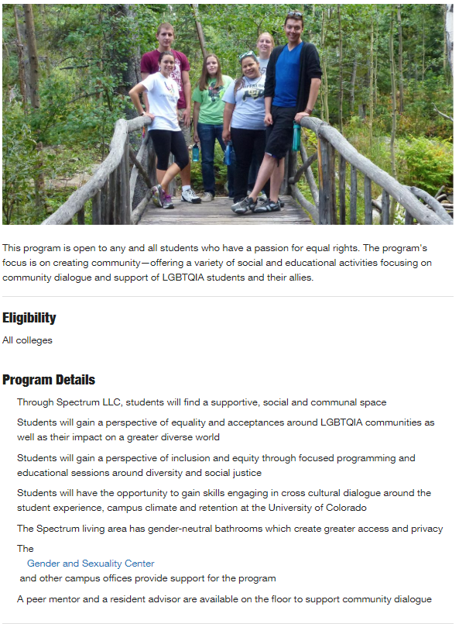

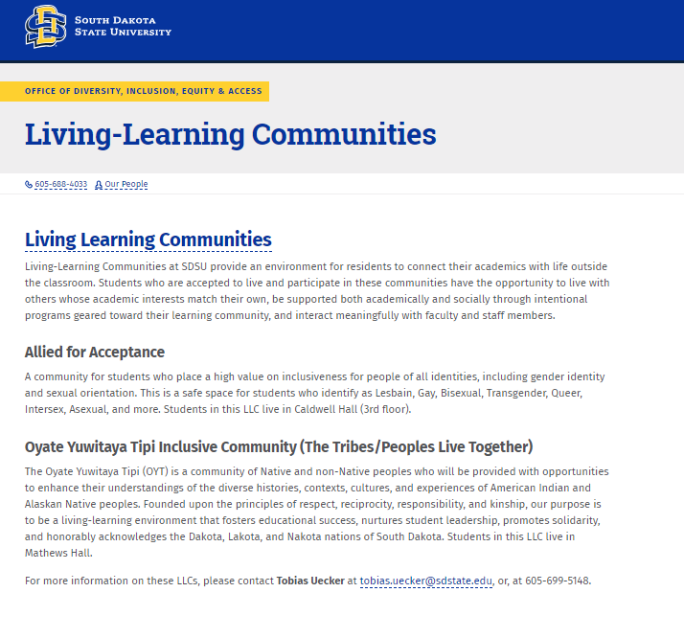**Addendum B**

**Addendum C**

**New Living Learning Committees for 2019-2020**

The creation of new three new Living Learning Communities is congruent with the strategic plan goal of having 100% of incoming first-year students in an LLC by 2020. Each of these communities will have resident assistant staff that is trained specifically to meet the needs of students in this community, and may identify as a member of this community as well. Students may choose to live in these communities as they apply for housing this year. Students will opt into these communities and agree that they fit the requirements as stated in the descriptions below.

**Spectrum Community**

**Location:** Downey Hall

Spectrum is an living option for students who identify as LGBTQIA+ (Lesbian, Gay, Bisexual, Transgender, Queer/Questioning, Intersex, Asexual), additional diverse sexualities and genders, as well as those who identify as allies (those who identify as supportive, welcoming, and inclusive of LGBTQIA+ community members). Students living in this community will have access to optional diversity learning opportunities, programs, and trainings. While all Resident Assistants are trained to create inclusive communities, the RAs of this community will have additional training and knowledge to best support students of all sexualities and genders. UW Residence Life & Dining Services is committed to ensuring that all residents feel welcome and safe to express themselves within our residence halls. We recognize that the Spectrum living environment may not be the best fit for everyone and encourage prospective residents to consider this option fully before selecting to live here.

**Learning Outcomes**

Residents will grow and develop their identity by…

· Having an opportunity to engage with difference through informal interactions and programming

· Finding affinity with other community members in a safe and welcoming environment

· Understanding University resources and support structures and how to utilize them effectively

· Having opportunities to learn about the LGBTQIA+ community through training and educational programs

**Addendum D**

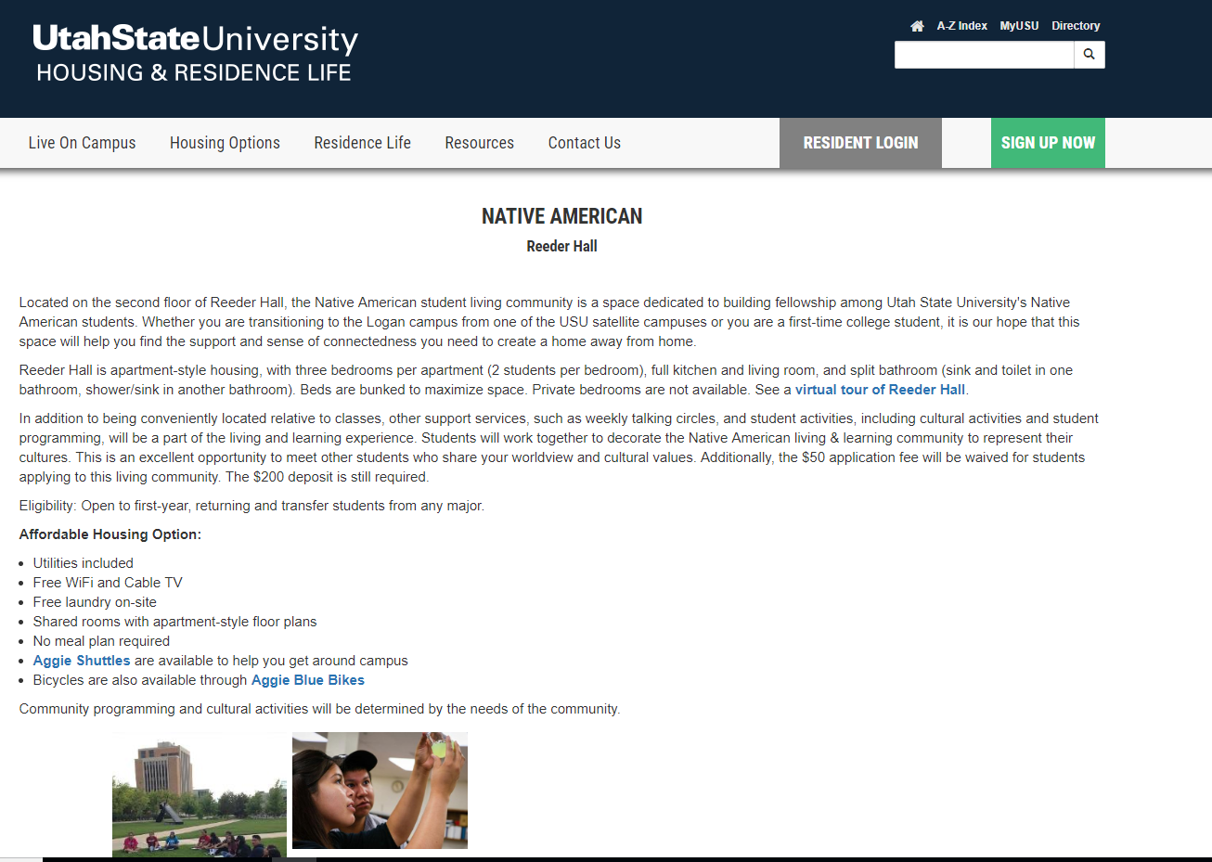

**Addendum E**

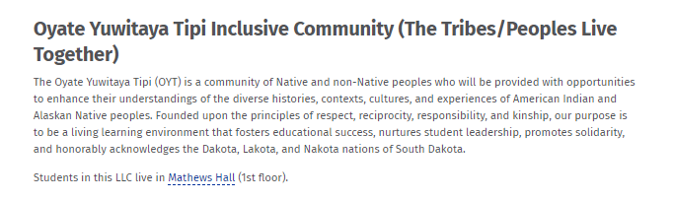from South Dakota State University

**Addendum F**

**New Living Learning Committees for 2019-2020**

The creation of new three new Living Learning Communities is congruent with the strategic plan goal of having 100% of incoming first-year students in an LLC by 2020. Each of these communities will have resident assistant staff that is trained specifically to meet the needs of students in this community, and may identify as a member of this community as well. Students may choose to live in these communities as they apply for housing this year. Students will opt into these communities and agree that they fit the requirements as stated in the descriptions below.

**Native American Community**

**Location:** McIntyre Hall

The Native American Living Learning Community is a cultural community offered to support Native students at the University of Wyoming in collaboration with the Native American Education and Cultural Research Center. While the Native American Living Learning Community is not a FIG (Freshman Interest Group), the floor is an opportunity for Native students to network with one another and create a cultural and learning community within the residence halls. Residents will have the opportunity to engage in programs and events centered on the Native American community.

**Learning Outcomes**

Residents will…

· Find support at UW from RLDS, NAERCC, and community members

· Understand available campus resources such as financial aid, academic support services, and campus engagement opportunities

· Find affinity with Native students and gain a deeper understanding of their cultural identity

· Have educational and programmatic opportunities in their community

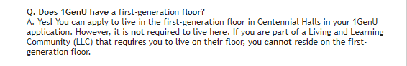**Addendum G**

From University of Denver

**Addendum H**

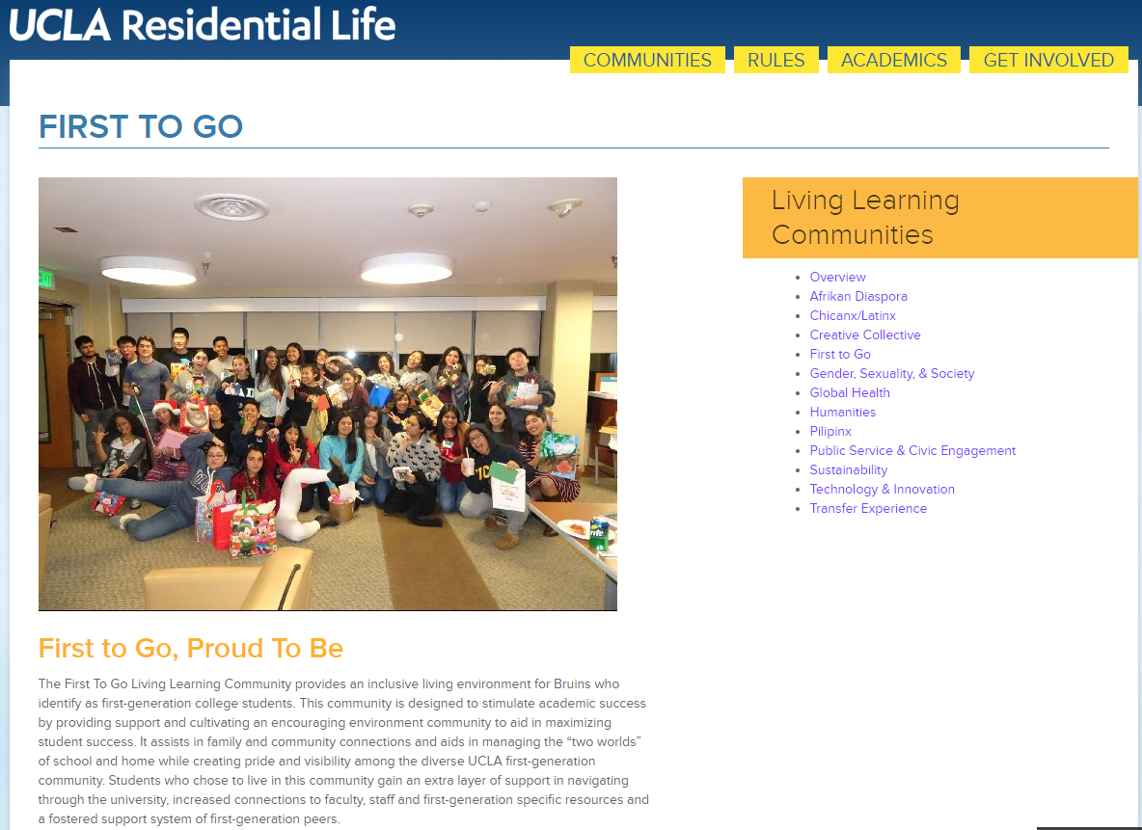

**Addendum I**

**New Living Learning Committees for 2019-2020**

The creation of new three new Living Learning Communities is congruent with the strategic plan goal of having 100% of incoming first-year students in an LLC by 2020. Each of these communities will have resident assistant staff that is trained specifically to meet the needs of students in this community, and may identify as a member of this community as well. Students may choose to live in these communities as they apply for housing this year. Students will opt into these communities and agree that they fit the requirements as stated in the descriptions below.

**First-Generation Community**

**Location:** Tobin House

The First-Generation community is offered to students who are the first in their family to earn a four-year degree. First-generation students can face unique challenges, and this community aims to help students have a successful transition to college. Students who choose this community will have access to additional opportunities to learn about the university, interact with first-generation staff and faculty, and gain valuable skills and resources.

**Learning Outcomes**

Residents will…

· Gain an understanding of University policies, procedures, and support services and how to access them

· Have opportunities to network with first-generation faculty, staff, and alumni

· Gain necessary skills to be academically and professionally successful

· Find affinity with other first-generation students

· Be supported in their adjustment to college culture through intentional programming and RLDS staff presence