**SENATE RESOLUTION #2666**

**TITLE:** ASUW Support for an Elected Board of Trustees

**DATE INTRODUCED:** April 9, 2019

**AUTHOR:** Senator Pierson; SAL Titus

**SPONSORS:** Senators Anselmi-Stith, Lane, Mueller and Strock; Vice President Wilkins; Director of Governmental and Community Affairs Houghton; Director of Diversity Tay

1. WHEREAS, the purpose of the Associated Students of the University of Wyoming (ASUW)
2. Student Government is to serve our fellow students in the best manner possible through
3. accurate representation; and,
4. WHEREAS, as per the Wyoming State Constitution Article 7, Section 17, the majority of the
5. members of the University of Wyoming Board of Trustees (BOT) are appointed by the
6. Governor as shown in Addendum A; and,
7. WHEREAS, the BOT have acted in a manner inconsistent with the values of the ASUW; and,
8. WHEREAS, University of Wyoming (UW) students, staff, and faculty have expressed
9. growing dissatisfaction with many of the recent BOT decisions, as referenced in
10. Addendums B and C; and,
11. WHEREAS, other public institutions have successfully established elected bodies to govern
12. said institutions; and,
13. WHEREAS, such an elected body would better represent members of the UW community in
14. the matters of governing the University.
15. THEREFORE, be it resolved that the Associated Students of the University of Wyoming
16. (ASUW) Student Government strongly recommend to the Wyoming State Senate and House
17. of Representatives that they amend the Wyoming Constitution to reform the Board of
18. Trustees into an elected body; and,
19. THEREFORE, be it further resolved that such an elected body of 12 total voting BOT
20. members should consist of: nine voting BOT members elected by the eligible voters of the
21. State of Wyoming, one voting BOT member elected by the University of Wyoming student
22. body, one voting BOT member elected by the University of Wyoming staff, and one voting
23. BOT member elected by the University of Wyoming faculty; and,
24. THEREFORE, be it further resolved that the 107th Administration of the ASUW Student
25. Government during the Fall 2019 semester shall create and market a survey to University of
26. Wyoming students to evaluate and collect student opinions on the Board of Trustees (BOT)
27. and their current system of appointment; and,
28. THEREFORE, be it further resolved that upon its passage, copies of this resolution shall be
29. sent to the BOT, the office of the Governor of Wyoming, and the members of the Wyoming
30. State Legislature.

**Referred to:** Programs and Institutional Development; Student Outreach and Programming

**Date of Passage:** **Signed:**

**(ASUW Chairperson)**

**“Being enacted on** **, I do hereby sign my name hereto and**

**approve this Senate action.”**

**ASUW President**

**Addendum A**

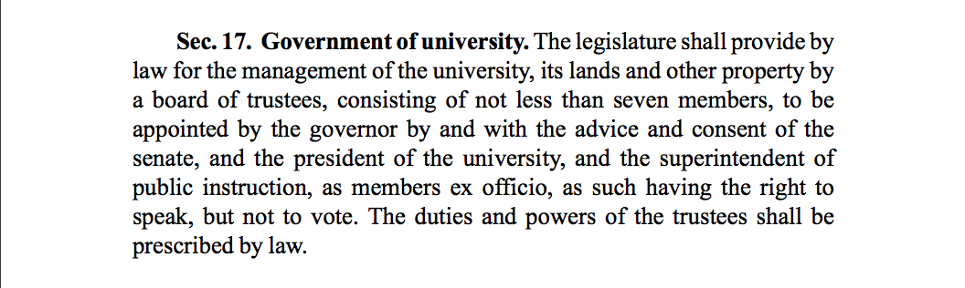

**Addendum B**

**Trustees hear criticism of Nichol’s decision**

[By DANIEL BENDTSEN dbendtsen@laramieboomerang.com](https://www.laramieboomerang.com/users/profile/dbendtsen)

 Mar 28, 2019Top of Form

Bottom of Form

[[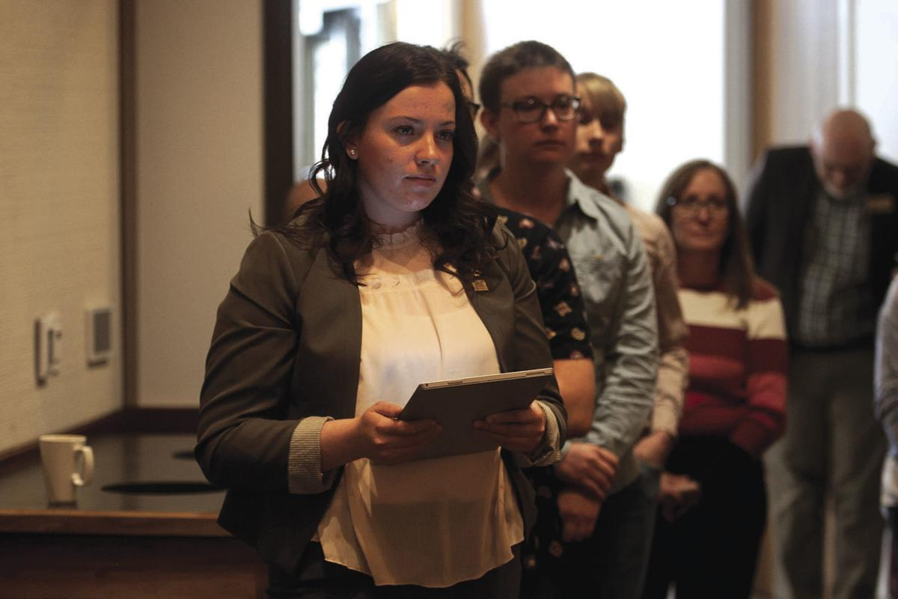](https://www.laramieboomerang.com/content/tncms/live/#1)](https://www.laramieboomerang.com/content/tncms/live/" \l "1)

Jaynie Welsch, former University of Wyoming ASUW vice president, stands in front of a line of more than a dozen people that gathered outside of the Marian H. Rochelle Gateway Center on Thursday in Laramie to show support for UW President Laurie Nichols. ([JOEL FUNK/Boomerang staff](https://www.laramieboomerang.com/users/profile/dbendtsen))

[[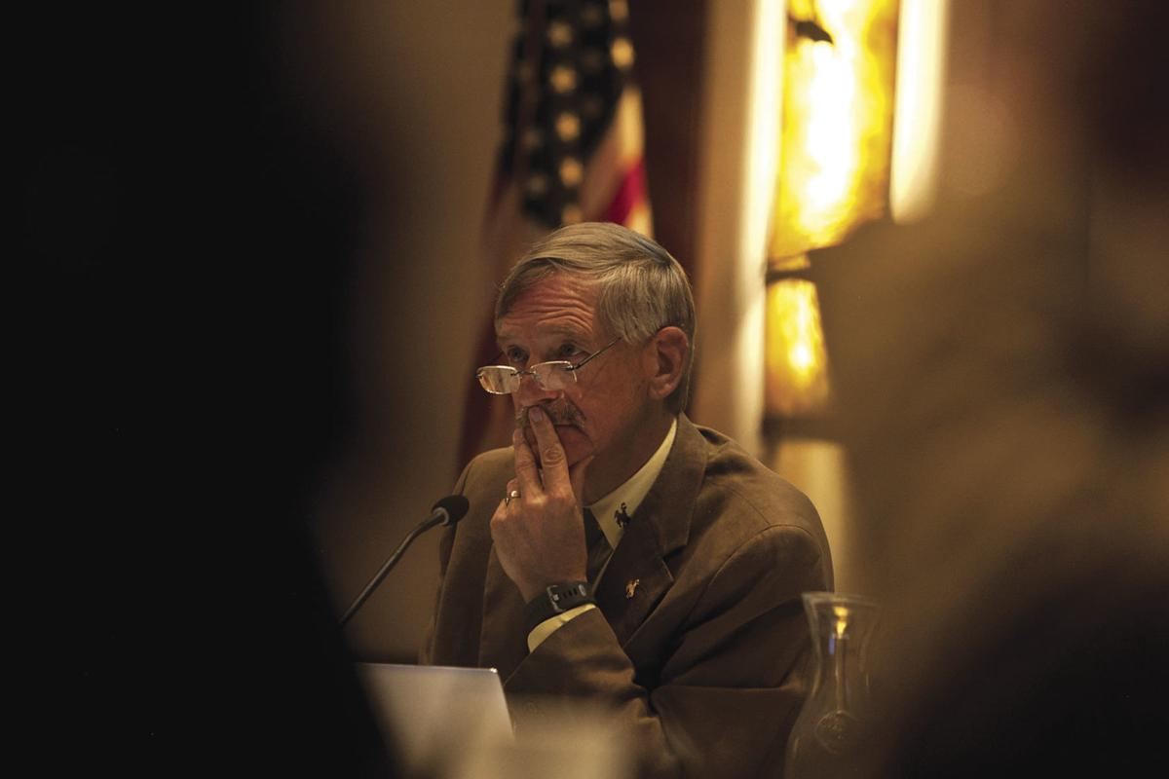](https://www.laramieboomerang.com/content/tncms/live/#2)](https://www.laramieboomerang.com/content/tncms/live/" \l "2)

UW Board of Trustees chairman Dave True listens to public comment Thursday. ([JOEL FUNK/Boomerang staff](https://www.laramieboomerang.com/users/profile/dbendtsen))

Top of Form

Bottom of Form

Public comment periods at the University of Wyoming’s board of trustees meeting typically don’t generate much interest, but it was a different story this week when a group of faculty, staff and students came to the board meeting to lament the decision not to extend President Laurie Nichols’s contract.

Nichols’s three-year contract expires in June. It came as a surprise announcement Monday that the trustees would be moving on from the popular president this summer.

Alex Mulhall, president of UW’s student body, told the trustees that “students deserve as much transparency as possible in the search and hire of a new president.”

Mulhall said Monday’s announcement led to “a resounding shock among students” and thinks “that shock was the result of the positive interaction students have had with Laurie Nichols throughout her time at the university.”

She urged the trustees to better integrate the opinions of faculty, staff and students into their decision-making.

Both Staff Senate president Renee Ballard and Faculty Senate chairman Donal O’Toole also offered praise of Nichols and expressed confusion at the decision.

“This looks bad,” O’Toole said, urging the trustees to publicly and quickly lay out a plan for hiring Nichols’s replacement.

Two students who spoke also suggested that the trustees’ decision was a betrayal of the university community.

“The disgrace of this board’s decision is exacerbated by the fact that faculty, staff and students were intentionally excluded from the discussion surrounding the president’s tenure,” UW student Jordan Pierson said. “I can only imagine the reason for this decision is a result of President Nichols’s success. She has been a champion of students, faculty and staff and we’ve seen her compassion and hard work first-hand during her time here. She stood up for us to this very board and was apparently not successful enough in being a figurehead for members of this board.”

Merav Ben-David, Zoology and Physiology department head, urged the trustees to hire the university’s next president from within UW.

“Someone who knows this institution at its highest success,” she said.

Molly Marcusse, an archivist at the American Heritage Center, urged the trustees to explain their decision.

“I’m going to disagree with all the people who say this is a personnel matter and we don’t know the reason why,” she said. “We are a public land-grant institution. People who lead these institutions know that they’re in a position of accountability. I think that the people … who care about this university deserve an answer. These things don’t go away. It may seem like in a few months, people will no longer be asking questions and you don’t have to answer why this decision was made. … People are still trying to solve the Tom Horn murder of the 1900s. If an answer on (the Nichols ouster) is not provided, people will continue to search for an answer for decades.”

Source:

Bendtsen, Daniel. “Trustees Hear Criticism of Nichols Decision.” *Laramie Boomerang*, 29 Mar. 2019, www.laramieboomerang.com/news/local_news/trustees-hear-criticism-of-nichols-decision/article_1596ae7b-9a68-5b49-9116-5a719579e354.html.

**Addendum C**

**Staff, students praise departing UW President Nichols, demand transparency from board**

[Seth Klamann, 307-266-0544, seth.klamann@trib.com](mailto:Seth%20Klamann%20307-266-0544,%20seth.klamann@trib.com)

Mar 28, 2019 Updated Apr 1, 2019

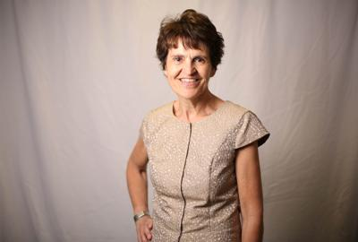

Nichols (File, Star-Tribune)

Top of Form

Bottom of Form

A group of faculty and students took turns Thursday praising departing UW President Laurie Nichols and demanding transparency from the board of trustees that did not renew her contract.

“The phrase I heard around campus is an acronym: WTF,” Faculty Senate Chair Donal O’Toole told the board during a public comment period, referring to shorthand for a more colorful expletive phrase. “... So there are a few things we expect of the board. Courtesy is one of them. I know you are capable of it. I expect you to do it. Please cowboy up.”

“I would suggest the board consider its cowboy ethics and addressing the circumstances that we are in today and will be in for the next few years as we struggle to overcome a very publicly damaging decision,” added Caroline McCracken-Flesher, an English professor.

##### [**In surprise move, Laurie Nichols out as University of Wyoming president**](https://trib.com/news/state-and-regional/govt-and-politics/education/in-surprise-move-laurie-nichols-out-as-university-of-wyoming/article_e7d31dae-c00c-5535-a5a7-8b478c316ed0.html)

A number of people lined up to show support for Nichols, who is the university’s first female president and guided it through a series of public crises in recent years. People crowded around the door, and when one speaker asked who was in the audience to support Nichols, half of the room either stood up or raised their hands. Speakers called for the board to explain, either publicly or at least to Nichols, why her contract wasn’t being renewed.

On Monday afternoon, the university released a brief statement — O’Toole told the board it spanned just 179 words — announcing that Nichols would become a faculty member after her three-year contract expired in late June. Neither board members nor the university has provided any public explanation for the change. O’Toole suggested, both during his public comments and in previous statements to the Star-Tribune, that even Nichols is unaware of why her contract will end after just three years.

Nichols declined to comment via a secretary on Monday, and she did not return a message left on her cellphone Wednesday. She told the Faculty Senate on Monday night that she did not want to discuss details but that she was surprised by the news, according to a tape of a meeting obtained by the Star-Tribune and as first reported by the Laramie Boomerang.

Dave True, the board’s president, has repeatedly declined to provide details of why Nichols will not continue as president. He told the Star-Tribune on Monday that it was a personnel matter. Asked if the board would release more information, he declined to say. As for a plan for replacing Nichols, he told the newspaper on Monday that “with how timely all of this is, the board has not had a chance to evaluate that.”

Flight records indicate that a plane registered to the board flew to Arizona for 90 minutes on March 15, a day after Nichols arrived there for a vacation. Nichols and her husband own a home a brief drive from the airport where the plane landed, records show. Neither True nor other board members would comment on the flight.

**Campus support**

If the public comment on Thursday was anything to go by, the silence from the board has apparently not helped campus process the news, which O’Toole previously said “came out of a clear blue Wyoming sky.”

Renee Ballard, the president of the university’s staff senate, told the board she was shocked and disappointed. She praised Nichols’ strategic plan and the hires she made during her three-year tenure. She said she was concerned that a new president — the fifth in six years — will halt the momentum built under Nichols.

Alex Mulhall, the president of the Associated Students of the University of Wyoming, said students “did feel a sense of shock, not understanding” upon learning that Nichols would be replaced. She urged the board to be transparent going forward. She praised the “positive reaction from Laurie Nichols during her time at the university.”

“Overall, President Nichols has done a fantastic job,” she said.

O’Toole was more critical. He noted that three board members whom he considered bellwethers — David Fall, Macey Moore and Michelle Sullivan — had not resigned and “that’s a signal to” the Faculty Senate.

“This looks bad,” he said. “We’ve had multiple presidents over the last couple of years. This hurts the university in the short term.”

Jaynie Welsh, a former vice president of the university’s student government, said the Nichols decision would have a negative impact and that, as a result, the board was doing a disservice. Jordan Pierson, a senator with the student government, wondered if the board was “demoting” Nichols because of her success championing students, staff and faculty.

“She stood up for us to this very board,” she said. “Apparently, she wasn’t successful enough in being a figurehead for this board.”

McCracken-Flesher, the English professor, asked the board to recall what happened with Bob Sternberg, who was very briefly president before he was replaced with Dick McGinity, Nichols’ predecessor.

“No one came to talk to you to say that was a mistake,” she said. “I think you’re hearing from a lot of people today that perhaps, there’s a decision being made that’s a mistake.”

She looked to Nichols, who was sitting next to True at the front of the room with the rest of the board.

“Thank you President Nichols for your service, and thank you to the board for the continued deliberation on this matter.”

Source:

Klamann, Seth. “Staff, Students Praise Departing UW President Nichols, Demand Transparency from Board.” *Casper Star-Tribune Online*, 28 Mar. 2019, trib.com/news/local/education/staff-students-praise-departing-uw-president-nichols-demand-transparency-from/article_d831f879-ba15-5e01-866f-e509a6efe38c.html?utm_content=bufferc7db3&utm_medium=social&utm_source=facebook.com&utm_campaign=LEEDCC&fbclid=IwAR1RS6AssAzcYLjCYy_swGnqOFhPfn4YfKUtTU2nskOTJrV9mUDYrruQg9k.