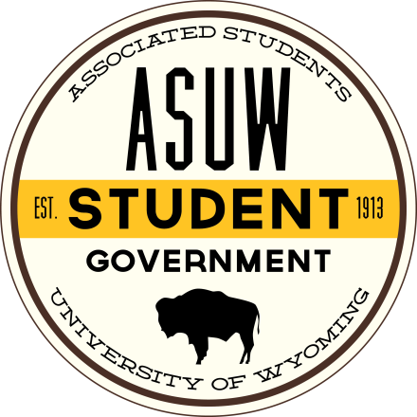

**James C. Hurst Scholarship**

As the Multicultural Student Leadership Initiative (MSLI) was one of James C. Hurst’s special and personal projects, the James C. Hurst Scholarship was established in the hope of recognizing and rewarding an outstanding MSLI mentee. In the spirit of the award, it is assumed that, as a part of their ultimate goals, the recipient will have worked to further the success of MSLI, the success of their own academic career, and success in other areas of student involvement at the University of Wyoming.

Scholarship Requirements

The following policies govern the awarding of the scholarship:

1. Recipient(s) of the scholarship(s) shall be a MSLI mentee(s) and selected by a committee comprised of: an ASUW executive, who will serve as chair of the committee, an ASUW Senator, one member of the ASUW Staff, a designee from the Dean of Students Office, and a student-at-large (hereinafter called “Committee”). All members of the Committee (with the exception of the Dean of Students Office designee) shall be selected by the ASUW President. The above outlined Committee will choose the award recipient during the spring semester of each year.
2. The scholarship application submission deadline shall be determined annually by the ASUW Office Staff and Committee chair in accordance with Student Financial Aid procedures.
3. The recipient must have a minimum GPA of at least 3.0 for the fall semester of the current year; confirmed by the Committee in the spring semester.
4. The recipient of the award shall have demonstrated dedication to, and involvement in MSLI.
5. The recipient shall be judged, in part, by the qualifications he/she provides in a written résumé of campus and community involvements, awards, employment, etc.
6. The recipient shall also be judged, in part, by a 500-750 word essay written on a topic, chosen by the ASUW President (through correspondence with the Multicultural Student Leadership Initiative Advisor) annually, pertinent to MSLI.
7. The recipient shall also be judged, in part, by a letter of reference pertaining to the recipient’s professionalism.
8. Recognition will be given to the award recipient(s) in an annual scholarship reception.
9. The scholarship may be revoked at the discretion of the Committee should the recipient fail to fulfill the requirements of this scholarship.

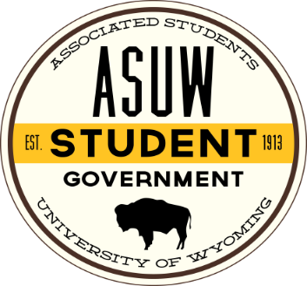

**James C. Hurst Scholarship Application**

Name:

(Last) (First) (Middle Initial)

W#

Local Address:

City, State, Zip:

Permanent Address:

City, State, Zip:

Phone: E-mail:

Home Town Newspaper:

This one-year scholarship will have a value of $1,000 each semester and will be awarded the fall semester following application. This year, ASUW will be awarding 1 (one) $2,000 scholarship to a full time fee paying student at the University of Wyoming.

Please include with this application:

1. A 500 word essay on the following topic:

* As a leader, why and how should you encourage diversity?

1. A résumé of campus and community involvements, awards, employment, etc.
2. A letter of reference from a UW faculty or staff member who can speak to your involvement in leadership activities at UW
3. An official UW transcript (minimum 3.0. GPA for Fall 2013)

I hereby give the University of Wyoming permission to release my grade point average and credit hours completed to ensure that scholarship requirements are met and upheld.

Signature of Applicant: Date:

**DEADLINE – December 15, 2014 BY 5:00PM**

Late Applications WILL NOT be Accepted

RETURN TO THE ASUW OFFICE

(UW Student Union Room 020 located in the basement)