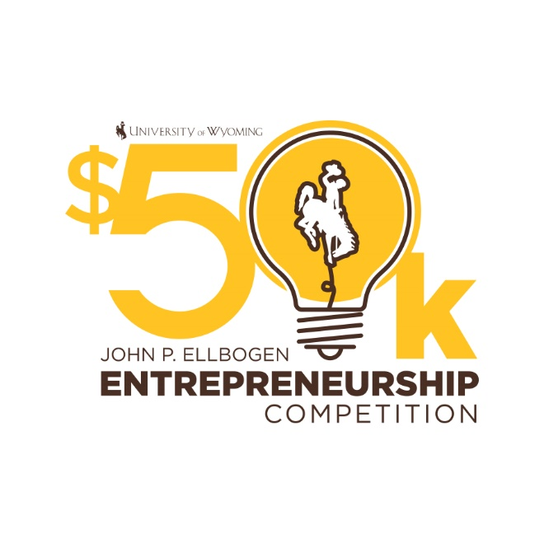

**2024-2025 RULES & GUIDELINES**

**CONTENTS PAGE**

OVERVIEW 3

GENERAL INFORMATION 4

IMPORTANT DEADLINES 4

COMPETITOR ELIGIBILTY 5

COMPETITION GUIDELINES

ROUND 1: 6

ROUND 2: 7

ROUND 3: 8

HISTORY 9

DONOR RECOGNITION 9

JUDGES 9

SCORING RUBRICS

ROUND 1: EXECUTIVE SUMMARY 10

ROUND 2 PART I. WRITTEN BUSINESS CONCEPT 11

ROUND 2 PART II. VIRTUAL PITCH PRESENTATION 12

ROUND 3 PART I. WRITTEN BUSINESS PLAN 13

ROUND 3 PART II. ORAL PRESENTATION 14

JUDGE’S RANKING SHEET 15

PRIZES & AWARDS 16

PROGRESS REPORTS 16

AUXILIARY AWARDS

ETHICAL STARTUP AWARD 17

TOP SUBMISSION AWARDS 18

JON BENSON STUDENT AWARD IN ENTREPRENEURSHIP 19

HELPFUL RESOURCES 20

FAQs 21

For questions or additional information about the

University of Wyoming John P. Ellbogen $50k Entrepreneurship Competition, contact:

ENTR@uwyo.edu | Tel: (307) 766-4197

**OVERVIEW**

Welcome to the 2024-2025 John P. Ellbogen $50k Entrepreneurship Competition ($50k EEC), hosted by the University of Wyoming College of Business.

This competition encourages Wyoming students to act on their talents, ideas, and energy to produce tomorrow’s leading businesses. Such businesses allow Wyoming to grow and diversify its economy and create local jobs. In addition, the competition provides real-world learning opportunities for entrepreneurship students. Open to both undergraduate and graduate students from all Wyoming colleges, the $50k EEC fosters multidisciplinary teams that combine diverse skills for successful ventures.

Since its inception in 2000, the $50k EEC has grown to be the largest student entrepreneur competition in Wyoming. It has hosted over 311 teams, awarded more than $770,500, and provided mentorship and support.

Participation in ROUND 3 requires at least one team member to enroll in ENTR 4700-01 (Business Model Creation & Launch) during the spring semester. This course helps teams develop through collaboration with other students and provides access to entrepreneurial resources. To offset the expense of enrollment in ENTR 4700-01, one member of each finalist team who completes the ENTR 4700-01 course and competes in the final round will be eligible for $1000 Completion Award at the conclusion of the event and the course.

The competition is open to new, independent ventures in the seed, start-up, or early growth stages. It offers resources crucial to entrepreneurship, including:

* Networks of entrepreneurs and entrepreneurial resources
* Mentorship from experienced professionals
* Education in business planning and entrepreneurial skills
* Teambuilding opportunities
* Support and resources for improving customer insight and business model
* Funding and support to launch the winning ventures.

The 2024-2025 competition may include separate Small Business and High Growth tracks, to be determined by a $50k EEC organizing committee based on team registration.

These Rules and Guidelines provide an overview of the competition process from ROUNDS 1 and 2 in the fall semester to ROUND 3 and its events in the spring semester. Review this document thoroughly before applying to understand the competition requirements and judging criteria. The process is designed to help businesses grow from ROUND 1 through each round, practice, and class meeting, ultimately aiming to establish a solid startup foundation by the final competition.

**GENERAL RULES**

Participating in the $50k EEC implies acceptance of the following rules:

* **Entry Fees:** No entry fee.
* **Use of Materials:** The $50k EEC may use any materials prepared for the competition in any media format. Portions of the competition may be videotaped or photographed.
* **Rule Changes:** Rules and prizes may change at the discretion of the $50k EEC. Staff has the right to interpret these rules.
* **Competition Decisions:** All decisions regarding rules, procedures, and winners are at the sole discretion of the $50k EEC and judges.
* **Confidentiality:** Public sessions may be recorded and broadcast. Teams should protect their intellectual property, as confidentiality cannot be guaranteed.
* **Funding Requests:** SEC rules prohibit asking for funding from investors. Ellbogen prize funds do not equate to equity.
* **Copyrights & Permissions:** Teams must obtain permission to use copyrighted materials and provide documentation upon request.
* **IP Disputes:** Judged on a case-by-case basis.
* **Conflict of Interest:** Judges, mentors, volunteers, and staff cannot have any financial interest in competing companies.
* **Special Situations:** Requests for special situations must be submitted in writing to ENTR@uwyo.edu.
* **Rules Violations:** Address questions to ENTR@uwyo.edu. Written reports of violations are required. False reports are violations. The $50k EEC has final authority on violations and penalties, which can be appealed within 72 hours.

**IMPORTANT DEADLINES**

* **Oct 16, 2024:** ROUND 1: Executive Summary Application due (9 am MST).
* **Oct 25, 2024:** Teams for ROUND 2 announced via email.
* **Nov 5, 2024:** ROUND 2: Written Business Concepts Due (9 am MST).
* **Nov 11, 2024:** Judges Part I: Written Business Concepts Scorecards Due (9 am MST).
* **Nov 13-14, 2024:** ROUND 2: Virtual Pitches.
* **Nov 22, 2024:** ROUND 2: Winners Announced.
* **Spring 2025:** ENTR 4700 Coursework (Business Model Creation and Launch).
* **Mar 6, 2025:** Submit final team member changes (9 am MST).
* **March 25 and April 1, 2025:** Pitch Practices (required).
* **Apr 3, 2025:** Final Written Business Plan due (9 am MST).
* **Apr 7, 2025:** (Optional) Ethical Startup Submissions due (9am MST).
* **Apr 10, 2025:** Judges’ Part I: Written Business Plan Scorecards Due (9 am MST).
* **Apr 14, 2025:** Final PowerPoint Slideshow Due (9 am MST).
* **Apr 16, 2025:** Dress Rehearsal for all Teams.
* **Apr 17, 2025:** ROUND 3: Competition and Entrepreneurial Ecosystem Fair (BU 123 & BU Atrium).
* **Sep 1, 2025:** Progress Reports from ROUND 3 Ellbogen Prize Teams Due.

**COMPETITOR ELIGIBILITY**

To compete in the $50k EEC, teams must meet the following criteria:

* **Team Composition:** Open to Wyoming undergraduate and graduate students enrolled through December 2024 at UW or a Wyoming community college. Teams may include up to one non-student member.
* **Age:** All team members must be 18 years or older by April 15, 2025.
* **Team Size:** Teams must have at least one current Wyoming college student and can have up to ten members. A designated Team Leader must be appointed for communication with $50k EEC organizers.
* **Outside Funding:** Ventures with significant private funding in the past three years (before August 2024) are generally excluded, subject to review by $50k EEC organizers.
* **Student Involvement:** Ventures must be student-created and managed. Students must drive the venture, develop the business plan, hold key management roles, and own significant equity.
* **Nature of Ventures:** Eligible ventures include new, independent ventures in seed, start-up, or early growth stages. Excluded are buy-outs, expansions, real estate syndications, tax shelters, franchises, and licensing agreements for distribution in different areas.
* **Licensing Technologies:** Encouraged for ventures based on university-developed research. Waiver of the 50% equity ownership rule is considered case-by-case. All submissions must be original or appropriately licensed.
* **Prior Activity:** Technologies may only be presented once in the $50k EEC, if previously advanced to ROUND 3. Ideas or technologies worked on in prior academic years are eligible if not previously entered in the competition.

The $50k EEC reserves the right to determine team eligibility.

**COMPETITION GUIDELINES: ROUND 1**

**ROUND 1: Executive Summary Application**

**Click application link found on webpage:** [**www.uwyo.edu/business/entrepreneurship**](http://www.uwyo.edu/business/entrepreneurship)

Please note that team leader and team members will each need to submit their own application.

Entry Fees: None.

Required Submissions:

1. Executive Summary (One page of text, single-spaced, plus one optional page of visuals)
2. Each team member must submit:
   * contact & educational background information
   * UW Model Release Form
   * Confidentiality Agreement Form

ROUND 1: Executive Summary, please include at minimum:

1. One page of written text:
   1. company name
   2. problem and solution
   3. customer identification, market analysis
   4. team background/competency
2. (Optional) One page of visuals, examples include:

* marketing/branding
* customer reviews
* drawings/photos of prototype
* customer reviews or data sets/tables

Evaluation of Executive Summary is based on:

* differentiation/value proposition
* customer/market identification
* viability
* Wyoming impact & job creation potential
* team strength
* communication

Selection of ROUND 2 teams will be made by a panel of judges and teams will be notified of their status by October 25, 2024.

**COMPETITION GUIDELINES: ROUND 2**

**ROUND 2: Written Business Concept and Virtual Pitch:**

1. Written Business Concept Due: Nov 5, 2024 (9 am MST). Limit of six pages total of text, single-spaced, to include:
   1. cover sheet
   2. product/service description
   3. market analysis
   4. sales plan
   5. IP status (if relevant)
   6. competitor analysis
   7. team background/competency
   8. financial highlights
2. Virtual Pitch: Nov 13-14, 2024; 8-minute presentation followed by 8 minutes of Q&A with ROUND 2 judges.

Evaluation of both the Written Business Concept and the Virtual Pitch is based on:

* content of concept or presentation
* business information & research
* communication
* financial summary
* probability of successful launch
* Wyoming impact/job creation potential

**COMPETITION GUIDELINES: ROUND 3**

**ROUND 3: Spring Semester 2025**

* Teams are paired with a mentor for the spring semester based on team growth areas.
* Teams are required to participate in the Pitch Practice Sessions March 25 and April 1 during the ENTR 4700 class meeting time.
* Written Business Plan due Apr 3, 2025 (9 am MST) to [ENTR@uwyo.edu](mailto:ENTR@uwyo.edu). Please include:
  + cover page: company name, school, presenting team members, leader contact info.
  + table of contents
  + executive summary (one page)
  + body of paper (up to ten pages)
    - product or service description (include status of development)
    - customer/market analysis (market size and potential market share)
    - sales and marketing plan (how will you go-to-market)
    - intellectual property status (e.g., patents, licenses, etc., if applicable)
    - competitor analysis (competitors and your competitive difference)
    - management team and/or advisors, including relevant experience.
    - financial highlights (summary of cash flow, income statement, balance sheet)
    - planned use of Ellbogen funds (if they be awarded; how will your team utilize Ellbogen funds?)
  + non-financial appendices (up to five pages)
  + financial projections (up to five pages)
  + citations (up to two pages)
  + total paper length (up to 25 pages, following limits for all individual sections above)
* PowerPoint due Apr 14, 2025 (9 am MST) to [ENTR@uwyo.edu](mailto:ENTR@uwyo.edu).
* Dress Rehearsals: Apr 16, 2025.
* Final Event/Oral Presentations: Apr 17, 2025; 8 minutes presentation + 8 minutes Q&A.

Judging of Written Business Plan and Oral Presentation is comprised of these dimensions:

* Written Business Plan
  + executive summary
  + products or services
  + market and marketing strategy
  + management
  + summary financials
  + viability/serviceability
  + overall assessment of written plan
* Oral Presentation
  + market opportunity
  + distinctive competence
  + management capability
  + financial understanding
  + viability/effectiveness
  + presentation

ROUND 3 judges have full discretion to award prize funds.

**HISTORY**

A $10k Competition was formed in 2001 with contributions from First Interstate Bank and the Woodson Family Foundation. Its mission was to provide a platform for student entrepreneurs to develop their business plans and compete for cash prizes to continue their entrepreneurial pursuits after college. In 2005, First Interstate Bank made a commitment that was matched by the state of Wyoming, and in 2010 the John P. Ellbogen Foundation made a commitment that was also matched by the state of Wyoming. In 2011 the name was changed to the John P. Ellbogen $30k Entrepreneurship Competition. In 2017, First Interstate Bank and the John P. Ellbogen Foundation made additional commitments matched by the state of Wyoming that would increase the cash prize given each year, so the name changed once more to become the John P. Ellbogen $50k Entrepreneurship Competition ($50k EEC). The $50k EEC and Entrepreneurship Programs at UW College of Business have benefitted from the creation of several other entrepreneurship-related endowments from donors including G. Russell Mortenson in 2006, Charles A. Micale Foundation in 2008, Gary P. McDaniel in 2017, Patrick C. Rile and Kathleen L. Rile in 2020. Thanks to their support, the competition awards at least $50k in prizes every single year.

**DONOR RECOGNITION**

The John P. Ellbogen $50k Entrepreneurship Competition Organizing Committee would like to recognize the support and commitment of generous donors to UW College of Business Entrepreneurship Program and the John P. Ellbogen $50k Entrepreneurship Competition, including:

* First Interstate BancSystem Foundation Entrepreneurship Fund, 2005 – Present
* Bud & Bing Mortenson Entrepreneurship Endowment, 2006 – Present
* Charles A. Micale Foundation Entrepreneurship Competition Excellence Fund, 2008 – Present
* John P. Ellbogen Foundation, 2010 – Present
* McDaniel Family Entrepreneurship Excellence Fund, 2017 – Present
* Rile Excellence Fund in Entrepreneurship, 2020 – Present

**JUDGES**

Judges are selected by the $50k EEC to include a diverse group of individuals with experience in a variety of backgrounds. Judges of ROUND 3 will not judge other rounds.

Upon acceptance of the invited role of JUDGE, Judges **MUST** fill out and submit

the following forms and information:

1. Contact Information
2. Model Release Form
3. Confidentiality Agreement Form
4. Bio Headshot Photo (ROUND 3)
5. Bio Information (ROUND 3)

**Conflict of Interest Statement:** No judge, financial consultant, mentor, volunteer, or competition staff member may have any vested interest, equity stake, or financial stake in any of the competing companies until after completion of the competition. Any of the previously listed parties that stand to gain financially or otherwise from the success of any of the competing companies is strictly prohibited until their completion of the competition. Any such associations will result in disqualification of the team and/or removal of that individual from his/her associated position with the competition.

**SCORING RUBRIC**

**ROUND 1: EXECUTIVE SUMMARY**

Team/Company Name:­­­­­­­­­­­­­­­­­­­­­­­­­­__________________________________________

**Instructions for judge: Please evaluate the Executive Summary on the following aspects:**

**Differentiation/Value Proposition Strongly Disagree Strongly Agree**

The business idea is differentiated from its competition. 1 2 3 4 5 6 7

**Customer & Market**

The customer or target market has been thoroughly identified. 1 2 3 4 5 6 7

**Viability of Business Venture**

This business venture appears viable. 1 2 3 4 5 6 7

**Wyoming Impact/Job Creation Potential**

This venture will impact the community and create jobs. 1 2 3 4 5 6 7

**Team Strength**

Team possesses identifiable strengths for this business idea. 1 2 3 4 5 6 7

**Communication**

This team communicated their ideas clearly. 1 2 3 4 5 6 7

**Strengths of the Business Concept**

**Areas for Improvement**

**SCORING RUBRIC**

**ROUND 2 Part I. Written Business Concept**

*(Completed PRIOR to virtual pitches)*

Team/Company Name:­­­­­­­­­­­­­­­­­­­­­­­­­­__________________________________________

**Instructions for judge: Please evaluate the Written Business Concept on the following aspects:**

**Content of Concept Strongly Disagree Strongly Agree**

Concept is clearly identified. 1 2 3 4 5 6 7

**Business Information & Research**

Effective amount of business information

and research to support potential venture. 1 2 3 4 5 6 7

**Communication**

Writing and visuals are clear & effective. 1 2 3 4 5 6 7

**Financial Summary**

Demonstrates consistency with plan and details

utilization of potential prize money. 1 2 3 4 5 6 7

**Probability of Successful Launch**

This venture appears to have viability. 1 2 3 4 5 6 7

**Wyoming Impact/Job Creation Potential**

This venture will impact the community and create jobs 1 2 3 4 5 6 7

**Strengths of the Business Concept**

**Areas for Improvement**

**SCORING RUBRIC**

**ROUND 2 Part II. Virtual Pitch Presentation**

Team/Company Name:­­­­­­­­­­­­­­­­­­­­­­­­­­__________________________________________

**Instructions for judge: Please evaluate the Pitch Presentation on the following aspects:**

**Content of Presentation Strongly Disagree Strongly Agree**

Concept is clearly identified. 1 2 3 4 5 6 7

**Business Information & Research**

Effective amount of business information

and research to support potential venture. 1 2 3 4 5 6 7

**Communication**

Speakers and visuals are clear & effective. 1 2 3 4 5 6 7

**Financial Summary**

Demonstrates consistency with plan and details

utilization of potential prize money. 1 2 3 4 5 6 7

**Probability of Successful Launch**

This venture appears to have viability. 1 2 3 4 5 6 7

**Wyoming Impact/Job Creation Potential**

This venture will impact the community and create jobs 1 2 3 4 5 6 7

**Strengths of the Business Concept**

**Two Specific Areas for Improvement**

**SCORING RUBRIC**

**ROUND 3 Part I. Written Business Plan**

*(Completed PRIOR to competition)*

Team/Company Name:­­­­­­­­­­­­­­­­­­­­­­­­­­__________________________________________

**Instructions for judge: Please evaluate the Written Business Plan on the following aspects:**

**Executive Summary Strongly Disagree Strongly Agree**

This is a clear, exciting and effective

stand-alone overview/plan. 1 2 3 4 5

**Products or Services**

Plan covers features and benefits, pricing, current

stage of development, and proprietary position or key functions. 1 2 3 4 5

**Market and Marketing Strategy**

Plan describes market, shows competitive analysis, needs

identification, unique capabilities, and sales/promotion. 1 2 3 4 5

**Management**

Plan describes backgrounds of key individuals, ability to execute

strategy, people operations, and the organizational

structure. 1 2 3 4 5

**Summary Financials**

Financials are presented in summary form, easy to read and

understand, consistent with plan and effective. 1 2 3 4 5

**Viability/Serviceability**

Proposal is investible or serviceable and shows ability to move to

production or service 1 2 3 4 5

**Overall Assessment of Written Plan**

The plan is clear and compelling. 1 2 3 4 5

**Strengths of the Written Business Plan**

**Areas for Improvement**

**SCORING RUBRIC**

**ROUND 3 Part II. Oral Presentation**

Team/Company Name:­­­­­­­­­­­­­­­­­­­­­­­­­­__________________________________________

**Instructions for judge: Please evaluate the Oral Presentation & Business Viability on the following aspects:**

**Market Opportunity Strongly Disagree Strongly Agree**

There is a clear market need presented

as well a clear solution to that need. 1 2 3 4 5

**Distinctive Competence**

The company provides something novel/unique/

special that gives it a competitive advantage in its market. 1 2 3 4 5

**Management Capability**

This team can effectively develop this company and its people

And handle the risks associated with the venture. 1 2 3 4 5

**Financial Understanding**

This team has a solid understanding of the financial

requirements of the business. 1 2 3 4 5

**Viability/Effectiveness**

The business represents a real investment opportunity

in which one would consider investing or an effective non-profit

structure which one would consider supporting. 1 2 3 4 5

**Presentation**

The team presented their venture in a logical, persuasive

manner, and answered questions well. 1 2 3 4 5

**Strengths of Presentation**

**Areas for Potential Improvement**

**JUDGE’S RANKING SHEET**

**Instructions for judge:** At the END of the competition, please rank all **8** presenting companies from highest (1) to lowest (8). Please do NOT use the same number twice (i.e., no ties).

**RANKING**

**(1 = highest/best, 8 = lowest/worst)**

**Company Name: _________________________________ _______________________________**

**Company Name: _________________________________ _______________________________**

**Company Name: _________________________________ _______________________________**

**Company Name: _________________________________ _______________________________**

**Company Name: _________________________________ _______________________________**

**Company Name: _________________________________ _______________________________**

**Company Name: _________________________________ _______________________________**

**Company Name: _________________________________ _______________________________**

**PRIZES & AWARDS**

Prize awards may be subject to taxes and are the responsibility of the recipient. Prizes will be awarded to a team only after the team completes a UW Supplier Registration. Please note that payments sometimes take several weeks to be processed, and check with the $50k EEC Project Coordinator with any questions you have.

Ellbogen Fund awards (up to $50,000) are given at the judges' discretion. Winners receive half the prize money after the competition and the other half after submitting a satisfactory Progress Report (see below) in the fall.

Auxiliary Award winners (e.g., Ethical Startup Award, Top Submissions, Jon Benson Student Award in Entrepreneurship) must also have a Supplier Form or W-9 Form on file with COB before prizes are paid.

**PROGRESS REPORTS**

Ellbogen Fund prize winners must submit a Progress Report by Monday, September 1, 2025, via email to ENTR@uwyo.edu in PDF format. Files should be named: PR_CompanyName.pdf.

The second prize installment depends on the judges' approval of the Progress Report, which should include:

- Brief business introduction/background

- Goals & objectives (including any changes)

- Progress & achievements

- Problems & solutions

- Budget details (how the first prize installment was used and plans for the final installment)

- Sales performance (if applicable)

- Income & profit analysis (if applicable)

- Time management

- Working environment

- Personal reflections & learning experiences

- Next steps

Teams will be notified by the project coordinator of the $50k EEC if their Progress Report is accepted or denied. Denied teams have a final deadline of Friday, December 4, 2025 to submit a Progress Report for second installment consideration; otherwise, prize winnings will be void.

**ETHICAL STARTUP AWARD**

Funded by:

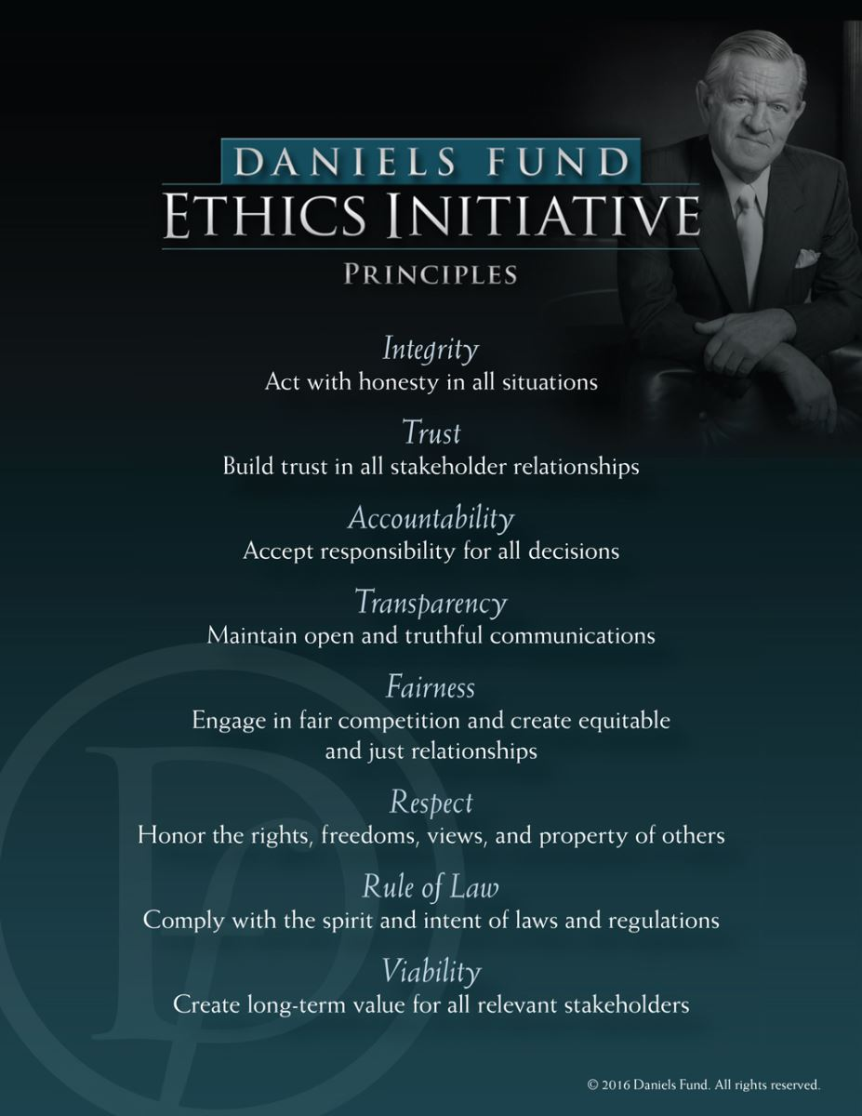**Award:** $2,500 from the Daniels Fund Ethics Initiative Collegiate Program at the University of Wyoming.

**$50k EEC Team Entry Process:** Teams competing in ROUND 3 of the $50k EEC may apply for the Ethical Startup Award by submitting a strategy for creating an ethical culture within their organization. Strategy proposal must be received by [ENTR@uwyo.edu](mailto:ENTR@uwyo.edu), by **Monday, April 7, 2025, 9 am MST**. The proposal should utilize the eight Daniels Fund Ethics Initiative Principles (pictured at right) as the framework through which to create your ethical culture. Submissions should demonstrate the applicability of the principles to your business. Please note proposals must be two pages or less and in the APA format style.

**Selection Process:** The winning proposal will be selected by a team of judges chosen from the executive board of UW’s Ethics Club.

**Announcement of Winner:** The winner of the Ethical Startup Award will be recognized at the $50k EEC, April 17, 2025.

**Questions:** Please contact Daniels Fund Ethics Initiative Faculty Fellow Kent Noble, at [knoble@uwyo.edu](mailto:knoble@uwyo.edu).

**TOP SUBMISSION AWARDS**

Funded by:

1. **Top Submission - Community College** Team (Eligibility: Any team with at least one community college member)
2. **Top Submission - Female Entrepreneur** (Eligibility: Any team with at least one female member)
3. **Top Submission - Social Enterprise** (Eligibility: Any team with a social mission)

**Award**: $2,000/Award

**$50k EEC Team Entry Process:** Teams competing in ROUND 3 of the John P. Ellbogen $50k Entrepreneurship Competition ($50k EEC) are automatically eligible for these awards.

**Selection Process:** Winners of the Top Submission Awards will be selected by the judging panelists.

**Announcement of Winners:** The winners of the Top Submission Awards will be announced during the Announcement of Awards, April 17, 2025.

**Questions:**  Please contact [ENTR@uwyo.edu](mailto:ENTR@uwyo.edu)

**JON BENSON STUDENT AWARD IN ENTREPRENEURSHIP**

Funded by a generous endowment set up through the University of Wyoming Foundation in honor of Jon Benson and:

**ABOUT THE AWARD**

The Jon Benson Student Award in Entrepreneurship celebrates Jon Benson’s inspiring journey from academia to entrepreneurship. The Jon Benson Wyoming Impact Award celebrates Dr. Benson's inspiring vision for identifying and cultivating high-growth businesses in Wyoming. With boundless passion and unwavering dedication, he joined the University of Wyoming in 2005 to develop and operate the first technology-focused business incubator in the state. Over his thirteen years of dedicated service at UW, he advised hundreds of Wyoming-based startups and faithfully educated university students in entrepreneurship, driven by the belief that entrepreneurial skills are teachable and crucial for Wyoming's economic diversification efforts.

Jon Benson

Eligibility: any ROUND 3 team

**Award**: $2,500

**$50k EEC Team Entry Process:** Teams competing in ROUND 3 of the John P. Ellbogen $50k Entrepreneurship Competition ($50k EEC) are automatically eligible for this award.

**Selection Process:** Winners of the Jon Benson Student Award in Entrepreneurship will be selected by the judging panelists.

**Announcement of Winners:** The winner of the Jon Benson Student Award in Entrepreneurship will be announced during the $50k EEC Announcement of Awards on April 17, 2025.

**Questions:**  Please contact [ENTR@uwyo.edu](mailto:ENTR@uwyo.edu)

**HELPFUL RESOURCES**

These resources can help you build your business plan.

**IMPACT 307**

<https://www.impact307.org/>

IMPACT 307 is a network of innovation-driven business incubators committed to growing and strengthening Wyoming’s entrepreneurial community by providing resources and support for founders to thrive.

**Small Business Development Center (SBDC)**

<http://www.wyomingsbdc.org/>

No-cost, confidential advising and technical assistance to help entrepreneurs start, grow, reinvent, or exit their business.

**How to Build a Startup (Online Course)**

<https://www.udacity.com/course/how-to-build-a-startup--ep245>

In an introduction to the basics of the famous Customer Development Process, Steve Blank provides insight into the key steps needed to build a successful startup.

The main idea in this course is learning how to rapidly develop and test ideas by gathering massive amounts of customer and marketplace feedback. Many startups fail by not validating their ideas early on with real-life customers. To mitigate that, students will learn how to get out of the building and search for the real pain points and unmet needs of customers. Only with these can the entrepreneur find a proper solution and establish a suitable business model.

Building a startup is not simply building an execution plan for a business model that the entrepreneur thinks will work, but rather, a search for the actual business model itself.

**U.S. Small Business Administration**

<http://www.wyomingsbdc.org/>

Supporting America's small businesses. The SBA connects entrepreneurs with lenders and funding to help them plan, start and grow their business.

**LivePlan ($20/month)**

<https://www.liveplan.com/>

Over 550 sample business plans included for all sorts of businesses; find a sample plan and use it as a guide to write your own. Offers step-by-step instructions, full financial forecast, one-page pitch builder and more.

**FAQs**

* **How are teams selected to compete in the $50k EEC?**

Teams are selected based on the evaluation and scoring of their submitted work in each ROUND. A small group of judges with various expertise review and evaluate each submission based on the judging criteria outlined in the Rules.

* **If selected to compete, does the competition cover any of my travel expenses?**

Mileage, per diem and accommodation are provided to out-of-town teams for them to be able to attend dress rehearsal, final ROUND of competition, and awards.

* **How many people can be on one team?**

Teams must be between one (1) and ten (10) members.

* **Can I change my team after I’ve submitted my application?**

Teams have until March 6, 2025, to make any changes to composition. Any changes must result in a team that meets eligibility requirements as listed in the Rules section. You **MUST** notify the $50k EEC of the team changes.

* **Can I enter more than one idea into the competition?**

Yes. You may enter as many ideas as you would like, however, you may only present one idea in the final ROUND of the competition.

* **Can I see examples of plans that have won the competition in the past?**

A past winner has offered to share their entries from ROUNDS 1, 2 and 3.

* **How is the confidentiality of the intellectual property protected?**

We are able to ask mentors, judges, staff, volunteers, and teams to sign a confidentiality agreement. However, while the $50k EEC will make every effort to limit distribution of business plans presented at the competition, but due to the nature of the competition the $50k EEC cannot guarantee that other individuals will not obtain access to electronic or hard copies of the business plan. All presentations are open to the public, and some presentations may be recorded. Attendance by media personnel may occur. When in doubt, protect your ideas and IP.

* **Who are the judges and what are their backgrounds?**

We select a diverse group of individuals with experience in a variety of backgrounds.

* **If I win, do I have to invest the prize money in my business?**

Yes. To accept prize funds a team will need to apply for a UW Supplier number which will involve the necessity for the business entity to have a Tax ID Number on file with UW.

Have additional questions not addressed here? For questions or additional information about the

University of Wyoming John P. Ellbogen $50k Entrepreneurship Competition, contact us at:

[ENTR@uwyo.edu](mailto:voight@uwyo.edu) | Tel: (307) 766-4197