ACEC Member Organization
2019 Scholarship Application
Complete all sections of this application to the Member Organization address below:
Name of Member Organization
Address
City, State & Zip Code
Telephone Email

Include a certified grade transcript(s) and clearly identify your cumulative grade point average(s) on a four-point scale:
My Bachelor’s (Undergraduate) GPA is:

Applicant’s Name:
I am applying for the following ACEC scholarship (select only one):
General Scholarships – six available
Specialty Scholarship – one CASE scholarship available
Note: To qualify for the CASE scholarship, you must be enrolled in a Master’s degree program in Structural Engineering in the fall of 2019. Students who qualify for the CASE scholarship will also be eligible for the General scholarships.

In the fall of 2019, I will enter (indicate one):
Junior year Senior year Fifth-year Master’s
College/University:
Degree/Discipline expected (with date):

Include certified grade transcript(s), including 2018 Fall Semester, and clearly identify your cumulative grade point average(s) on a four-point scale:
My Bachelor’s (Undergraduate) GPA is:
My Master’s GPA is:
General Information
Name:
Home Address:

College Address:

Phone: Home: ( ) _School: ( )
Cell Phone: ( )
Email Address:
Personal Information
Age: Date of Birth: Citizenship:
Parent/Guardian: Name:
Address:

Current College/University
Name:
Address:

Date Admitted:
Degree/Discipline expected (with date):
Educational Background
List most recent additional educational institution first. Use additional sheets and attach if necessary.
College/University & Address:

Dates of Attendance: Degree/Discipline Awarded:

College/University & Address:

Dates of Attendance: Degree/Discipline Awarded:

College/University & Address:

Dates of Attendance: Date of Graduation:

Secondary School (High School) & City:
Dates of Attendance: Date of Graduation:
Work Experience
Work experience is limited to the last three years prior to the date of your application. List most recent work experience first. Use additional sheets and attach if necessary.
Employer:
Address:

Dates: Total Time (Months): Hrs/Weeks:
Supervisor’s Name and Title:
Your Position:
Duties:
Year in School: Type of Business:

Employer:
Address:

Dates: Total Time (Months): Hrs/Weeks:
Supervisor’s Name and Title:
Your Position:
Duties:
Year in School: Type of Business:

Employer:
Address:

Dates: Total Time (Months): Hrs/Weeks:
Supervisor’s Name and Title:
Your Position:
Duties:
Year in School: Type of Business:

Employer:
Address:

Dates: Total Time (Months): Hrs/Weeks:
Supervisor’s Name and Title:
Your Position:
Duties:
Year in School: Type of Business:
College Activities
Indicate any leadership positions held in the listed activities or organizations. Use additional sheets and attach if necessary.
Student Organizations:

Community Activities:

Organized Athletics and/or Musical Activities:

Other:

Essay
On a separate sheet of paper write a short essay (approximately 500 words) on the following topic: Describe how consulting engineers make their community a better place to live both technically and socially.
Your interest, understanding and commitment to the business and management of the profession are important and should be reflected in the essay.
Permission To Release or Validate Information
By signing this application, I authorize ACEC and its state Member Organizations to confirm and/or release any information included on this application.
Applicant’s Signature: Date:

I have reviewed this application and I recommend the student for consideration.
Dean or Professor’s Signature: Date:
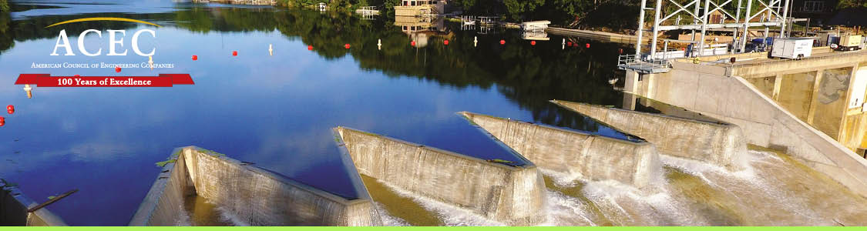
2019 ACEC Scholarship Recommendation Form
Complete this form and return to the Member Organization address below by:
Name of Member Organization
Address
City, State & Zip Code
Telephone Email

Name of Student:
Name of School:
Degree/Discipline Expected:
Date Expected:

Your Name:
Title:
Organization:
You are (indicate one): Engineering professor Consulting engineer Land Surveyor
Address:

How long, how well, and in what capacity have you known the applicant?:

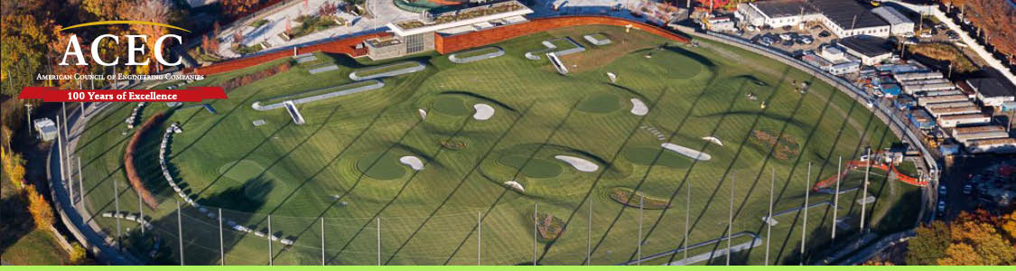
Please rate the student in each of the following categories (rating 1, 2, 3, 4, or 5; with 1 the lowest and 5 the highest). Rate each category as best you can, do not leave any catergory without a rating point.
Rating Use space below to explain your answers
Cooperation
Leadership
Initiative
Industrious
Dependability
Courtesy
Maturity
Self-control
TOTAL POINTS
Why will the student be a good engineer?

Signature: Date:

