Superintendent eInternship Guide

eInternship Sections

Your eInternship will be set up on a Google site and must contain the following sections:

Section One (4 Pages)

- Internship Plan –description of where you are interning, with whom you will be interning, and when you will be interning.
- School University Agreement for Internship in Educational Leadership
- Intern Agreement Form
- Pre-Internship Self Evaluation

Section Two (1 Page)

Do not log hours until you receive approval from your University of Wyoming Supervisor. When you have completed 110 hours with your mentor, your mentor must sign the log. Then scan and upload the logs to Section Two. You should have two logs with mentor signatures.

Section Three (3 Pages)

- Post-Internship Self Evaluation
- At the end of the internship please complete a 1-2 reflection of your internship experience.
- Mentor evaluation (to be completed by your mentor when you are finished with your hours) - please review the evaluation with your mentor and upload the evaluation to this page.

Google Site Tutorial

Google Sites is a free Internet Wiki based on collaborative web design. You may use it to create your eInternship packet. Unlike many wikis, Google Sites does not require you to learn HTML, CSS, or Wiki syntax to develop content. You can also determine who can access your content; your eInternship packet should be private and limited to you and your internship supervisor.

Below is a list of topics covered in this tutorial. This tutorial is only meant to provide the basics of Google sites. Additional forums are located at http://www.google.com/support/forum/p/sites?hl=en

- Obtain an Account
- Create a New Site
- Create a New Page
- Edit a Page
  - Insert a Link
  - Insert an Image
  - Insert a Table
  - Insert a YouTube Video
- Remove Attachments/Comments from a Page
- Preview a Page
- Delete a Page
- Site Navigation
  - Add Pages to Navigation List
  - Reorder Pages from Navigation List
  - Remove Pages from Navigation List
  - Remove Recent Site Activity from Sidebar
- Share your eInternship

Obtain a Google Sites Account
To obtain a Google sites account you will need to have a Google Account. Those of you who already use Gmail or related Google Services already have access to Google Sites. Just navigate to http://sites.google.com and login using your Google account information. If you need to create an account, navigate to http://sites.google.com and select the Sign up for Sites option on the page. You will be asked to fill out a form and then allowed to login to your site.

Create a New Site
If you have not created a site, you will be presented with a brief overview of the program. Click the Create site button.
eInternship
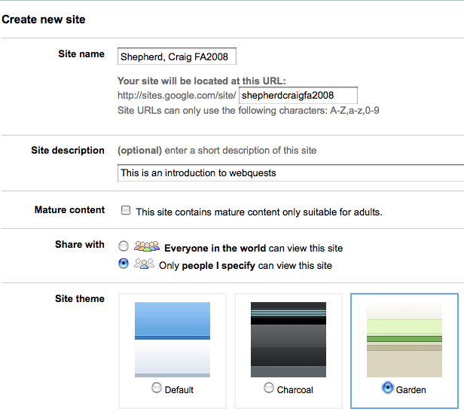
- Name your site “Last name, First name eInternship”
- In the Share with option select “Only people I specify can view this site”
- Pick a site theme
- Type the code to verify that you are a real person
- Select the Create site button

Once you create a site, the home page will automatically generate (pictured below). The Home page is a special page because it automatically displays when your site is entered. Because of this, you will retitle it to become your eInternship introduction page (see Edit a Page for details).

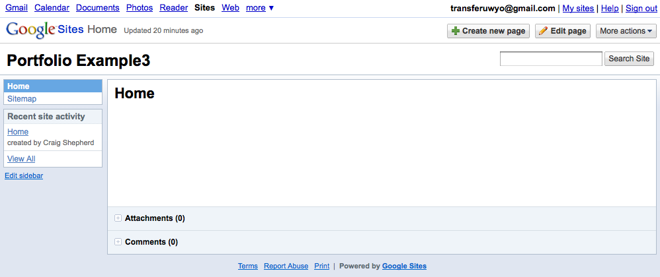
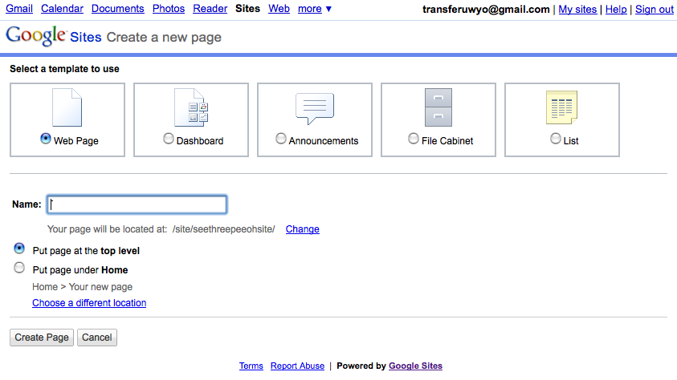
Create a New Page
- Click the Home link in the navigation bar
- Click the + Create new Page button in the top-right of your screen.
- Title your page
- Select the Webpage template
- Select “Put the page at the top level”
- Select Create page

Edit a Page
- Navigate to the page you want to edit
- Click the Edit page button
- A page editor will appear. Within this editor you can alter the title of your page, type content, format text, insert images, etc.
- Select the Save button

Insert a Link:
- Type the text that you want displayed on your page
- Highlight this text with your cursor
- Select the Link button from the menu
- Indicate if you want to link to a web address or to another page on your website
- Select if you want your link to open in a new window
- Type (or paste) the address to the page
- Click the OK button

Insert an Image:
- Select the Insert menu
- Choose Image from the list
- In the pop-up window, indicate if you will obtain your image from a website or if you will upload it from your computer
- Locate the image
- Click on the Add image button
- A window will appear below your image. Indicate whether you want to align your image to the left, center, or right of the screen, what size you want you image, and whether you want to wrap text around it. If these links don’t appear underneath your image, click on your image to select it.

Insert a Table:
- Select the Table menu
- Scroll over Insert Table from the list and select the number of rows and columns by highlighting them in the grid that appears
- After highlighting the number of rows and columns, left-click your mouse
- Click within a cell to add text
- To add or delete additional rows or columns, select the Table button, and choose the corresponding option from the list

Insert a YouTube Video:
Note: If your video is hosted outside of YouTube, create a hyperlink to it.
- Select the Insert menu
- Scroll over Video and choose YouTube from the list
- Copy and paste the web address for this video into the provided box
- Indicate whether you want a border or title in your video
- If you want a title, be sure to enter it in the box
- Press the Save button

Remove Attachment/Comments Options from a Page
- Navigate to the page you want to remove attachment or comment options
- Click the More actions button.
- From the drop-down list, select Page settings
- Deselect Allow attachments and/or Allow comments from the list
- Click the Save button.

Preview a Page
Google Sites provides tools, features, and page views to web authors that are not shown to average viewers. However, they also provide a tool to preview what your page will look like to someone else.
- Navigate to the page that you want to view
- Click on the More actions button
- From the drop-down list, select Preview page as viewer

Delete a Page
- Navigate to the page that you want to remove
- Click on the More actions button.
- From the drop-down list, select Delete

Site Navigation
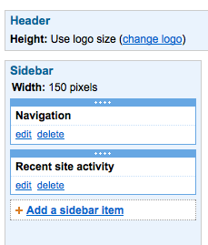
The navigation menu allows you to quickly navigate to webpages that you created in your eInternship site. By default your Home page and Site Map are included in this menu. However, you can add, remove, and reorder any page on your site in this menu.

Add Pages to Navigation List:
- Select the Edit sidebar link on the bottom-left of your window
- Under the Navigation heading select the edit link (circled at right)
- Deselect Automatically organize my navigation
- Select the Add page link
- Select your page from the list and press OK
- Repeat steps 4 and 5 to add more pages
- Select OK when you are finished
- Select Save Changes
- Select the Return to site link in the upper-left portion of your window to return to your webpage

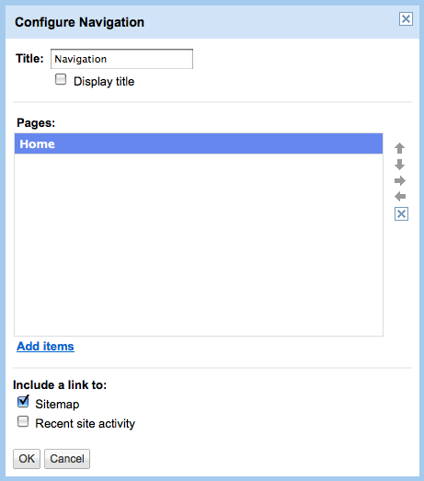
Reorder Pages from Navigation List:
- Select the Edit sidebar link on the bottom-left of your window
- Under the Navigation heading select the edit link (circled on previous page)
- Deselect Automatically organize my navigation
- To reorder a page on the navigation bar, select page title with your cursor and use the arrow keys (circled at right) to reposition or indent it
- Press the OK button when you are satisfied with your navigation list
- Select the Save Changes button
- Select the Return to site link in the upper-left portion of your window to return to your webpage

Remove Pages from Navigation List:
- Select the Edit sidebar link on the bottom-left of your window
- Under the Navigation heading select the edit link (circled on previous page)
- Select the page with your cursor and press the X button (below the arrow keys circled above) in the upper-right hand corner of the pop-up window
- Press the OK button when you are satisfied with your navigation list
- Select the Save Changes button
- Select the Return to site link in the upper-left portion of your window to return to your webpage

Remove Recent Site Activity from Sidebar:
- Select the Edit sidebar link on the bottom-left of your window
- Under the Navigation heading select the edit link (circled on previous page)
- Deselect Recent site activity from the Include a link to: list
- Press the OK button when you are satisfied with your navigation list
- Select the Save Changes button
- Select the Return to site link in the upper-left portion of your window to return to your webpage

Share your eInternship
Google sites provides three ways to share your work with others. Please share only the link with your University of Wyoming Supervisor. To share your eInternship:

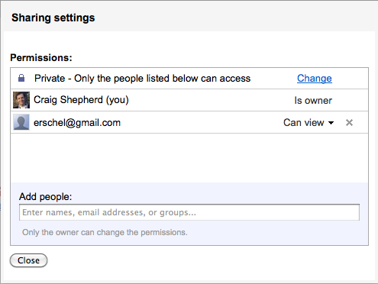
- Click on the More Actions button at the top-right of your window and select Site permissions. A window will appear identifying who has access to the site.
- Select the Change link to the right of that window
- You want your site to be private except for your University of Wyoming Supervisor. Select Private.

