ZOO/KIN 3115, Exam 3

On my honor, I pledge that I will neither give nor receive unauthorized assistance or information on this examination, and I will not tolerate such conduct on the part of others.
Name______________________________________________

Signature___________________________________________

Equations and parameters
[x] = α_{x}P_{x}
[O₂]_{bound} =k[Hb]SO₂
[O₂]_{bound} =[O₂]_{solution} + k[Hb]SO₂
P_{tot} = ∑P_{x}=PN₂+PO₂+…etc.
P_{x} = (F_{x}/100)P_{tot}, where in dry air F_{N2} =78%, F₀₂=21%, F_{CO2}=0.03%
MV=RRxTV
AV= RR (TV – DSV)
VO₂=Q([O₂]_{art}-[O₂]_{vein}]
k=1.4 ml/g
[Hb]=150 g/L
αO₂=0.03 ml O₂ /(Lxmm Hg)
P_{atm}(sea level) = 760 mm Hg
C_{x}P_{x}=U_{x}(dV/dt)
GFR= C_{inulin}
FF=GFR/Renal Plasma Flow

Multiple Choice Questions (2 points/question, total 60 points)
1) George Washington weighed about 100 kg. When he developed pneumonia, his physician removed 2 L of blood. The percentage of total blood volume removed was:
a) 25%
b) 20%
c) 35%
d) 50%
e) 45%
2) Without clinical intervention a subject with a full gastrectomy (stomach removal) would suffer anemia because:
a) she would not be able to secrete EPO
b) she would not have sufficient vitamin B₁₂
c) she would lack sufficient iron
d) her red blood cells rupture
e) of an autoimmune attack to erythropoyetic cells

3) Hepatic cirrhosis causes damage to the liver. A patient with hepatic cirrhosis would have
a) increased levels of conjugated bilirubin only
b) a form of posthepatic jaundice
c) increased levels of both conjugated and unconjugated bilirubin
d) a form of prehepatic jaundice
e) increased levels of unconjugated bilirubin only.

4) Which of the following statements about hemophilia is CORRECT:
Hemophilia A is a condition characterized by a deficiency
a) of platelets resulting from a defective recessive gene found in the x chromosome.
b) of fibrinogen resulting from a defective recessive gene found in the x chromosome.
c) of platelets resulting from a defective recessive gene found in the y chromosome.
d) of clotting factor VIII resulting from a defective recessive gene found in the x chromosome
e) of thrombin resulting from a defective recessive gene found in the y chromosome.

5) Which of the following statements about the hemoglobin molecule is FALSE
a) The affinity for oxygen of adult hemoglobin is higher than that of fetal hemoglobin
b) Its synthesis requires vitamin B₁₂
c) Bilirubin is a product of its catabolism
d) Its synthesis requires adequate intake of iron
e) It contains 3 heme groups

6) A hyperbaric chamber filled with dry air has a total partial pressure equal to 2000 mmHg. Therefore the partial pressure exerted by
a) oxygen is 420 mm Hg
b) oxygen is 1560 mm Hg
c) nitrogen is 420 mm Hg
d) nitrogen is 600 mm Hg
e) carbon dioxide is 60 mm Hg

7) The un-shaded portion of this graph represents the events that take place during _______________. The curve in panel C represents changes in _____________ and has units equal to _____________.
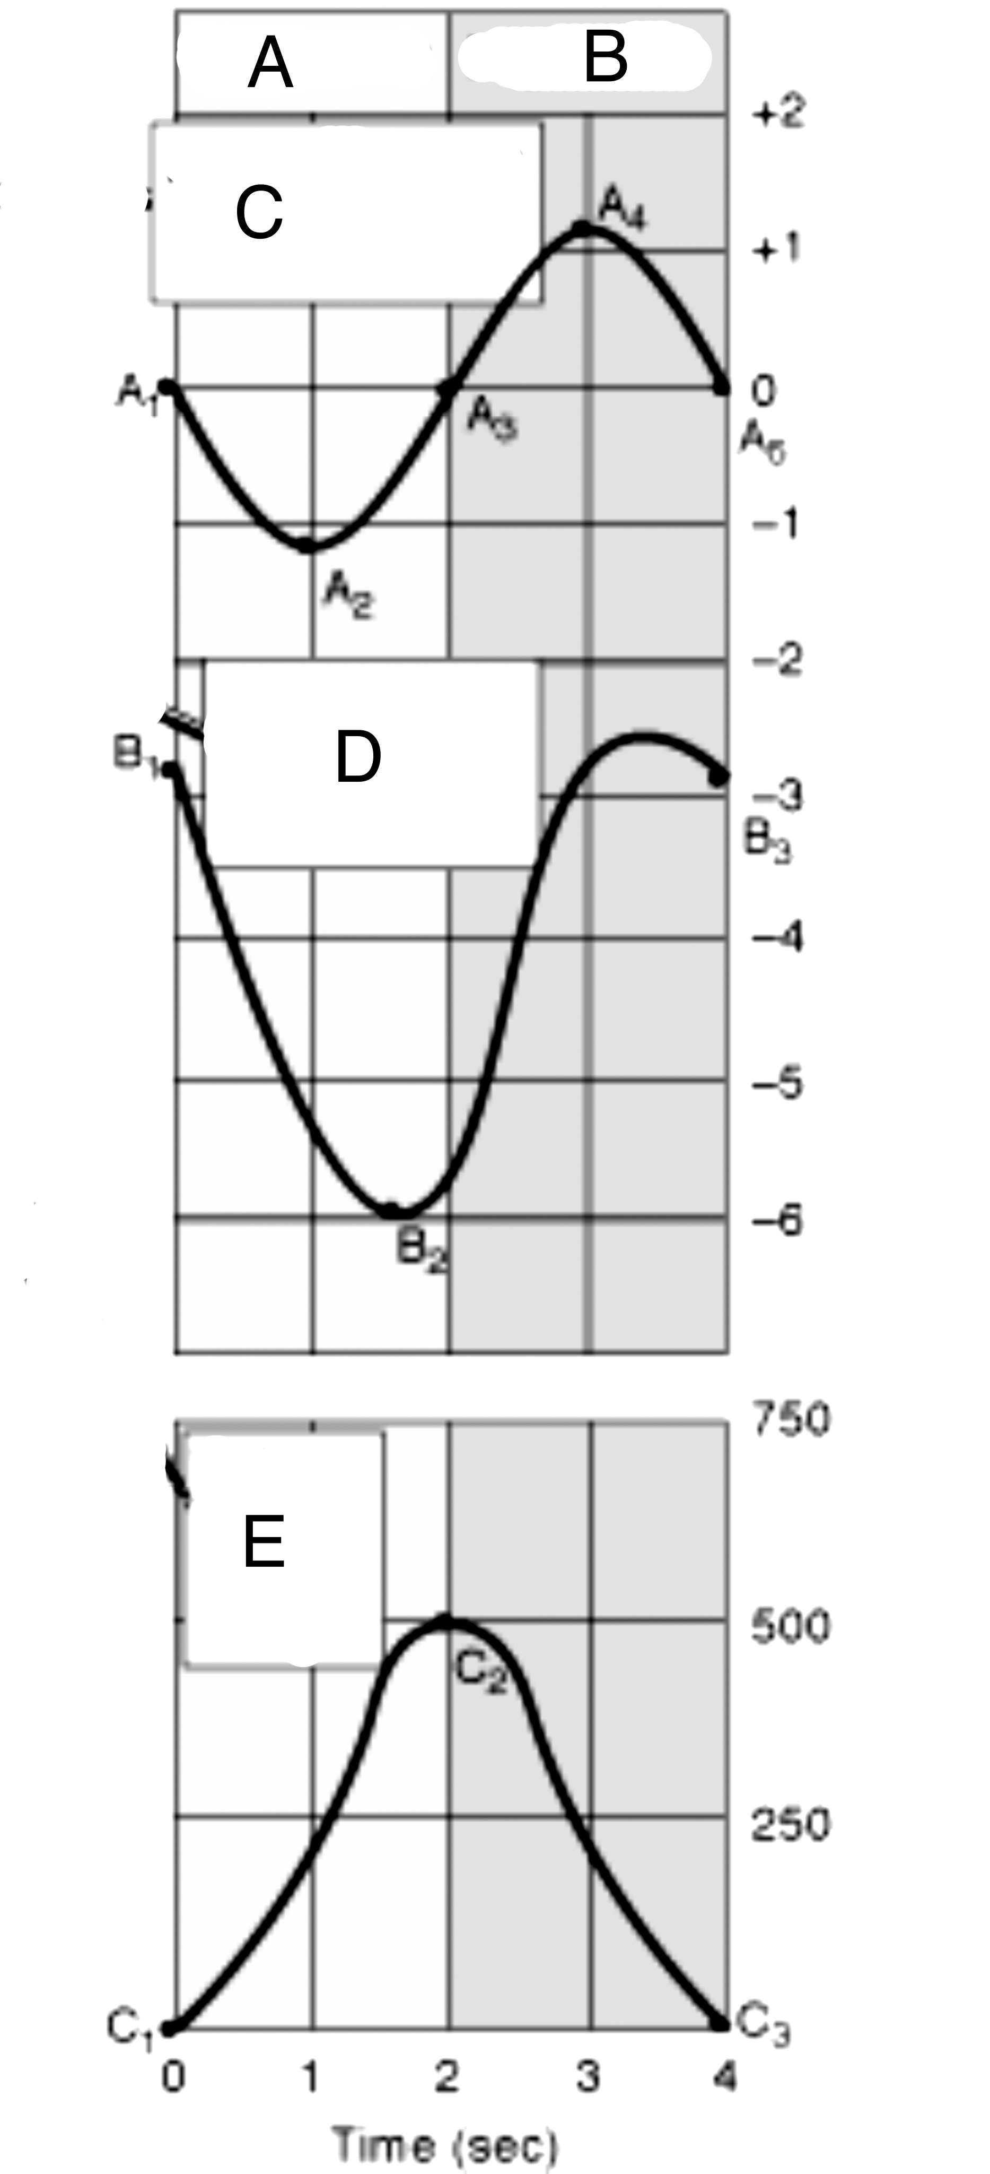
a) expiration, intrapulmonary pressure, mm Hg.
b) inspiration, intrapulmonary pressure, mm Hg
c) expiration, the volume of air moved in and out of the lung, Liters
d) expiration, intrapleural pressure, mm Hg
e) expiration, the volume of air moved in and out of the lungs, ml.

7) Which of the following statements about hemophilia is CORRECT:
Hemophilia A is a condition characterized by a deficiency
a) of platelets resulting from a defective recessive gene found in the x chromosome.
b) of fibrinogen resulting from a defective recessive gene found in the x chromosome.
c) of clotting factor VIII resulting from a defective recessive gene found in the x chromosome.
d) of platelets resulting from a defective recessive gene found in the y chromosome.
e) of thrombin resulting from a defective recessive gene found in the x chromosome.

8) The production of NO (nitric oxide) and prostacyclin by cells of _____________________________
a) the subendothelium, stimulates the aggregation of platelets
b) the endothelium, contributes to vasoconstriction after injury to vascular tissues
c) the endothelium, prevents platelet aggregation
d) collagen, stimulates the secretion of von Willebrands Factor
e) the subendothelium, stimulates a vascular spasm

9) The following table shows partial blood analysis results for a patient, Jane Doe. The values are expressed in international units (IU) per liter of blood. These values suggest that the patient has a condition affecting her:
a) pancreas
b) liver
c) heart
d) bone marrow
e) kidney

Jane Doe | Measured Value | Normal range
Amylase | 125 | 23-85 U/L
Lipase | 390 | 25-250 U/L
AP (alkaline phosphatase) | 75 | 21-91 U/L
ALT (alanine aminotransferase) | 20 | 10-32
AST (aspartate aminotransferase) | 12 | 8-20 U/L
Hemoglobin g/L | 145 | 130-180

10) Which of the following statements about white blood cells is FALSE
a) They can synthesize their own proteins
b) They are more numerous than red blood cells
c) They are part of the immune system
d) Not all of them are generated in bone marrow
e) They can be classified as leucocytes and phagocytes

11) Clots dissolve as a result of the action of
a) platelets
b) plasmin
c) vWF
d) thrombin
e) Vitamin K

12) The following table shows values for the FEV test of a 53-year-old, 60 kg, male.
Measurement | Observed value
FVC (liters) | 3.0
FEV₁
100x(FEV₁/FVC), % | 40%
Which one of these statements about this person is CORRECT?
This person’s FEV₁ equals
a) 1,200 ml. This person does not suffer from an obstructive respiratory condition.
b) 1,800 ml. This person does not suffer from an obstructive respiratory condition.
c) 1.2 L. This person suffers from an obstructive respiratory condition.
d) 1.8 L. This person suffers from a restrictive respiratory condition.
e) equals 4 L. This person suffers from an obstructive respiratory condition.

13) The following table represents some respiratory values at rest for the subject of the previous question. The correct value for this person’s alveolar ventilation is:
Respiratory Rate (breaths/minute) | Dead Space Volume (ml) | Tidal Volume (ml)
12 | 200 | 500
a) 6000 ml/min
b) 3.6 L/min
c) 2400 ml/min
d) 3 L min
e) 1600 ml/min

14) Which of the following statements about the solubility of gases in water is FALSE
a) solubility increases with increasing temperature
b) solubility increases with decreasing concentration of other solutes
c) solubility decreases with increasing temperature
d) the solubility of CO₂ is approximately 20 times higher than that of O₂
e) the amount of gas x in solution increases with P_{x}.

15) Hematocrit has a direct effect on __________ and ____________ in the equation that relates [O₂]_{blood} with PO₂.
a) k, SO₂
b) [Hb], [O₂]_{bound}
c) [Hb], [O₂]solution
d) k, [Hb]
e) [Hb], SO₂

16) A blood sample taken from the vena cava has a PO₂ of 25 mmHg and a total oxygen content equal to 50 ml/liter. The person’s hemoglobin concentration was 75 g/L. The SaO₂ of the hemoglobin (in %) is approximately:
a) 20%
b) 47%
c) 23%
d) 75%
e) 100%

17) Blood stored in blood banks loses its normal content of 2-3 DPG. Therefore
a) the affinity of hemoglobin for O₂ in stored blood is lower than that of fresh blood.
b) at the same partial pressure of O₂, fresh blood has more oxygen than stored blood
c) the affinity of hemoglobin for O₂in stored blood is higher than that of fresh blood.
d) the O₂dissociation curve of stored blood is shifted to the right of that of fresh blood.
e) the presence of 2-3-DPG facilitates the loading of O₂ into blood’s hemoglobin.

18) Which of the following is CORRECT about the fetal-maternal dissociation curve for hemoglobin illustrated?
a) The pH of maternal blood is higher than fetal blood
b) Maternal blood contains more red blood cells than fetal blood
c) Fetal blood is saturated at a higher oxygen partial pressure than maternal blood
d) The partial pressure of oxygen is lower in maternal blood at 60% saturation
e) Fetal hemoglobin has a greater affinity for oxygen

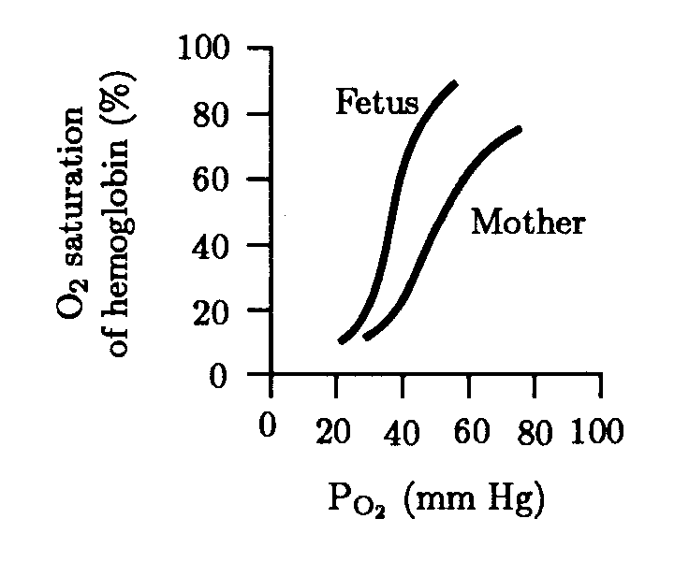

19) The following graph represents the effect of X on minute ventilation. Variation in X is detected by ____________ _________________________
a) X = arterial PCO₂, chemoreceptors in the central nervous system
b) X = arterial PCO₂, chemoreceptors in both the central nervous system and in the carotid arteries and aorta
c) X = arterial PO₂, chemoreceptors in the carotid arteries and aorta
d) X = arterial PO₂, chemoreceptors in both the central nervous system and in the carotid arteries and aorta
e) X = arterial PCO₂, chemoreceptors in the carotid arteries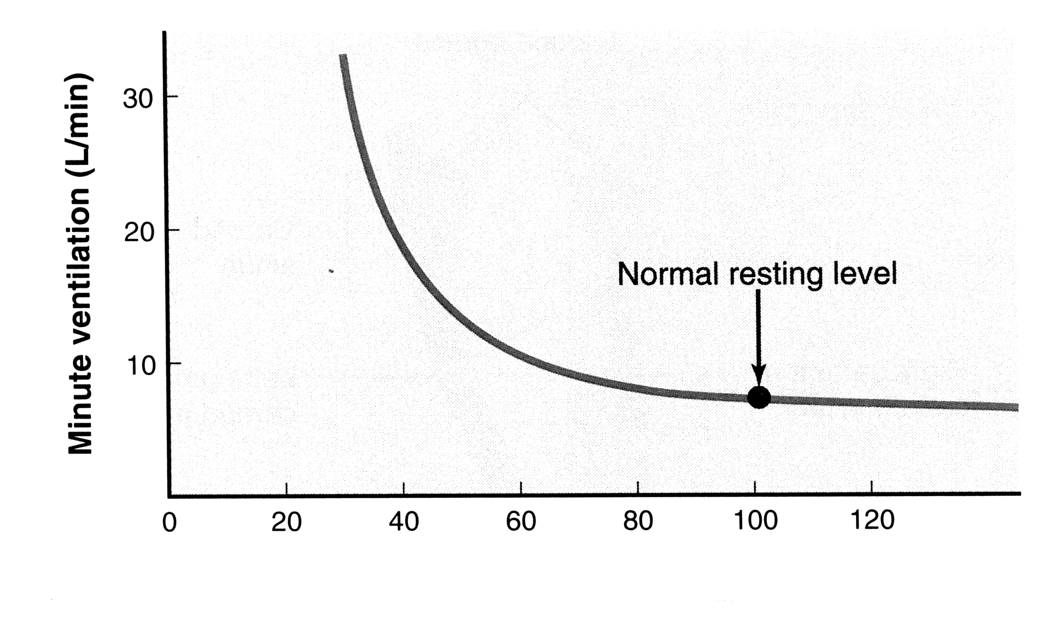X

20) Sucrose intolerance is relatively common among Greenland Inuits. The results of two “sucrose tolerance” tests are shown in the following table. The allele that codes for the presence of intestinal sucrase activity is called S, whereas the allele that codes for the absence of intestinal sucrase activity is called NS. S is dominant over NS. Based on your results you infer that the genotypes of patients 1 and 2 are _______ and __________, respectively; and therefore that patient 2 is ______________________________
 | Fasting Blood Glucose (mg/100 mL) | Blood Glucose 30 min after ingestion of sucrose (mg/100 mL) | Fasting [H₂] in breath (ppm) | [H₂] in breath 30 min after ingestion of sucrose
Subject 1 | 80 | 120 | 5 | 4.5
Subject 2 | 85 | 86 | 5 | 200
- S/NS or S/S, NS/NS, sucrose intolerant
- NS/NS, S/NS or S/S, sucrose intolerant
- NS/NS, S/NS or S/S, sucrose tolerant
- S/NS or S/S, NS/NS, sucrose tolerant
- NS/NS, S/NS or S/S, sucrose tolerant

21) Which of the following enzymes is NOT secreted by the pancreas
a) trypsin
b) enterokinase
c) amylase
d) lipase
e) Chymiotrypsin

22) All the following statements about gastric secretion are correct EXCEPT
a) It is stimulated by the hormone gastrin
b) Gastric secretion of HCl contributes to the activation of pepsin
c) Gastric secretion of HCl requires ATP
d) Gastric secretion of pepsinogen is required for vitamin B12 absorption
e) It is reduced when lipid is present in the duodenum

23) Which of the following statements about the intestinal transport of glucose is FALSE?
a) Glucose is transported into enterocytes by a Na⁺/glucose symporter
b) Glucose is transported out of enterocytes by a facilitative tranporter called GLUT2
c) Glucose is transported into enterocytes by primary active transport
d) Glucose transport into enterocytes is concentrative
e) The same protein that transports glucose transports galactose into enterocytes.

24) Which of the following statement about the assimilation of the nutrient illustrated here is FALSE?
a) The first step in its assimilation is the emulsification of lipid droplets
b) The products of its digestion diffuse into enterocytes
c) After assimilation it is transported in the circulatory system as a lipoprotein
d) It is reconstituted in the endoplasmic reticulum of enterocytes
e) After exiting the enterocyte it enters into the capillaries of the small intestine

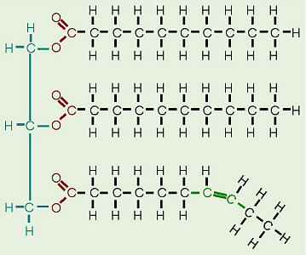

25) Bile
a) secretion is stimulated by secretin
b) secretion is stimulated by the presence of carbohydrate in the duodenum
c) duct obstruction causes malabsorption of calcium
d) salts are synthesized from hemoglobin
e) salts are recovered in the ileum and recycled

26) Which ONE of the following does NOT favor a high GFR?
a) High Bowman’s capsule hydrostatic pressure
b) High glomerular oncotic pressure
c) High glomerular hydrostatic pressure
d) High resistance in the afferent arteriole
e) High resistance in the efferent arteriole

27) If a substance is only filtered. It is neither secreted into nor reabsorbed from the proximal renal tubule then
a) its clearance can be used to determine the renal plasma flow
b) its renal clearance is higher than that of inulin
c) its concentration in the distal tubule is higher than in the plasma
d) it will appear in urine after its maximal rate of transport is exceeded
e) its clearance value is equal to glomerular filtration rate

28) If renal blood flow rate is 1.25 liters/minute, hematocrit is 40%, and glomerular filtration rate is 125 ml/min, then the filtration fraction (%) is approximately
a) 100
b) 10
c) 17
d) 25
e) 1
(Hint. Careful with units and recall that blood volume equals plasma plus cells).

29) Which of the following factors DOES NOT influence the form of this curve?
a) Myogenic regulation of afferent smooth muscle
b) Mesangial cell contraction
c) Paracrine secretion of cells of the macula densa
d) Signals from arterial baroreceptors
e) Oncotic pressure of glomerular fluid
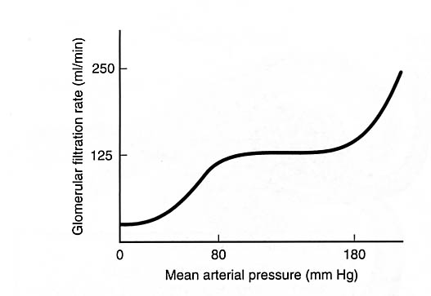

30) In healthy individuals the concentration of glucose in plasma is about 1 mg/ml, GFR equals 125 ml/min, the concentration of glucose in urine is 0, and the rate of urine production is 1.5 ml/min. These measurements imply that the renal clearance for glucose equals
a) 0 ml/min
b) 125 ml/L
c) 125 mg/min
d) 1 ml/min
e) 125 ml/min.

Data Analysis Questions (40 points)
(please show all the equations and calculations that you have used to solve each problem, each answer is worth 2 points). Please report correct units in all your answers.

- The following figure shows a spirometer trace for the proverbial 70 kg young male. To answer this question please round up your measurements to the nearest 0.2 L (note please, that this spirometer plot is upside down from the one in your book. This plot is sometimes depicted in this way just to confuse the unwary!). Each answer is worth 5 points.

- What are the resting tidal volume, inspiratory reserve volume, and vital capacity of this imaginary individual ?

- If his resting respiratory rate equals 12 breaths per minute and his dead space volume equals 150 ml/breath what are the values for his minute and alveolar ventilation rates?

- What was this individual’s breathing rate during the 10 seconds of exercise?

d) When this individual is exercising at a brisk pace, his tidal volume equals the maximal one shown in the spirometer trace. At this pace, dead space represents 20% of tidal volume. If you assume that the breathing rate that you calculated in c is maintained during brisk exercise, what are the minute and alveolar ventilation rates of this individual?

- The following table shows various combinations of blood gases and oxygen consumptions in 5 different peoples (A, B, C, and D). Data set D shows normal data at sea level. (30 points)
 | A | B | C | D
Arterial PO₂  (mm Hg) | 40 | 80 | 100 | 100
Arterial O₂ content (ml/L) | 150 | 185 | 130 | 200
Venous O₂ content (ml/L) | 115 | 100 | 90 | 5 points
O₂ consumption  ml/min | 400 | 5 points | 250 | 250
Cardiac output (L/min) | 5 points | 2.9 | 5 points | 5

- Estimate the missing entries in this table (20 points).
- Identify the individual climbing at 6000 m. Assuming that her hemoglobin concentration is 150 g/L estimate the % saturation value for her hemoglobin.
(3.3333 points)

c) Identify the anemic individual and estimate the concentration of his hemoglobin. (3.3333 points)

d) Identify the individual with heart failure. (3.3333 points)

- Subjects suffering from diabetes mellitus typically show higher peak glucose levels that are much higher than the fasting levels and the levels remain high for a long time. In the following table we have data for a subject that has been infused constantly with inulin (not insulin) during a glucose tolerance test. The values show data for the subject when he was fasting and 30 minutes after ingesting a high dose of glucose. The subject’s renal plasma flow rate did not differ in the two phases of the study and was equal to 550 ml/min. There are no points for placing the correct equation in the table, but it should help you. (10 points, 1 point /entry)

Table 1 shows the data collected during this study.
TABLE 1 | Fasting | 30 minutes after glucose ingestion
Urine volume (ml) | 180 | 90
Plasma inulin concentration (mg/ml) | 1 | 1
Urine inulin concentration (mg/ml) | 80 | 40
Plasma glucose concentration (mg/ml) | 1 | 3
Urine glucose concentration (mg/ml) | 0 | 30
Plasma creatinine concentration (mg/ml) | 0.01 | 0.01
Urine creatinine concentration (mg/ml) | 0.9 | 0.45

Complete Table 2 below
TABLE 2 | Before | After | Equation
Urine production rate (ml/min)
GFR
Filtration fraction (%)
Clearance rate of creatinine (ml/min)
Glucose Filtered Load (mg/min)

