How to change module titles and refresh your WyoCourse home page module list with Design Plus design tools.

- To make edits to the module titles, log in to Canvas and enter “Modules” page. Select the three dots found on the right and select "Edit.”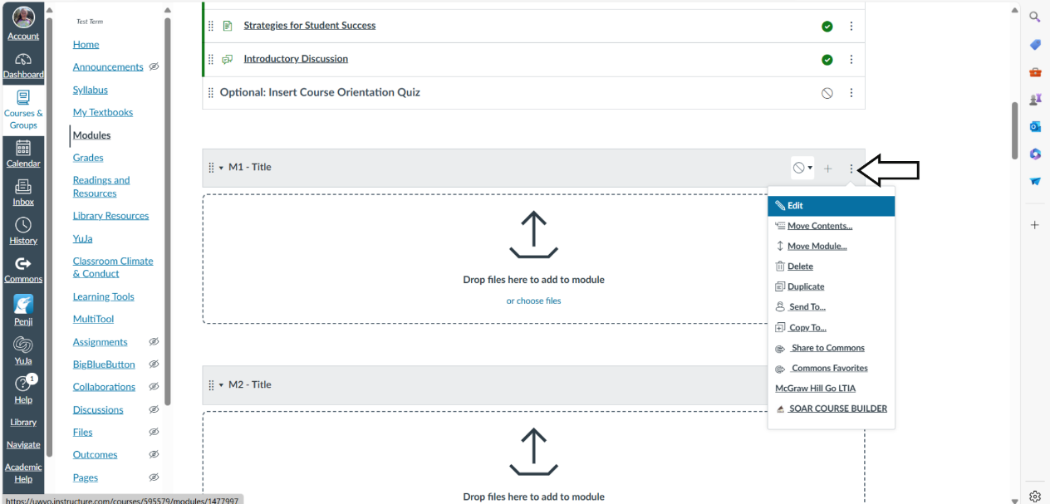

- Enter the new module name and select “Update Module.”
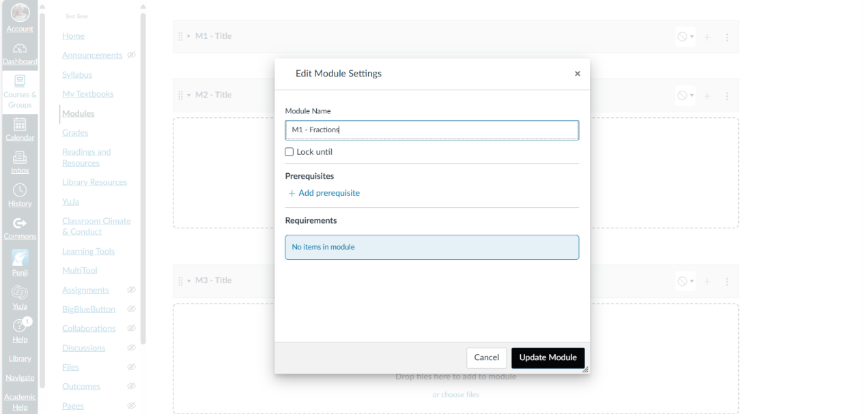

- Your title should be updated.
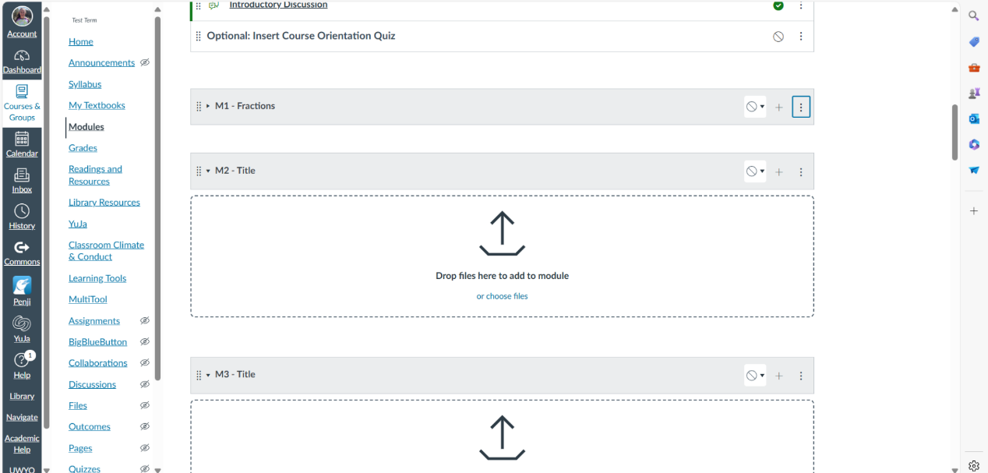

- To ensure changes in module are reflected on home page, go to home page and select “Edit.”
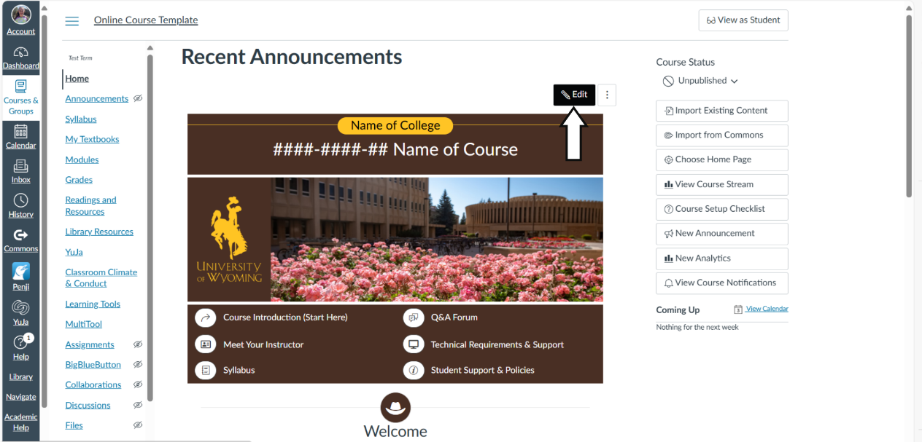

- Open Design PLUS Tools Side Bar. If the side bar does not launch automatically, use the shortcut Alt+Shift+D on a PC or Option+Shift+D on a Mac.
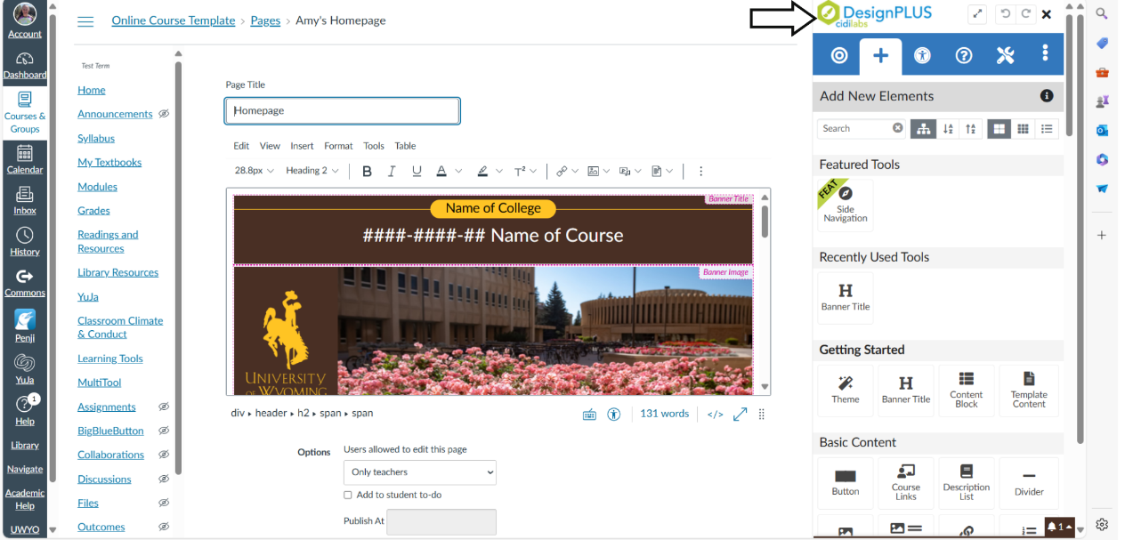

- Select “Edit Current Element” icon (bullseye) on the top blue navigation bar.
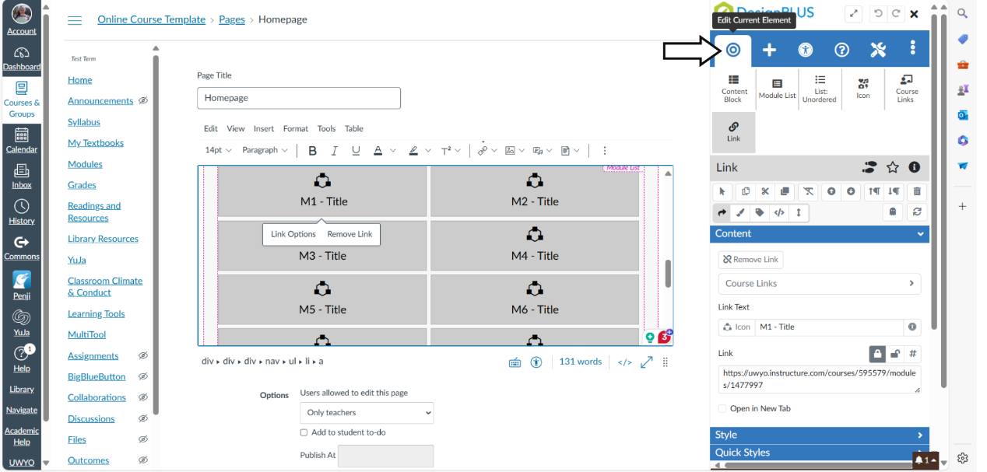

- Select “Module List”
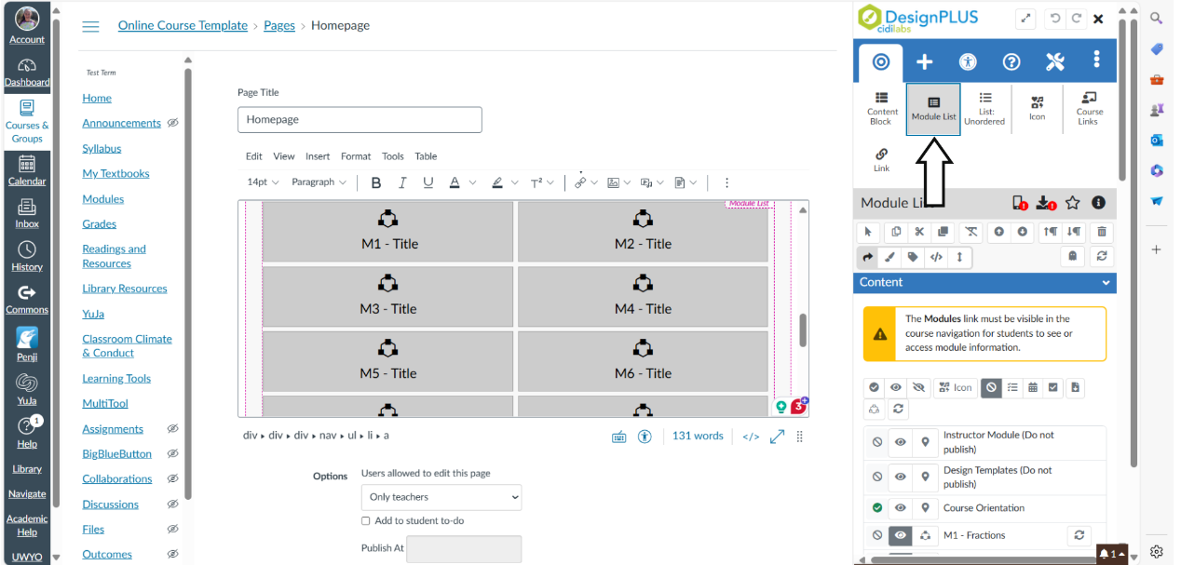

- Select the “Refresh Customizations” icon. The modules list on your home page should now reflect the current names of modules.
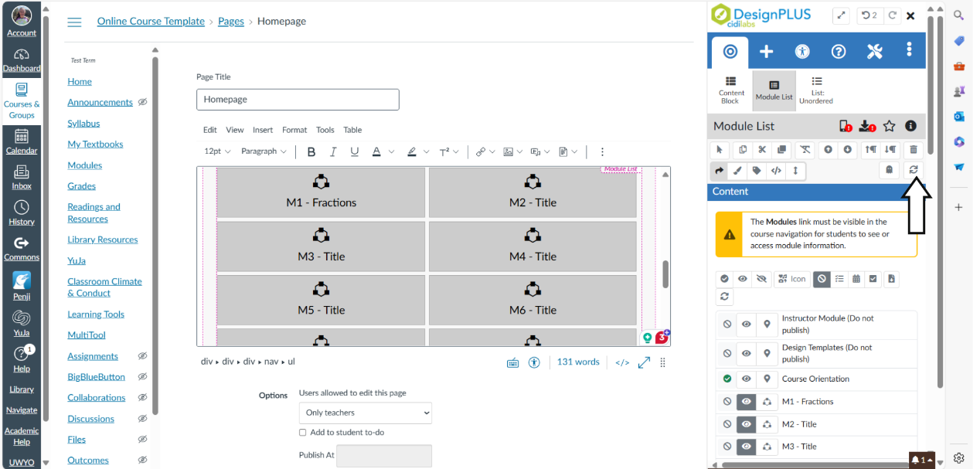

- Select "Save" at bottom of page to save changes.

