How to replace the banner image on the home page of a WyoCourse page using Design PLUS tools.

- Go to home page and select “Edit.”
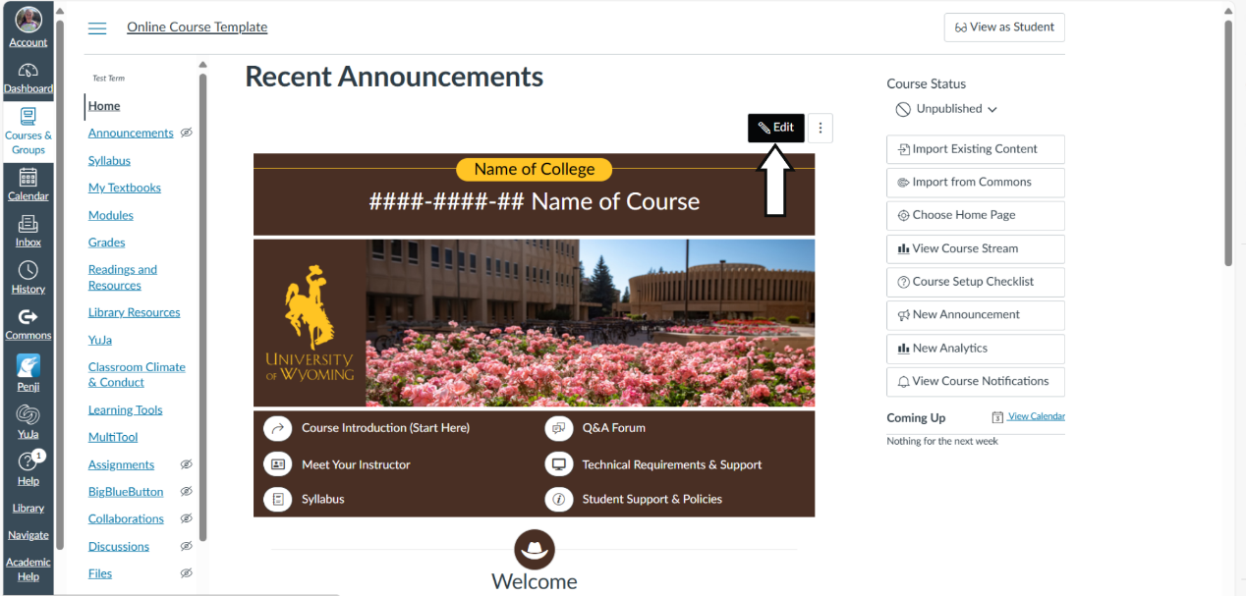

- Open Design PLUS Tools Side Bar. If the side bar does not launch automatically, use the shortcut Alt+Shift+D on a PC or Option+Shift+D on a Mac.
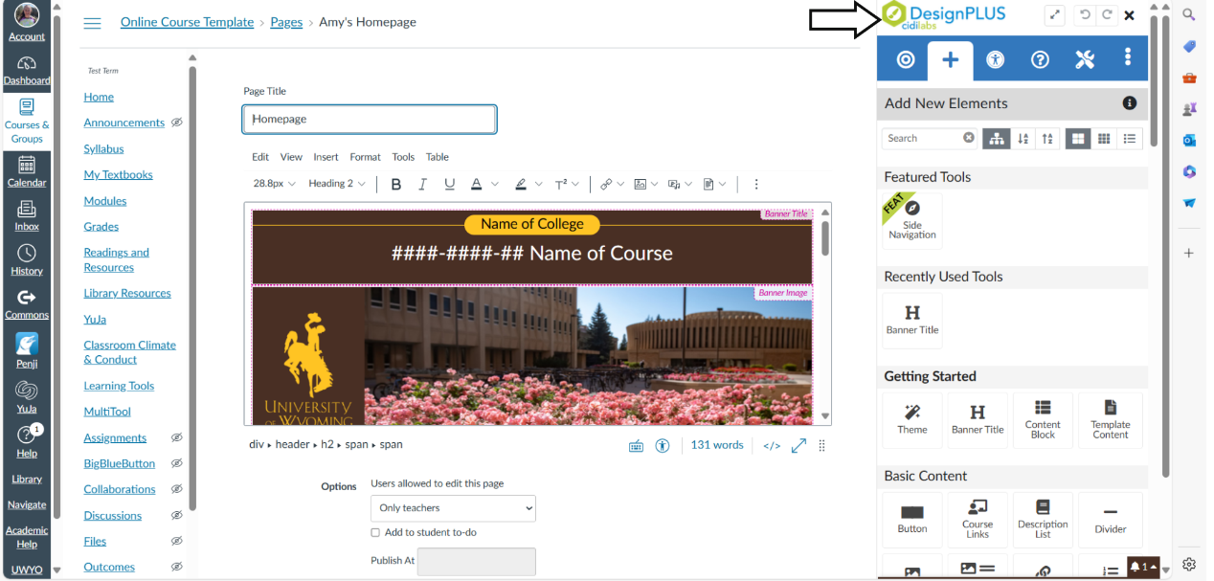

- Select “Edit Current Element” icon (bullseye) on the top blue navigation bar.
- Click on the current banner image.
- Select “Image.”
- Select “Change Image.”
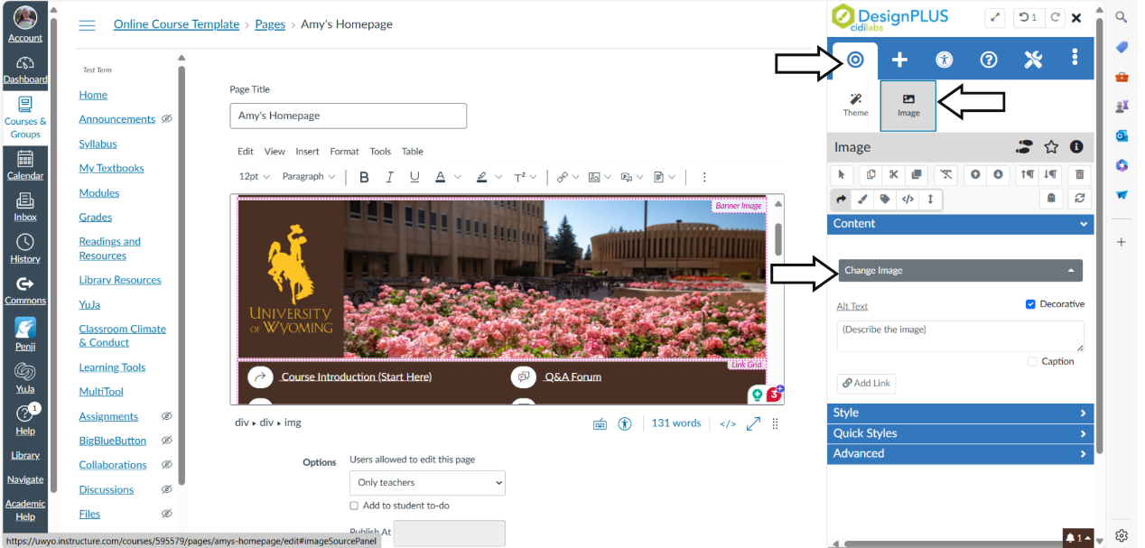
- Select “Folders/Filters” and next select “Banners.” This will open a selection of banners.
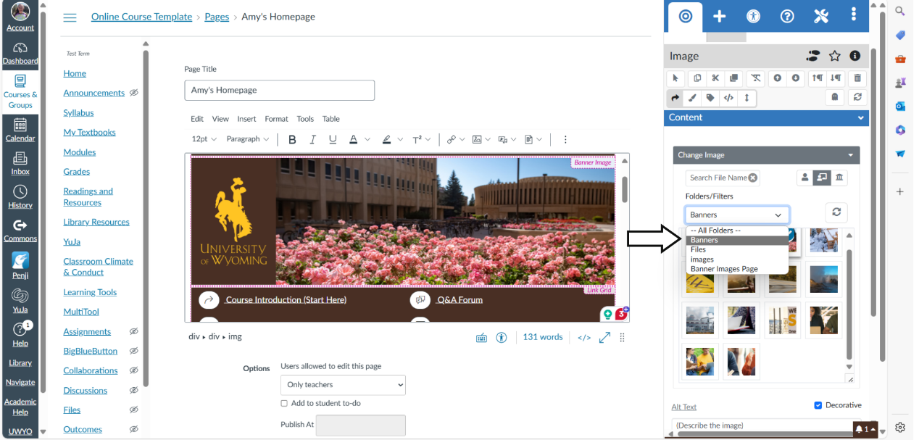
- Select the image you want to use as your new banner. (If you have a specific image that is not currently in your course files, you can upload it in via your course “Files”)
- Once you have selected the image, make sure to save your changes by selecting the “Save” button.

