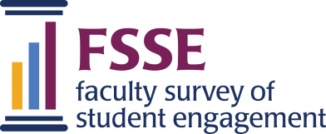

The Office of Academic Affairs and the Ellbogen Center for Teaching and Learning invite you to lend your voice and participate in the Faculty Survey of Student Engagement (FSSE). This survey collects data related to instructional staff perceptions and expectations regarding student learning and development. FSSE was also designed to complement the National Survey of Student Engagement (NSSE), which is administered to undergraduate students.

UW has been participating in FSSE for many years and we are pleased to continue our participation to better understand how UW can support the important work of student learning. We invite you to access data from previous years on our Assessment for Student Learning website.

Who is eligible to complete the survey? Faculty, instructors, and graduate teaching assistants who teach at least one undergraduate course during AY 21/22 should have received an invitation to participate in the survey via email from FSSE Survey, Qualtrics (noreply@qualtrics-survey.com).

When does the survey close? The survey closes in late spring and those eligible to complete the survey will receive a final reminder email from FSSE on April 6th.

How long does it take? 18-25 minutes.

What types of topics will be addressed in this survey?
- Student-Faculty Interaction, Effective Teaching Practices
- Learning Strategies, Quantitative Reasoning
- Learning with Peers: Collaborative Learning, Discussions with Diverse Others

We also have selected two topical modules that speak directly to work happening at UW:
- Transferable Skills, Career, and Workforce Development
- The Scholarship of Teaching and Learning (SoTL)

How will the findings be used? We want to use this as another data point in our assessment plan moving forward. Looking at multiple data points to assess student learning, and most importantly how we can improve student learning at UW. A small committee will work to analyze the NSSE & FSSE data and communicate findings and guidance based on survey responses in Fall 2022.

Questions? Heather Webb Spring @ hwebb1@uwyo.edu

We greatly appreciate your time and thank you for being part of this important process.

