New Degree or Certificate Proposal Feasibility Study Template
Feasibility Study for B.S. in Applied Software Development

Executive Summary
Degree or Certificate Title: Applied Software Development
Level of Degree or Certificate: Bachelors
Delivery Mode(s): online or hybrid
Estimated Startup Cost of Degree: $78,270, already allocated to SoC
Anticipated Launch Date: Fall 2024
Description:
The Applied Software Development degree program combines practical experience and knowledge of modern programming languages, tools, and processes used in the rapidly evolving field of Software Development. The courses cover a wide range of topics that are sought after by employers for web, mobile and other front end application development including the use of modern programming languages, development environments, databases, testing and collaboration pipelines, operational infrastructure, and security practices. The program incorporates, throughout the curriculum, opportunities for students to engage in real-world software development by working in teams to develop, implement, present, and refine solutions for problems proposed by industry and other clients.

Table of Contents
Overview and Description of Degree or Certificate, Purpose, Strategic Plan Overlay
Learning Outcomes
Curriculum Map and Program Structure
Course Descriptions
Assessment Plan
Degree Program Evaluation
New Resources Required
Substantive Change Determination
Executive Summary of Demand Statistics

Overview and Description of Degree or Certificate, Purpose, Strategic Play Overlay
We propose a new degree called Applied Software Development; the title emphasizes that the focus is on the use of software development techniques to create computing solutions. This program combines hands-on experience with practical knowledge to provide students with the skills to build and maintain software using modern programming languages, tools, and processes. The courses cover a wide range of topics that are sought after by employers for web, mobile, and other front-end application development including the use of modern programming languages, development environments, databases, testing and collaboration pipelines, operational infrastructure, and security practices. The program incorporates, throughout the curriculum, opportunities for students to engage in real-world software development by working in teams to develop, implement, present, and refine solutions for problems proposed by industry and other external clients. This degree program is based on and informed by existing accredited and implemented programs such as the Applied Software Engineering program at Cardiff University.
Currently UW students can only pursue a software engineering focus in a 4-year degree through the Computer Science and Computer Engineering programs. As part of accredited engineering programs these tracks require high-level proficiency in mathematics and science, with 30+ credit hours of dedicated mathematics classes. This limits opportunities for many Wyoming students to enroll in this broad and growing field of software engineering/development, especially for community college transfer students. Mathematical skills are advantageous for aspects of software engineering (estimating costs and system loads, making data driven decisions, analyzing results, using logic to verify code, developing the most efficient solutions, etc) and essential for research in software engineering, but advanced mathematics is not required for many software development tasks. Software development is concerned with writing, modifying, and debugging software for end-customer use, often with a focus on front end systems such as web development or mobile app development, engagement with end-customers and project management.
The B.S. in Applied Software Development has been designed in partnership with colleagues from many Wyoming community colleges. Students will be able to enter the program at UW with a two-year degree from a partnering community college or as freshman on the UW campus. Students who enter as freshman will complete the required software development courses during the first two years through the course sharing platform. These courses will be taught by partnering community college professors. Currently there are no plans to teach the first two years of software development courses on the UW campus.
This program aligns with the University of Wyoming’s current strategic plan specifically through promoting economic options, offering diverse disciplines to strengthen Wyoming’s workforce with students from diverse backgrounds, collaboration from K-12 to employment and everything in between and after.
Learning Outcomes
Students will learn how to design, code, test, and maintain high quality software of their own. Coursework will include studies in databases, systems design, and programming languages to create scalable programs. Learning outcomes include:

- Work effectively as part of a team to develop and deliver quality software artifacts.
- Recognize the applicability of computing and evaluate its impact on individuals, organizations, and global society.
- Evaluate and use appropriate methods and professional standards in computing practice.
- Apply computing theory and programming principles to practical, secure and robust software design and development.
- Design ergonomic and aesthetic user interfaces that are accessible to a wide range of audiences.
- Demonstrate effective use of written, verbal, and non-verbal communication, employing relevant knowledge, skills, and judgment.
- Work as a professional maintaining high standards of practice, making ethical judgments and decisions, and sustaining a professional standing through a commitment to life-long learning.
- Develop an ability to acquire and apply new knowledge as needed, using appropriate learning strategies.

Curriculum Map and Program Structure
Community College Courses
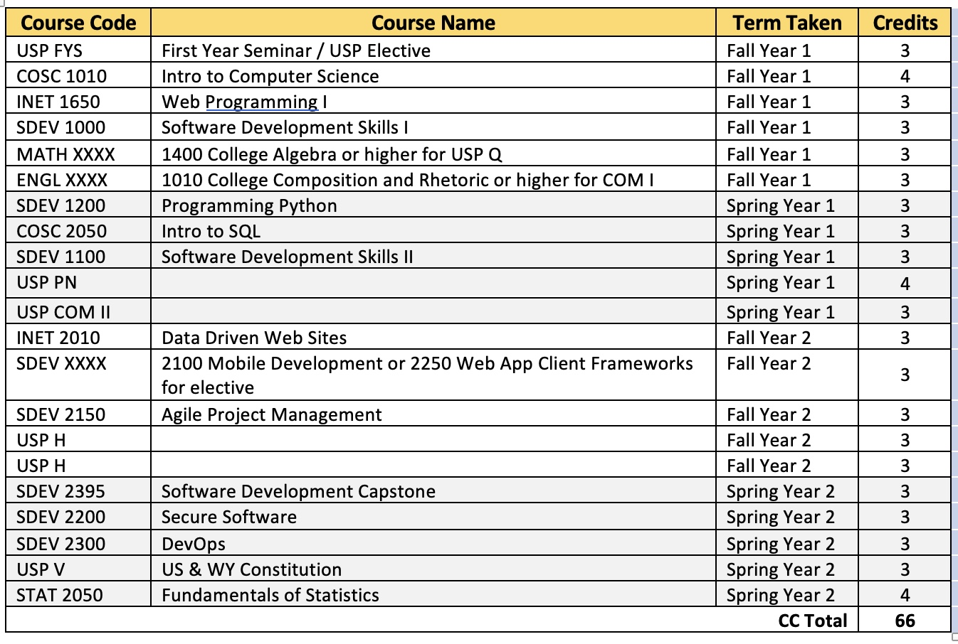

University of Wyoming Courses
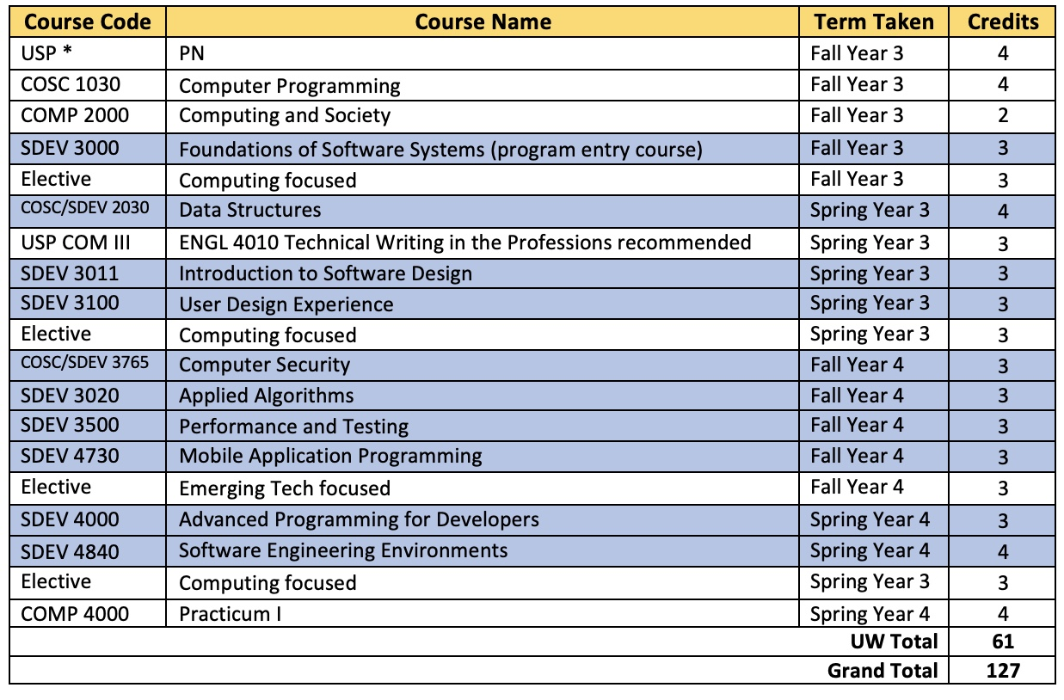
Denotes new courses
Course Descriptions
All courses will be taught online or hybrid.
- SDEV 2030: Data Structures: Investigation of techniques for program design, testing, and debugging. Data structures are studied, including stacks, queues, linked lists, binary trees, and Hashing. Sorting, recursion, strings, and arrays are also covered. Taught in appropriate high-level language (C++)
- SDEV 3000: Foundations of Software Systems: This course will give students an introduction to Linux system level programming with the Go programming language. It will provide students with an understanding of the fundamental concepts and principles of underlying software systems. Students will explore topics such as software requirements, design principles, programming paradigms, as well as software testing and maintenance.
- SDEV 3011: Introduction to Software Design: Cross Listed with COSC 3011. This course introduces the principles and practice of software design, including UML and design patterns. Uses case studies to illustrate design in action. This course includes large scale project work and theoretical aspects of OOP. Students will work in teams over the semester to accomplish a project.
- SDEV 3020: Applied Algorithms: Building on Data Structures, an understanding of algorithms and their implementation. Implementation of algorithms such as heaps, directed and undirected graphs, sorting, Divide-and-conquer, greedy, and dynamic programming algorithm design techniques.
- SDEV 3100: User Design Experience: This course is designed to give students an understanding of crafting an enjoyable and meaningful experience for users. This course will utilize practical experience as well as a theoretical overview of concepts. This course will introduce students to the principles, methodologies, and techniques involved in designing user-centered interfaces and interactions (UIUX).
- SDEV 3500: Performance and Testing: This course provides training in the principles, methodologies, and tools used in software performance and testing processes.
- SDEV 3765: Computer Security: Cross listed with COSC3765. Security is paramount to creating software and systems. This course introduces the fundamentals of computer security and applied cryptography from theory to practice. Topics include cryptographic fundamentals, authentication, access control, network/wireless security, software security, OS security, common protocols, and ethics. Course projects will focus on developing reliable code and understanding attacks.
- SDEV 4000: Advanced Programming for Developers: This is an intensive course for the final semester of the SDEV program. This course will give students experience designed to hone their programming skills and delve into new concepts. In addition, students will be presented with concepts, techniques, and best practices used in modern software development. This course goes beyond standard programming and focuses on sharpening programming proficiency while also improving problem-solving and code optimization skills. This course will feature a project sponsored by an industry partner to give students an understanding of applying their learned skills in their “real world”.
- SDEV 4730: Mobile Application Programing: Continues the development of applications on mobile devices. Presents the principles, techniques, and tools for developing mobile applications. Differences between desktop applications and mobile applications are discussed.
- SDEV 4840: Software Engineering Environments: This course provides students with a comprehensive understanding of the tools, processes, and techniques used in developing and maintaining software in various environments. Students will gain practical knowledge and skills to effectively manage software projects and collaborate with teams in an efficient and productive manner.

Assessment Plan
Students will learn how to design, code, test, and maintain high quality software of their own through hands-on activities in the classroom and through experiential learning opportunities with industry partners and local businesses. Students will use these experiences to learn how to solve real-world business problems. The courses in the software development degree will cover all aspects of front-end development from an understanding of underlying software systems to effective user interfaces and ethics of computing and software development. Courses will include group projects and peer feedback to foster effective teamwork and to support demonstration of effective verbal and non-verbal communication. The grading scale and grading policies used in these courses are as follows:
A: 90-100
B: 80-89
C: 70-79
D: 60-69
F: Below 60
Assignments and exams will be graded on a 100-point scale. Participation and attendance will also be considered when determining the final grade. All assignments must be completed and submitted on time to receive full credit. Late submissions will be subject to a penalty of up to 10 points deducted from the assignment grade. Make-up exams will only be permitted in the event of an excused absence. Cheating and plagiarism will not be tolerated and will result in a zero for the assignment.
Degree Program Evaluation
The program will be evaluated using both internal and external assessments. The internal assessments be done using a tiered approach including:
- Student course evaluations.
- An exit survey of course completers.
- An employer / internship assessment.
- Consistent curriculum assessment to ensure that content is following the most recent trends and best practices.
The Higher Learning Commission accreditation program will serve as the outside assessment.
Substantive Change Determination
We completed the Higher Learning Commission's (HLC's) Certificate Program Screening Form. Based on the information provided, the requested certificate program listed below does not require individual approval from HLC because at least 50% of the program is made up of existing courses or the program is a subset of an existing degree program. HLC accepts this degree as one of your institution's academic programs. The program will be added to HLC's records of the academic programs considered as part of your institution's accreditation.
New Resources Required
The Applied Software Development Program will leverage some existing courses in the Computer Science Department to fulfill course requirements. A Curriculum Committee with members from both EECS and the SoC meets weekly to discuss course utilization (optimization) and any reorganization or revision to existing EECS courses to ensure smooth articulation for Software Development students as well as support increased enrollment in courses currently underutilized or currently not taught (such as Software Engineering). Additionally, the Curriculum Committee will determine the best system to support both current CS students as well as incoming Software Development students in existing CS courses, such as the creation of additional sections for SDEV students. The School of Computing, in partnership with EECS, has developed the ten new courses described above for the Applied Software Development Program.
The B.S. in ASD does not require significant additional resources to be developed and implemented. Students in the program will be advised by staff in the Advising Center for Educational Success (ACES) and the courses will be taught by SoC hires or current faculty in EECS. The program is anticipated to be self-supporting through tuition dollars within 5 years of launching. Additional lecturers may be needed in the future, but we anticipate these positions being filled through strategic hires in the School of Computing.
Partnerships with industry from Wyoming and beyond as well as with entities across campus will also support the sustainability of the program. Internships with industry and interdisciplinary experiential learning courses will improve school-to-work pipelines for Wyoming students and business’ as well as ensure that graduates from this program have up-to-date applied knowledge and skills.
Marketing for the new program will be done through the use of dedicated funds from the Wyoming Innovation Partnership and in collaboration with participating Wyoming Community Colleges.
Preliminary budget, including potential funding sources, projected expenses and revenues, and potential faculty, academic professionals, lecturers, professors of practice, and staff:

Total projected additional expenses = $202,020
- 2 faculty/lecturer positions in Applied Software Development ($70,000 + fringe = $101,010. 2 positions = $202,020), one or both of these positions may be covered by strategic hires in the School of Computing.
- Administrative support will be covered by existing SoC personnel and other costs such as travel will be mainly covered through WIP or other existing funds.

Total projected additional revenues due to added course requirements for the Applied Software Development BS = $123,750
- Increased tuition generation per year
- Per resident student in program at $160/undergraduate credit X 30 credits = $4,800
- Per non-resident students in program at $665/undergraduate credit X 30 credits = $19,950
- Estimate: 5 resident students and 5 non-resident each year = $123,750 additional tuition

We anticipate enrollment will begin with 5-10 students who will articulate from Sheridan College. Central, Western, and Northwest are in the first stages of launching 2+2 degree, so we anticipate another 5-10 students from each of these institutions by fall 2025, increasing the tuition generated.
Executive Summary of Demand Statistics
A market analysis indicates strong growth for computer and information technology occupations. The U.S. Bureau of Labor Statistics indicates:
Overall employment in computer and information technology occupations is projected to grow 15 percent from 2021 to 2031, much faster than the average for all occupations; this increase is expected to result in about 682,800 new jobs over the decade. In addition to new jobs from growth, opportunities arise from the need to replace workers who leave their occupations permanently. About 418,500 openings each year, on average, are projected to come from growth and replacement needs.
A recent Wyoming Workforce Services report (see Table 1) has similar projections for Wyoming between 2020 and 2030, including:
- a 20.6% growth, or 68 new positions per year, in Computer and Mathematical occupations;
- Almost all of these occupations require a bachelor's degree;
- A 35.4% growth, or 15 new positions per year, in Software Development.
The median annual wage for this group was $97,430 in May 2021, which was higher than the median annual wage for all occupations of $45,760.
In addition, in Fall 2021, EAB prepared an evaluation of employer demand for graduates of a proposed bachelor’s level computing program for both regional and national markets. Summary results from this study are the following:
- Historical and projected employer demand trends suggest a high need for bachelor’s-level computing graduates.
Within the last 12 months, regional and national employers posted a high number of job postings for relevant professionals (i.e., 48,482 and 779,920 job postings, respectively). Further, between August 2018 and July 2021, regional and national employer demand growth for bachelor’s-level computing professionals outpaced that of all bachelor’s-level professionals (i.e., 3.01 percent vs 1.56 percent and 2.54 percent vs 1.26 percent, respectively). These trends suggest a growing market for bachelor’s-level computing professionals. Additionally, employment in the top relevant regional and national occupations is projected to increase faster than average in the next 10 years. This suggests employment opportunities for program graduates will likely increase in the coming years.
- Relevant degree completion trends indicate strong student demand for bachelor’s-level computing programs.
Between the 2014-2015 and 2018-2019 academic years, regional and national completions increased on average (i.e., 42.91 percent average annual growth and 41.34 percent, respectively). While student demand is rapidly increasing at around the same rate in both regions, competition is also growing.
- Competitive landscape trends suggest a small regional and concentrated national competitive landscapes.
Between the 2014-2015 and 2018-2019 academic years, the number of regional and national institutions reporting completions increased on average (6.25 percent average annual growth and 31.32 percent, respectively). Regionally, during the 2018-2019 academic year, two of the top five institutions held a combined 86.08 percent of the market (i.e., Colorado School of Mines and Brigham Young University). These well-established competitors may challenge a new program entering the market. Nationally, between the 2014-2015 and the 2018-2019 academic years, all top 10 reporting institutions increased the number of completions they report, indicating growth among top programs. Further, top programs reported far more completions than the 2018-2019 median number of completions (i.e., 18-90 completions compared to 2 median completions). This indicates program growth may be concentrated among top programs. Although student interest is rapidly increasing, a concentrated market could challenge a new program at the University of Wyoming.
Figure 1 illustrates the projected growth in regional computing related jobs. This illustrates the rapid projected growth for Software Developer jobs.
Figure 1 (from 2021 EAB report)
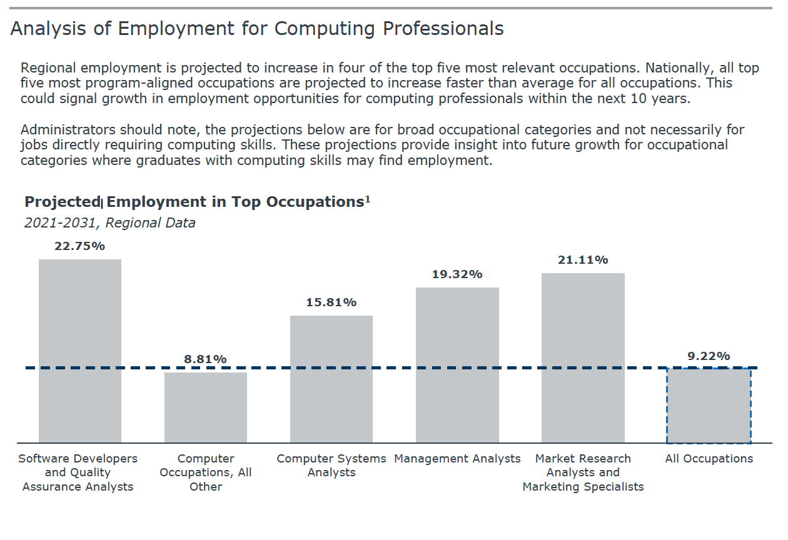
The B.S. in Applied Software Development will not only prepare students for existing jobs in the Software Development field but will provide UW graduates with a broad skillset in applied computing which will help with the state level goal of diversifying the Wyoming economy. Graduates of this program may be able to work remotely in well-paying jobs while staying in their hometowns or will have learned skills that allow them to become entrepreneurs and small business owners. The B.S. in Applied Software Development is one avenue to retain young talent in the Wyoming education system and workforce.

