2019 LANG 1101
International Partnership Recipe
and Suffrage Recipes

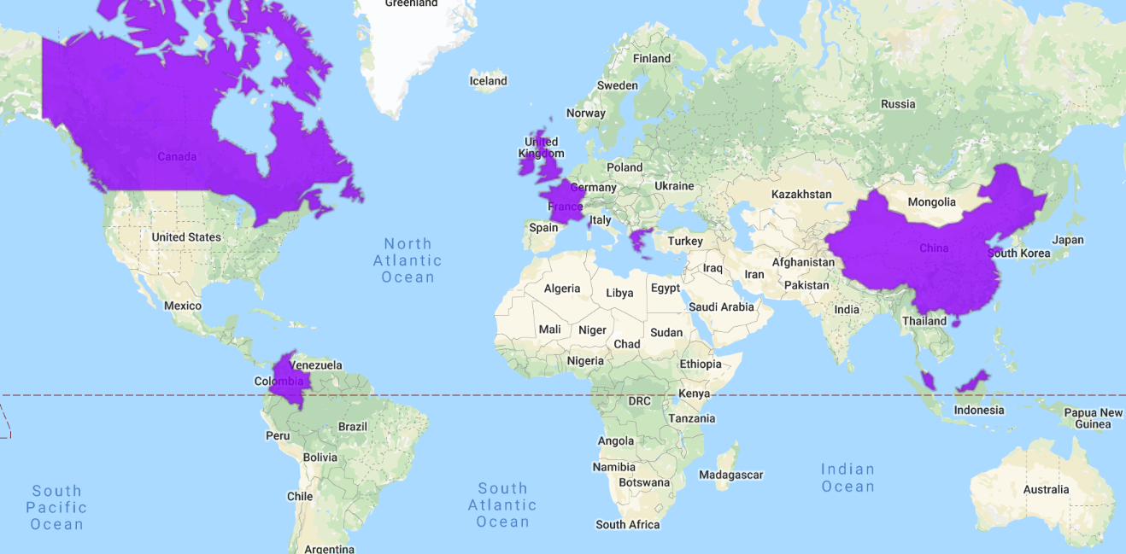
A Taste of the World!
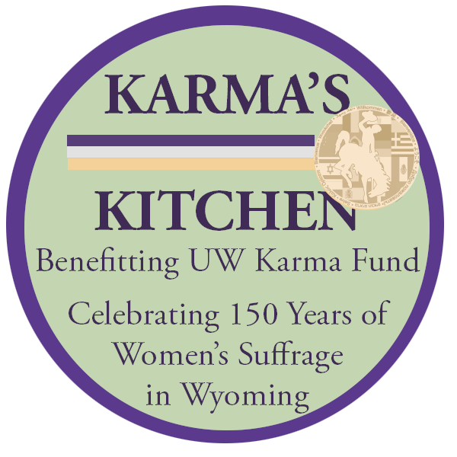
Recipes from Canada, Colombia, Ireland,
Scotland, France, Greece, China, Malaysia …
A Taste of Time Travel!
Recipes from cookbooks
that helped fund the Suffrage Movement

Mollie Hand, Instructor
and First-Year Seminar Students
Class of 2023

Setting the Table (of Contents)
Nanaimo Bar (Canada) 3
Ulster Fry (Ireland) 5
Potato Farl/Bread (Ireland) 5
Champ (Ireland) 5
Traditional Scottish Potato Scones (Scotland) 5
Language Story (France) 6
Avgolemono Chicken Soup with Rice (Greece) 6
(Avgolemono: egg and lemon broth) 6
Sichuan Mapo Tofu (麻婆豆腐 /má pó dòu fu/ ) (China) 7
Dumpling Recipe (China) 9
Unique Food Story (China) 10
Food Story (China) 10
Dumpling Filling (China) 11
Sweet and Sour Pork Ribs (China) 11
Food Story (China) 11
Bao Dumplings (China) 12
Malaysian Stir Fry (Malaysia) 13
Suffrage Recipes and Writings 14
Pie for a Suffragist's Doubting Husband (1915) 15
Soft Molasses Gingerbread 15
Eminent Opinions on Woman Suffrage 15
The Class and Its Sponsors 16

By Claire Rankin
Recipe Partner: Roxy Ramirez

Nanaimo Bar (Canada)
(recipe from Great Canadian Cookbook as published on www.foodnetwork.com)
INGREDIENTS:
Bottom Layer
½ cup (125 mL) unsalted butter (preferably European-style cultured butter)
5 Tbsp (75 mL) cocoa powder
¼ cup (50 mL) granulated sugar
1 egg, beaten
1 ¾ cups (425 mL) graham wafer crumbs
1 cup (250 mL) shredded coconut
½ cup (125 mL) almonds, finely chopped
Middle Layer
½ cup (125 mL) unsalted butter, softened
2 tbsp + 2 tsp (40 mL) whipping or heavy cream
2 Tbsp (30 mL) vanilla custard powder
2 cups (500 mL) icing sugar
Topping
4 oz (115 g) semi-sweet chocolate
2 Tbsp (30 mL) unsalted butter
DIRECTIONS:
Bottom Layer
1. Pour 2 cups (500 mL) water into bottom of double boiler. Place on stove over medium heat and bring water to simmer.
2. In top of double boiler; combine butter, cocoa and sugar; place over simmering water. Heat, stirring, until butter has melted and mixture is smooth.
3. Add beaten egg; stir until thick. Remove top of double boiler from heat. Stir in graham wafer crumbs, coconut and almonds.
4. Scrape into parchment paper-lined 8-inch (2 L) square baking dish. Press firmly to create even bottom layer.
5. Tip: If you don’t have a double boiler, half-fill a saucepan with water and heat over medium heat until water begins to simmer. Then, place a metal or glass bowl over the simmering water and proceed as directed.
Middle Layer
1. In bowl, cream together butter, cream and custard powder. Gradually add icing sugar; beat until light and fluffy. Scrape over bottom layer, smoothing top with spatula or palette knife.
Topping
1. In clean double boiler, melt chocolate and butter together. Remove from heat; let cool slightly. When cool, but still liquid, pour over custard layer.
2. Cover and refrigerate until cold.

I learned from Roxy that Canadian food isn’t completely different from American food but they still definitely have their own cuisine.

By Marissa Brenneman
Conversation Partner: Julian
Lechona Tomilmense (Colombia)
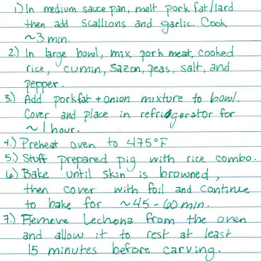
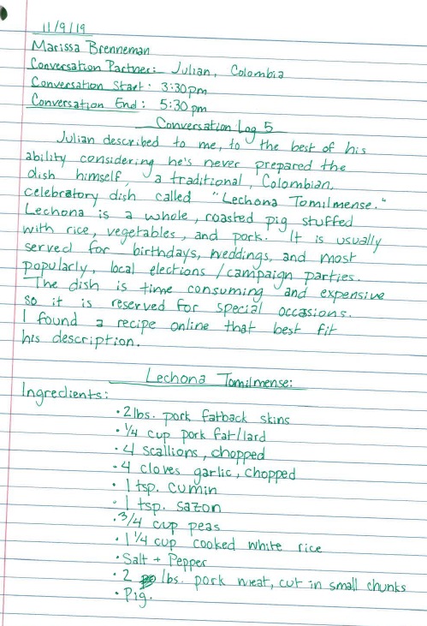
By Sam Espinoza
Recipe Partner: Robert
I was not able to meet with my partner so I interviewed an international student living on my floor.
Robert was so excited he shared three recipes with me. The first one he called the Ulster Fry. He said this is the Irish style of the full English breakfast but is equally good for any time of the day. He also mentioned that back in the old day they would use lard but today there are healthier options like butter.

Ulster Fry (Ireland)
Ingredients: Cooked sausage, bacon, one fried egg, potato farl (which is like potato bread), soda farl (which consists of soda flour, salt, and butter), baked beans with tomato sauce, one fried tomato, fried onions, and black pudding (which is some kind of animal blood+meat). These are all cooked separately and then put together on one plate. Robert also added that some people often choose to add a pancake as well!

Potato Farl/Bread (Ireland)
Ingredients: Mashed potatoes, flour, and butter.
Everything is mixed together until a dough is made. Then you roll it into a ball and fry it in oil. This can be eaten for breakfast or a snack.

Champ (Ireland)
Ingredients: Mashed potatoes, milk, butter, and scallions.
This is like mashed potatoes and can be used as a side dish as well.
I learned that Robert likes to cook and that he often uses the kitchen at the Visual Aids Department to make some of his food. When he made potato farl he offered everyone a sample. I found the potato farl very simple and kind of similar to mashed potatoes.

By Emily Smith
Recipe Partner: John

Traditional Scottish Potato Scones (Scotland)
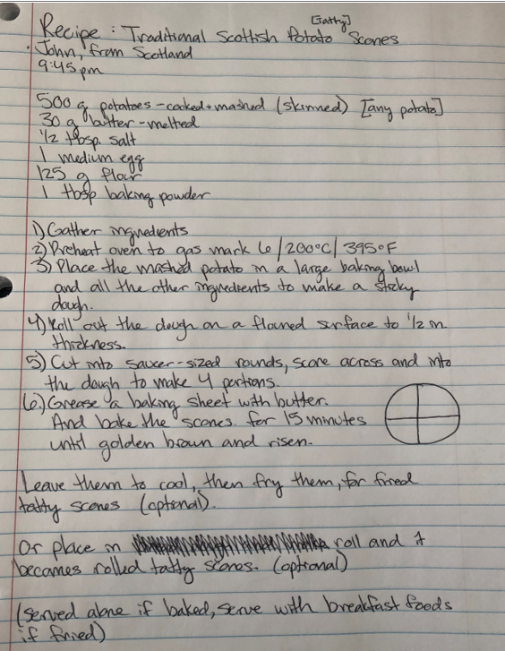

By Megan McFate
Conversation Partner: Ana Vinagre
Country: France

Language Story (France)
Ana was born in Portugal and grew up speaking Portuguese. Her parents work with a company that is based out of Portugal. When she moved to France she knew no French and was very out of her element. She was only ten when she started attending school in France.
Can you imagine moving to a whole new country and then having to attend a new school when you don’t even speak the language? Her first couple days were very hard and she even refused to attend after the first week. She would come home crying to parents because she hated the school.
In school, she was required to go to a counselor of sorts that would help her learn French. While she was going through the changes of school she found it very hard to make friends due to the language barrier. Luckily, she was still a child and caught on to the language quite fast. She eventually started making friends, most of which she still has to this day.
Her parents, however, refuse to learn French. They work for a Portugal company so there is no value to them to learn French. This means that when they have business or events that need French, Ana is the primary translator. In France, they start learning English as a requirement. Ana, however, excelled in English because she got very into the band One Direction. She would spend her time translating her songs, and in return her English skills increased. To this day she is fluent in English, French, and Portuguese.

By Anna Papadopoulos
Partner: Olympia Kledaras

Avgolemono Chicken Soup with Rice (Greece)

(Avgolemono: egg and lemon broth)
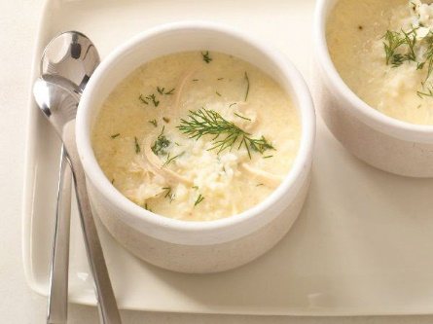
Ingredients:
- 4 cups homemade chicken stock or low-sodium broth
- Salt and freshly ground pepper
- 2 cups cooked white rice, warmed
- 2 large egg yolks
- 1/4 cup plus 2 tablespoons fresh lemon juice
- 1 lb. rotisserie chicken, meat pulled from bones, coarsely shredded
- 1/4 cup chopped fresh dill
In a large saucepan, season the stock with salt and pepper and bring to a simmer. Transfer 1 cup of the hot stock to a blender. Add 1/2 cup of the rice, the egg yolks and the lemon juice and puree until smooth. Stir the puree into the simmering stock along with the chicken and the remaining 1 1/2 cups of rice and simmer until thickened slightly, 10 minutes. Stir in the dill and serve. https://www.foodandwine.com/recipes/avgolemono-chicken-soup-rice
Olympia chose this recipe because she said that this is the food that she would think of when someone asked her what kind of comfort food she prefers: “Avgolemono always makes me think of when I’m sick or it’s really cold outside and I want to feel like at home. This soup always makes me feel at home; it doesn’t matter where I am” (Olympia Kledaras).

By Krisanna Andrews
Conversation Partner: Yingwu Wang

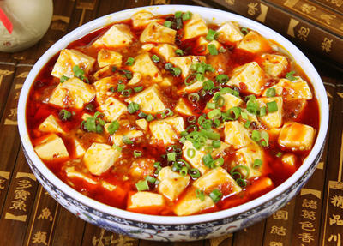
Sichuan Mapo Tofu (麻婆豆腐 /má pó dòu fu/ ) (China)
History of this food (written by Yingwu):
In Qing dynasty(1862), there is a small restaurant in Chengdu (the capital of Sichuan province). Most customers are poor man. The owner is a loving couple. But the host died early and his wife continued to run it. Everyone friendly calls her “Chen Mapo” because there are some spot on her face. Finally, she became famous due to the special still for cooking Tofu well. We can find her story from some history books now.
Sichuan Mapo Tofu is a fiery pork and tofu stir-fry with the hallmark málà(麻辣) balance of tongue tingling and spicy. The best part is that it can be put together in under 15 minutes, which makes Mapo Tofu the perfect weeknight stir-fry.
It’s not hard to make and comes together in minutes, but there are a few key points to make the best Mapo Tofu. The first is that because this dish (like all stir-fries) comes together so quickly once you start cooking, it’s imperative that you measure out and prep everything in advance, so you can toss in one ingredient after the other. Doing this over low heat so you can prep while you cook is a sure way to mess this up.
The second key point is to parboil the tofu in salt water before adding it to the stir-fry. It may seem like an extra hassle, but this step draws out excess liquid from the tofu, ensuring your Mapo Tofu doesn’t end up watery when you serve it. It also has the added benefit of firming up the tofu a bit, so it doesn’t fall apart as you toss it with the sauce.
Finally, I like to be able to eat my Mapo Tofu with rice and chopsticks, so I make the sauce a little on the thick side. This gives the Mapo Tofu a beautiful glossy sheen and allows for the sauce to cling to each cube of tofu, ensuring you get an even mix of both with each bite. If you like your Mapo Tofu a bit saucier, you can halve the amount of potato starch.
Ingredients:
400 g. soft tofu
½ cup chicken broth
2 tsp potato starch
1 tsp sesame oil
2 Tbsp vegetable oil
9 g. douche (~1 Tbsp fermented black beans, roughly chopped
2 g. Sichuan pepper (~ 1 tsp. ground, see note below)
2 Tbsp doubanjiang (to taste)
50 g. scallions (white part only, minced)
24 g. garlic (2 large cloves minced)
20 g. ginger (1 in. piece minced)
150 g. ground pork

The most important materials: Pixian doubanjiang (bean paste) and Sichuan pepper.
You can buy it at Asian Market. Pixian in a city of Sichuan province, which is famous for that bean paste.

Steps:
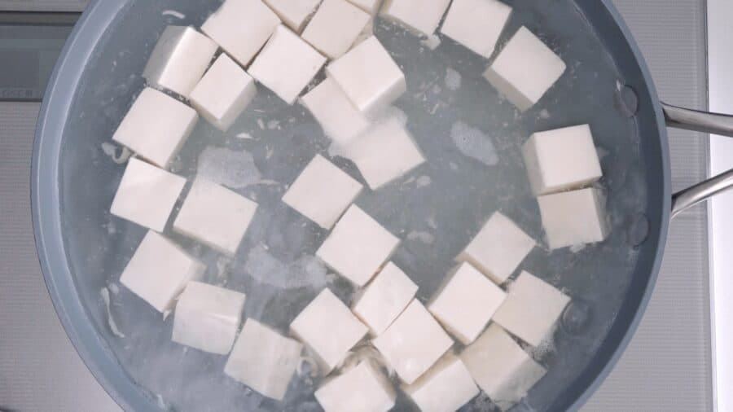
1. Adding 2 cups of water along with 1 teaspoon of salt to a boil. Add the tofu and cook for 1 minute. Gently tip the tofu into a colander and drain well.
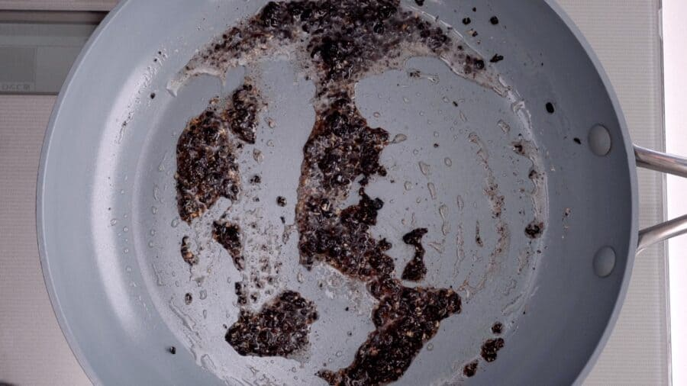
2. Heat the vegetable oil in a frying pan until very hot (but not smoking) and add the Sichuan pepper and douchi and stir-fry for a few seconds until fragrant.
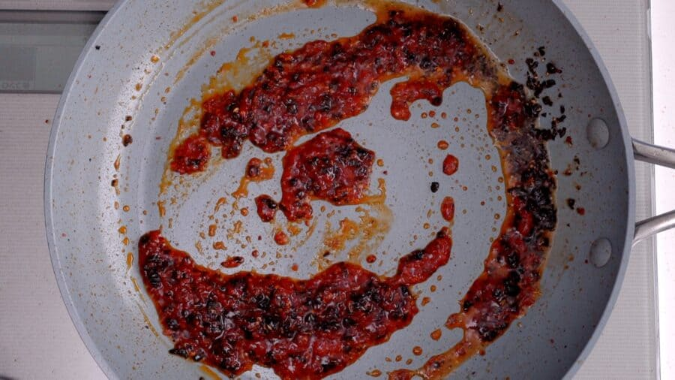
3. Add the doubanjiang and stir-fry until the oil turns red (a few seconds)
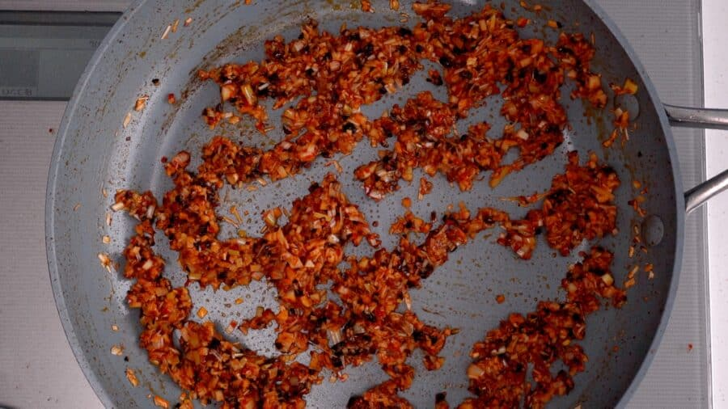
4. Add the white parts of the scallions, garlic, and ginger and stir-fry until you can get the smell.
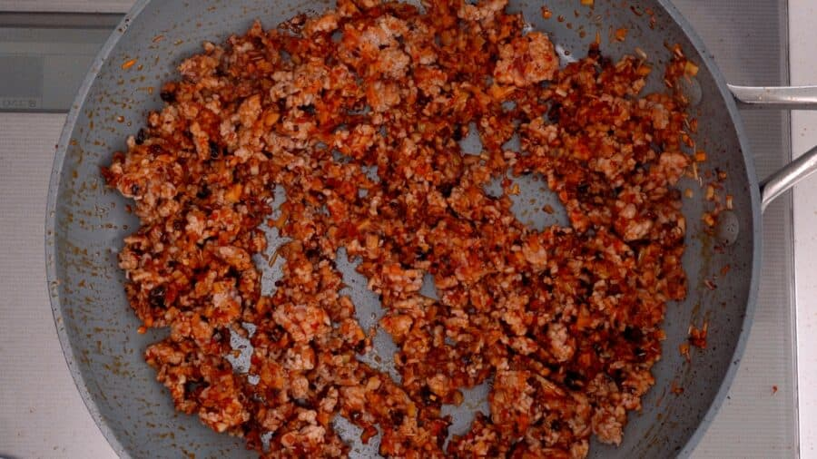
5. Add the pork and stir-fry breaking it up into small pieces as you go.
6. Stir the chicken stock and then pour it in. Let this boil until it thickens.
7.Add the tofu and toss in the pan to coat evenly with the sauce.
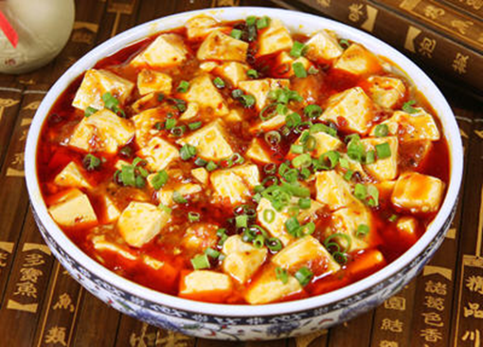
Normally, it looks like the picture showed above. Enjoy it!
By Shayna Deveraux
Conversation Partner: Liam Wong
Country: China

During one of our conversations, Liam and I chatted about a family recipe of his; dumplings. Although Liam said he never cooks them himself, he said he loves when his mom makes them. When asked how to make them, he only had a general idea on how to make them. He said to start, you need to gather the ingredients. For this recipe, he said all that was needed was cabbage, pork, and dumpling wrappers. Then, he said you mix the pork with the cabbage and place it in the middle of the dumpling wrapper. After doing this, you need to wet the edges of the wrapper so it’ll stick together nicely. When I asked how they’re cooked, Liam said that his mother typically fries them in a pan on the stove. He didn’t know an exact time, but he said probably for 5 minutes.
What I learned from Liam during this chat, was that he is very conscious about what he puts into his body. Liam is very interested in working out and staying fit, so he told me that he always makes sure that what he’s eating is reasonably healthy.

By Evan Duel
Conversation Partner: Liam Wong

Dumpling Recipe (China)
Liam wanted to share a traditional dumpling recipe for Shayna and I. He started by saying that we need dumpling wrapper/paper to stuff the fillings in. Traditionally, they use pork, green onions, and garlic for the center of the dumplings. They put flour where they are wrapping them so that they do not stick to the table. After this, they use water as a means to seal the wrapper. After this they are either steamed or pan-seared and served with vinegar as a dipping sauce. He says that he usually eats them with a glass of orange juice, but his family has them with water as their preferred side.
Liam did tell me an interesting story about hunting too. He was very interested in the concept of hunting, because they can not do it too much in China. This is due to how urbanized, and regulated the country is. He said that he always saw pictures of “cowboys” shooting bears and other various animals on horseback. Liam then proceeded to ask me many questions on American hunting. I found this incredibly interesting because he was so excited on the matter.
He had no knowledge of the rules and regulations of hunting, so I tried to explain some to him. An example of this would be that you need your hunting license, and a tag for the type of animal you want to kill. I told him that for less common animals the tags were much more expensive. He then started looking up tag prices and was shocked. We both found out that it is 4,500$ to purchase a bison tag for out of state. This shocked us both.
I found the conversation very interesting because it exposed both of us to topics we were not familiar with. I found it very interesting that most Chinese people are pro hunting, despite most of them not being able to actually do it. In the end we are all just people. We may be separated by the Pacific Ocean, but many of our ideals and values hold true. I think more times than not we try and differentiate, when what we really should be doing is looking for commonalities. This is why it is very important to talk to other cultures. It is through this process that we can truly find out more about the world that we all live in.

By Erik Gwaltney and Katie Banks
Conversation Partner: Tang Fan

Unique Food Story (China)
Tang shared a very interesting fact in one of our conversation sessions; one that was a bit troubling but interesting. I suppose it is only troubling to me due to our very different cultural settings and norms, but it still seemed to bother my inner self in a very unusual way. In the conversation, we were talking about some of the foods that his country found as delicacies, and he said one of the most honoring foods that his culture consumed was well prepared dog. He said, “It may seem funny to Americans but it is very nice where I am from.” As soon as he spoke, Sunil, our other conversation partner, said, “Don’t talk about dogs to Americans that way, they actually like their dogs.” While he wasn’t wrong, I found that fact to be very thought provoking; we really are one of the only countries that like our pets in this type of manner. I remember visiting Costa Rica when I was a sophomore in high school, and I will never forget the way that they treated dogs. It was almost as if they were treated as trash, and whenever a dog approached anybody, they would “shoo” the dog away. Every dog looked very skinny and malnourished, but it was simply because the people did not hold any love for the species. In the end, I learned that different cultures can hold very different views on things that may seem very simple from one perspective. There are many different norms that others hold, and they aren’t to be judged on them, but they should be recognized in a way that unites us all.

By Hazel Homer-Wambeam
Conversation Partner: Qinlan Lang

Food Story (China)
Something that surprised me about my Chinese conversation partner, was that she really enjoyed the Panda Express in the Union. I always thought Panda Express was a more American version of Chinese food, and that it did not represent Chinese culture accurately, but my conversation partner said Panda Express reminded her of home and was very close to what she ate on a daily basis in China. She also said that China has many McDonalds and other American fast food restaurants, so she was already familiar with American Cuisine. My conversation partner showed me the proper way to eat with chopsticks, a skill I had never been able to learn before, and she said that chopsticks were even more common than forks in her country.
Something interesting I have learned about my conversation partner is that she really enjoys taking pictures and videos of squirrels. She gets very excited to see an animal which is so uncommon where she is from. I found this funny because squirrels are such a normal part of our everyday lives as Americans and are sometimes even regarded as pests. It made me wonder what kind of social norms in China would be shocking to me. Overall, it has been a wonderful experience sharing cultures!

By Kaylen Maltais
Conversation Partner: Wong Linxiang

Dumpling Filling (China)
-Once you have your "dumpling wrappers" prepared you will mix pork, garlic, egg, and 2 tbs of chives, soy sauce, sesame oil, and ginger into a large bowl until all ingredients are properly combined.
-Lightly flour the table or hard surface and place "dumpling wrapper" on the flour. Spoon some of the mixture in the middle (roughly 1 tbs)
-Wet the edge with some water and press the edges together to close the dumpling
-Put vegetable oil in a skillet (1-2 tbs) over medium-high heat. Put dumplings in pan and cook until browned. (Usually about 2 minutes per side)
-Pour in a cup of water, cover, and cook until the dumplings are tender (this takes about 5 minutes)
I learned that my partner is going to school to get his masters in physical education because his dad is a physical education teacher and they both have a deep love for basketball. It's odd to see someone pursue their parent's career path when so many of my friends, and myself included, choose careers that have nothing to do with our parents for the sole purpose of not following their footsteps. I wonder if this is just something he was inclined to do, or if this is a common trend among young Chinese adults.

By Emma Magruder
Conversation Partner: Yusi Ni

Sweet and Sour Pork Ribs (China)
1. Small row of 500 grams of water, cook for 30 minutes, broth can cook noodles, do not dump.
2. Use a tablespoon of cooking wine, 1 tablespoon soy sauce, half a tablespoon soy sauce, and 2 tablespoons of balsamic vinegar (not white vinegar) for 20 minutes.
3. Remove the washing and water control spare, fry until golden, do not put more oil, you can save fuel, just turn over and work hard.
4. Put the ribs in the pot, marinate the ribs of water, three tablespoons of sugar (brown sugar, three tablespoons, don't be afraid). Half a bowl of broth is boiled, and half-teaspoon of salt is added.
5. Take a small fire for ten minutes to collect the juice. When you receive the juice, add a tablespoon of balsamic vinegar. The sweet and sour taste will come out.
6. Put out the pot and sprinkle with sesame seeds and a little MSG.
I think this recipe sounds very interesting, it’s a little difficult to understand because of the translation but it is definitely something I want to try to make. I don’t know how I would find MSG to add to the recipe though because we always try to stay away from that in America. I think that it is still very difficult to translate with Yusi even through messages because of the language barrier. I learned that she does like to eat meat and does not worry about hunting.

By Maggie Rossman
Conversation Partner: Bin Zhu

Food Story (China)
Bin Zhu shared a story with me about how around Thanksgiving they would make “blessing cards” in their classes when he was younger. He said they would write and draw pictures about what they are thankful for. I really liked this idea of blessing cards around the time for Thanksgiving because I think some holidays are more centered around receiving gifts and eating food rather than the people or things one is grateful for. Something interesting that I learned about Bin Zhu is that one of his favorite foods is McDonalds. I thought this was interesting because you do not realize that places that are “American” also span all the way across the globe. The cheap and accessible aspect of McDonalds is a universal theme of appeal when regarding fast food.

By Elena Stewart
Conversation Partner: Yingwu Wang

Bao Dumplings (China)
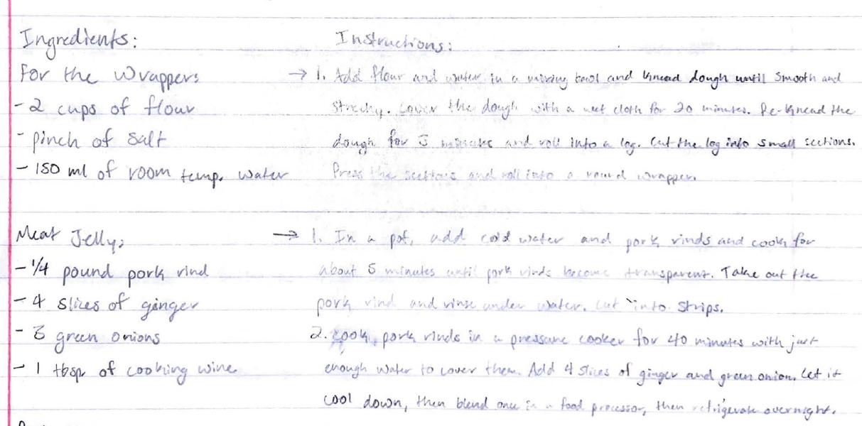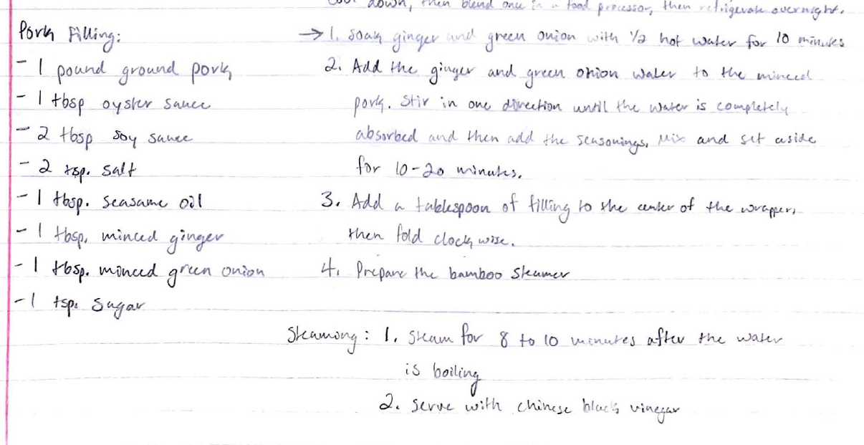

By Josie Fettig
Conversation Partner: Aaron Chen

Malaysian Stir Fry (Malaysia)
(Aaron found this recipe for me because his family uses it a lot.)
Ingredients:
  - 3/4 pounds boneless, skinless chicken breasts
  - 3 tablespoons fish sauce
  - 2 tablespoons hot chili sambal
  - 1 tablespoon sesame oil
  - 1 large yellow onion
  - 1 teaspoon sugar
  - 1 tablespoon rice vinegar
  - 1/4 cup water
  - 1 tablespoon garlic
  - 1 tablespoon ginger
  - 1 cup sliced scallions
Instructions:
- Cut the chicken pieces and mix with 2 tablespoons of fish sauce and 1 tablespoon of hot chili sambal.
- Heat the oil in skillet over medium-high heat, and add the chicken.
- Stir the chicken and add the onion to the pan. Stir-fry the chicken and onions.
- Stir the sugar, vinegar, water, garlic, ginger, and remaining 1 tablespoon of fish sauce and 1 tablespoon of chili sambal.
- Pour the sauce into the pan and add the scallions. Cook until done. Serve with rice.

I think it is interesting how Aaron knows multiple languages including Cantonese, Mandarin, and French.

Suffrage Recipes and Writings
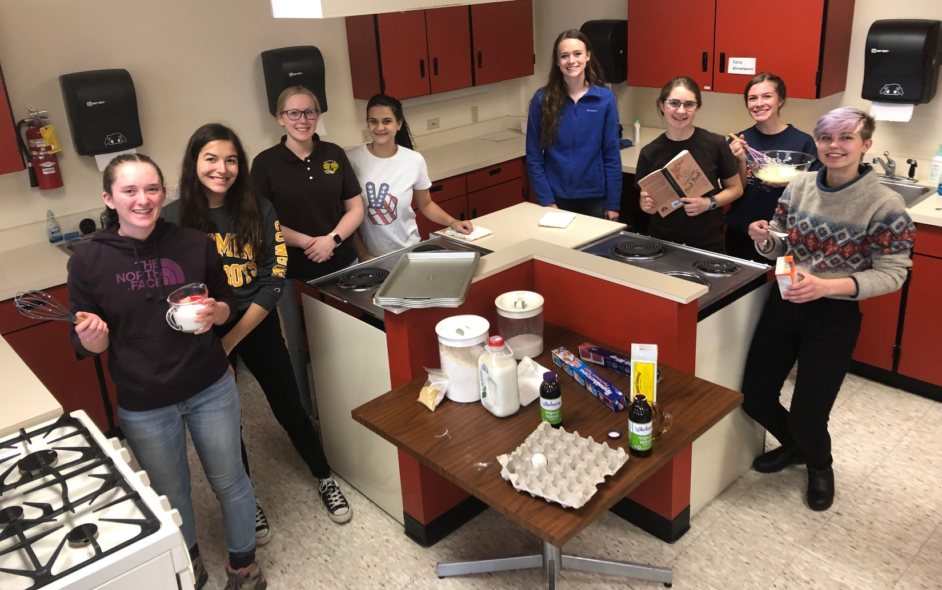

Students have chosen various topics to research which have been inspired by either their international conversation partners, class lectures, or personal interest. This book is a compilation of things they learned from their conversation partners and the Suffrage Cookbooks.
During the University of Wyoming Holiday Market, students will celebrate the 150th anniversary of women's voting rights in Wyoming by sharing some history about the importance of cookbook sales to the Suffrage Movement.
Between 1886 and 1920 at least six cookbooks were published by suffragette associations around the country. Suffrage Cookbooks had not only recipes but also political statements for the fight to get women's vote.
Give us the vote and we will cook
The Better for a wide outlook
- 1909 Washington Women's Cook Book
“Now that women are coming into their own, and being sincerely interested in the welfare of the race, it is entirely proper that they should prescribe the food, balance the ration, and tell how it should be prepared and served.” - L. O. Kleber, Editress (The Suffrage Cook Book, 1915)
At a time when Illinois's constitutional law had this statement, "Idiots, lunatics, paupers, felons and women shall not be entitled to vote," a cookbook was being sold with pro-suffrage quotes, such as
… I ask the ballot for myself and my sex. As I stood by you, I pray you stand by me and mine.
-- Clara Barton, The Holiday Gift Cook Book
Cookbooks not only raised money for the Suffrage Movement, but they also allowed women to network during sales events such as bazaars and fairs.
Along with humorous political statement recipes, women submitted sensible recipes of all kinds. The next page gives an idea as to the political recipe as well as the recipe students baked in LANG 1101 (and which inspired their “Gingerbread in a Jar” sales to benefit the UW Karma Fund.

Pie for a Suffragist's Doubting Husband (1915)
1 qt. milk human kindness
8 reasons:
War
White Slavery
Child Labor
8,000,000 Working Women
Bad Roads
Poisonous Water
Impure Food
Mix the crust with tact and velvet gloves, using no sarcasm, especially with the upper crust. Upper crusts must be handled with extreme care, for they quickly sour if manipulated roughly
- 1915 Suffrage Cook Book (Pittsburgh)

Soft Molasses Gingerbread
One cupful of sugar, one-half cupful of butter, once cupful of milk, one egg, one cupful of molasses, one teaspoonful of soda in the milk, three scant cupfuls of flour, ginger or not as you like. --Lucy Goddard from The Women's Suffrage Cook Book, page 81
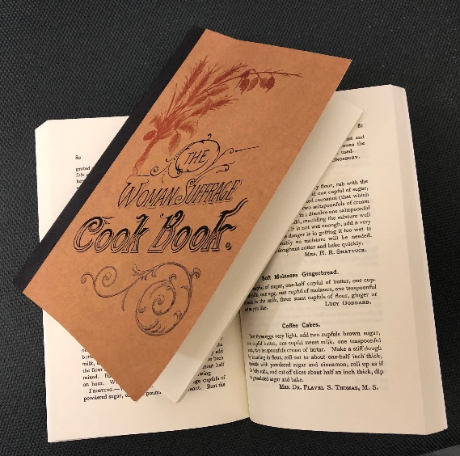

Eminent Opinions on Woman Suffrage
STATE OF WYOMING EXECUTIVE DEPARTMENT CHEYENNE.
Dec. 22, 1914.
Editress Suffrage cook Book:
After observing the operation of the women suffrage laws and full political rights in the state and territory of Wyoming for many years, I have no hesitation in saying that everything claimed by the advocates of such laws have been made good in the state. I am unqualifiedly and without reservation in favor of womnan suffrage and equal political rights for women for all of the states of the American union.
Very truly yours, JOSEPH M. CAREY, Governor
(Suffrage Cook Book, 1915)

Woman’s suffrage is undoubtedly coming, and I for one expect a great deal of good to result from it.
– Henry Wadsworth Longfellow (1886 The Women’s Suffrage Cook Book)

If prayer and womanly influence are doing so much for God by indirect methosds, how shall it be when that electric force is brought to bear through the battery of the ballotbox.—Frances E. Willard (1886)

- Laugh as we may, put it aside as a jest if we will, keep it out of Congress or political campaigns, still, the women question is rising in our horizon larger than the size of a man’s hand ; and some solution, ere long, that question must find. – James A Garifield (1886)

- Women cannot make a worse mess of the voting than men have. They will make mistakes at first. That is to be expected. It will not be their fault, but the fault of the men who have withheld from them what they should have had before this. But eventually they will get their bearings, and will use the ballot to better effect than men have used it. Whatever the outcome, it will be better to have intelligent women voting than the illiterates and incompetents who have now the right to vote because they are men.
– Irvin S. Cobb (1915)

The Class and Its Sponsors

This book was made possible by support from the University of Wyoming Service, Leadership, Civic Engagement (SLCE) Office and the Office of Engagement and Outreach.

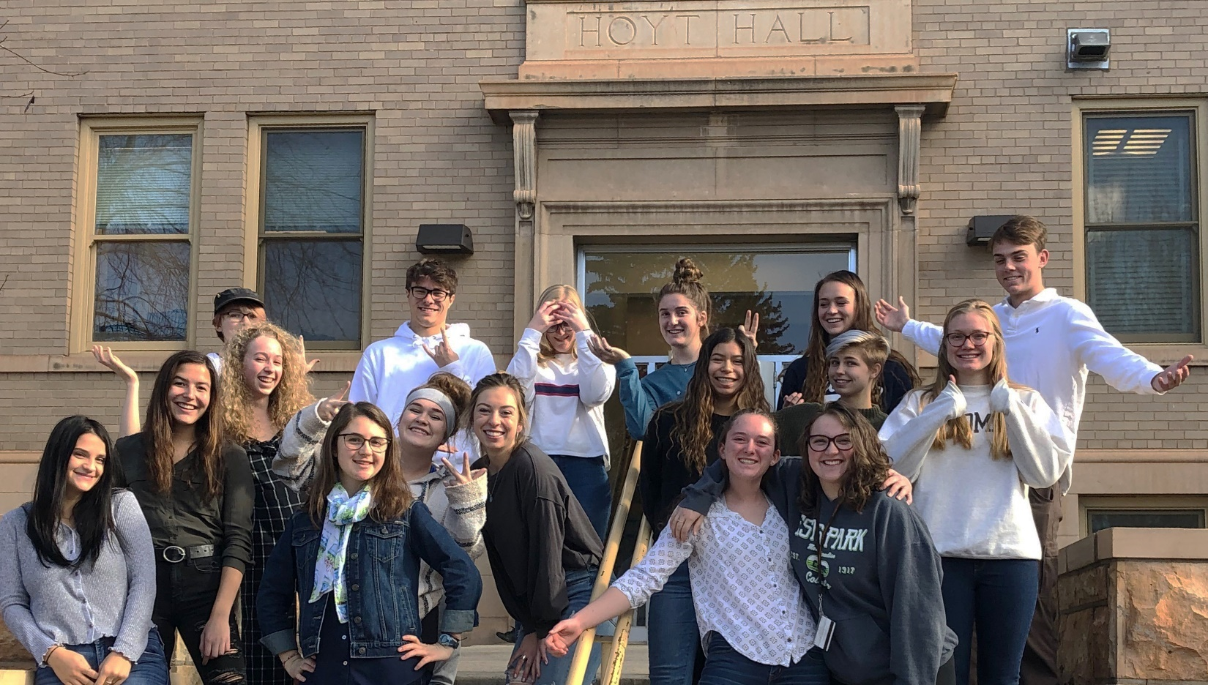
Top row: Simon Talcott, Erik Gwaltney, Emma Magruder, Katie Banks, Josie Fettig, Evan Duel;
Second row: Anna Papadopoulos, Elena Stewart, Hazel Homer-Wambeam, Emily Smith, Megan McFate, Maggie Rossman, Sam Expinoza, Marissa Brenneman, Claire Rankin;
Third row (right): Krisanna Andrews, Kaylen Maltais.
Not pictured: Shayna Deveraux (Shayna is pictured 7th from left on page 14),

Thank you for your support!

