The UW in Scotland Project

cfp for the 2022 Faculty Cohort in Scotland

Would you like to research and teach abroad, but lack the experience?
Do you have experience but lack the community to leverage your knowledge?

UW in Scotland is a collaborative and transdisciplinary research and teaching project. The aim of the project is to build, sustain, and enable a faculty committed to international and transdisciplinary research, and to exploratory teaching in Scotland. The project is anchored at Walter Scott’s historic house in the Scottish Borders.

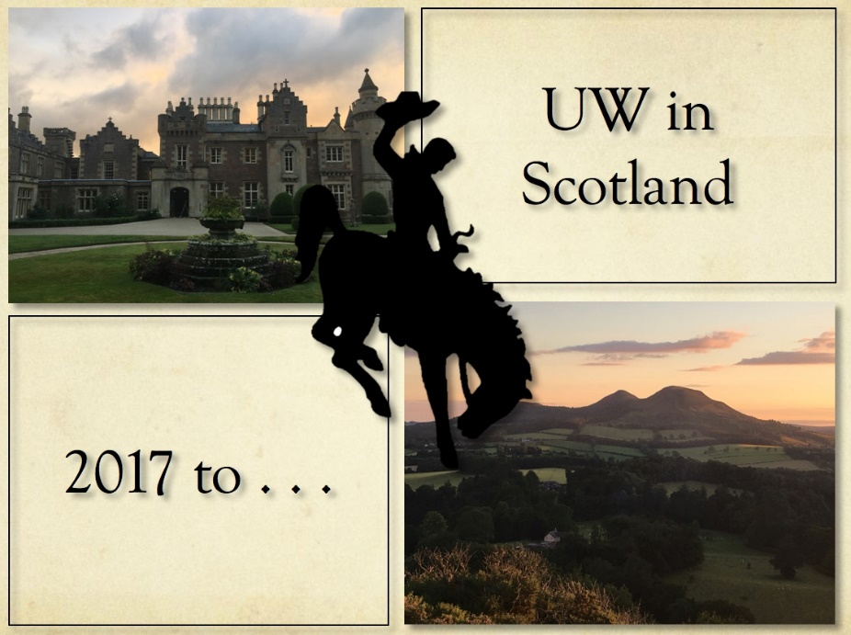

Project leader: Caroline McCracken-Flesher
Director, Center for Global Studies

The project:

UW in Scotland offers UW faculty the opportunity to develop their international connections and capabilities through a funded colloquium, resident for one week at Walter Scott’s historic house in Scotland (25 July–1 August 2022).

Colloquium activities in Scotland include visits to a number of sites relevant to the research of participants, and engagement with Scottish institutions and program supporters.

Cohort members receive accommodation at Walter Scott’s Abbotsford for the duration of the experience, and paid admission to most sites; some meals are covered within the itinerary.

Members are expected to identify their own travel funds. They may apply for CGS International Research Awards, and should apply for additional UW funding as relevant (e.g. college, department, WIHR).

/OVER
Commitment for successful applicants:

Spring 2022: Bi-weekly meetings for participants to share regional and disciplinary expertise.

Summer 2022: One week’s residence in Scotland in shared accommodation at Abbotsford
Participation in all cohort activities in Scotland
(we will travel to sites on approx. 4 days; transportation is by small tour bus).

Thereafter: Research and course development

UW in Scotland aims to
—cultivate research collaborations for UW scholars in Scotland.
—develop transdisciplinary study-abroad courses to be team-taught in Scotland

Non-credit, community courses are also in development following similar transdisciplinary protocols. These will pilot in Spring 2022.

Faculty:

On completion of the cohort experience, the UW in Scotland/Abbotsford faculty will meet once a semester to continue their transdisciplinary discussions, to support the project, and to welcome additional interested faculty.

Every fifth year, active faculty and potential faculty will aim to reconvene at Abbotsford to refresh and reenergize the project: 2017, 2022, 2027

The selection committee for the 2022 UW in Scotland cohort will include:

  - The director of UW in Scotland (Director of Center for Global Studies)
  - The VP of Global Engagement, or designated representative
  - Three faculty who have recently participated in the project

Applications to:
Caroline McCracken-Flesher cmf@uwyo.edu

Deadline: November 1 2021

