DIRECT DEPOSIT AUTHORIZATION

Please complete the form by providing the appropriate information and attaching a voided check or other document* verifying the correct routing number and account number. The form MUST be signed in the presence of either a University of Wyoming department representative OR a notary public.
_-- Affix check here with TAPE -- Affix check here with TAPE -- Affix check here with TAPE -- Affixcheck here -Affix check here -- Affix check here

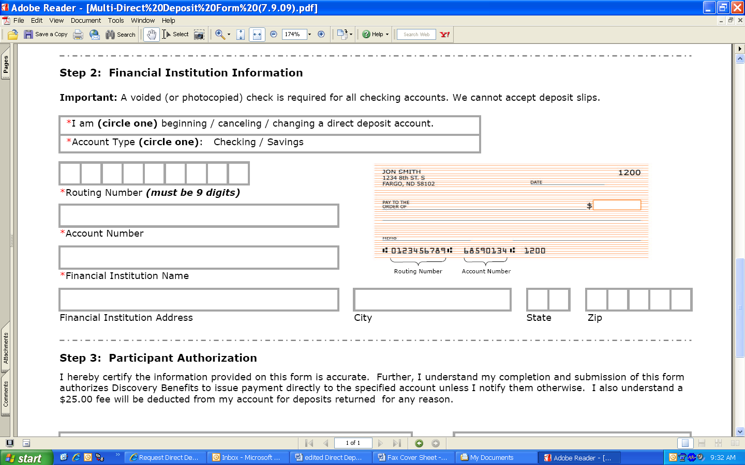
-- VOID --
*If a voided check is unavailable, please ensure the document provided (deposit slip, photocopy of account card, etc.) includes the correct routing and account number. If necessary, contact your financial institution for this information. For example, Wells Fargo, US Bank, Bank of the West and others DO NOT have the correct routing number on deposit slips- a voided check is needed to obtain the correct routing number.

NAME__________________________________________SSN_________________________________
EMPLOYEE ID NUMBER__________________________

Select one: ⁯ NEW Agreement ⁯ CHANGE of Agreement ⁯ CANCEL Agreement

Name of Bank _______________________________________________
Select one:
⁯ Checking ⁯ Savings
Routing Number _____________________________________________
Account Number_____________________________________________
Deposit Start Date___________________________

I have read and understand this form and the information provided is accurate. I understand that in signing this form, I authorize the University of Wyoming to issue payment to the specified account until the University of Wyoming receives written notice from me to change or cancel this agreement.

SIGNATURE______________________________________________ DATE_____________________

I hereby certify that on this date, the above named individual appeared before me and signed this document in my presence.

____________________________________________________ __________________
UW Department Representative OR Notary Public (if UW rep not available) Date

