**Selection of Faculty Fellows**

* Quality of course proposal including the development of creativity and reasoning skills
* Development of a multifaceted student-centered course
* Evidence of energy and creativity in teaching
* Enthusiasm for working with and nurturing the development of high school students
* Flexibility and willingness to adapt in response to this special student audience
* Range of personal, academic, and cultural interests

**What Do Faculty Fellows Gain From This Experience?**

Being a Faculty Fellow for the Summer High School institute means you will have the rare opportunity to share the joy of learning in a community atmosphere where curiosity and enthusiasm inspire discovery. Your time will also be compensated with up to a $3500 stipend.

**To Apply Please Provide:**

1. A course description (3-5 pages) which includes a general description of the instructional format and a suggested list of reading materials. (Please be specific about the ways in which you would have the students actively engaged in class. Variety--even within one class period—is essential for high school students.)
2. A cover letter explaining your reasons for wanting to teach and learn in this environment.
3. A brief resume of your academic career, including references to course development and teaching achievements.

**Deadline has been extended until position is filled. Please submit as soon as possible--**

**Bring or send to:**

UW Summer High School Institute

Red House

(200 S. 10th Street)

**Email applications should be sent to:**

hsi@uwyo.edu.

Due February 1st

If you have any questions about the program or application process, please call Rene Sanchez at 766-3005.

**Attention**

**UW**

**Faculty**

**Apply to the Summer**

**High School Institute!**

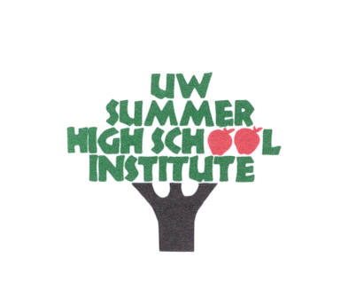

**2017**

**June 4 – June 24**

**What is the Summer High School Institute?**

The Institute is a three-week summer residential program for approximately one hundred of Wyoming’s outstanding high school sophomores. These young people are selected on the basis of demonstrated achievement in a combination of the following areas: general intellectual ability, specific academic aptitude, creative thinking, leadership skills, and the arts.

**What Role Will**

**Faculty Play?**

You are invited to be a part of an exciting teaching/learning experience. Applications are requested from UW tenured and tenure-track faculty for positions as Faculty Fellows in the 2017 UW Summer High School Institute. At the Institute we attempt to provide the students with an enriching academic experience within a lively, nurturing environment. The emphasis of the program is on the development of the whole person. The goal is to draw talented high school students to the University to challenge their intellectual interests, adaptability, creativity, and critical thinking abilities.

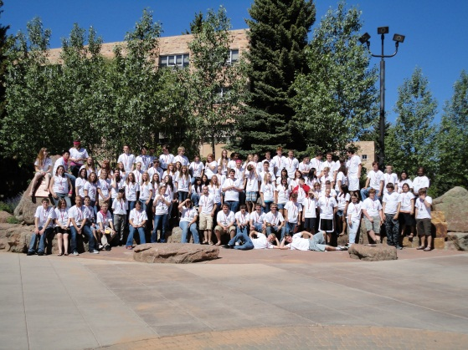

**Expectations**

***It is our belief that a close relationship between instructors and students greatly contributes to the academic progress of the students.*** Therefore, we encourage open communication and active dialogue between instructors, students and staff.

Because the students are 15-16 years old, instructors must make extra effort to ensure student safety and comfort away from home.

The Institute is an intense and exhilarating immersion experience. In addition to the courses, an array of cultural and recreational activities offers excitement every day of the week. Faculty members are encouraged to be active participants and engage the students outside the classroom. One of the most popular and appreciated activities in recent years has been a class dinner in the faculty members’ homes. Instructors are also expected to attend the closing brunch and one group activity.

**The Curriculum**

Students in the program have a wide spectrum of interest; course designs should engage them in as many different ways as possible. The most successful courses in the past have given students the chance to develop their intellectual and creative abilities through a variety of activities. The classes offered at the Summer High School Institute do not focus on grades but rather on critical thinking and discussion. Thus, introducing them to courses designed for college level reasoning.

Each student will enroll in one Human Culture class and one Physical & Natural World class. Each class will contain 13-16 students and will meet four times per week. Human Culture classes will meet in the morning (9:00- 11:15am), Physical & Natural World classes will meet in the afternoon (1:45-4:00pm), and extra time will be allotted for field trips.

