# ALEKS PPL How-to Guide

### **To take the exam online, students must:**

1. Purchase the ALEKS PPL test pack. You can get to the ALEKS PPL website by clicking the button labeled “[I’ve Read and Acknowledged the Guidelines and Am Ready to Take the Exam](https://www.uwyo.edu/mathstats/math-placement/interrupt.html)” and entering the class code: **6EKAN-DPQQ3**
2. Sign-in or create a student account
3. Purchase access or, if you've already purchased the test pack, apply access by entering the 16-digit access code from the confirmation email you received after purchasing (if your class is “On Hold,” you likely still need to apply or purchase access).
4. Download and purchase the Honorlock remote proctoring extension (see the [Take the MPE Online](https://www.uwyo.edu/mathstats/math-placement/take-the-mpe-online.html) page for more information)
5. Complete the demographic survey. Note: None of the questions on the survey are tied to the test and they will not impact your placement—the survey is used for our department to monitor the validity and reliability of the assessment.
6. Complete the tools tutorial which will show you how to enter in fractions, answer questions using graphs, etc.
7. Take the exam.
8. Complete the required three hours of practice in the guided learning module before [retaking the exam](https://www.uwyo.edu/mathstats/math-placement/after-the-exam.html).

### **Creating an ALEKS Account**

After reviewing the Honorlock & ALEKS PPL guidelines, click “[I’ve Read and Acknowledged the Guidelines and Am Ready to Take the Exam](https://www.uwyo.edu/mathstats/math-placement/interrupt.html)” and you will be taken to the page below. Insert the class code: **6EKAN-DPQQ3**.

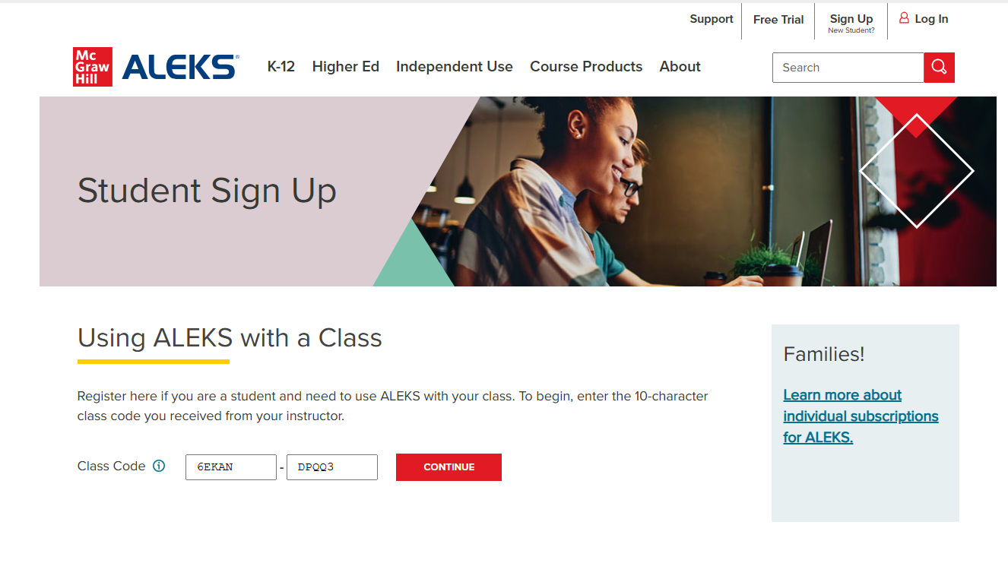

Please note that the current cohort is named "UWyo Math Placement Exam beyond, Fall 2023." This is correct, though it may not reflect the current year.

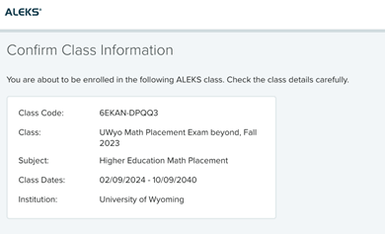

Select “Confirm” to go to the next page. There you will be prompted to select if you already have an ALEKS account.

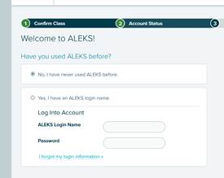

**If you have not taken the MPE at UW before, select “No, I have never used ALEKS before.”** You will then be prompted to create an account.

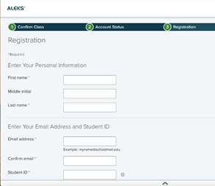

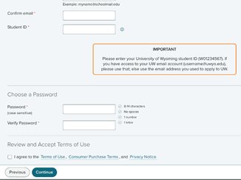

It is recommended that you provide you uwyo email address but not required. Students can take the MPE before they’re officially admitted. However, if you do not yet have a W#, then there will be a delay in uploading your score.

Once registered, you should receive an email like the one below. Please note that ALEKS PPL creates your username for you (so be sure to save or screenshot the email in case you forget).

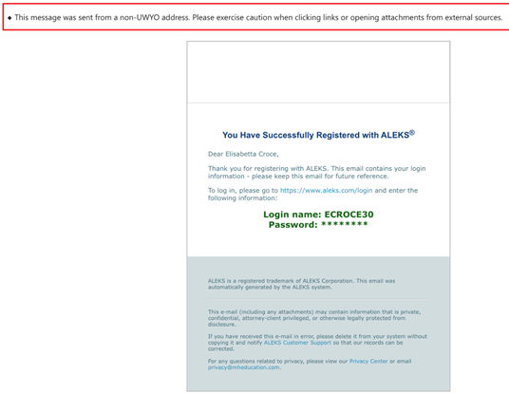

### **Paying for the MPE**

Once you are registered and successfully signed in, the system will prompt you to “apply access.” Your access code is different from the class code. If you've already purchased the test pack, the access code should be in your email.

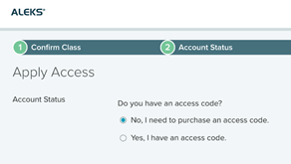 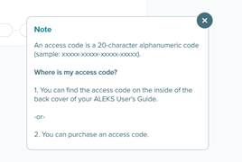

If you choose “No, I need to purchase an access code,” the system will take you to the payment screen below:

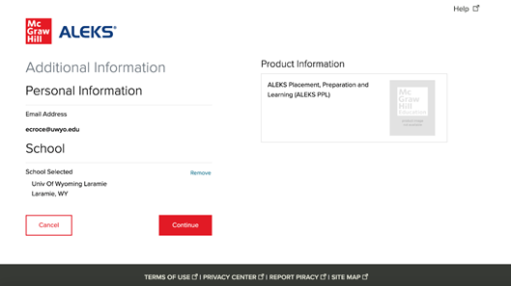

You'll need to follow the prompts until you receive your access code. Then, you'll need to go to the “Apply Access” screen and enter the access code.

### Accessing the MPE “course”

Once you confirm access, you should see the landing page below.

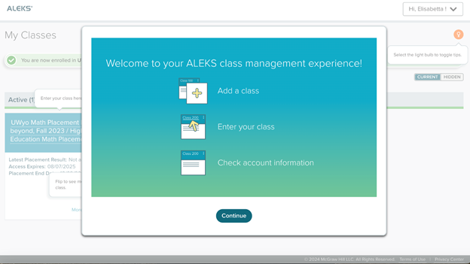

Select "continue" and then click on the course title. Note: if the tile the course appears in says “On Hold” as opposed to “Active,” it means access was not successfully applied (try entering the code again or making sure that your purchase was successful).

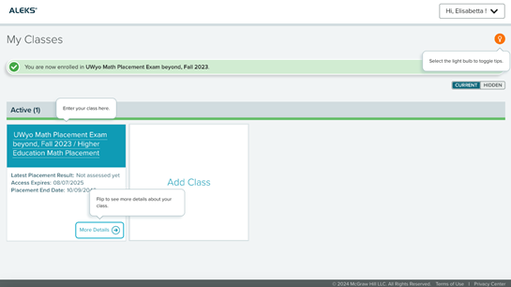

## **Demographic Survey**

After clicking on the underlined class title, select “Take a Survey.”

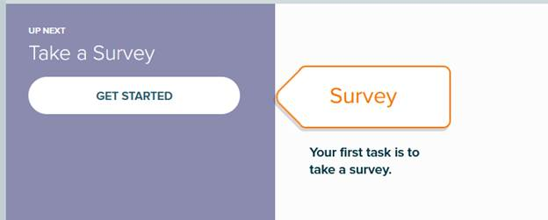

This is a demographic survey of questions that we use to assess changes to cutoff values and the like. *This survey does not impact your placement assessment* ***in any way.*** The system states this at the start of each page of the demographic survey questions.

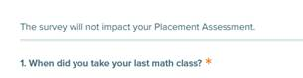

Once you complete the survey, a confirmation page will appear.

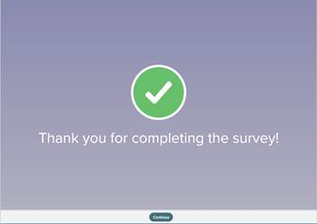

## **Tutorial**

You will then be prompted to complete an ALEKS tools tutorial.

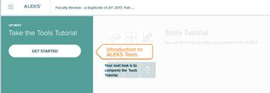

This training will teach how to enter and clear answers, fractions, and exponents, plot points on a graph, and show you when and how you can use the built in ALEKS calculator.

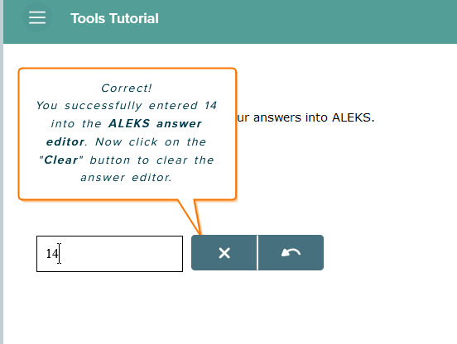

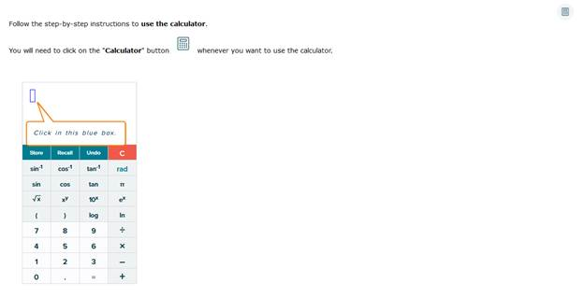

Once you complete the tutorial, you’ll see the screen below:

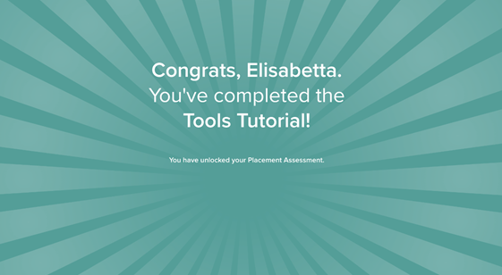

## **Take the Assessment**

Once you complete the demographic survey and the Tools Tutorial, then you will be able to access the assessment. If you’re taking the exam online, you will see “Honorlock Proctored” under the time limit. If you don’t see this, you’ll need to stop and download Honorlock.

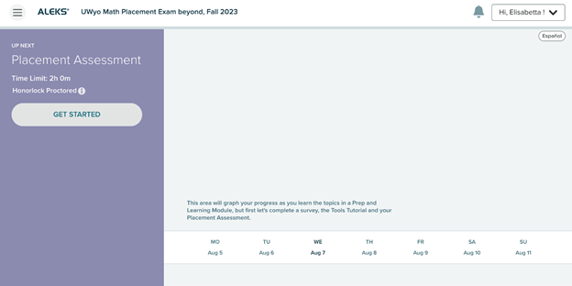

Once you hit “Get Started”

* If you are taking the exam in-person, it will prompt for a proctor password
* If you are using Honorlock it *should* skip to the start page. If it doesn’t skip to the start page, try hitting enter without entering anything into the password field. If it still doesn’t work, check your system requirements meet those for Honorlock proctoring. Troubleshooting details can be found here: <https://www.uwyo.edu/mathstats/math-placement/take-the-mpe-online.html>

When proctoring is confirmed, it will take you to the start of the MPE, which has a three-part launch screen like the one pictured below:

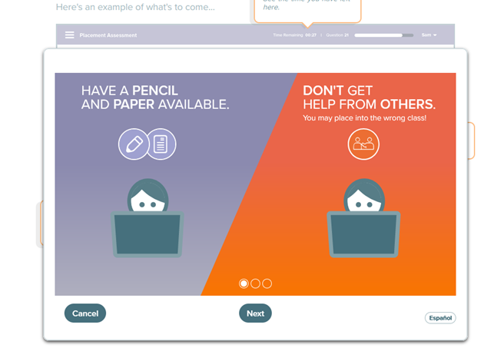

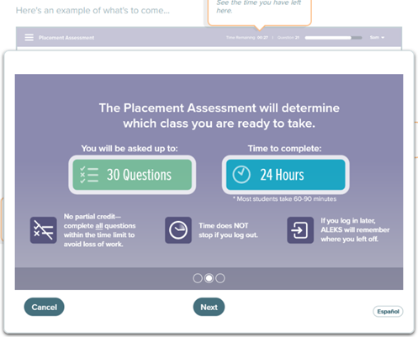

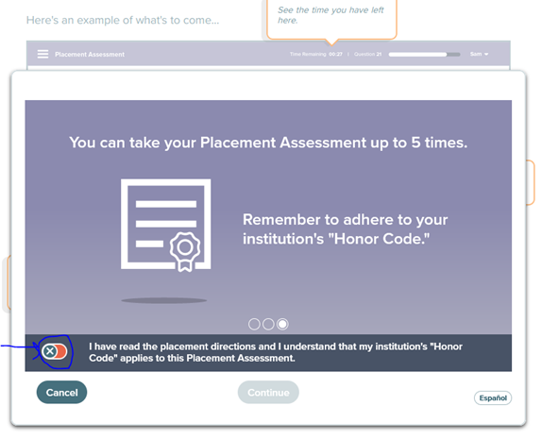

Note: You **must** toggle the circled section before you can continue. If you click out of the launch screen, the system will require the proctor password to be re-entered (you may have to restart Honorlock).

Once you finish the launch, the screen below will show you where you can find tools specific to the exam.

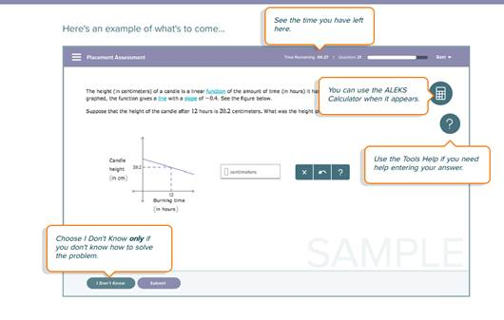

You have an option to select “I Don’t Know” for problems you do not know. You should only select that option if you have no idea how to start the problem because it will impact your result.

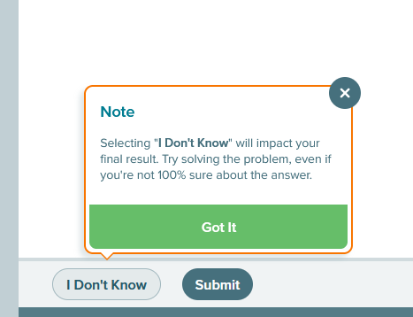

Once you hit submit it will take you to the exam. You will have two hours to answer 25 questions. You should expect about seven or eight questions in each of the topic areas.

## After the Exam

As soon as you complete the exam, you’ll get a confirmation email and a page with your results will appear on the screen.

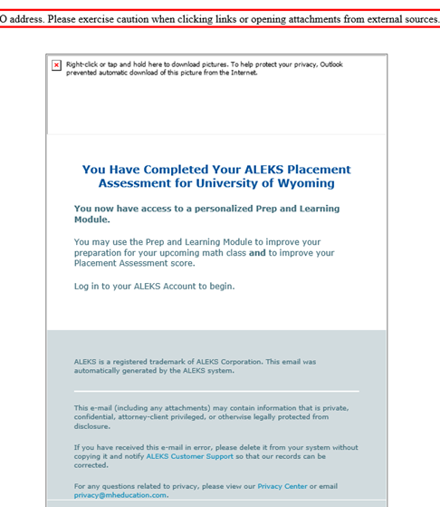

Notice that the results list the topics that were seen/completed during the attempt:

Next, it will start you on the Prep and Learning Module. This is a guided learning course in ALEKS that will try to cover the topics that you were missing in your last assessment so you can get a higher score in the next attempt.

Based on your results, ALEKS will suggest which prep and learning module you should start with. Once the module is selected it **cannot** be changed, so you also have the option to select “Not Now.” You will need to satisfy a preset amount of time in the prep and learning module before you’re able to attempt the MPE again (three hours of practice is required between the first and second attempts).

Once the learning module is selected, you will be taken to the new course homepage. Here you can:

* Work through your prep and learning module
* See old placement results (and download them to send elsewhere)
* See how long you have left in your cool-off period (24 hours between each attempt)
* See how much time you need to spend in the prep and learning module before your next attempt

## Prep Requirements

If you are retaking the exam in-person, the proctor can override the guided learning module requirement for you. **If you are retaking the exam online, you must complete the required number of practice hours before ALEKS PPL will let you test again.**

Questions?

Contact [Math-registration@uwyo.edu](mailto:Math-registration@uwyo.edu)