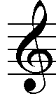 | RHYTHM | MUSIC  SYMBOLS | NOTE  VALUES | RECORDER  NOTES
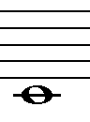 | 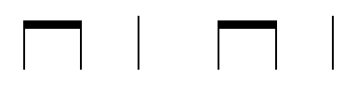 | 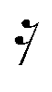 | 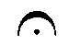 | 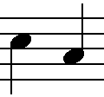
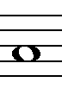 | 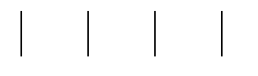 |  |  | 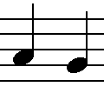
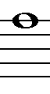 | 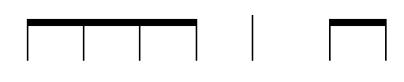 | FREE | 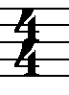 | 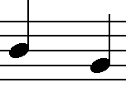
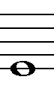 | 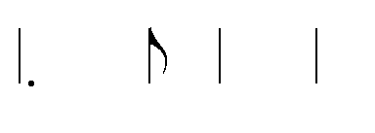 |  | 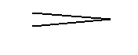 | 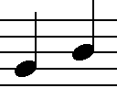
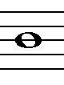 | 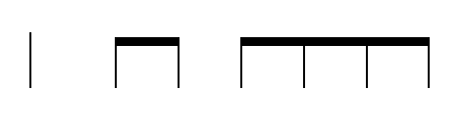 | 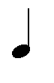 | 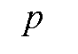 | 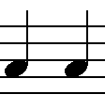

 | RHYTHM | MUSIC  SYMBOLS | NOTE  VALUES | RECORDER  NOTES
 |  | 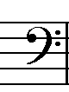 | 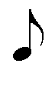
 |  | 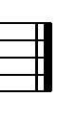 | 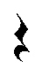
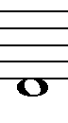 |  | FREE
 |  | 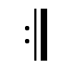
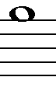 | 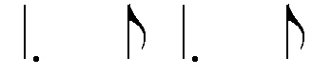 |  | 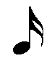 | 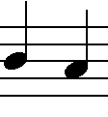

 | RHYTHM | MUSIC  SYMBOLS | NOTE  VALUES | RECORDER  NOTES
 |  | 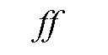
 |  | FREE
 | 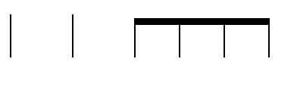 |  | 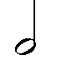 | 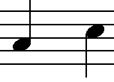

 | RHYTHM | MUSIC  SYMBOLS | NOTE  VALUES | RECORDER  NOTES
 |  | FREE
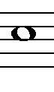 |  |  |  | 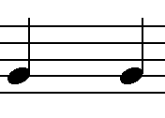

 | RHYTHM | MUSIC  SYMBOLS | NOTE  VALUES | RECORDER  NOTES
 |  | FREE
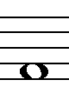 | 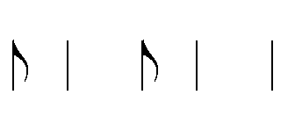 |  |  | 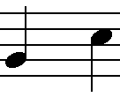

 | RHYTHM | MUSIC  SYMBOLS | NOTE  VALUES | RECORDER  NOTES
 |  | FREE
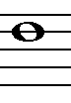 |  |  | 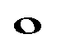 | 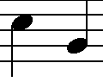

 | RHYTHM | MUSIC  SYMBOLS | NOTE  VALUES | RECORDER  NOTES
 |  | FREE
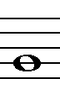 | 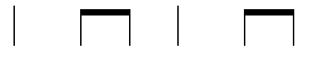 | 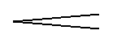 | 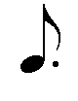 | 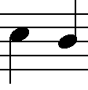

 | RHYTHM | MUSIC  SYMBOLS | NOTE  VALUES | RECORDER  NOTES
 |  | FREE
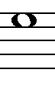 | 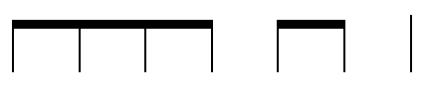 | 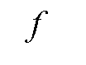 | 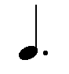 | 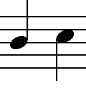

 | RHYTHM | MUSIC  SYMBOLS | NOTE  VALUES | RECORDER  NOTES
 |  | FREE
 |  | 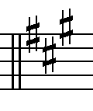 | 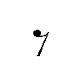

 | RHYTHM | MUSIC  SYMBOLS | NOTE  VALUES | RECORDER  NOTES
 |  | FREE

 | RHYTHM | MUSIC  SYMBOLS | NOTE  VALUES | RECORDER  NOTES
 |  | FREE

 | RHYTHM | MUSIC  SYMBOLS | NOTE  VALUES | RECORDER  NOTES
 |  | FREE

 | RHYTHM | MUSIC  SYMBOLS | NOTE  VALUES | RECORDER  NOTES
 |  | FREE

 | RHYTHM | MUSIC  SYMBOLS | NOTE  VALUES | RECORDER  NOTES

 | RHYTHM | NOTE  VALUES | MUSIC  SYMBOLS | RECORDER  NOTES

 | RHYTHM | NOTE  VALUES | MUSIC  SYMBOLS | RECORDER  NOTES

 | RHYTHM | NOTE  VALUES | MUSIC  SYMBOLS | RECORDER  NOTES

