Listening Unit Plan
McKeage/2007

Title and composer of work Farandole, from the L'Arlesienne Suite #2 by Georges Bizet

Total Listening Time 3 min 29 seconds

Medium Orchestra

Genre Orchestral Suite

Major Concepts Texture, form

Rationale
This brief work incorporates examples of the following texture types: monophonic, homophonic, and both imitative and non-imitative polyphony. It also is in an easy to identify binary form.

Prior knowledge
For the primary grade activities, students must:
- Be able to tap/clap beat.
- Be able to identify aurally/visually common orchestral instruments.

For the upper grade activities, students must:
- Be acquainted with canon and partner songs (imitative and non-imitative polyphony), along with homophony (melody and accompaniment) and monophony (melody alone in unison, whether performed by one instrument/voice or many).
- Be able to identify large and internal (small) forms with appropriate labels (either traditional letters or symbols).
- Understand meter as either duple or triple.
- Be able to read/recognize simple rhythmic patterns.

Background
French composer Georges Bizet (1838-1875), began studying music composition at the Paris Conservatory at the age of 10. His most famous composition is the opera Carmen, which includes the popular March of the Toreadors. He also wrote music for the play L'Arlesienne, and those melodies were compiled in two different groups (or suites) to be performed by an orchestra alone. The most famous of these melodies is the Farandole, a very fast piece that features two very simple, yet appealing melodies. The March is actually taken from a French Christmas tune The March of the Kings. The term Farandole actually refers to a French folk dance.

This page is intentionally blank.
Sequential Activities for Primary Grades

National standards met, K-4
6. Listening to, analyzing, and describing music

Key Concepts | Objectives | Activity | Materials | Assessments
high/low timbre  Form (A B)  Macro Beat | Students will identify instruments playing | Guided listening  Instrument identification, with emphasis on flute/piccolo (B) and the brass (A) | Pictures of orchestral instruments | Identification of instruments
high/low timbre  Form (A B)  Macro Beat | Students will be introduced to the two sections (A and B). | Guided listening  Movement to alternating sections  Students tap/pat/walk steady beat to the music Is the beat steady throughout the whole piece? Are the rhythms same or different between the A and B sections. | Space to move | TO of movement
high/low timbre  Form (A B)  Macro Beat | Students will demonstrate music literacy through production of graphics | Students draw to the music, interpreting what they hear. Have student share their work, describing how the drawings represent the music. | Paper, pencils | Artwork and student interpretations

Sequential Activities for upper elementary
National standards met, 5-8 6. Listening to, analyzing, and describing music, 5 Reading and notating music
Key Concepts | Objectives | Activity | Materials | Assessments
Beat/meter  identification | Students keep steady beat and identify meter as duple | Students pat/tap beat and count in duple meter. | None | TO
Internal form/phrases | Students will identify the internal sections; a, b, c, d. | Perform chants identified with each section of the music. | Chants (p. 6-7) on overhead or board | TO
Internal phrase recognition | Students will perform glissando during b section | After counting in 2 the B sections, students gliss, either instrumentally or vocally. | Instruments for glissando (slide whistle, barred percussion) | TO
Large form  (binary) | Students will listen for and identify the A, B, transition, and coda sections | 1) Students form three groups (A, B, and Transition) and move to individual sections. When their section is not playing, students sit on the floor or as statues  2) Use playing cards with graphics to chart the form. Identify the alternating sections of A, B, transitions and Coda, using included pictures and/or letters | Space to move  Listening map (p. 7)  Graphics (p. 8) | TO
Texture | Students will identify monophonic, homophonic, imitative and non-imitative polyphonic textures. | 1) Review the three texture categories, citing examples of each.  2) Ask students to draw the three categories and then have them display their drawings at the appropriate time in Farandole | Paper for drawing | Listening maps
literacy | Students will demonstrate understanding of traditional music literacy in charting form and reading rhythms | 1) Students will chart the form using either traditional form notation or their own listening maps.  2) Students complete rhythm puzzle  3) ) Students will identify rhythms from each of the sections. | Rhythm Puzzle (p. 11)  Rhythm worksheet (p.9) | Listening map/form chart  Rhythm worksheet

Chants for The March and The Piccolo Part

March
a
Do you know, this march from Farandole?
It’s big and very heavy, big and very heavy
Do you know, this march from Farandole?
The big and very heavy part that’s low.
b
The low parts’ back but it can’t get in
The low parts’ back and it really wants to get back in.
The low parts’ back but it can’t get in
It should keep trying or the pic part wins.

The Pic Part
c
This is the part with piccolo, it’s very high and really, really fast.
This is the part with piccolo, it’s very high and fast.
d
Now here comes the gliss, now here comes the gliss
This is the part with piccolo, it’s very high and really, really fast.
Now here comes the gliss, now here comes the gliss
This is the part with piccolo, it’s very high and fast.

A March

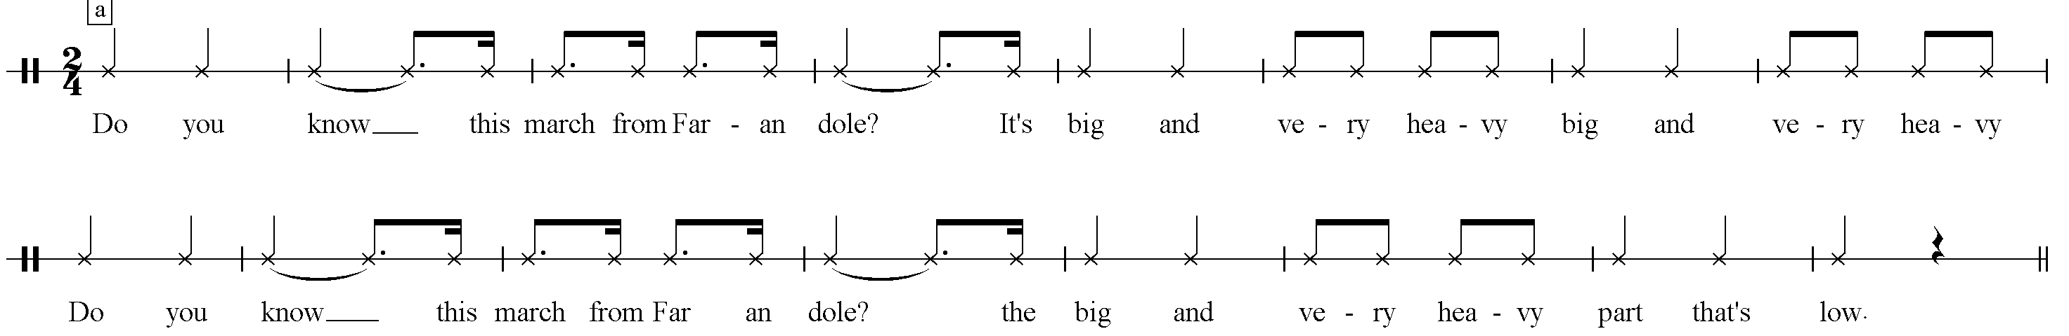
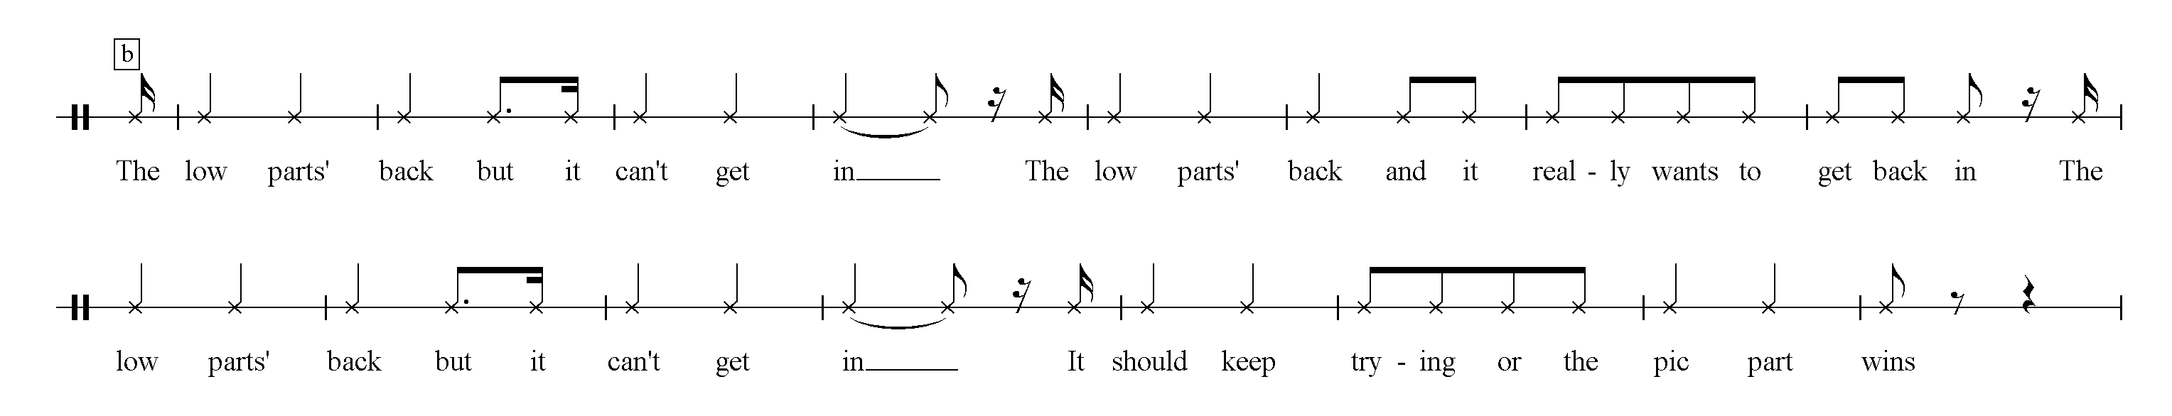

B The Pic Part

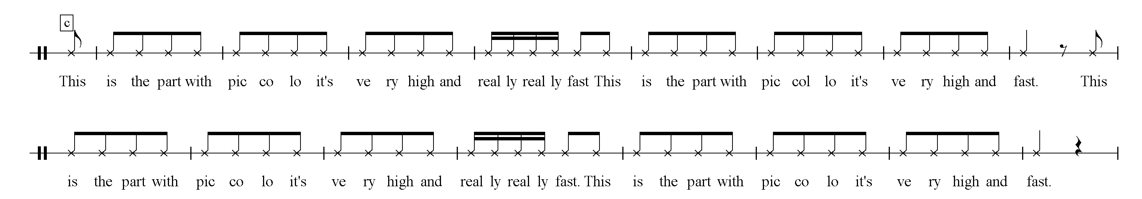

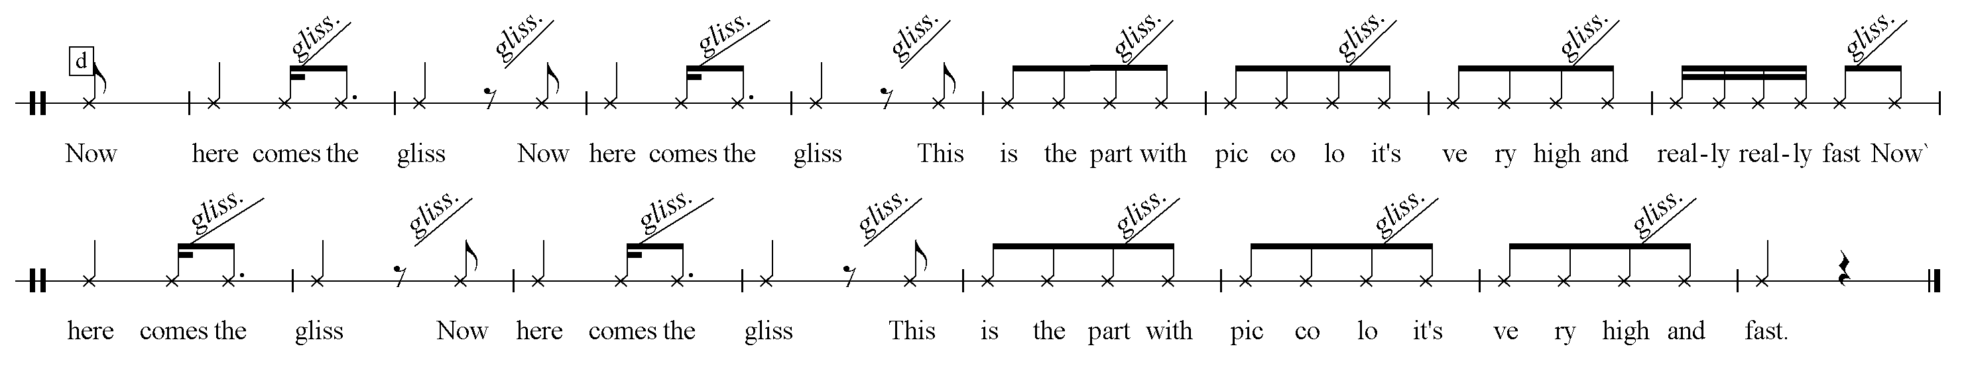

Bee da lee dee Transition and Coda

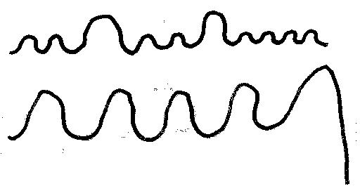
Listening Map
Graphic | Large Form | Internal form | texture | Notes/Questions
 | A The March | a  a (canon) | Homophonic  polyphonic | Statement of melody in brass and strings
 | transition |  | Monophonic | 4 measures in 2/4
 | B The Pic Part | c c  d  c c  d  c c | homophonic | Begins with piccolo/drums  Crescendo by adding instruments
 | A The March | a | Monophonic | Entire orchestra plays the same melody in octaves
 | B The Pic Part | c | Homophonic | Brief statement of c  Piccolo plays with drum only
 | A The March | b | homophonic
 | B The Pic Part | c  c | Homophonic | Modulates
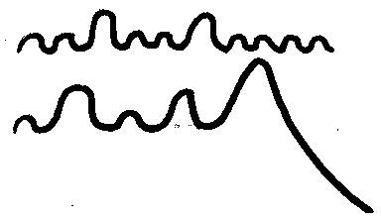 | Transition | c varied | homophonic | Transitional material based on c
 | A plus B  March and Pic Part  combined | a b a  c c d c c | Polyphonic  (non-imitative) | Crescendo by adding instruments
 | Coda  Bee da lee dee |  | Homophonic | The big finish

Graphics for Listening map.
For playing cards, 4 marches, 4 piccolos, 2 Bee da lee dees, 1 drum

Rhythm Worksheet
Identify each of these rhythms by either adding the proper words or indicating the phrase that is comes from. For example, the first excerpt is from phrase a.

1. phrase

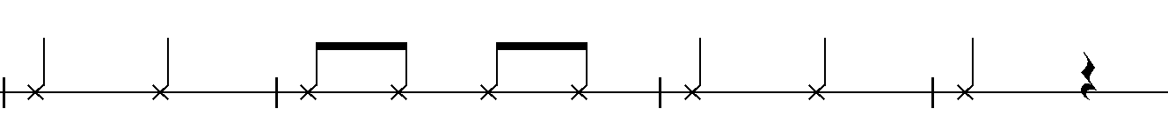

2. phrase

3. phrase

4. phrase

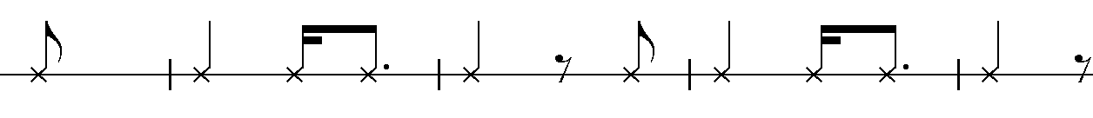

5. phrase

6. phrase

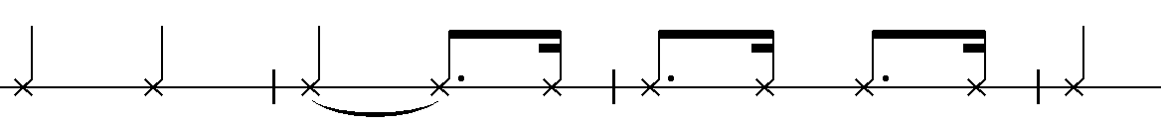

7. phrase

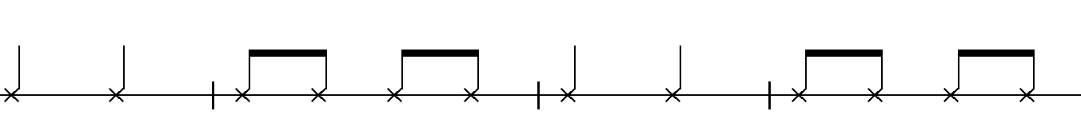
Farandole Rhythm Puzzle

Each line below represents ½ of a phrase from the Farandole. Cut out each line (omitting the titles) and jumble them up and have the students assemble them in order. This activity may be done along with the listening map.

The March a

The March b

The Piccolo Part c

The Piccolo Part d

